# Practical-10: Implement following Network devices configuration commands.

|  |  |  |
| --- | --- | --- |
| **Sr. no.** | **Network Device** | **Commands** |
| **1.** | **Router** | * **Enable the router** * **Set the clock** * **Set the password in user mode** * **Set the password in privilege mode** * **Set the hostname** |
| **2.** | **Switch** | * **Enable Switch** * **Set the hostname** * **Set password in console line** * **Encrypt the password** * **Set IP address** |

* **Router:**

1. **Enable the router**

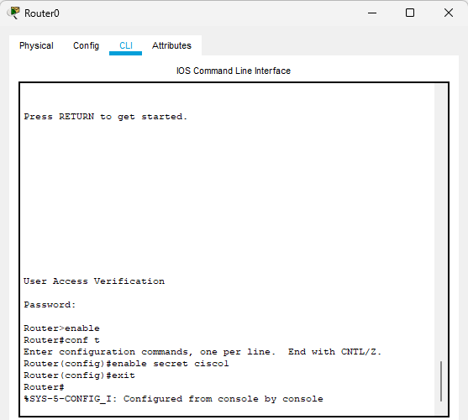

1. A screenshot of a computer

   Description automatically generated**Set the Clock**
2. **Set the password in user mode**

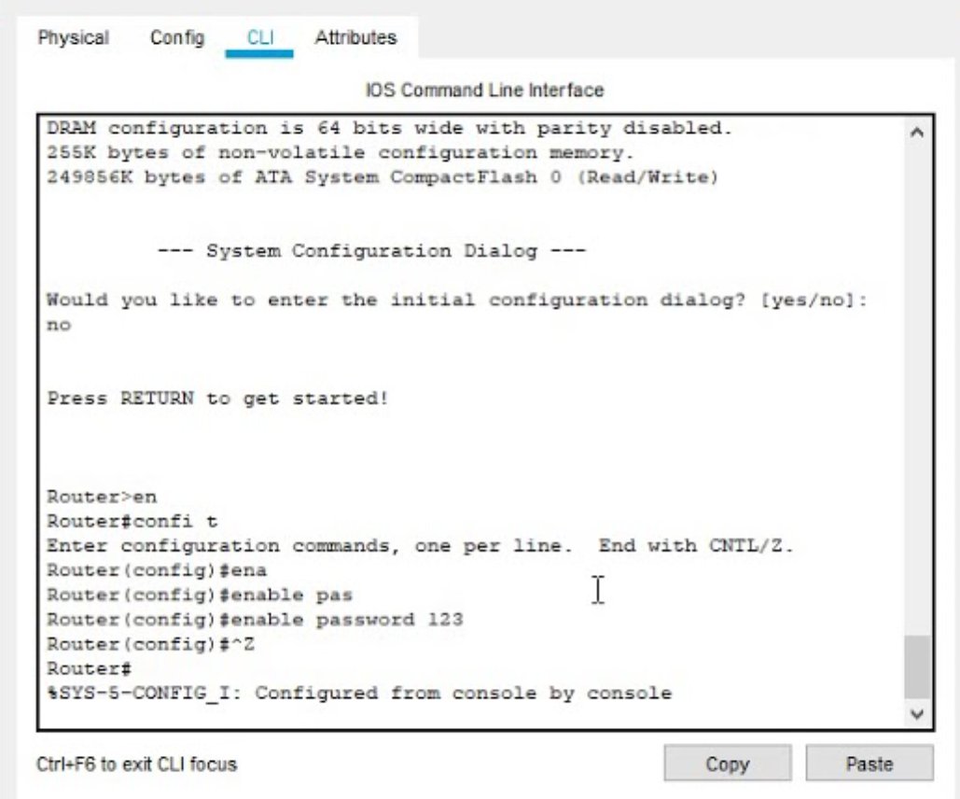

1. **Set password in privileged mode**

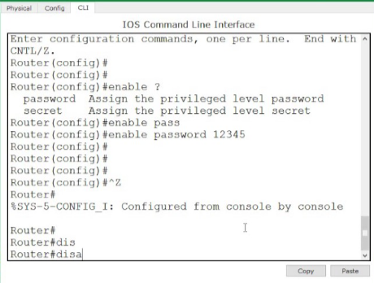

1. **Set host name**

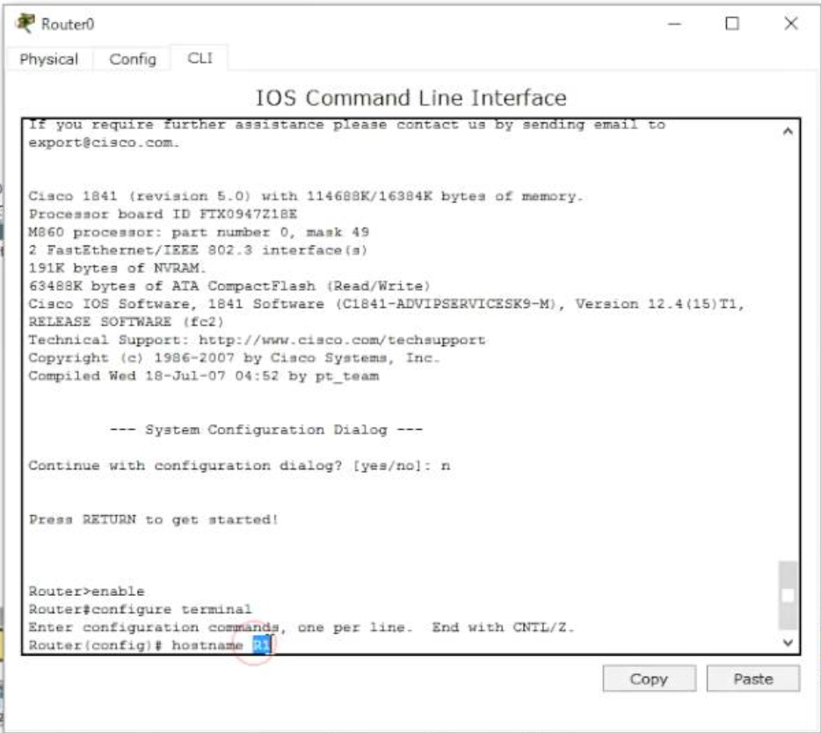

* + **Switch:**

1. **Enable Switch**

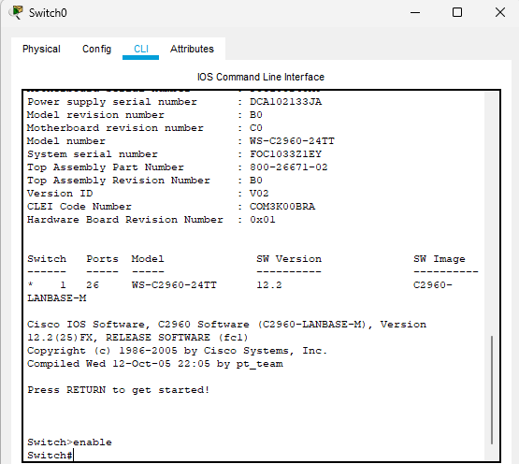

1. **Set host name**

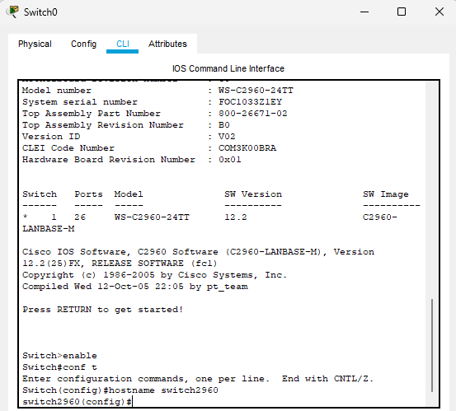

1. **Set password in console line**

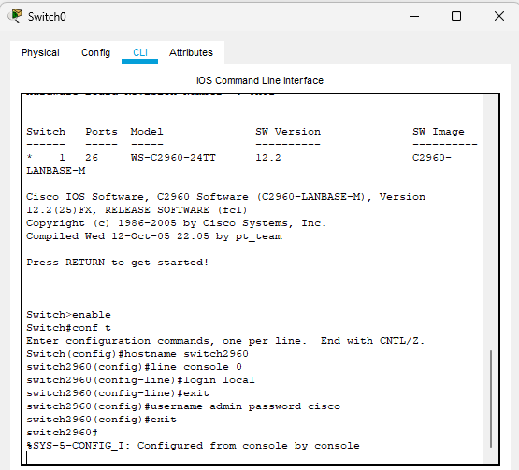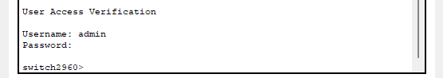

1. **Encrypt the password**

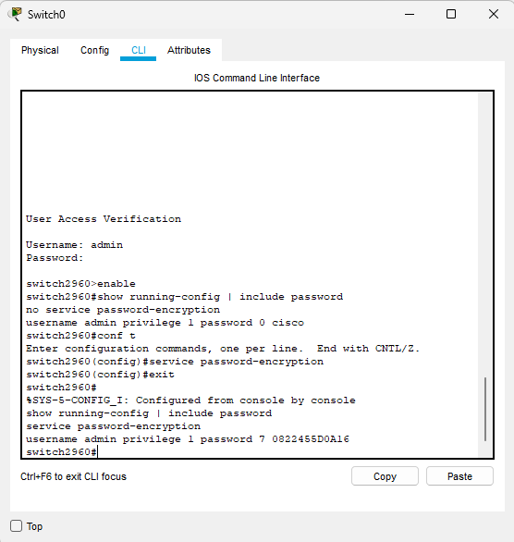

1. **Set IP address**

