**Practical 2:** Study of different types of network cables and practically implement the cross-wired cable and straight.

Network cables are essential for transmitting data between devices in a computer network. Two common types of network cables are straight-through cables and cross-over cables.

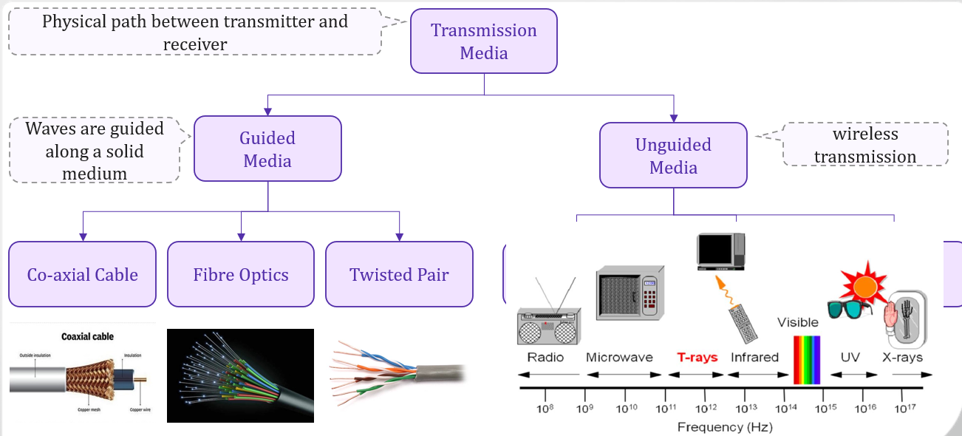

**Guided Media**

* **Co-axial Cable:**

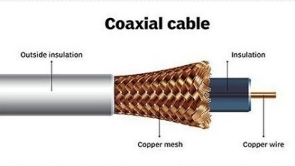

Coaxial cable is very commonly used in TV.

The inner conductor is made up of copper, and the outer conductor is made up of copper mesh. The middle core is made up of non-conductive cover.

The middle core is responsible for the data transferring whereas the copper mesh prevents from the EMI(Electromagnetic interference).



* **Fiber optic Cable:**

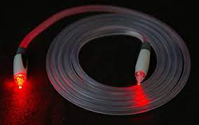

It uses electrical signals for communication.

Fiber optic is a cable that holds the optical fibers coated in plastic that are used to send the data by pulses of light.

The plastic coating protects the optical fibers from heat, cold, electromagnetic interference from other types of wiring.

Fiber optics provide faster data transmission than copper wires.

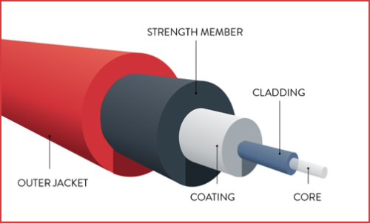

* **Twisted Pair:**

Twisted pair cables are a common type of electrical cable used in various applications, particularly in networking and telecommunications.

They consist of pairs of insulated copper wires twisted together.

The twisting of the wires helps reduce electromagnetic interference (EMI) from external sources and crosstalk between adjacent pairs.

Twisted pair is a physical media made up of a pair of cables twisted with each other.

A twisted pair cable is cheap as compared to other transmission media.

The frequency range for twisted pair cable is from 0 to 3.5KHz.

There are two main categories of twisted pair cables: unshielded twisted pair (UTP) and shielded twisted pair (STP).

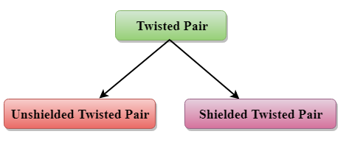

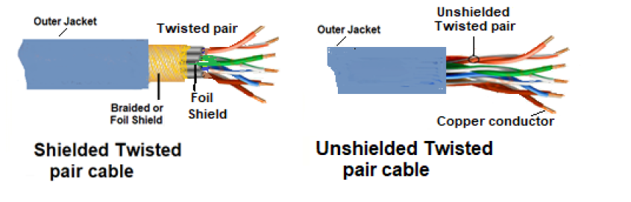

**Unguided Media**

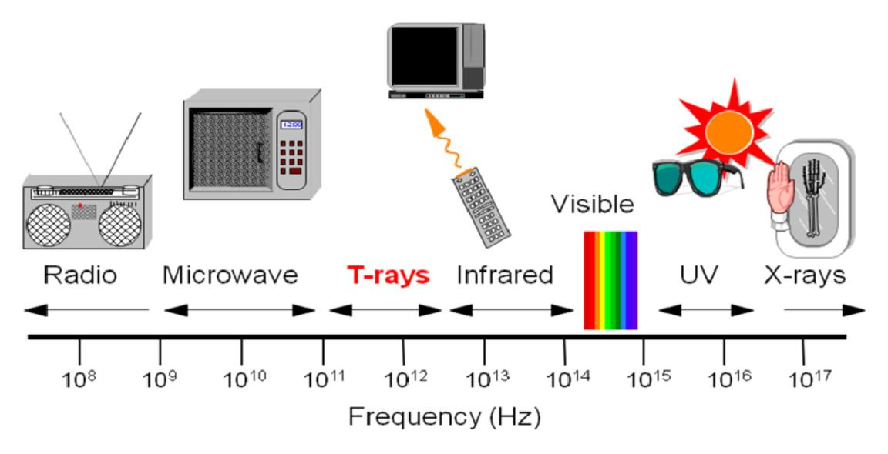

* **Radio wave:**

Radio waves are the electromagnetic waves that are transmitted in all the directions of free space.

Radio waves are omnidirectional, i.e., the signals are propagated in all the directions.

In the case of radio waves, the sending and receiving antenna are not aligned, i.e., the wave sent by the sending antenna can be received by any receiving antenna.

An example of the radio wave is FM radio.

* **Micro wave:**

Microwave technology is versatile, being applied in both household appliances like microwave ovens and advanced communication systems.

The ability of microwaves to quickly and efficiently heat food, as well as their use in point-to-point communication, demonstrates the broad applications of this technology.

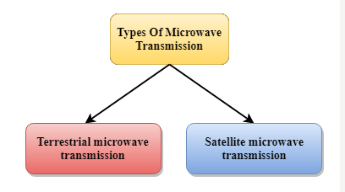

* **Terrestrial Micro wave:**

Terrestrial Microwave transmission is a technology that transmits the focused beam of a radio signal from one ground-based microwave transmission antenna to another.

Microwaves are the electromagnetic waves having the frequency in the range from 1GHz to 1000 GHz.

Microwaves are unidirectional as the sending and receiving antenna is to be aligned, i.e., the waves sent by the sending antenna are narrowly focused.

* **Satellite Micro wave:**

A satellite is a physical object that revolves around the earth at a known height.

Satellite communication is more reliable nowadays as it offers more flexibility than cable and fiber optic systems.

We can communicate with any point on the globe by using satellite communication.

* **Infrared:**

An infrared transmission is a wireless technology used for communication over short ranges.

The frequency of the infrared in the range from 300 GHz to 400 THz.

It is used for short-range communication such as data transfer between two cell phones, TV remote operation, data transfer between a computer and cell phone resides in the same closed area.

It supports high bandwidth, and hence the data rate will be very high.

Infrared waves cannot penetrate the walls.

Infrared communication is unreliable outside the building because the sun rays will interfere with the infrared waves.