**Practical 3:** Study of basic network command and Network configuration commands  
 [ PING , IPCONFIG , TRACERT , NSLOOKUP ,

NETSTAT , ROUTE , NBTSTAT , TELNET ,

NETSH , GETMAC, NET USER ,ARP, HOSTNAME, SYSTEMINFO]

These commands are useful for troubleshooting network issues, obtaining network information, and configuring various network settings on Windows systems. Keep in mind that some commands may have variations or additional options based on the operating system you are using.

1. **PING:**

Purpose: Tests connectivity between two network devices.

Syntax: ping <hostname or IP address>

Example: ping google.com

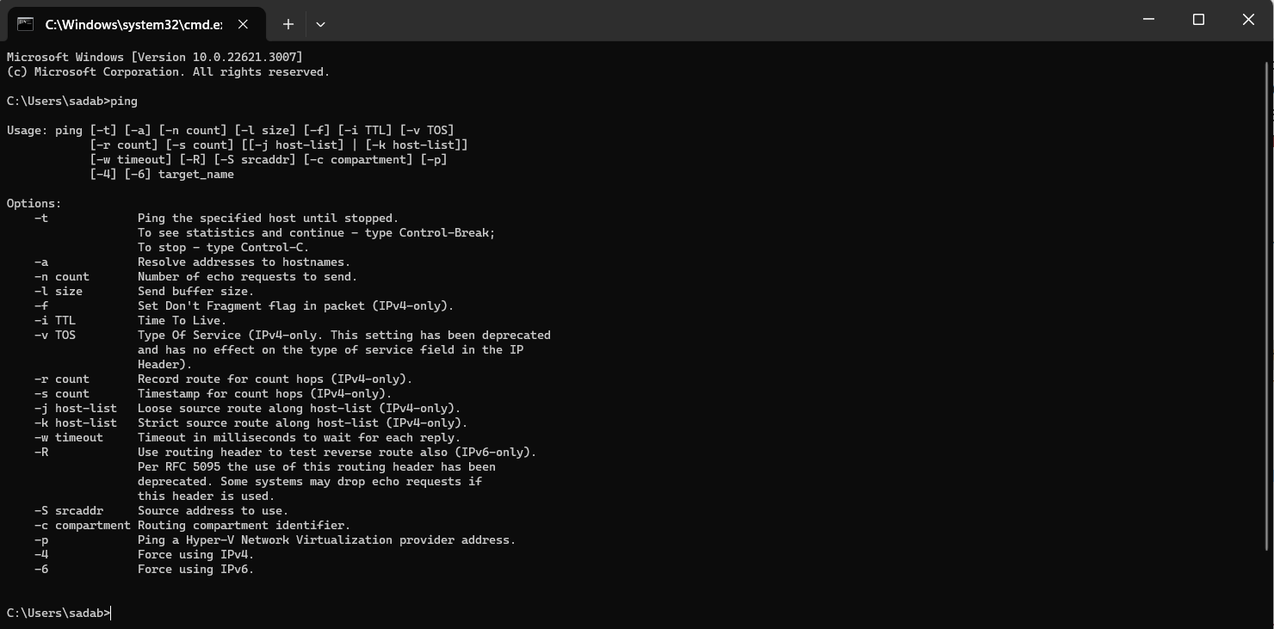



1. **IPCONFIG:**

Purpose: Displays the IP configuration for all network interfaces on the system.

Syntax: ipconfig

Example: ipconfig /all

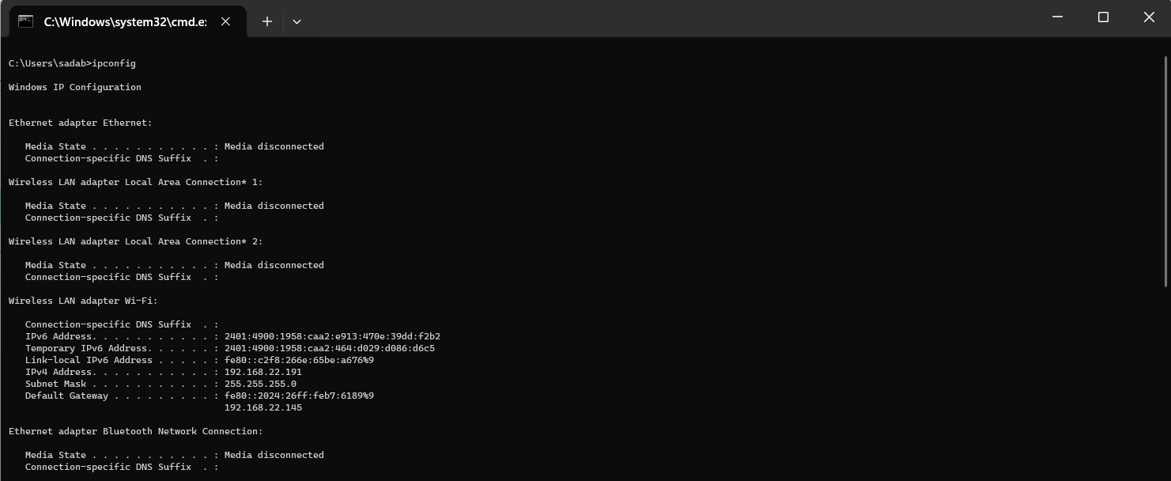



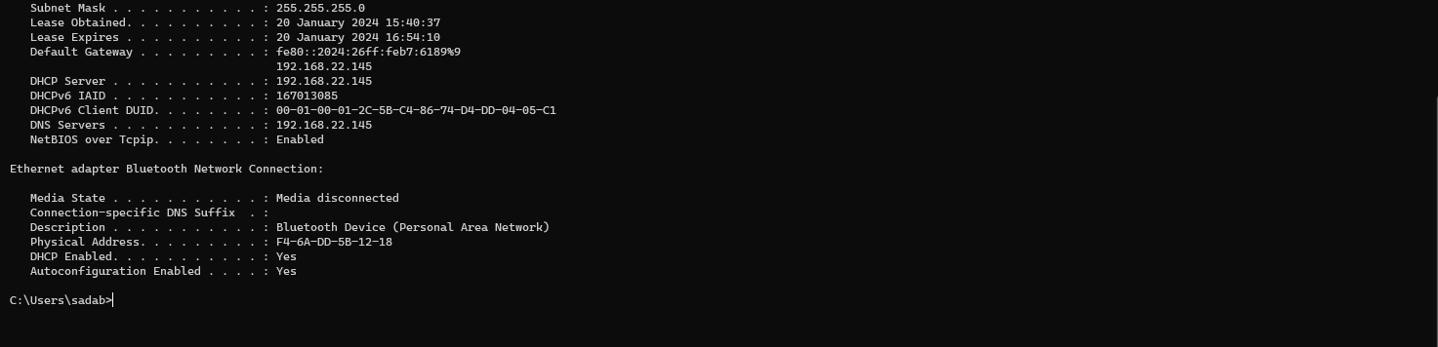

1. **TRACERT:**

Purpose: Traces the route that packets take to reach a destination.

Syntax: tracert <hostname or IP address>

Example: tracert google.com

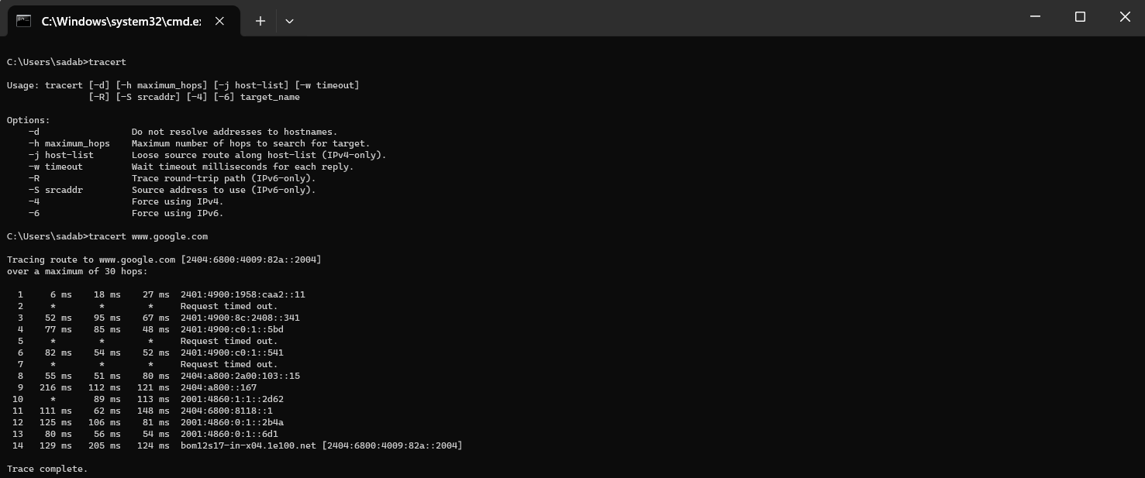



1. **NSLOOKUP:**

Purpose: Queries DNS to obtain domain name or IP address information.

Syntax: nslookup <hostname or IP address>

Example: nslookup google.com

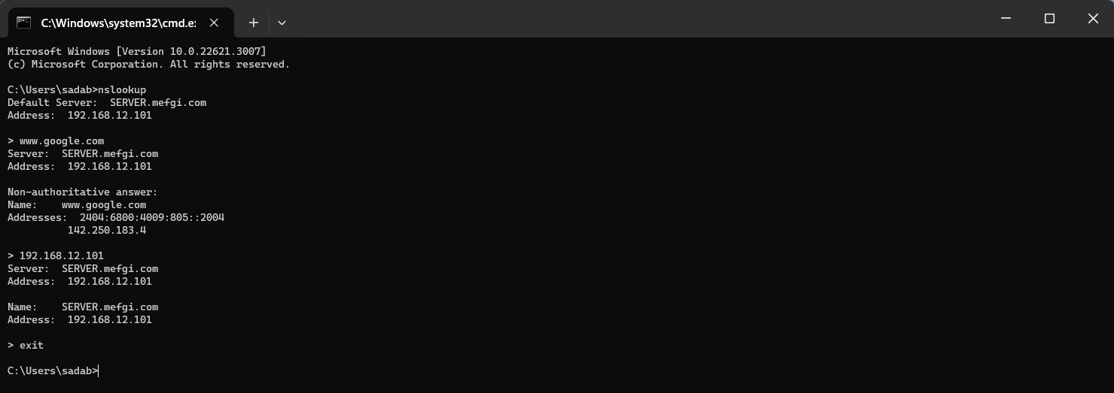

1. **NETSTAT:**

Purpose: Displays active network connections, listening ports, and routing tables.

Syntax: netstat

Example: netstat -a

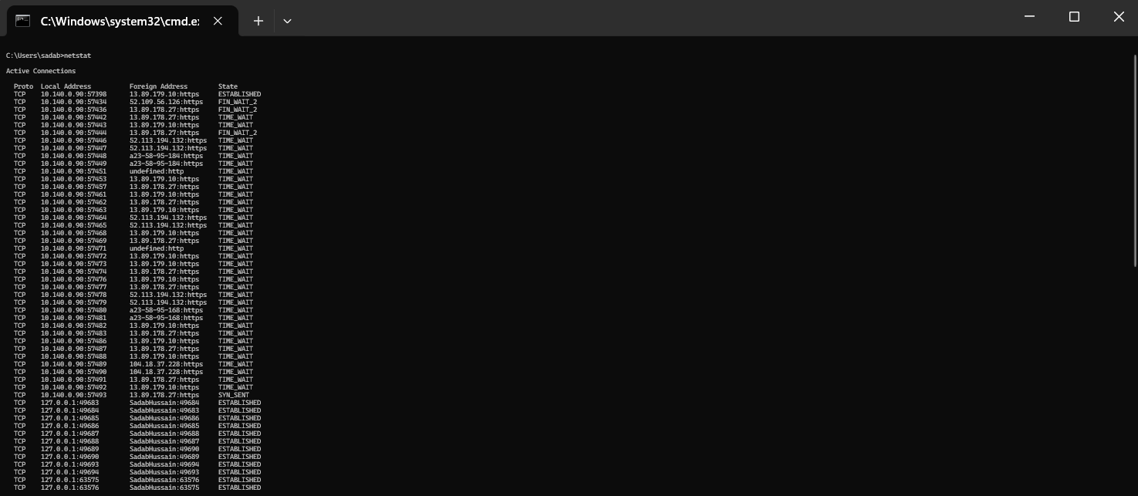





1. **ROUTE:**

Purpose: Displays or modifies the local IP routing table.

Syntax: route

Example: route print

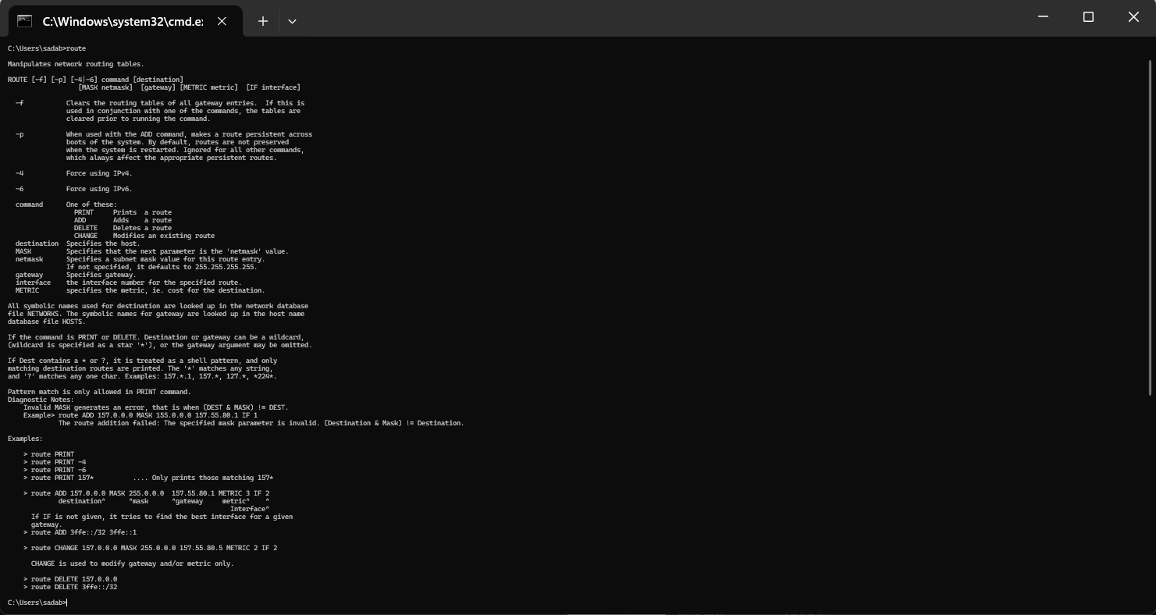

1. **NBTSTAT:**

Purpose: Displays NetBIOS over TCP/IP information, such as name resolution statistics.

Syntax: nbtstat

Example: nbtstat -a <hostname>

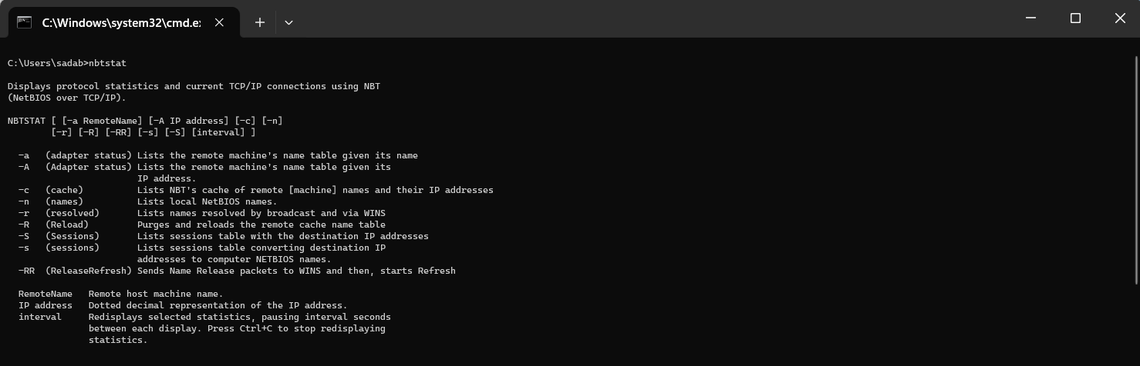

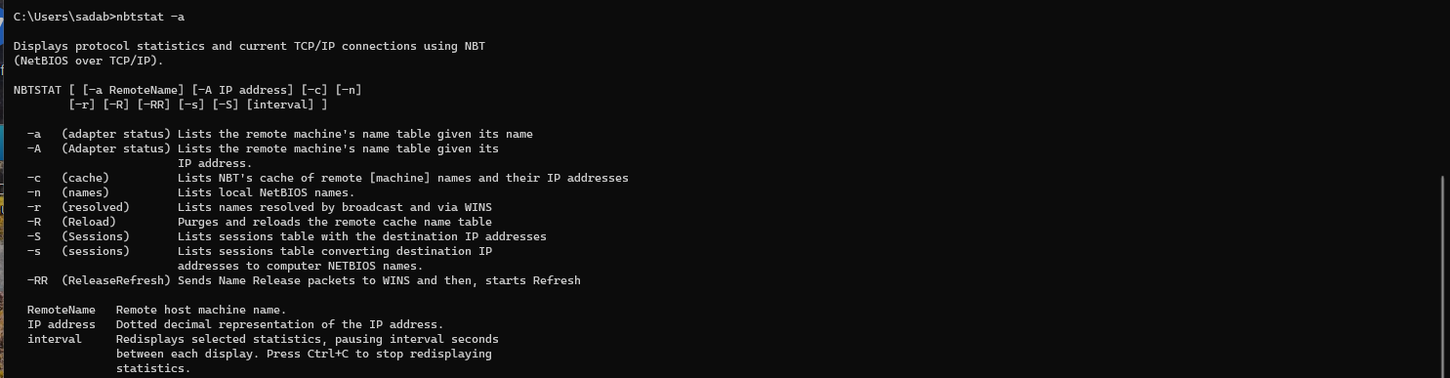

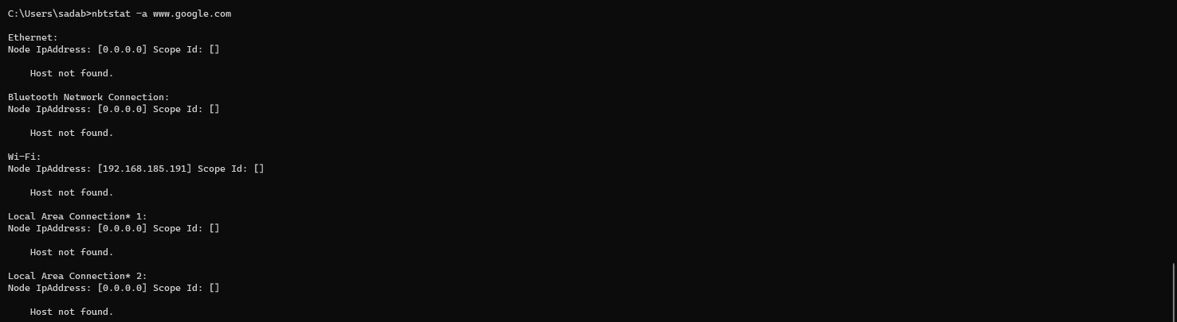

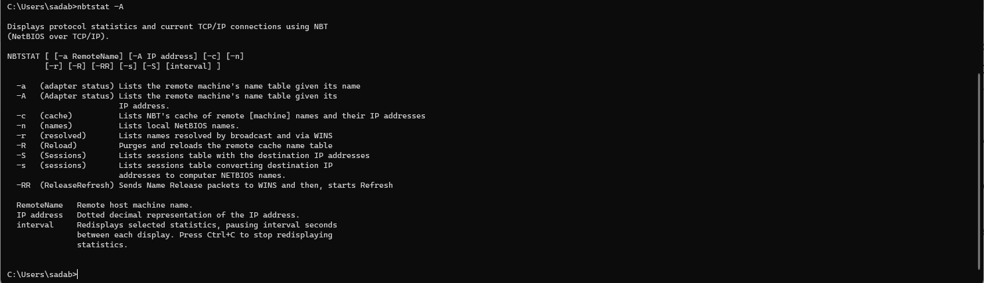

1. **TELNET:**

Purpose: Connects to a remote host via the Telnet protocol.

Syntax: telnet <hostname or IP address>

Example: telnet example.com

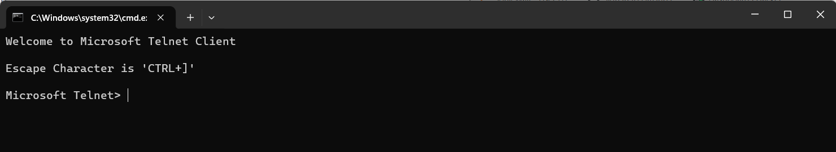

1. **NETSH:**

Purpose: Configures various network settings.

Syntax: netsh <command>

Example: netsh interface ipv4 show interfaces

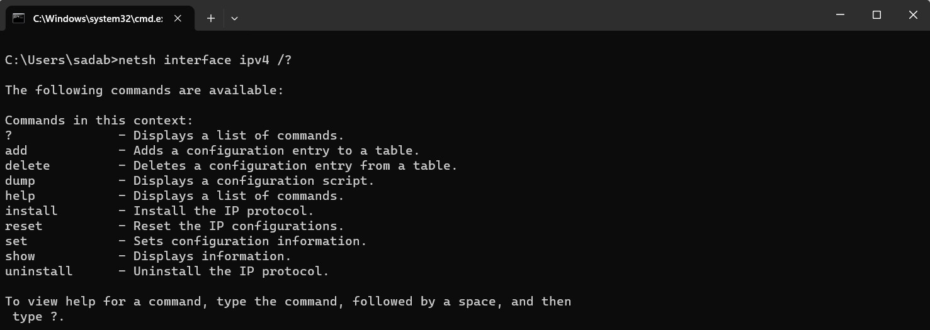

1. **GETMAC:**

Purpose: Displays the Media Access Control (MAC) address of network interfaces.

Syntax: getmac

Example: getmac

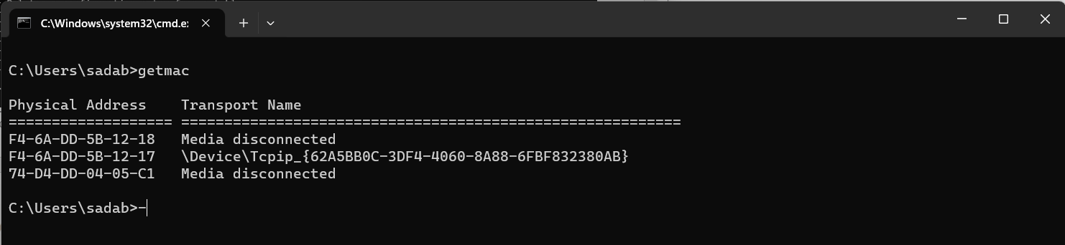

1. **NET USER:**

Purpose: Manages user accounts on a network.

Syntax: net user <username>

Example: net user john_doe

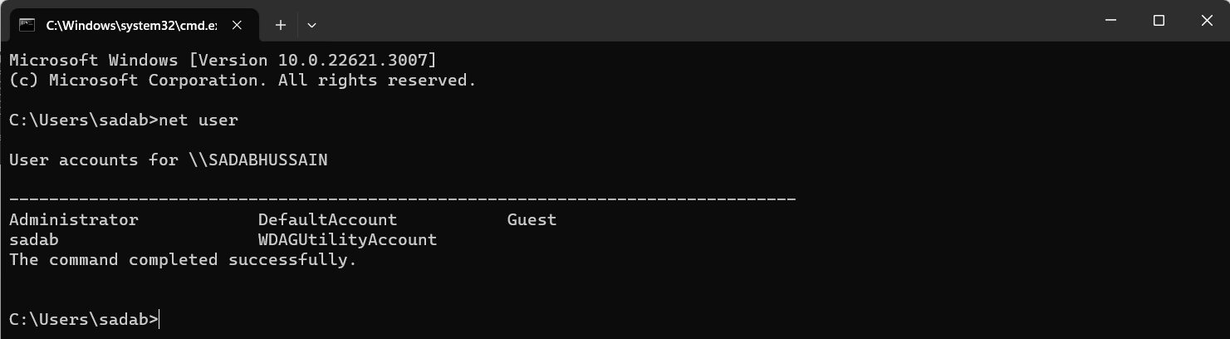

1. **ARP:**

Purpose: Displays and modifies the ARP (Address Resolution Protocol) cache.

Syntax: arp

Example: arp -a

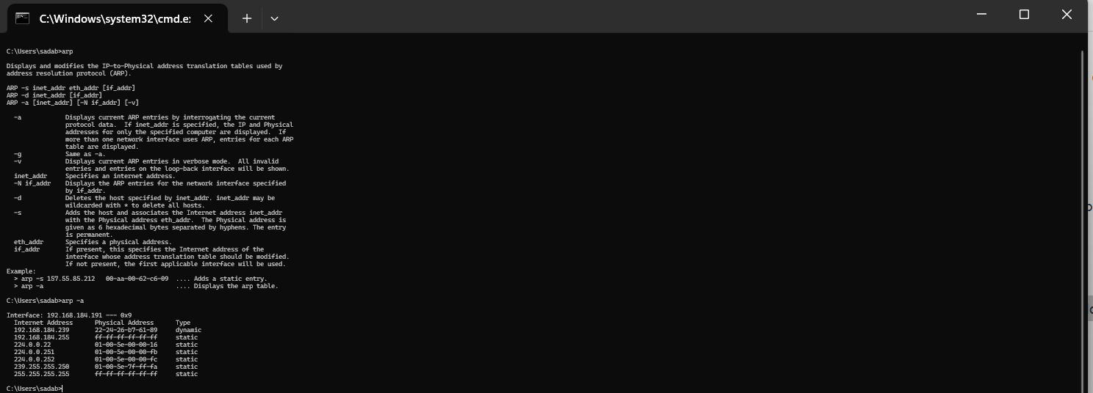

1. **HOSTNAME:**

Purpose: Displays the host name of the computer.

Syntax: hostname

Example: hostname

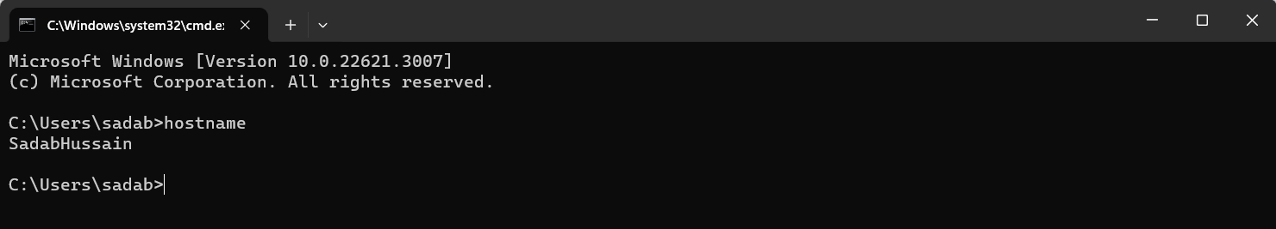

1. **SYSTEMINFO:**

Purpose: Displays detailed information about the computer's hardware and software configuration.

Syntax: systeminfo

Example: systeminfo

