**Computer Network (01CE0410)**

**Lab Manual (2023-24)**

**Name: Asif Alam**

**ER No.: 92201703058**

**Class: 4EC1**

**Lab Batch: C**

**Table of Contents**

|  |  |  |  |  |  |  |
| --- | --- | --- | --- | --- | --- | --- |
| **SR.NO.** | **Experiment Description** | **Page** | | **Date** | **Marks** | **Signature** |
| Practical – 1 | | | | | | |
| 1.1 | Study of different network devices in detail. |  | |  |  |  |
| Practical – 2 | | | | | | |
| 2.1 | Study of different types of network cables and practically implement the cross-wired cable and straight |  | |  |  |  |
| Practical – 3 | | | | | | |
| 3.1 | Study of basic network command and Network configuration commands [ PING , IPCONFIG , TRACERT , NSLOOKUP ,  NETSTAT , ROUTE , NBTSTAT , TELNET ,  NETSH , GETMAC, NET USER , NBTSTAT  ARP] |  | |  |  |  |
| Practical – 4 | | | | | | |
| 4.1 | Implement different LAN topologies using Network Simulator. |  | |  |  |  |
| Practical – 5 | | | | | | |
| 5.1 | Implement the concept of VLAN using Network Simulator. |  | |  |  |  |
| Practical – 6 | | | | | | |
| 6.1 | Configuration of DHCP Server in Packet Tracer Software and analysis of DHCP messages. |  | |  |  |  |
| Practical – 7 | | | | | | |
| 7.1 | Configuration of HTTP Server in Packet Tracer Software and analysis of HTTP request & response messages. |  | |  |  |  |
| Practical – 8 | | | | | | |
| 8.1 | Configuration of DNS Server with Recursive & Iterative approach in Packet Tracer Software. |  | |  |  |  |
| Practical – 9 | | | | | | |
| 9.1 | Configuration of E-mail Server in Packet Tracer Software. |  | |  |  |  |
| Practical – 10 | | | | | | |
| 10.1 | Implement the concept of static routing. |  | |  |  |  |
| Practical – 11 | | | | | | |
| 11.1 | Implement the concept of dynamic routing (RIP) |  | |  |  |  |
| Practical – 12 | | | | | | |
| 12.1 | Packet capture and header analysis by wire-shark (TCP,UDP,IP) |  | |  |  |  |
| Practical – 13 | | | | | | |
| 13.1 | WAP in C for Hamming Distance, if given two information’s. | |  |  |  |  |
| 13.2 | C program for the Implementation Of RSA Algorithm | |  |  |  |  |
| 13.3 | WAP in C for Encryption and Decryption the Message. | |  |  |  |  |
| 13.4 | WAP in c for CRC (Cyclic Redundancy Check). | |  |  |  |  |
| 13.5 | WAP for calculate the LRC (Longitudinal Redundancy Check). | |  |  |  |  |
| 13.6 | WAP in C for Checksum. | |  |  |  |  |
| 13.7 | C program for the Implementation Of Bit Stuffing | |  |  |  |  |
| 13.8 | Write a Program for the Implementation Of Byte Stuffing .k | |  |  |  |  |

**Practical 1:** Study of different network devices in detail.

1. **Hub:-** A hub is a central point or device that serves as a focal point for various activities, connections, or spokes. It can be used in different contexts, such as networking, transportation, or business.

* **Types of Hub:-** In networking, a hub is a basic networking device that connects multiple devices in a local area network (LAN). There are mainly two types of networking hubs: passive hubs and active hubs.

**Passive Hub:** A passive hub simply connects devices in a network without amplifying or regenerating signals. It doesn't require power and is a straightforward connection point.

**Active Hub:** An active hub, also known as a repeater hub, amplifies and regenerates signals, allowing for longer distances between connected devices. It requires power for its operation.

* **Advantages:-**

**Simplicity:** Hubs are simple to set up and use, making them suitable for basic networking needs.

**Cost-Effective:** Passive hubs, in particular, are cost-effective solutions for connecting devices within a small network.

* **Disadvantages:-**

**Limited Performance:** Hubs operate at the physical layer of the OSI model and do not filter or manage traffic.

This can lead to network congestion and reduced performance as the number of connected devices increases.

**Collision Issues:** In shared media environments, such as those created by hubs, collisions can occur when two devices

attempt to send data simultaneously. Collisions can lead to data loss and network inefficiency.

**Security Concerns:** Hubs do not provide the same level of security features as more advanced networking devices like

switches. Data transmitted through a hub is typically accessible to all connected devices.

**Outdated Technology:** With the advancement of networking technology, hubs have become somewhat outdated.

Switches are more commonly used due to their better performance and features.

* **Configuration Screenshot: -**

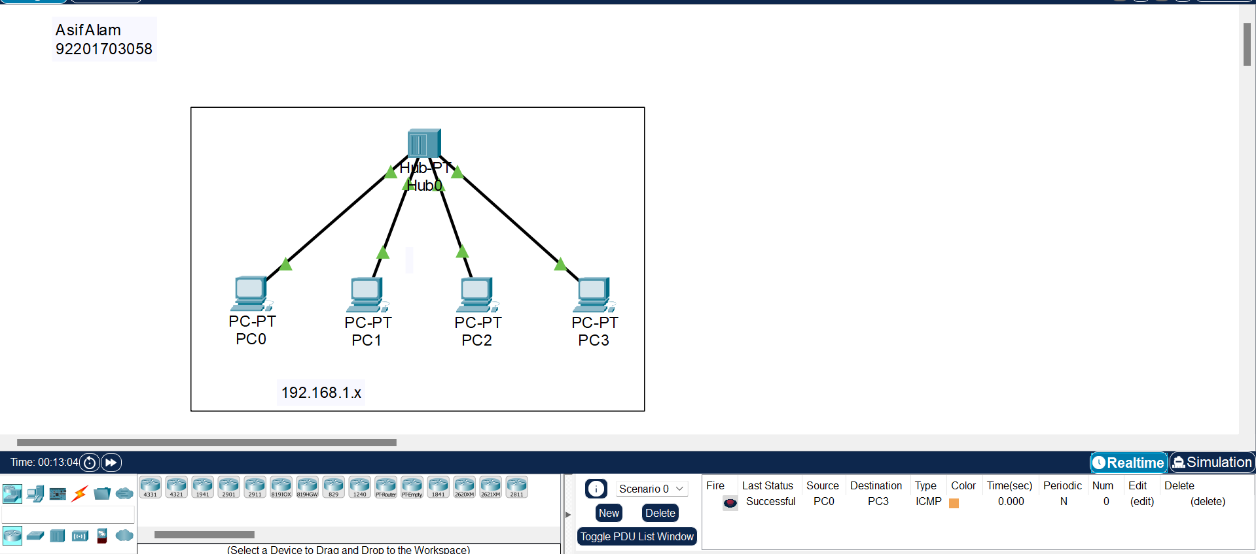

1. **Router:-** A router is a networking device that connects multiple computer networks together and directs data traffic between them. Routers operate at the network layer of the OSI (Open Systems Interconnection) model and make decisions based on IP addresses. They play a crucial role in directing data packets from one network to another, ensuring efficient communication between devices on different networks.

* **Types of Router:**

**Home Routers:** These are common in residential settings and typically combine a router, switch, and wireless access

point. They connect the home network to the Internet.

**Enterprise Routers:** Found in larger organizations, these routers handle higher traffic volumes and often have

more advanced features for security, QoS (Quality of Service), and routing protocols.

**Core Routers:** Placed in the core of large networks, core routers manage high-speed traffic between different

subnetworks.

**Edge Routers:** Positioned at the edge of a network, these routers connect an organization's internal network to

external networks, such as the Internet.

* **Advantages:-**

**Efficient Data Routing:** Routers ensure that data packets take the most efficient path between source and destination, optimizing network performance.

**Network Segmentation:** Routers enable the creation of separate network segments, improving security and reducing network congestion.

**Security Features:** Routers often include built-in firewalls and security features that protect against unauthorized access

and cyber threats.

**Network Address Translation (NAT):** NAT allows multiple devices within a local network to share a single public IP address, enhancing privacy and security.

* **Disadvantages:-**

**Cost:** High-quality routers with advanced features can be expensive, especially for enterprise-grade equipment.

**Configuration Complexity:** Configuring routers, especially for complex networks, can be challenging and may

require expertise.

**Potential Points of Failure:** Since routers direct traffic between networks, a failure in a router can disrupt

communication between connected networks.

**Limited Broadcast Domains:** Routers limit broadcast domains, which can affect applications or services that rely

on broadcasting to discover devices on the network.

* **Configuration Screenshot:**

1. **Switch:-** In networking, a switch is a device that connects devices within a local area network (LAN) and uses MAC addresses to forward data to the correct destination

* **Types of Switch :-**

**Unmanaged Switch:** A basic switch that operates without user configuration. It simply forwards data to connected

devices.

**Managed Switch:** A switch that allows for configuration, monitoring, and management of network traffic. It provides

more control over network operations.

* **Advantages:-**

**Efficient Data Transfer:**

Switches allow for efficient and direct communication between devices within a network, improving data transfer speeds

compared to hubs.

**Reduced Network Congestion:**

They help reduce network congestion by sending data only to the specific device intended, preventing unnecessary

traffic on the network.

**Enhanced Performance:**

Managed switches provide features like Quality of Service (QoS) and Virtual LANs (VLANs), enhancing network

performance and security.

**Scalability:**

Networks can easily scale by adding more switches to accommodate additional device

* **Disadvantages:-**

**Cost:**

Managed switches, with advanced features, can be more expensive than basic unmanaged switches.

**Configuration Complexity:**

Managing and configuring a network with managed switches can be complex, requiring a certain level of expertise.

**Limited Broadcast Domain:**

While reducing network congestion is an advantage, it can also limit the broadcast domain, which might be a disadvantage in certain scenarios where broadcasting is necessary.

**Single Point of Failure:**

If a switch fails, all connected devices may lose network connectivity. Redundancy measures are often required for critical networks.

* **Configuration Screenshot:-**

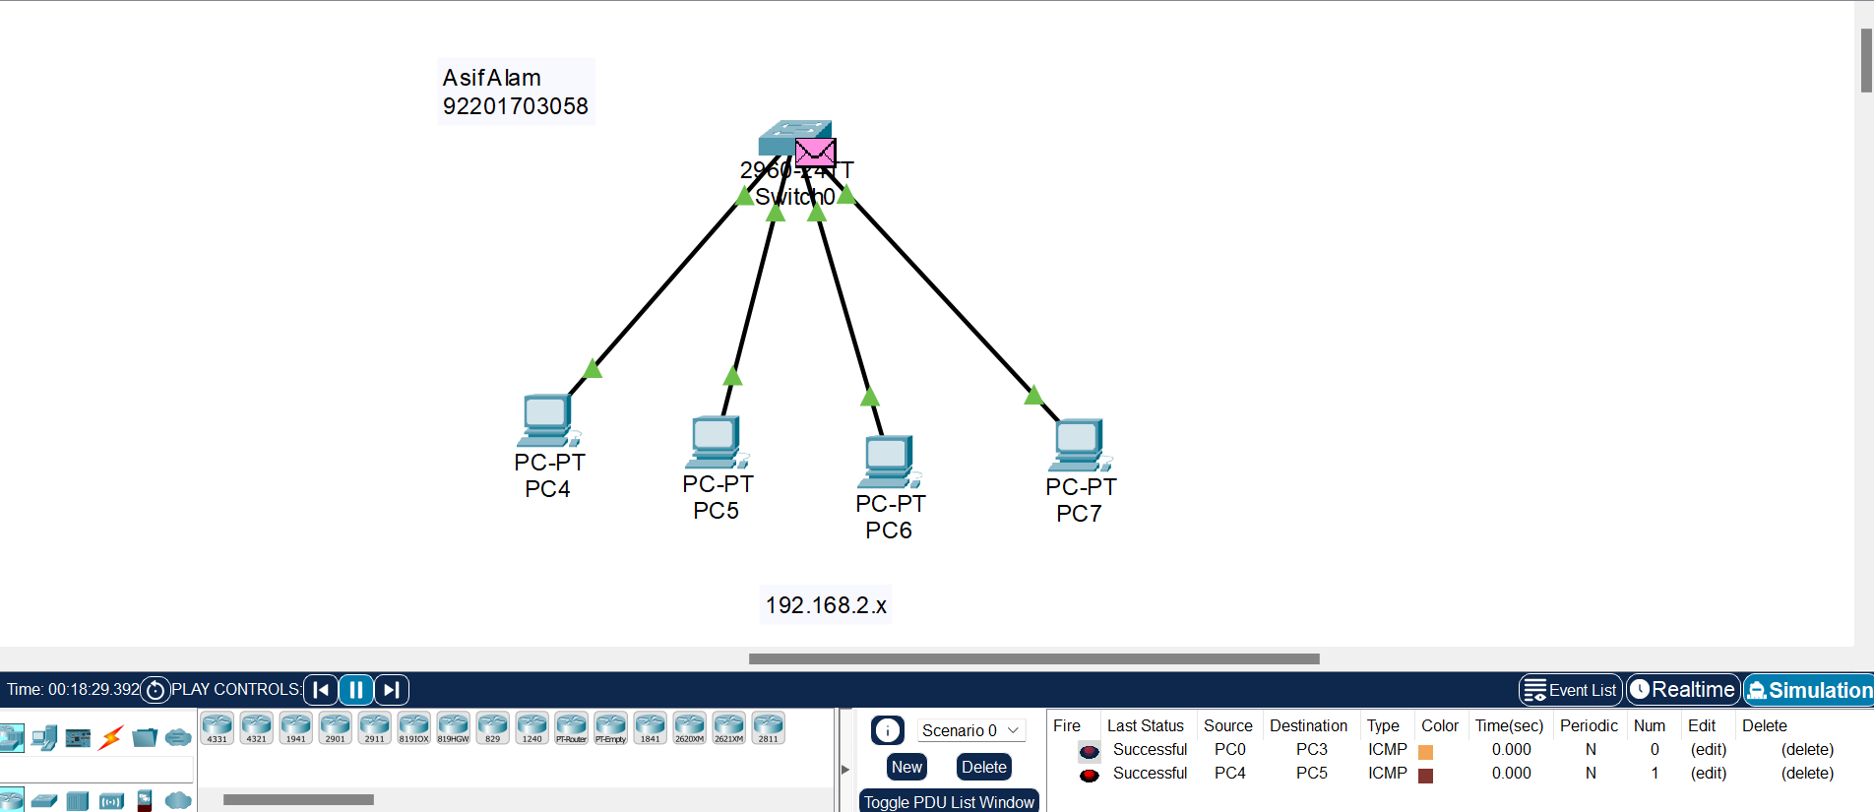

1. **Bridge:-** A bridge is a structure built to span a physical obstacle, such as a body of water, valley, or road, to provide passage over the obstacle. Bridges are designed to support the weight of vehicles, pedestrians, or other loads.

* **Types of Bridge :-**

**Beam Bridge:**

Simplest type, consisting of a horizontal beam supported at each end.

**Arch Bridge:**

Has an arch as the main structural component, which supports the weight and resists compression.

**Suspension Bridge:**

Features cables suspended from towers, with the deck hanging freely from these cables.

**Cable-stayed Bridge:**

Similar to a suspension bridge, but the deck is supported by cables that are directly connected to towers.

**Truss Bridge:**

Utilizes a framework of triangular structures (trusses) to distribute and support the load.

**Cantilever Bridge:**

Supported on one end and extends horizontally, often using counterweights on the other end.

* **Disadvantage:-**

**Cost:** Building bridges can be expensive, especially for long spans or challenging terrains.

**Maintenance:** Bridges require regular maintenance to ensure safety and longevity, and maintenance costs can be

substantial.

**Environmental Impact:** The construction of bridges can have environmental consequences, affecting ecosystems and

wildlife habitats.

**Safety Concerns:** Poorly designed or maintained bridges can pose safety risks, leading to accidents or structural failures.

**Obsolescence:** Advancements in technology may make older bridge designs obsolete, requiring upgrades or replacements.

* **Configuration Screenshot:-**

**Repeater:-**A repeater is a network device that receives and retransmits signals in order to extend the range of a network. It operates at the physical layer of the OSI (Open Systems Interconnection) model. Repeaters are commonly used in wired and wireless communication networks to counteract the attenuation (weakening) of signals over distance.

* **Types of Repeater:-**

**Analog Repeater:**

Used in analog communication systems.

Amplifies the entire signal, including noise.

Less commonly used in modern networks.

**Digital Repeater:**

Used in digital communication systems.

Regenerates and amplifies digital signals.

Filters out noise during the regeneration process

* **Advantage:-**

**Signal Range Extension:**

The primary advantage is extending the reach of a network by boosting and retransmitting signals.

**Simplicity:**

Repeaters are relatively simple devices, making them easy to install and maintain.

**Cost-Effectiveness:**

Repeaters are often more cost-effective than other signal-boosting solutions.

* **Disadvantage:-**

**No Signal Improvement:**

Repeaters amplify signals, including any existing noise. They don't improve signal quality; they just extend the range.

**Limited to Point-to-Point:**

Repeaters are most effective in point-to-point communication and may not be suitable for complex network topologies.

**Limited in Handling Multiple Signals:**

Some repeaters may struggle to handle multiple signals simultaneously, leading to potential collisions and interference.

**Dependency on Signal Quality:-**

If the incoming signal is too weak or distorted, a repeater may not effectively amplify and regenerate it.

* **Configuration Screenshot:-**

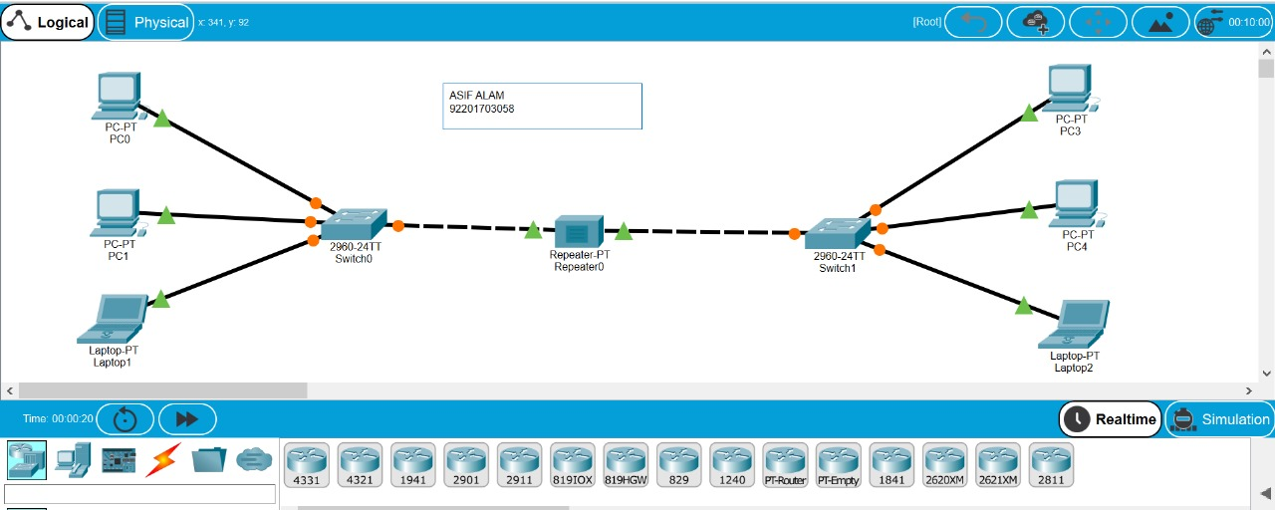

**14. Write a program in C/C++/ JAVA/ Python for socket programming and share your file from one system to another system.**

**Socket_programming.java :-**

import java.io.*;

import java.net.Socket;

public class Socket_programming {

        private static DataOutputStream dataOutputStream = null;

    private static DataInputStream dataInputStream = null;

    public static void main(String[] args)

    {

        // Create Client Socket connect to port 900

        try (Socket socket = new Socket("localhost", 900)) {

        dataInputStream = new DataInputStream( socket.getInputStream());

            dataOutputStream = new DataOutputStream(

                socket.getOutputStream());

            System.out.println("Sending the File to the Server");

        // Call SendFile Method

        sendFile("./Asif.txt");

            dataInputStream.close();

            dataInputStream.close();

        }

        catch (Exception e) {

            e.printStackTrace();

        }

    }

    // sendFile function define here

    private static void sendFile(String path)

        throws Exception

    {

        int bytes = 0;

        // Open the File where it is located in your pc

        File file = new File(path);

        FileInputStream fileInputStream

            = new FileInputStream(file);

        // Here we send the length of File to Server

        dataOutputStream.writeLong(file.length());

        // Here we break file into chunks

        byte[] buffer = new byte[4 * 1024];

        while ((bytes = fileInputStream.read(buffer))

            != -1) {

        // Send the file to Server Socket

        dataOutputStream.write(buffer, 0, bytes);

            dataOutputStream.flush();

        }

        // close the file here

        fileInputStream.close();

    }

}

**Server.java :-**

import java.io.DataInputStream;

import java.io.DataOutputStream;

import java.io.FileOutputStream;

import java.net.ServerSocket;

import java.net.Socket;

public class Server {

    private static DataOutputStream dataOutputStream = null;

    private static DataInputStream dataInputStream = null;

    public static void main(String[] args)

    {

        // Here we define Server Socket running on port 900

        try (ServerSocket serverSocket = new ServerSocket(900)) {

            System.out.println("Server is Starting in Port 900");

            // Accept the Client request using accept method

            Socket clientSocket = serverSocket.accept();

            System.out.println("Connected");

            dataInputStream = new DataInputStream(clientSocket.getInputStream());

            dataOutputStream = new DataOutputStream( clientSocket.getOutputStream());

            // Here we call receiveFile define new for that

            // file

            receiveFile("NewFile1.txt");

            dataInputStream.close();

            dataOutputStream.close();

            clientSocket.close();

        }

        catch (Exception e) {

            e.printStackTrace();

        }

    }

    // receive file function is start here

    private static void receiveFile(String fileName)

        throws Exception

    {

        int bytes = 0;

        FileOutputStream fileOutputStream = new FileOutputStream(fileName);

        long size  = dataInputStream.readLong(); // read file size

        byte[] buffer = new byte[4 * 1024];

        while (size > 0 && (bytes = dataInputStream.read(buffer, 0,

                    (int)Math.min(buffer.length, size))) != -1) {

            // Here we write the file using write method

            fileOutputStream.write(buffer, 0, bytes);

            size -= bytes; // read upto file size

        }

        // Here we received file

        System.out.println("File is Received");

        fileOutputStream.close();

    }

}

**Output :-**

**Server.java**

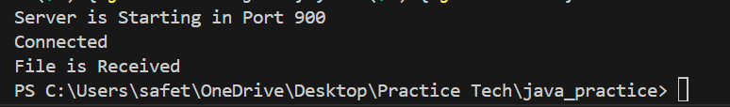

**Socket_programming.java**

