**Experiment-1**

**THEORY:**

What is a microprocessor?

Microprocessor is programmable, clock driven, register based electronic device that reads binary information from storage device called memory, accepts binary data as input and process the data according to instructions and produces binary result as an output.

Why 8085 microprocessor?

It is a microprocessor with simple architecture and adequate instruction set that enable to understand the programming concepts of hardware. Having learned the basic concepts of 8085 microprocessor, student can adapt to advance microprocessor and microcontroller environments very easily.

About 8085 microprocessor

The 8085 is an 8-bit microprocessor capable of addressing 64KB of memory. The device has 40 pins, requires +5V supply, and generally operate with a 3 MHz single-phase clock.

What is DYNA -85?

MICROFRIEND DYNA-85 is an introduction to a low cost trainer and development kit. It is a single board computer based on 8085 CPU designed especially for training applications. It is equally useful for novice as well as development engineers for studying the 8085 CPU and developing various product based on it.

**APPARATUS:**

1. Computer system

**DYNA-85 HARDWARE CONOVERVIEW**

**FEATURES OF DYNA-85 KIT**

8085A CPU operates at 3 MHz clock frequency.

* Memory
  + 4 KB powerful monitor firmware. Including all standard commands, codes, functions and utility subroutines.
  + 2 KB user RAM 6116.
  + Three 28 pin sockets provided for memory expansion upto a maximum of 56 K.

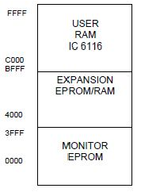

Fig. MemoryMapping

* + Versatile Keyboard/Display controller using 8279 IC.
  + 46 parallel I/O lines, 22 from 8155 IC and 24 from 8255 IC.
  + Serial I/O through auto adjusting type RS -232 channels.
  + Built-in audio cassette interface.
  + Programmable timer.
  + Powerful 8085 interrupt capabilities.
  + 6 digit seven segment LED display.
  + Highly reliable multi-function keypad. All address, data and control and hardware interrupt lines are brought out on a 50 pin FRC connector for system interfacing and expansion.
  + Three 16 bit Timer/Counter channels are available on-board, using 8253 IC.
  + These channels are available on a 10 pin FRC connector.
  + RAM sockets are provided with battery backup.

**SYSTEM COMMAND OVERVIEW**

The HEX Keypad mode supports the following commands:

* **RESET**: Provides hardware reset. Display shows“FRIEND”on pressing this key.
* **VI:** Vector interrupt key. Activate RST7.5 vectored interrupt.
* **SET**: Allows the user to examine & modify the contents of RAM and only examination of contents is possible in case of EPROM.
* **INR:** Increments memory address presently displayed on the *address field* of display.
* **DCR:** Decrements memory address presently displayed in the *address field* of display.
* **REG:** Allows the user to examine contents of CPU registers & modify them if necessary.
* **GO:** Allows the user to load the program counter by the desired memory address which is the starting address of the program to be executed.
* **EXEC:** Used to start the execution of GO or CODE command.
* **CODE:** Used for selecting one of the coded subroutines in the monitor.

**SAMPLE PROGRAM TO LOAD AND EXECUTE ON DYNA-85 KIT**

Load the Accumulator with 44h and copy the content of register A into register B.

|  |  |  |  |  |
| --- | --- | --- | --- | --- |
| **Address** | **Hex**  **Code** | **Label** | **Mnemonics** | **Comments** |
|  |  |  |  |  |
|  |  |  |  |  |
|  |  |  |  |  |
|  |  |  |  |  |

**PROCEDURE TO LOAD PROGRAM ON DYNA-85 KIT**

STEP 1: Connect the output line of SMPS to the Microprocessor kit

Obs. 1: FRIEND appears on the LED display screen

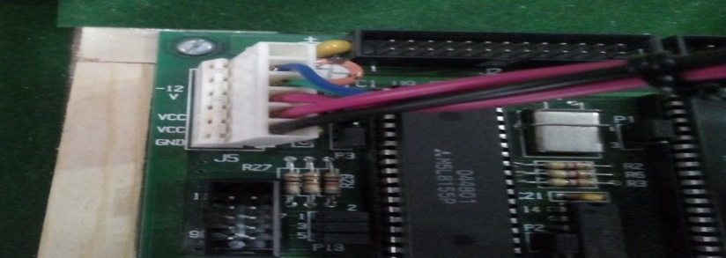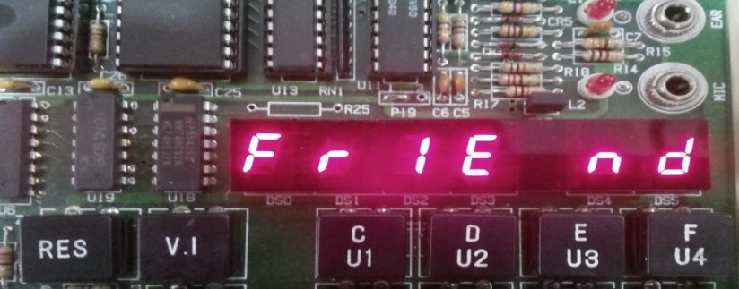

Step 2: Press SET to start programming

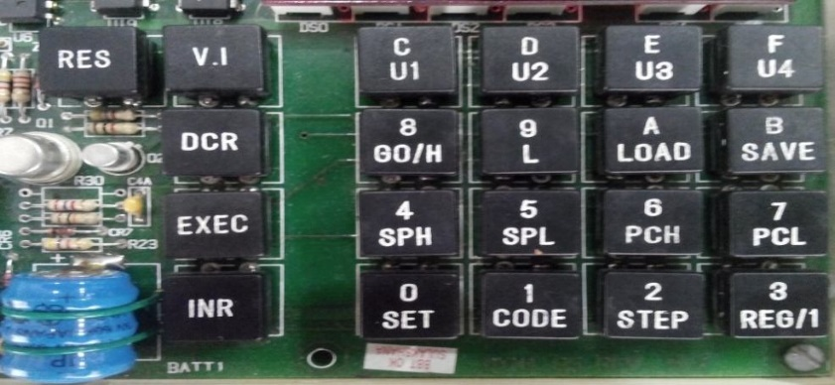

Step 3: Press the hexadecimal address where you want to store the program

(e.g. C000H)

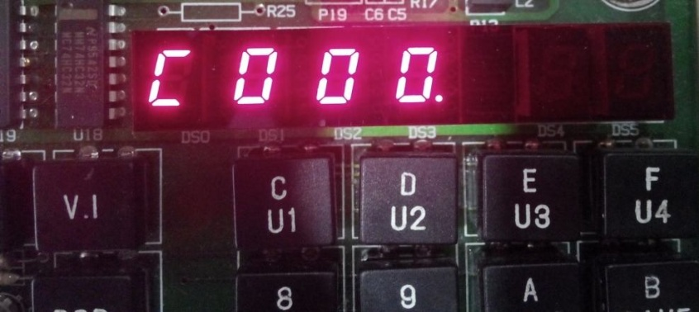

Step 4: Press increment key to enter the instruction/data.

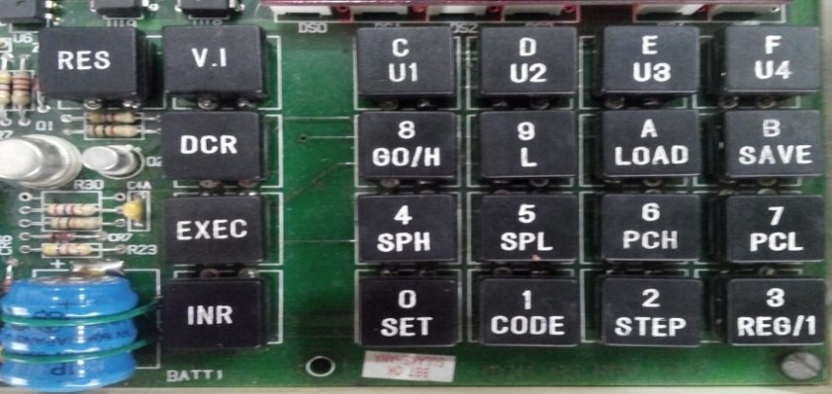

Step 5: Enter the Instruction/data to the previously entered address. Here 3E (Hex code of MVI A) Instruction has been entered.

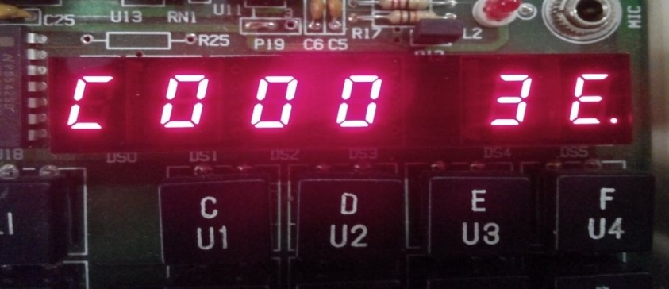

Step 6: Press increment key.

Obs. 2: Memory address will automatically increased by 1.

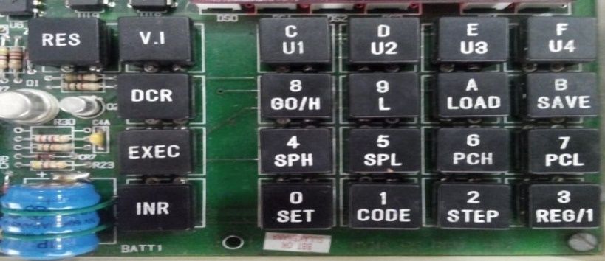

Step 7: Enter the instruction/ data to the address. Here 44H (Immediate Value) has been inserted

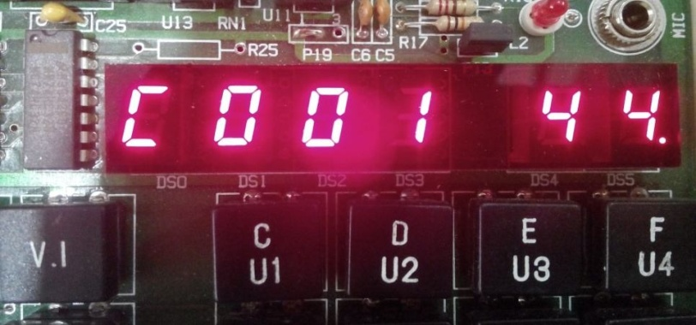

Step 8: Press increment switch. Obs3: Memory Address will be increased by1.



Step 9: Enter the Instruction/data to the previously entered address. Here 47(Hexcode of **MOVB, A**) instruction has been entered.

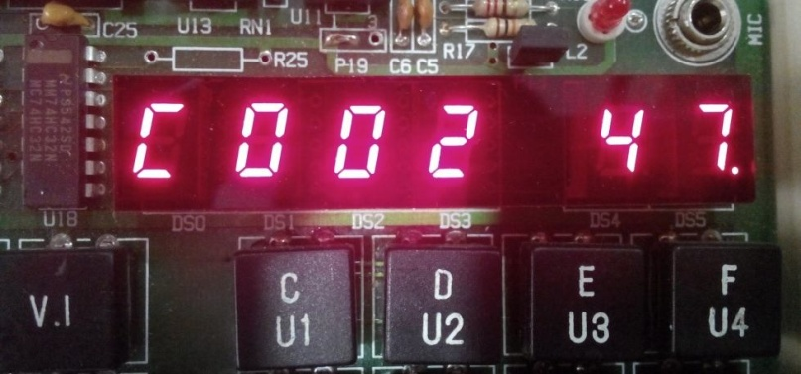

Step10: Press increment switch and Enter CF to end the program.

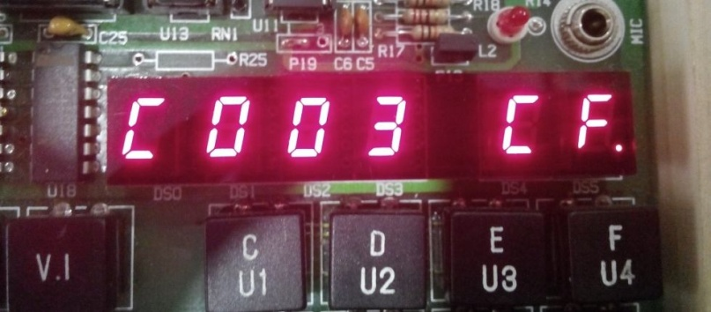

Conclusion: