HEL1OS Level-1 Light Curve Analysis
15 June 2026 Observation Dataset

Data Source: Aditya-L1 HEL1OS Level-1 Data
Author: Adarsh Jayprakash Mishra

Introduction:
HEL1OS (High Energy L1 Orbiting X-ray Spectrometer) is a hard X-ray instrument onboard the Aditya-L1 mission. It is designed to observe high-energy solar X-ray emissions associated with energetic particle acceleration and impulsive flare activity.
Unlike SoLEXS, which primarily observes soft X-rays, HEL1OS focuses on higher-energy X-ray emissions that provide insights into the most energetic phases of solar flares.
The objective of this analysis is to study the HEL1OS Level-1 light curve dataset recorded on 15 June 2026 and identify significant hard X-ray activity using statistical and threshold-based flare detection methods.

Core Function & Science Goals
- Solar Flare Monitoring: It continuously tracks hard X-ray emissions from the Sun across a wide energy band of 8 keV to 150 keV.
- Capturing Impulsive Phases: HEL1OS acts as a "harbinger" of solar activity by capturing the initial, highly volatile burst phase of solar flares.
- Electron Tracking: It allows scientists to study the explosive release of energy and how electrons accelerate and move during these space storms.

Advanced Detection Technology
Connecting back to the semiconductor materials, HEL1OS manages this wide X-ray spectrum by splitting the job between two state-of-the-art detector types:
- Cadmium Telluride (CdTe): Optimised for high resolution at lower energies (8 to 70 keV).
- Cadmium Zinc Telluride (CZT): Pixelated array used for processing higher-energy hard X-rays (20 to 150 keV).

Note: For the present analysis, the CdTe detector data was selected because it provides strong hard X-ray flare signatures in the 1.8–90 keV energy range. CZT detector analysis may be incorporated in future studies for additional validation and high-energy event characterization.

Dataset Structure Analysis:
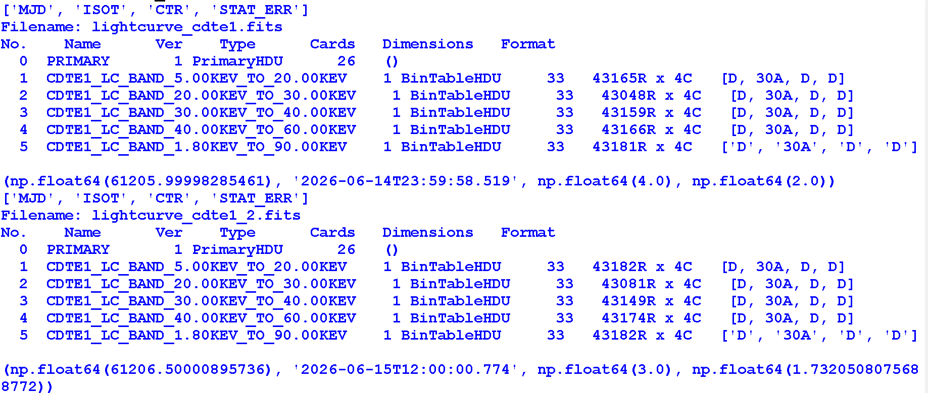
MJD: Standard astronomical time representation used for scientific observations.
ISOT: Human-readable observation timestamp in ISO-8601 format.
CTR (Count Rate): Number of detected X-ray photons per second. This parameter is used for flare detection and activity analysis.
STAT_ERR: Statistical uncertainty associated with each count-rate measurement.
Selected Dataset: The CDTE1 light curve Band-5 dataset (1.8–90 keV) was selected for analysis because it provides the broadest energy coverage and captures a wide range of hard X-ray flare signatures.

Merged Dataset Validation:
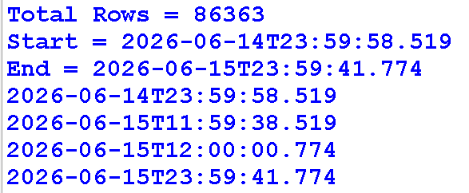
The complete 15 June 2026 observation was reconstructed by combining two half-day HEL1OS CDTE1 light curve files. Timestamp verification was performed to ensure continuity between the two datasets.
Observation: The first dataset ends at 11:59:38 UTC, while the second dataset begins at 12:00:00 UTC. The resulting gap of approximately 22 seconds is negligible compared to the total 24-hour observation period and does not significantly affect flare detection analysis.
The merged dataset provides nearly continuous coverage from 14 June 2026 23:59:58 UTC to 15 June 2026 23:59:41 UTC, enabling full-day hard X-ray activity analysis.

Hard X-ray Light Curve Visualization:
HEL1OS CDTE1 hard X-ray light curve showing count-rate variations throughout the observation period.
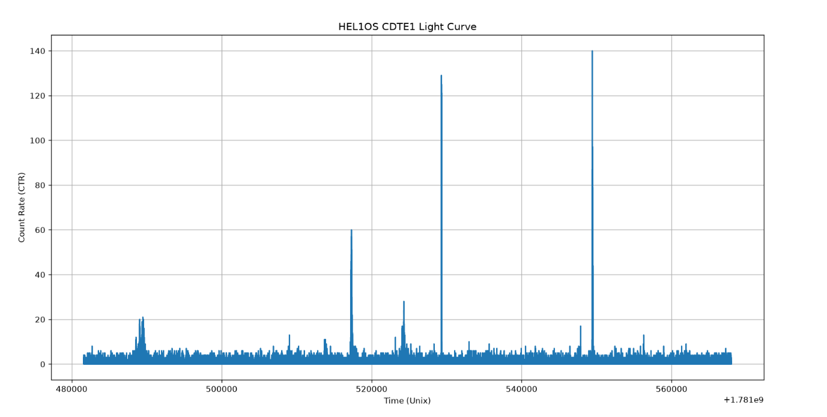
Observation:
The light curve exhibits multiple impulsive hard X-ray enhancements throughout the day. Several sharp peaks significantly exceed the background count rate, indicating periods of intense energetic activity associated with solar flare processes. The strongest event reaches approximately 140 counts per second.

Comparison with SoLEXS:
Unlike the smoother soft X-ray enhancements observed in SoLEXS data, HEL1OS records sharp impulsive peaks that represent high-energy particle acceleration during solar flare activity.

Peak Activity Analysis:
Zoomed view of the strongest hard X-ray enhancement detected in the dataset.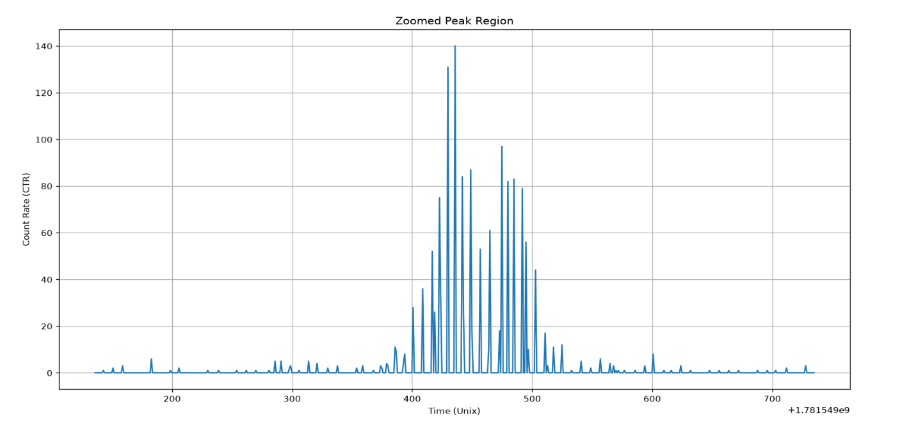
Observation:
The strongest event is characterized by a rapid increase in count rate followed by multiple impulsive spikes. This behavior is consistent with hard X-ray flare signatures produced during energetic particle acceleration processes in solar flare events.

Threshold-Based Flare Detection:
Threshold-based analysis of the strongest hard X-ray event using the Mean + 3σ detection criterion.
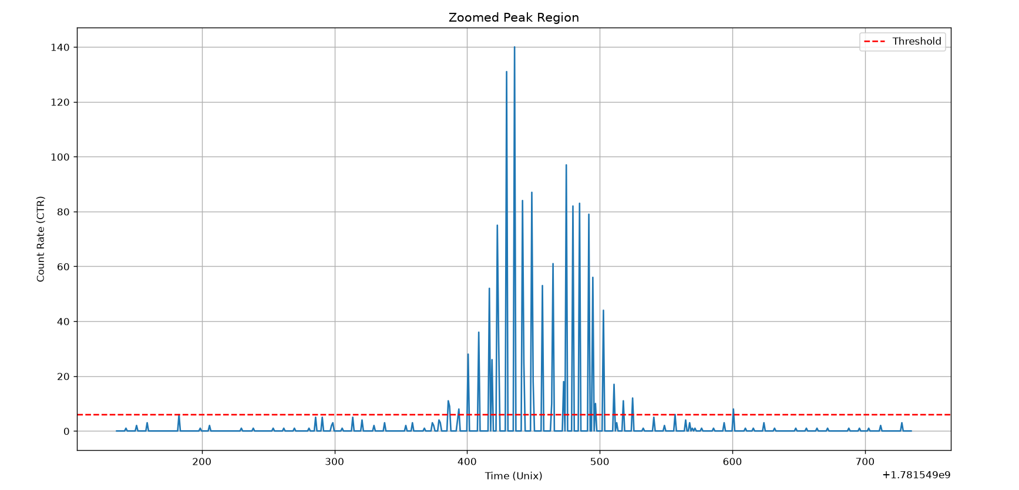
Observation:
The calculated threshold separates normal background activity from statistically significant hard X-ray enhancements. The strongest detected event exceeds the threshold by a large margin, confirming the presence of a major flare-like hard X-ray burst within the observation period.

Peak Activity Statistics:
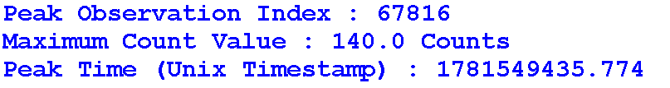
Interpretation:
The strongest hard X-ray enhancement was recorded at 18:50:35 UTC with a peak count rate of 140 counts per second. This event represents the most energetic activity detected within the HEL1OS CDTE1 dataset and is significantly above the background count level.

Statistical Analysis and Flare Detection Metrics:
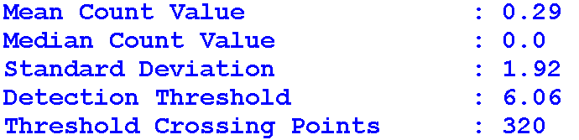
Interpretation:
A total of 320 threshold-crossing data points were identified above the calculated detection threshold. Since multiple consecutive points may belong to the same flare event, the actual number of distinct flare events is expected to be lower than the total number of threshold crossings.
Comparison with SoLEXS:
Compared to the SoLEXS soft X-ray dataset, HEL1OS detects fewer threshold-crossing points but exhibits significantly sharper and more impulsive hard X-ray bursts. This difference reflects the distinct physical processes captured by the two instruments.

Flare Detection Analysis:
Full-day HEL1OS CDTE1 flare detection analysis showing threshold crossings identified using the Mean + 3σ criterion.
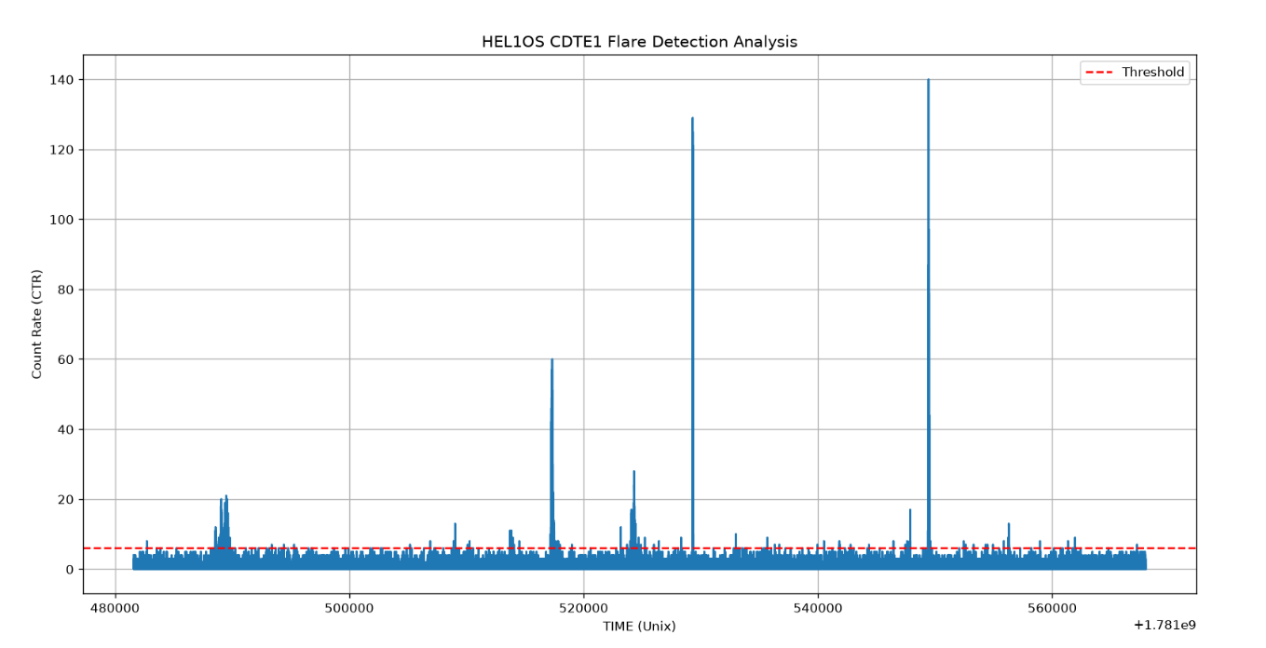
Observation:
Several hard X-ray bursts exceed the calculated detection threshold, indicating statistically significant solar activity. These threshold-crossing regions are identified as potential flare candidates and represent periods of enhanced energetic particle acceleration.

Key Findings:
• Complete 24-hour observation reconstructed from two half-day datasets.
• Broad-band CDTE1 (1.8–90 keV) light curve selected for analysis.
• Detection threshold calculated as 6.06 counts/s using the Mean + 3σ method.
• A total of 320 threshold-crossing points were identified.
• Maximum count rate reached 140 counts/s at 18:50:35 UTC.
• Multiple impulsive hard X-ray bursts were detected, indicating significant solar activity.

Conclusion
The HEL1OS Level-1 hard X-ray dataset for 15 June 2026 was successfully analyzed using the CdTe detector light curve data covering the 1.8–90 keV energy range.
Since the daily observation was distributed across two half-day files, both datasets were merged to reconstruct a complete day of observations. Verification of the timestamps confirmed that the combined dataset provides nearly continuous coverage of the entire observation period, with only a small gap of approximately 22 seconds.
Analysis of the CTR (Count Rate) parameter revealed several impulsive high-energy X-ray bursts characteristic of solar flare activity. A threshold-based flare detection method using Mean + 3 × Standard Deviation was applied, resulting in a detection threshold of 6.06 counts per second. The strongest detected event reached a peak count rate of 140 at 18:50:35 UTC on 15 June 2026.
Unlike the broader flare structures observed in SoLEXS data, HEL1OS exhibits sharp and impulsive enhancements, highlighting its sensitivity to high-energy flare emissions. A total of 320 threshold-crossing data points were detected, representing periods of significant hard X-ray activity above the background level.
Overall, the analysis demonstrates that HEL1OS Level-1 hard X-ray observations provide reliable information for detecting, characterizing, and monitoring impulsive solar flare activity. The results obtained in this study establish a strong foundation for integrating HEL1OS observations with SoLEXS data in future unified solar flare nowcasting and forecasting systems.

