SoLEXS Level-1 Light Curve Analysis
15 June 2026 Observation Dataset

Data Source: Aditya-L1 SoLEXS Level-1 Data
Prepared By: Adarsh Jayprakash Mishra

Introduction: SoLEXS (Solar Low Energy X-ray Spectrometer) is a scientific instrument designed to observe the Sun. It is one of the seven key payloads aboard Aditya-L1, India's first dedicated space-based solar observatory mission led by ISRO.
Here are the key details about the instrument:
- Primary Purpose: It monitors X-ray flares to help scientists study the thermal structure of the solar corona and understand its mysterious heating mechanisms.
- How it Works: It functions as a "Sun-as-a-star" spectrometer, measuring soft X-rays released by the Sun, specifically in the low-energy range of 1 to 30 keV (kiloelectron volts).
- Key Science Goals: Along with investigating coronal heating, SoLEXS provides accurate temperature estimates at solar flare sites and helps study the relationship between solar flares and Coronal Mass Ejections (CMEs).
- Development: The payload was developed indigenously by the U. R. Rao Satellite Centre (URSC) in Bengaluru.
In short, SoLEXS acts as a highly sensitive X-ray detector in space, continuously watching the Sun to capture essential data on low-energy solar flares and their impact on the wider space environment.

Dataset Structure Analysis:

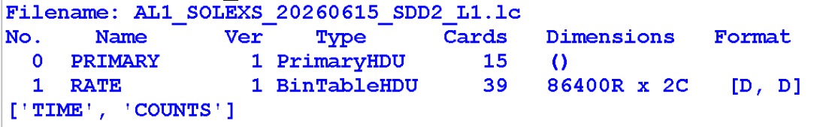

AL1 = Aditya-L1
SoLEXS = SoLEXS payload
20260615 = 15 June 2026
SDD2 = SoLEXS instrument contains 2 Silicon Drift Detectors
L1 = Level 1
Lc = Light curve

Rate
Dimensions = 86400R(Rows) X 2C(Columns)
Observation Duration:
24 Hours
Total Observations:
86,400 Samples
Sampling Interval:
1 Second

Dataset Parameters
Time: Time of observation
COUNTS: Number of X-ray photons detected during each one-second observation interval.

Sample Dataset Records:
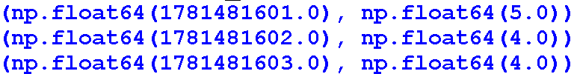
Observation Timing Analysis
Successive timestamps differ by approximately one second, confirming that the dataset was recorded with a one-second temporal resolution.

Light Curve Visualization:
SoLEXS light curve representing the variation of detected soft X-ray counts throughout the observation period.
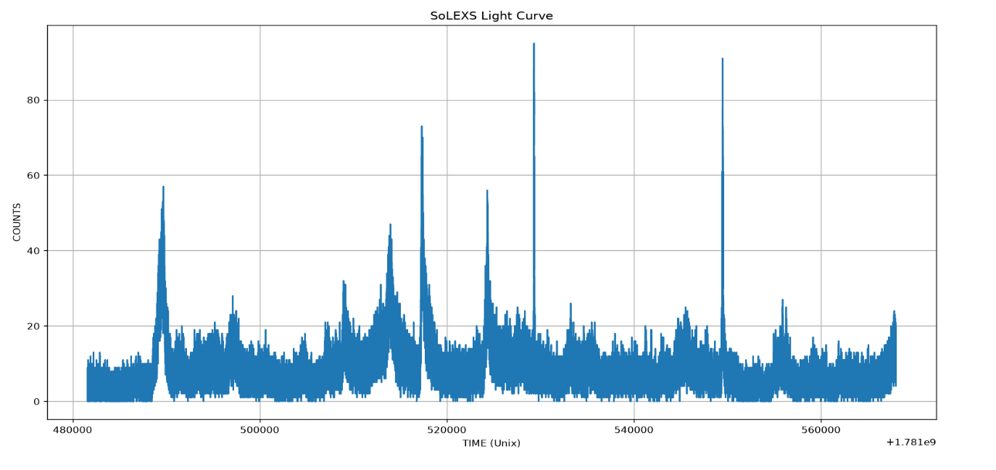
Observation:
The light curve exhibits multiple fluctuations in X-ray activity throughout the day. Several prominent peaks are visible above the background count level, indicating periods of enhanced solar activity. The strongest detected event reaches approximately 95 counts, suggesting the presence of a significant flare-like enhancement.

Peak Activity Analysis:
Zoomed view of the strongest flare-like enhancement detected in the dataset.
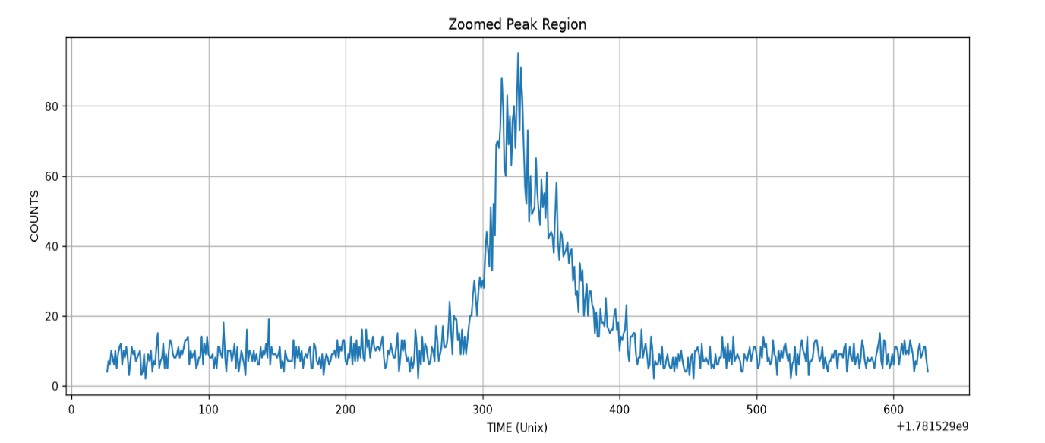
Observation:
The selected region contains the highest count rate observed during the entire observation period. A rapid increase in X-ray counts is followed by a gradual decline, producing a characteristic flare profile. This behavior is consistent with a strong solar X-ray emission event.

Threshold-Based Flare Detection:
Threshold-based analysis of the strongest flare region using the Mean + 3 × Standard Deviation detection criterion.
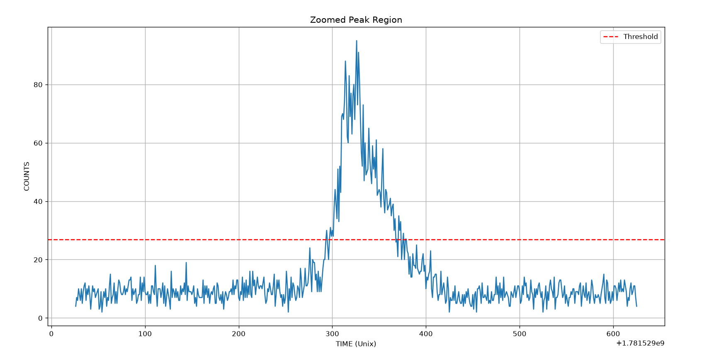
Observation:
The red dashed line represents the detection threshold calculated using statistical properties of the dataset. The flare peak significantly exceeds this threshold, confirming that the event is distinguishable from normal background activity and can be classified as a potential solar flare candidate.

Peak Activity Statistics:
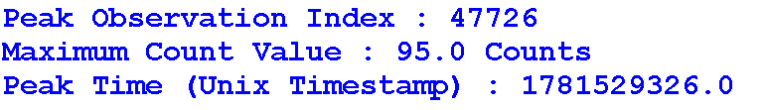
Interpretation: The strongest X-ray activity recorded during the observation period occurred at 13:15:26 UTC, reaching a maximum count value of 95. This value is significantly higher than the average background level and represents the most intense flare-like enhancement detected in the dataset.

Statistical Analysis and Flare Detection Metrics:
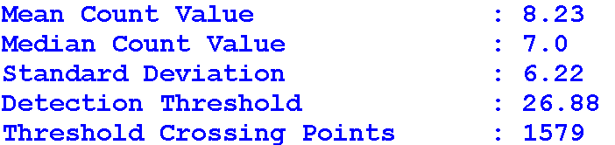
Interpretation:
The average background count level of the dataset is 8.23 counts, while the detection threshold was calculated as 26.88 counts using the Mean + 3σ criterion. A total of 1,579 threshold-crossing data points were identified, indicating multiple periods of enhanced X-ray activity throughout the observation period.
Note:
Threshold-crossing points do not necessarily represent individual flare events. Multiple consecutive points may belong to the same flare, therefore the actual number of flare events may be lower than the total number of detected threshold-crossing points.

Flare Detection Analysis:
Full-day flare detection analysis showing threshold crossings identified using the Mean + 3σ method.
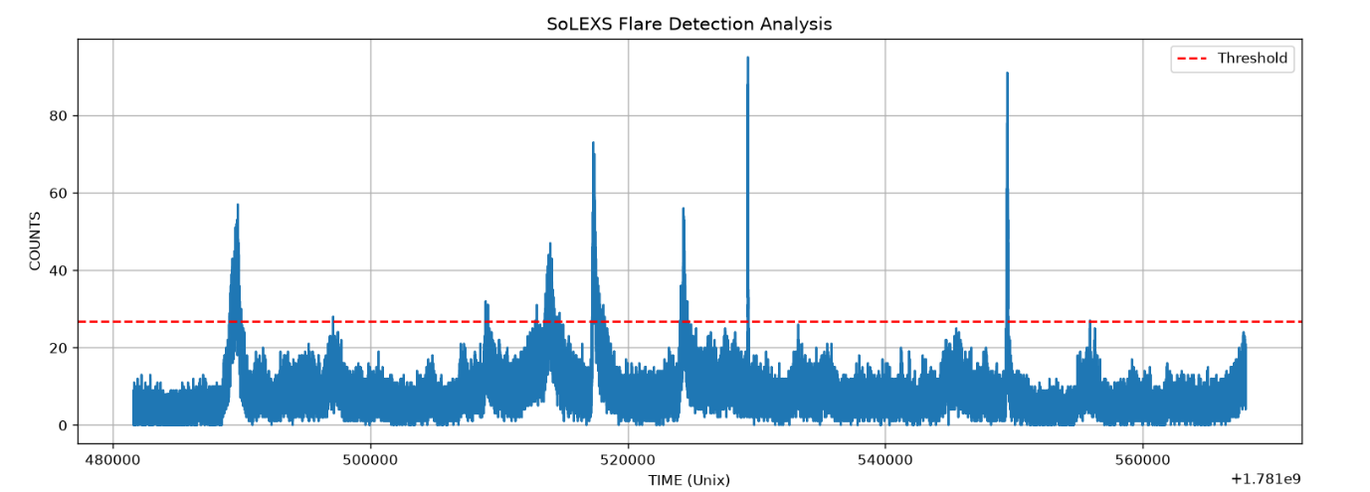
Observation:
Several regions exceed the calculated detection threshold, indicating statistically significant enhancements in X-ray activity. These regions are flagged as potential flare candidates and represent periods where the observed count rate is substantially above the normal background level.

Conclusion
The SoLEXS Level-1 light curve dataset for 15 June 2026 was successfully analyzed to characterize the temporal behavior of soft X-ray emissions from the Sun.
The dataset contains continuous observations with a cadence of approximately one second, resulting in 86,400 observations over a 24-hour period. Analysis of the TIME and COUNTS parameters revealed multiple periods of enhanced X-ray activity throughout the day.
A threshold-based flare detection method using Mean + 3 × Standard Deviation was applied to identify significant activity above the background level. The analysis produced a detection threshold of 26.88 counts and identified 1,579 threshold-crossing data points. The strongest observed event reached a peak count of 95 at 13:15:26 UTC on 15 June 2026.
The light curve demonstrates several clear flare-like enhancements, indicating that the dataset contains multiple episodes of elevated solar activity. These observations confirm that SoLEXS data can be effectively used for soft X-ray flare detection, event characterization, and future solar flare nowcasting and forecasting studies.
Overall, the analysis demonstrates that the SoLEXS Level-1 light curve dataset provides reliable information for detecting, characterizing, and monitoring solar flare activity. The results obtained in this study establish a strong foundation for the development of automated solar flare nowcasting and forecasting systems using Aditya-L1 observations.

