Im looking a develop that can develop some simple games (3 games) using React that will be integrated in an existing application, you can find more details in the attached document.

**General Objectives**

* Develop the games using ReactJs/TypeScript/SASS (will be integrated into a CreateReactApp)
* Strings should be able to be localised (add a json file with the localisation text and reference it in your code)
* Should be compatible with mobile devices (Cordova)
* Games should be able to have parameters in a json file (for example time limit, sets, etc).
* Add methods that can be called when game starts and game finishes to get the score.

**GAME #1 : COLOR RUN**

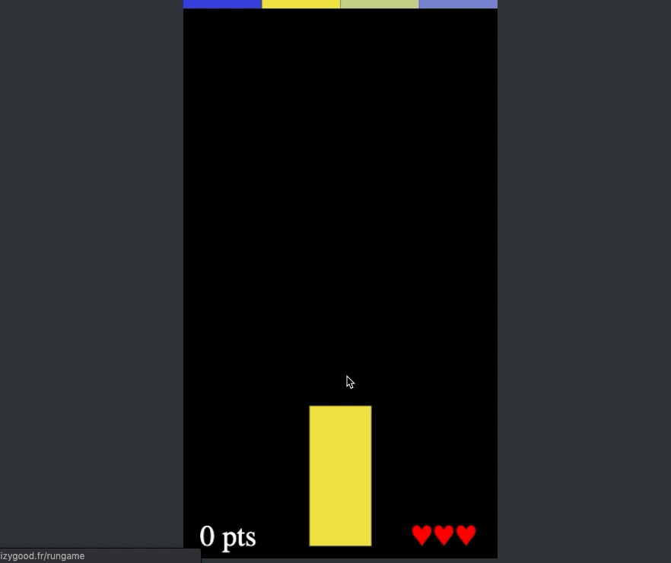

**Objective**

* Improve your color discrimination and your visual speed.

Description

* To match same colour among a color variation.

Explanations :

* 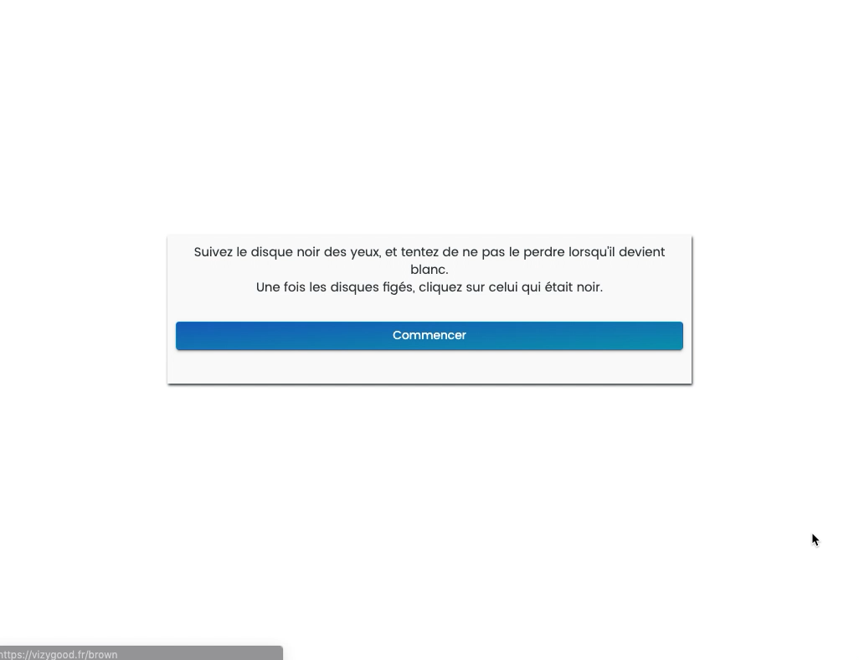Four boxes with different colours go down from the top of the screen to the bottom. There is a unique box at the bottom of the screen. This box has the same colour of one the 4 other boxes. The user has to match the 2 unique coloured boxes together. He can move the unique boe at the bottom line from right to left or left to right.

Scores and level :

* A game has a time limit of 5 minutes (parameter).
* Each set can be 1 minute (parameter)
* Player has 3 lives.
* Each set can offer 50 points if the user wins.
* Colors are randomized each set (colors can be paramterized)
* Mobile version can be controled by touching, desktop can be controlled with the keyboard arrows.

Level 1 : 3 boxes

Level 2 : 4 boxes

Level 3 : 5 boxes

Level 4 : 6 boxes

Level 5 : 7 boxes (parameters)

**Game # 2 : BROWN**

**Objectif : To stimulate visual memory and eye movements**

**Description/ Explanations :**

The user will have to focus on a black ball which moves with a random trajectory among a group of white balls. After several seconds, the black ball becomes white as all the others. It follows its way for a couples of seconds. Then all balls stop moving. The user will have to find and click on the original black ball.

**Evolution/ progression de la partie :**

* Each game lasts 1 minute.
* Each user has 3 sets.
* Each level is presented 3 times before upgrading if the user won.
* Each user has 5 seconds to find and click on the ball.
* If the user doesn’t find the ball, then he can do again another set with the same level.

**Level progression :**

Level 1: 1 ball to find among 3 white balls

Level 2: 1 ball to find among 6white balls

Level 3: 1 ball to find among 9white balls

Level 4: 1 ball to find among 12white balls

Level 5: 1 ball to find among 15 white balls

Level 6: 1 ball to find among 18 white balls

Level 7: 1 ball to find among 21 white balls

Level 8: 2 balls to find among 9 white balls

Level 9: 2 balls to find among 12 white balls

Level 10: 2 balls to find among 15 white balls

Level 11: 2 balls to find among 18 white balls

Level 12: 2 balls to find among 21 white balls

Level 13: 3 balls to find among 12 white balls

Level 14: 3 balls to find among 15 white balls

And so on

**Score :**

* Each game lasts 1 minute.
* A won ball is 10 points.
* A lost ball doesn’t offer negative points.
* When the user begins a new game, it’s based on his previous level.

**Variables :**

* Number of black balls
* Number of white balls
* Speed of the white balls movement
* Speed of the black balls movement

**Cré-eation :**

Background orange : #fdc7a6

White ball : #ffffff

Black ball : #000000



**Game # 3 MEMORY**

**Objective: Stimulate visual memory**

**Description :**

The user must find all colored boxes hidden to make the original shape.

**Explantation :**

A shape appears and it’s composed by several colored squares. The shape is a random shape.

The user needs to find all squares to design the original shape.

**Game and scoring :**

* Each game lasts 1 minute.
* The user needs to valid 3 shapes before going up to the higher level.
* If the user doen’t design correctly the shape, then he can try again a second time :
  + If he succeeds then he can go up.
  + If he losts then he go down to a easier level.
* Each colored square won offers 5 points.
* There is no negative points if then shape is lost
* The user begins a new game at his previous level.

**Levels :**

Level 1: 2 squares to find among 9 squares in 6 seconds.

Level 2: 3 squares to find among 9 squares in 9 seconds.

Level 3: 4 squares to find among 9 squares in 12 seconds.

Level 4: 5 squares to find among 9 squares in 15 seconds.

Level 5: 6 squares to find among 16 squares in 18 seconds.

Level 6: 7 squares to find among 16 squares in 21 seconds.

Level 7: 8 squares to find among 16 squares in 24 seconds.

Level 8: 9 squares to find among 25 squares in 27 seconds.

Level 9: 10 squares to find among 25 squares in 30 seconds.

Level 10: 11 squares to find among 25 squares in 33 seconds.

And so on

**Variables :**

* Number of colored squares to find
* Number of other squares
* The time of each shape to find (depending of the number of colored squares)

