Topic: Battery-Checker Alarm

**USER MANUAL**

Battery Checker Alarm is a simple tkinter application which helps one to keep a check on users laptop/computer’s battery percentage and warns when the battery percentage reaches a certain limit set by the user.

1. **User can enter any battery percentage which the user wants to set as the limit.**

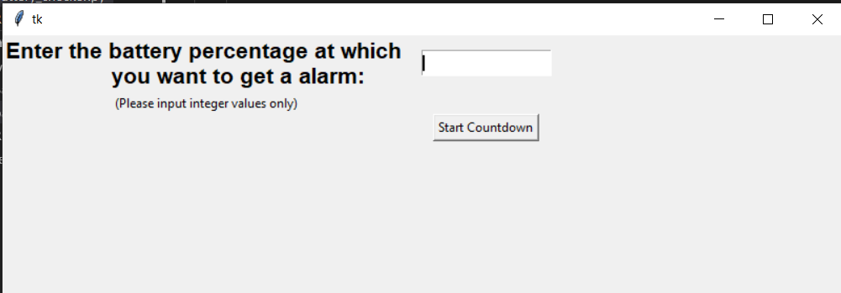

1. **If this is the current battery percentage of user’s laptop/computer.**

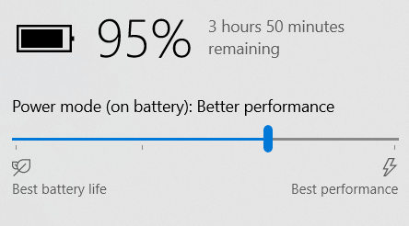

1. **So if the current battery percentage of users laptop is lesser than the input battery percentage limit , a warning will be displayed.**

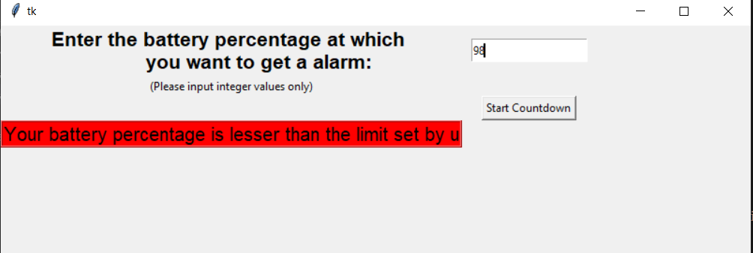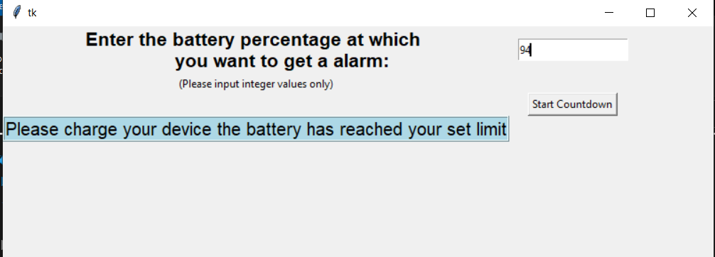

1. **If the battery percentage of user’s laptop reaches the limit that he/she has provided then an alarm sound will turn on and a warning will be displayed.**