



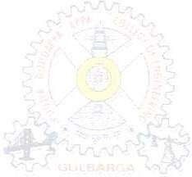





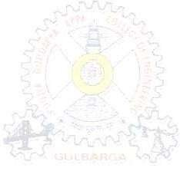


H.K.E.Society’s
POOJYA DODDAPPA APPA COLLEGE OF ENGINEERING
Kalaburagi-585102

(An Autonomous Institution, Affiliated to VTU Belagavi, and Approved by AICTE)

MAJOR PROJECT REPORT ON
“AIRSKETCH:GESTURE BASED VIRTUAL DRAWING”
Submitted to the
H.K.E.Society’s
POOJYA DODDAPPA APPA COLLEGE OF ENGINEERING, KALABURAGI

(An Autonomous Institution, Affiliated to VTU Belagavi, and Approved by AICTE)
In partial fulfillment of the requirement for the award of the Degree of

BACHELOR OF ENGINEERING

IN

COMPUTER SCIENCE & ENGINEERING

Submitted by
HISHAM KHURAM (3PD23CS050)
MD AHMED RAZA SOFI (3PD23CS065)
MOHAMMED ABDUL MAAZ HANAN (3PD23CS070)
Under the Guidance of
Dr. ANITA HARSOOR
DEPARTMENT OF COMPUTER SCIENCE & ENGINEERING
(Accredited by NBA, New Delhi)
POOJYA DODDAPPA APPA COLLEGE OF ENGINEERING, KALABURAGI - 585 102
2026-2027






H.K.E.Society’s

POOJYA DODDAPPA APPA COLLEGE OF ENGINEERING
Kalaburagi-585102

(An Autonomous Institution, Affiliated to VTU Belagavi, and Approved by AICTE)

DEPARTMENT OF COMPUTER SCIENCE & ENGINEERING

Certificate

Certified that the Major Project Phase-I entitled “AIR-SKETCH:GESTURE BASED VIRTUAL DRAWING” carried out by Mr Hisham Khuram USN 3PD23CS050, Md Ahmed Raza Sofi USN 3PD23CS065, Mohammed Abdul Maaz Hanan USN 3PD23CS070 a bonafide student of POOJYA DODAPPA APPA COLLEGE OF ENGINEERING in partial fulfillment for the award of Bachelor of Engineering/Bachelor of Technology in Computer Science and Engineering of Visvesvaraya Technological University,Belgaum during the year 2026-27. It is certified that all corrections/suggestions indicated for Internal Assessment have been incorporated in the report deposited in the departmental library.
The project report has been approved as it satisfies the academic requirement in respect of project work prescribed for said Degree.

Dr. ANITA HARSOOR | Dr.Suvarna Nandyal | Dr.Shridevi Soma | Dr S.R.Patil
Guide | Project  Co-ordinator | HOD  Dept of CSE | Principal  PDACEK

Examiners: Signature with Date

1.

2.






Acknowledgement

The satisfaction that accompanied the successful completion of any task would be incomplete without the mention of the people who made it possible and whose constant guidance and encouragement crown all the efforts with success. This acknowledgement transcends the reality of formality when I would like to express deep gratitude and respect to all the people who has inspired and helped me for the completion of my Major Project work.

I express my foremost gratitude to my Principal, Dr. S. R. PATIL, for his constant support and valuable guidance.
I am sincerely thankful to Dr. Shridevi Soma, Head of the Department Computer Science & Engineering for her counseling and advice throughout my Major Project work.
I express my deep gratitude to Dr. Suvarna Nandyal, Coordinator of Computer Science and Engineering Department for providing continuous suggestions to me with immense care and deal throughout my Major Project work.
I would like to express my deep gratitude to my guide Dr. Anita Harsoor of CSE for providing valuable suggestions to me during my Major Project work.
I am very much thankful to my parents for their consistent moral support and I am also very much thankful to all the faculty members of the Department of Computer Science & Engineering, PDACEK, for their encouragement and support.

Student Names :
Hisham Khuram (3PD23CS050)
Md Ahmed Raza Sofi (3PD23CS065)
Mohammed Abdul Maaz Hanan (3PD23CS070)

ABSTRACT

AirSketch is an innovative gesture-based virtual drawing application designed to transform digital drawing by using real-time hand gesture recognition through a webcam. Unlike traditional drawing systems that rely on devices such as a mouse, stylus, or touchscreen, the application enables users to interact with a virtual canvas using natural hand and finger movements. By extending a single finger, users can draw seamlessly, while predefined gestures allow them to change colors, activate eraser mode, clear the canvas, and control drawing functions efficiently. The system uses computer vision and real-time hand tracking techniques to accurately detect hand landmarks and convert gestures into precise drawing actions with minimal latency. The project integrates technologies such as computer vision, image processing, and human-computer interaction to provide a smooth, touch-free, and user-friendly experience. The salient features of AirSketch include real-time gesture detection, virtual canvas interaction, multiple color selection, eraser functionality, touchless operation, smooth and responsive drawing, and accessibility support for physically challenged users. The application enhances creativity and user engagement while demonstrating the practical implementation of gesture-controlled systems in modern web technologies. Furthermore, AirSketch highlights the growing importance of contactless and intelligent interaction systems in areas such as education, entertainment, design, and smart digital environments, making digital drawing more interactive, efficient, and inclusive.

CONTENTS
1. Introduction…………………………………………………………………………………..6
1.1 Domain Introduction……….………………..………………………………………6
1.2 Project Introduction……...…………………………………………………………..6
2. Literature Survey…...………………………………………………………………………...7
3. Existing and Proposed System…….……………………………………………………….....14
4. Problem Definition, Objectives ……………………………..………………………………...17
5. System Design………..…….…………………………………………………………………18
5.1 System Architecture………...……………...…………….…………………………...18
5.2 Module Description……………….………………………………………………….19
5.3 Algorithms……………………………………………………………………………21
6. System Implementation…….…………………………………………………………………22
7. Results and Discussion……………......……………………………………………………….23
8. Conclusion and Future Scope...……………………………………………………………….26

I. INTRODUCTION

1.1) DOMAIN INTRODUCTION
With the rapid advancement of computer vision, artificial intelligence, and human-computer interaction technologies, gesture-based systems have emerged as an innovative approach for creating natural and interactive digital experiences. Traditional drawing methods mainly rely on devices such as a mouse, stylus, or touchscreen, which may limit flexibility and accessibility for some users. Hand gesture recognition technology enables users to interact with digital systems through simple finger and hand movements captured using a webcam, creating a touch-free and intuitive environment. These systems are increasingly being used in areas such as education, gaming, virtual reality, and smart interactive applications

1.2) PROJECT INTRODUCTION
The AirSketch: Gesture-Based Virtual Drawing System is proposed to provide an innovative and interactive solution for digital drawing using real-time hand gesture recognition technology. The system utilizes a webcam to capture hand movements and applies computer vision and image processing techniques to detect and track hand landmarks accurately. By interpreting specific finger gestures, the application allows users to draw on a virtual canvas without requiring traditional input devices such as a mouse, stylus, or touchscreen. Users can perform different operations such as drawing, changing colors, activating eraser mode, and clearing the canvas through predefined gestures, creating a smooth and touch-free user experience. The system is designed to provide real-time responsiveness, accurate gesture detection, and seamless interaction with minimal latency. In addition, the project supports accessibility by enabling physically challenged individuals to interact with digital systems more comfortably using simple hand gestures. Overall, the project demonstrates the practical implementation of gesture-controlled interfaces and highlights the growing importance of contactless technologies in modern digital environments.

II. LITERATURE SURVEY

[1]Skeleton-based Online Micro Hand Gesture Recognition Authors: H. Chang, P. Ren, B. Zhang, D. Li, T. Han, H. Zhang, L. Xie, H. Chen, and E. Yin,2026:
The research work by Haochen Chang et al. introduces OMG-Bench, the first large-scale public benchmark designed specifically for skeleton-based online micro hand gesture recognition. The paper focuses on recognizing subtle and continuous hand gestures in real time, which are highly important for modern human-computer interaction systems, virtual reality environments, and gesture-controlled applications. The authors highlight the limitations of existing gesture recognition datasets, such as low diversity, limited gesture classes, poor skeleton quality, and lack of real-time continuous interaction support. To overcome these challenges, the researchers developed a multi-view self-supervised data collection pipeline capable of generating high-quality hand skeleton data with accurate frame-level annotations.

[2]Dynamic LIBRAS Gesture Recognition via CNN over Spatiotemporal Matrix Representation. Authors: J. Moreira, 2026

The study by J. Moreira proposes a Convolutional Neural Network (CNN)-based approach for dynamic LIBRAS (Brazilian Sign Language) gesture recognition using spatiotemporal matrix representation techniques. The system captures both spatial and temporal features of hand movements, enabling accurate recognition of dynamic gestures by analyzing motion patterns across continuous frames. The proposed method improves gesture classification performance and demonstrates the effectiveness of deep learning models in gesture-based human-computer interaction systems. However, the approach is computationally intensive and requires higher processing power, making it less suitable for lightweight real-time applications and large-scale deployment in practical environments.

[3] Painting with Hand Gestures using MediaPipe Authors: R. Vasavi, N. Rahul, A. Snigdha, K. J. Moses, and S. V. Simha, 2022.
The study by R. Vasavi et al. presents a virtual painting system that uses MediaPipe-based hand gesture recognition to enable users to draw digitally without physical contact. The system utilizes real-time hand tracking and computer vision techniques to detect finger movements and convert them into drawing actions on a virtual canvas. By integrating MediaPipe and OpenCV, the proposed approach achieves smooth and intuitive interaction, making the system user-friendly and efficient for gesture-controlled applications. The research highlights the growing importance of touchless human-computer interaction systems and demonstrates how hand gestures can replace conventional input devices in creative applications. This work is highly relevant to the AirSketch project because it focuses on real-time virtual drawing, gesture tracking, and interactive user experience. However, the system performance may be affected by poor lighting conditions, background disturbances, and hand occlusions, which can reduce gesture detection accuracy in real-world environments.
[4] Air Canvas Hand Tracking, Authors: A. Swathi, 2024.
The work by A. Swathi presents an Air Canvas system that uses hand tracking and computer vision techniques to enable virtual drawing through touchless interaction. The system detects and tracks hand movements in real time using a webcam, allowing users to draw on a virtual canvas without relying on traditional input devices such as a mouse or stylus. The study demonstrates how gesture-based interaction can provide an intuitive, low-cost, and user-friendly digital drawing experience by integrating hand landmark detection and motion tracking methods. The proposed approach is highly relevant to the AirSketch project because it focuses on real-time gesture recognition, smooth virtual drawing, and natural human-computer interaction. However, the performance of the system is sensitive to factors such as poor lighting conditions, complex backgrounds, camera quality, and hand occlusions, which may reduce tracking accuracy and affect overall responsiveness in practical environments.

[5]A Deep Learning-based Multimodal Depth-Aware Dynamic Hand Gesture Recognition System Authors: H. Mahmud, M. M. Morshed, and Md. et al., " 2022.
The study by H. Mahmud et al. proposes a deep learning-based multimodal depth-aware system for dynamic hand gesture recognition that combines RGB image data and depth information to improve gesture detection accuracy and robustness. The system utilizes deep learning algorithms to analyze dynamic hand movements and extract meaningful spatial and temporal features for accurate gesture classification. By integrating depth sensing with conventional image processing techniques, the proposed approach performs effectively even in challenging conditions such as background clutter and varying lighting environments. The research demonstrates strong recognition performance and highlights the importance of multimodal data in improving gesture-based interaction systems. This work is relevant to the AirSketch project because it focuses on real-time hand gesture recognition and interactive human-computer communication. However, the system requires specialized depth sensors and higher computational resources, making it less practical for low-cost, lightweight, and webcam-based real-time applications like AirSketch.
[6]Hand Gesture Recognition using Image Processing and Feature Extraction Techniques, Authors: A. Sharma, A. Mittal, S. Singh, and V. Awatramani, 2020.
The study by A. Sharma et al. presents a hand gesture recognition system based on image processing and feature extraction techniques for detecting and interpreting hand movements. The proposed system uses contour detection, shape analysis, segmentation, and feature extraction methods to identify different hand gestures from captured images. The research highlights the effectiveness of traditional image processing approaches in developing simple and cost-effective gesture-controlled systems without requiring advanced hardware. This work is relevant to the AirSketch project because it focuses on gesture recognition and virtual interaction using computer vision techniques. However, the approach is highly sensitive to background noise, lighting variations, and complex environments, which may reduce accuracy and robustness in real-time applications such as AirSketch where smooth and continuous gesture tracking is essential.

[7] Computer Vision-based Hand Gesture Recognition for Human-Robot Interaction Authors: J. Qi, L. Ma, Z. Cui, and Y. Yu, 2023.
The study by J. Qi et al. provides a comprehensive review of computer vision–based hand gesture recognition techniques used in human-robot interaction systems. The paper discusses both traditional image processing methods and modern deep learning approaches for gesture detection and classification, along with commonly used datasets, feature extraction techniques, and recognition models. The research highlights the growing importance of gesture-based interaction in creating natural and efficient communication between humans and intelligent systems. It also examines challenges such as varying lighting conditions, complex backgrounds, occlusions, and real-time processing limitations that affect gesture recognition accuracy and robustness. This work is highly relevant to the AirSketch project because it identifies key technologies, challenges, and research gaps associated with real-time hand tracking and gesture-controlled interaction systems.
[8] Hand Gesture and Voice-controlled Mouse for Physically Challenged using Computer Vision, Authors:A. Morajkar, A. M. James, M. Bagwe, and A. S. James, 2022.
The study by A. Morajkar et al. presents a computer vision–based system that combines hand gesture recognition and voice commands to control mouse operations for physically challenged users. The proposed system uses webcam-based gesture detection and speech recognition techniques to perform functions such as cursor movement, clicking, and navigation without relying on conventional input devices. The research emphasizes accessibility and demonstrates how natural interaction methods can improve computer usability for individuals with physical disabilities. By integrating gesture recognition with voice control, the system provides a more flexible and user-friendly human-computer interaction experience. This work is relevant to the AirSketch project because it highlights the importance of touchless interaction and accessibility-oriented design in gesture-controlled systems.

[9] MediaPipe-LSTM-Enhanced Framework for Real-Time Dynamic Sign Language Recognition in Inclusive Communication Systems, Authors: N. Anithadevi, S. Palanisamy, S. S. Rubini, and S. Shrestha 2024.
The study by N. Anithadevi et al. proposes a MediaPipe-LSTM–based framework for real-time dynamic sign language recognition aimed at improving inclusive communication systems. The proposed approach combines MediaPipe hand landmark detection with Long Short-Term Memory (LSTM) networks to capture both spatial hand features and temporal motion patterns for accurate gesture recognition. The system effectively tracks hand movements in real time and improves recognition accuracy for dynamic gestures by learning sequential motion information. The research highlights the importance of integrating computer vision and deep learning techniques to create responsive and intelligent gesture-based interaction systems. This work is highly relevant to the AirSketch project because it demonstrates efficient real-time hand tracking, motion analysis, and gesture interpretation techniques that can enhance virtual drawing applications.
[10] Towards Understanding the Faults of JavaScript-Based Deep Learning Systems, Authors: L. Quan, Q. Guo, X. Xie, S. Chen, X. Li, and Y. Liu, 2023.
The study by L. Quan et al. investigates faults and reliability issues in JavaScript-based deep learning systems used in AI applications. It identifies problems related to model implementation, debugging, framework inconsistencies, and performance issues that can affect the accuracy and stability of real-time systems. The research is relevant to the AirSketch project because it highlights the importance of developing reliable and efficient web-based gesture recognition applications. The literature survey overall shows that while deep learning and multimodal approaches improve gesture recognition accuracy, they often require high computational resources, whereas MediaPipe- and computer vision–based methods provide efficient hand tracking with lower computational cost, making them more suitable for lightweight real-time applications like AirSketch.

No. | Research papers | Conclusion & Drawback | Relevance for our system | Published By
1 | A New Challenging Benchmark for Skeleton based Micro Hand Gesture Recognition. 2026 | C. Real time hand tracking using MediaPipe and OpenCV.  D. Dependancy on camera based tracking sensitive to lighting and background variations | Accurate hand tracking with simple gesture mapping can enable a responsive real-time air drawing system | ScienceOpen
2 | Dynamic LIBRAS gesture recognition 2026 | C. Improves user interaction and enables accurate air writing on virtual canvases  D.Struggles with variability in hand movements and lack of tactile feedback | Combing fingertip detection with preprocessing enhance security | Cornell University
3 | Painting with hand gestures using media pipe, 2024 | C. Effective real-time hand gesture painting system by tracking fingertip movements.  D. Sensitive to lighting conditions and background noise which can reduce drawing accuracy. | Simple fingertip tracking and gesture mapping can be used to build an air drawing system, which we can enhance with better accuracy and stability. | IJISRT
4 | Air Canvas Handtracking 2022 | C. Virtual air canvas system built using color-based object tracking  D. Reliance on colored markers, making it less natural and less flexible | Simpler color detection methods can reduce computational complexity, | JETIR
5 | Deep Learning based Dynamic Hand Gesture Recognition System 2022 | C. Deep learning significantly improves accuracy and efficiency  D. Complex multimodal fusion and depth data processing, increasing system complexity | Combining multiple data modalities (depth + skeleton) enhances gesture understanding, | ResearchGate
Table 2.1 Abstract Table of Literature Survey

6 | Hand Gesture Recognition using Image Processing and Feature Extraction Techniques 2020 | C. Combining image preprocessing with feature extraction improves hand gesture recognition accuracy  D. Complex feature extraction and multiple processing steps | Effective preprocessing and feature extraction are crucial for improving recognition accuracy | ResearchGate
7 | Computer vision-based hand gesture recognition for human-robot  interaction: a review 2022 | C. human–robot interaction stages like detection, segmentation, and classification.  D. challenges such as gesture variability, environmental sensitivity, and high computational complexity. | Complete pipeline (data acquisition → detection → feature extraction → classification). | SpringerNature
8 | Hand gesture and voice-controlled mouse for physically challenged using computer vision 2023 | C. creates a multimodal system for hands-free and accessible computer control.  D. Synchronizing gesture and voice inputs and may suffer from reduced accuracy due to noise, lighting conditions etc | Integrating multiple input modalities (gesture + voice) improves usability and accessibility | ResearchGate
9 | Enhanced Framework for Real-Time Dynamic Sign Language Recognition 2024 | C. Integrating Deep Learning with hand tracking enables more accurate recognition.  D. Increases computational cost and makes real-time deployment on low-end devices challenging | Temporal modeling of gestures improves recognition of dynamic movements | WILEY
10 | Faults of JavaScript-Based Deep Learning Systems 2023 | C. Deep learning recognition models can effectively capture complex hand movements and improve interaction accuracy  D. Requires large datasets and high computational resources | Advanced deep learning improves gesture understanding and motivates us to design a lightweight and efficient system | Cornell University
Table 2.2 Abstract Table of Literature Survey

III. EXISTING AND PROPOSED SYSTEM

3.1 Existing System:

3.1.1 Microsoft Kinect:
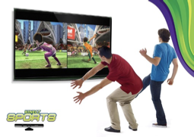
Figure 3.1.1 Xbox 360 Kinect
The existing system for gesture-based interaction mainly relies on motion-sensing technologies such as Microsoft Kinect, which uses RGB cameras, depth sensors, and infrared technology to track body and hand movements. These systems enable users to interact with digital applications without physical controllers and are widely used in gaming, virtual reality, rehabilitation, and interactive environments. Gesture recognition in such systems provides a natural and interactive user experience by converting physical movements into digital commands.
However, most existing systems require specialized and expensive hardware, making them less affordable and less portable for common users. Their setup process can be complex and hardware-dependent, limiting flexibility and scalability in lightweight or web-based applications.

3.1.2 Leap Motion Controller:
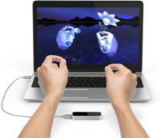
Figure 3.1.2 Leap Motion

The Leap Motion Controller is a hardware-based gesture recognition system that uses infrared cameras and optical sensors to capture highly precise hand and finger movements in real time. It is capable of tracking individual fingers, hand orientation, and complex gestures with high accuracy, making it suitable for applications such as virtual reality, augmented reality, 3D modeling, medical training, and interactive simulations. The system enables natural and touchless interaction by converting hand movements into digital commands, improving user engagement and interaction quality in advanced gesture-controlled environments.
However, the Leap Motion Controller requires dedicated external hardware, which increases the overall system cost and limits accessibility for general users. The device also requires proper setup, calibration, and positioning to achieve accurate tracking, while its interaction range remains limited compared to webcam-based systems. In addition, the dependency on specialized hardware makes it less portable and less scalable for lightweight, low-cost, and web-based applications. These limitations make webcam-based gesture recognition approaches, such as the proposed AirSketch system, more practical and accessible for real-time virtual drawing applications.

3.2 Proposed System:

The proposed system, AirSketch, is a web-based gesture-controlled virtual drawing application that enables users to create digital drawings using real-time hand gestures captured through a standard webcam. The system utilizes computer vision, MediaPipe hand tracking, and image processing techniques to detect and track hand landmarks accurately. By monitoring the movement of the user’s fingertip, the application converts natural hand gestures into drawing actions on a virtual canvas, eliminating the need for traditional input devices such as a mouse, stylus, or touchscreen. The system is designed to provide a smooth, touch-free, and intuitive human-computer interaction experience.
AirSketch includes several interactive features that enhance usability and creativity. Users can select different drawing colors through predefined gestures, adjust brush thickness for varied stroke sizes, activate eraser mode to remove unwanted drawings, and clear the entire canvas using specific gesture commands. The application processes webcam frames continuously in real time, ensuring low-latency gesture detection and responsive drawing performance. The use of efficient hand tracking algorithms allows smooth interaction while maintaining accuracy and stability during continuous motion.
Unlike hardware-dependent gesture recognition systems, AirSketch is lightweight, cost-effective, and easily accessible because it only requires a webcam and a modern web browser for operation. The system does not require external sensors, special controllers, or software installation, making it portable and suitable for deployment across multiple platforms. In addition to supporting creative and educational applications, the proposed system also improves accessibility for physically challenged users by enabling touchless digital interaction through simple hand gestures. Overall, AirSketch demonstrates an efficient and practical implementation of gesture-based technology for modern interactive applications.

IV. PROBLEM DEFINITIONS, OBJECTIVES

4.1 Problem Definitions:
Traditional digital drawing systems rely heavily on physical input devices such as a mouse, stylus, or touchscreen. These methods require direct physical interaction, which may not always be intuitive, portable, or accessible to all users. Individuals with physical disabilities or hand movement limitations face significant challenges in using conventional input devices.Existing gesture-based systems often focus only on basic functionalities, lacking a complete and interactive drawing experience suitable for real-world applications.
There is therefore a need for an intuitive, touchless, and accessible system that leverages computer vision and hand gesture recognition to provide a natural and inclusive digital drawing experience, one that is available through a standard web browser without requiring any specialized hardware.

4.2 Objectives:

- To develop a gesture-based virtual drawing platform that detects and interprets hand gestures in real time for touchless interaction
- To enhance accessibility by enabling users with physical limitations to interact without traditional input devices
- To demonstrate the practical use of AI-driven human–computer interaction systems
- To provide an interactive and user-friendly interface with features such as drawing, color selection, erasing, and canvas clearing

V. SYSTEM DESIGN
5.1) SYSTEM ARCHITECTURE:

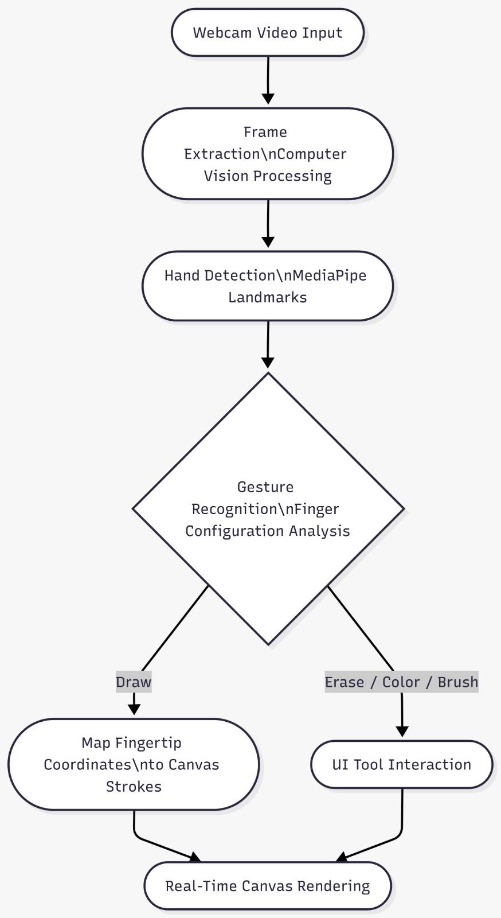
Figure 5.1: System Architecture of AirSketch
The system architecture of AirSketch is designed to enable real-time gesture-based virtual drawing using computer vision and hand tracking technologies. The system begins with webcam video input, where continuous video frames are captured from the user’s camera. These frames are processed through computer vision techniques for frame extraction and preprocessing. The processed frames are then passed to the MediaPipe hand detection module, which identifies hand landmarks and tracks fingertip positions in real time. The detected hand landmark data is further analyzed through the gesture recognition module, where finger configurations and hand movements are interpreted to identify user gestures.

5.2) MODULE DESCRIPTION

1. Webcam Input Module
This module captures live video feed from the user’s webcam and continuously processes frames for gesture detection. It acts as the primary input source for the AirSketch system and ensures smooth frame acquisition with minimal latency. The module supports real-time video streaming directly within the web browser without requiring additional hardware or software installation.

2. Frame Processing & Computer Vision Module
This module performs image processing and frame analysis using computer vision techniques. It converts webcam frames into a suitable format for gesture detection and improves detection quality through operations such as frame resizing, color conversion, and noise reduction. The module prepares the input data for accurate hand tracking and gesture interpretation.

3. Hand Detection & Tracking Module
The hand detection module uses MediaPipe hand landmark technology to identify and track hand positions in real time. It detects multiple hand landmarks, including fingertip coordinates and finger orientations, enabling accurate monitoring of user hand movements. This module forms the core of the gesture recognition process by continuously tracking finger motion and hand gestures.

4. Gesture Recognition Module
This module analyzes finger configurations and hand landmark patterns to recognize predefined gestures. Different gestures are mapped to specific operations such as drawing, selecting colors, activating eraser mode, adjusting brush size, and clearing the canvas. The module ensures responsive and accurate gesture interpretation for smooth user interaction.

5. Virtual Canvas Rendering Module
The virtual canvas module converts fingertip coordinates into digital strokes and renders drawings in real time. It manages line generation, stroke continuity, brush thickness, and drawing colors while ensuring low-latency rendering. The module provides a smooth and natural drawing experience by instantly reflecting user movements on the digital canvas.

6. User Interface & Tool Interaction Module
This module manages interaction between the user and application tools such as color palettes, brush settings, eraser controls, and canvas management options. It provides a simple and user-friendly interface that allows users to perform actions using predefined hand gestures without physical contact.

7. Accessibility & Performance Module
This module focuses on maintaining efficient system performance and improving accessibility. It optimizes real-time processing speed, minimizes lag during gesture tracking, and ensures smooth interaction across different devices and environments. The module also supports touchless interaction, making the system more accessible for physically challenged users and users with limited hand mobility.

5.3) ALGORITHMS

1. Hand Landmark Detection Algorithm
The AirSketch system uses the MediaPipe Hand Tracking algorithm to detect and track hand landmarks in real time. The algorithm identifies key points of the hand, including fingertips and finger joints, from webcam video frames. By continuously analyzing these landmarks, the system accurately tracks finger movements and hand positions required for gesture-based interaction. The algorithm provides fast and efficient hand detection with low latency, making it suitable for real-time applications.

2. Gesture Recognition Algorithm
The gesture recognition algorithm analyzes the position and configuration of fingers to identify predefined gestures. The system compares fingertip positions and finger states (extended or folded) to determine user actions such as drawing, color selection, erasing, brush adjustment, and canvas clearing. Each recognized gesture is mapped to a specific application function, enabling smooth and touchless interaction with the virtual canvas.
3. Coordinate Mapping Algorithm
The coordinate mapping algorithm converts fingertip positions detected from webcam frames into corresponding coordinates on the digital canvas. The system continuously tracks fingertip movement and connects successive coordinate points to generate smooth drawing strokes. This algorithm ensures accurate synchronization between hand movement and on-screen drawing actions.

4. Real-Time Rendering Algorithm
The real-time rendering algorithm updates the virtual canvas continuously as new gesture data is received. It renders lines, colors, brush thickness, and erasing effects instantly while minimizing delay between user movement and screen output. The algorithm maintains smooth interaction and responsive drawing performance during continuous hand motion.

VI. SYSTEM IMPLEMENTATION

The implementation of AirSketch focuses on developing a real-time gesture-based virtual drawing system using computer vision and hand tracking technologies. The system eliminates the need for traditional input devices such as a mouse, stylus, or touchscreen, providing a touch-free and interactive drawing experience.
The system begins by capturing live video input from the webcam using browser-supported technologies. Each video frame is processed using computer vision and image processing techniques to improve gesture detection accuracy. Operations such as frame resizing, color conversion, and noise reduction are applied before passing the frames to the MediaPipe hand tracking framework. MediaPipe detects and tracks hand landmarks in real time, including fingertip coordinates and finger positions, which are essential for gesture recognition and drawing operations.
Gesture recognition is implemented by analyzing finger configurations and hand landmark patterns. Different gestures are assigned to specific functions such as drawing, selecting colors, adjusting brush size, activating eraser mode, and clearing the canvas. When the drawing gesture is detected, the system maps fingertip coordinates onto the virtual canvas to generate smooth digital strokes in real time.
The proposed system is designed to be lightweight, cost-effective, and easily accessible since it operates entirely within a web browser and only requires a webcam for interaction. The implementation also focuses on accessibility by enabling touchless interaction for physically challenged users or individuals with limited hand mobility. By integrating MediaPipe, computer vision, and real-time gesture analysis, AirSketch demonstrates an efficient and practical implementation of gesture-based human-computer interaction for modern digital applications.

VII. RESULTS AND DISCUSSION

The AirSketch system demonstrates effective real-time gesture-based drawing functionality across standard hardware configurations. The application successfully detects hand landmarks using the MediaPipe framework with low latency, enabling users to draw on the virtual canvas in a smooth and responsive manner. The implemented features — including fingertip-based drawing, color selection, brush size adjustment, eraser mode, and canvas clearing — operate correctly through predefined hand gestures, providing a natural and touch-free interaction experience. The output screenshots demonstrate successful fingertip tracking, smooth stroke generation, and proper interaction between the hand gesture controls and the digital canvas interface.

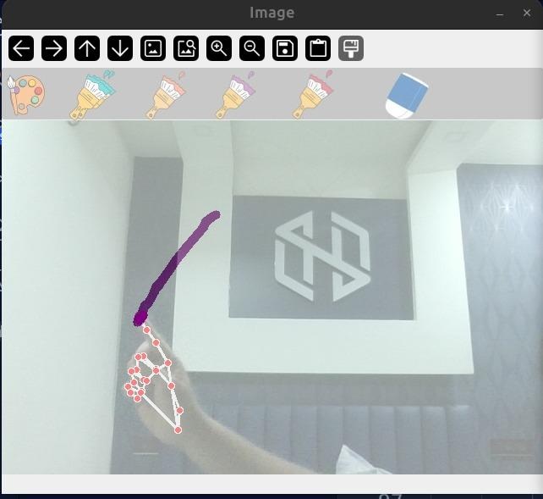
Figure 6.1: Real time Hand Gesture Detection and Drawing

The AirSketch system demonstrates effective real-time gesture-based drawing functionality across standard hardware configurations. The application successfully detects hand landmarks using the MediaPipe framework with low latency, enabling users to draw on the virtual canvas in a smooth and responsive manner. The implemented features — including fingertip-based drawing, color selection, brush size adjustment, eraser mode, and canvas clearing — operate correctly through predefined hand gestures, providing a natural and touch-free interaction experience. The output screenshots demonstrate successful fingertip tracking, smooth stroke generation, and proper interaction between the hand gesture controls and the digital canvas interface.
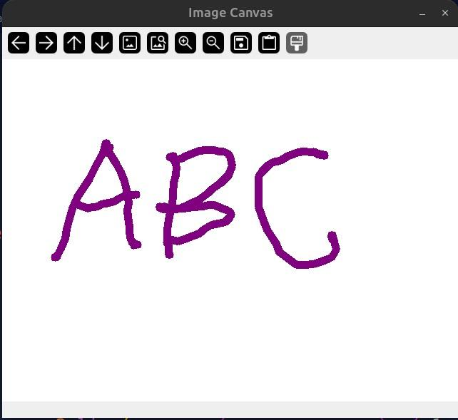
Figure 6.2: Real Time Drawing Output on AirSketch Canvas

The implementation results further show that webcam-based gesture recognition can provide a practical and cost-effective alternative to hardware-dependent systems such as Kinect and Leap Motion controllers. The touchless interaction capability improves usability and accessibility, especially for physically challenged users or users with limited hand mobility. The real-time hand landmark visualization and virtual drawing output confirm that the system maintains stable performance and accurate gesture interpretation during continuous interaction. The lightweight design also ensures portability and easy deployment across different platforms and devices.
However, certain limitations were observed during testing. The system performance can be affected by poor lighting conditions, background disturbances, motion blur, and temporary hand occlusions, which may reduce tracking accuracy and introduce slight landmark jitter or irregular strokes. Rapid hand movements may occasionally cause minor delays in gesture interpretation and rendering. Future improvements may include adaptive preprocessing techniques, temporal smoothing algorithms, and enhanced gesture classification methods to improve stability and robustness under varying environmental conditions. Overall, the implementation results validate the feasibility, efficiency, and practicality of AirSketch as a lightweight real-time gesture-controlled virtual drawing system.

VIII. CONCLUSION AND FUTURE SCOPE

This project presents AirSketch, a web-based gesture-driven virtual drawing application that enables users to interact with a digital canvas using real-time hand gestures captured through a webcam. By integrating MediaPipe hand tracking, computer vision, and image processing techniques, the system provides a smooth and touchless drawing experience without requiring traditional input devices such as a mouse, stylus, or touchscreen. Features such as fingertip-based drawing, color selection, brush adjustment, eraser mode, and canvas clearing demonstrate effective real-time interaction and responsive performance.
The implementation results show that MediaPipe-based hand tracking provides an efficient and lightweight solution for gesture-controlled applications while maintaining practical accuracy and low computational requirements. The project successfully demonstrates that webcam-based gesture recognition can serve as a cost-effective alternative to hardware-dependent systems such as Kinect and Leap Motion controllers. In addition, the system improves accessibility by enabling physically challenged users or individuals with limited hand mobility to interact with digital applications through natural hand gestures.
Although the system performs effectively in real time, certain challenges such as lighting sensitivity, background disturbances, and minor landmark jitter still exist. Future enhancements may include adaptive preprocessing techniques, improved gesture recognition, stroke smoothing algorithms, multi-hand support, gesture-based undo and redo operations, handwriting recognition, and cloud-based storage for saving and sharing drawings. AirSketch can also be extended for applications in education, gaming, virtual classrooms, and assistive technologies, making gesture-controlled interaction more practical and widely accessible in modern digital environments.

IX. REFERENCES

[1] OMG-Bench: A New Challenging Benchmark for Skeleton-based Online Micro Hand Gesture Recognition Authors:Haochen Chang, Pengfei Ren, Buyuan Zhang, Da Li, Tianhao Han, Haoyang Zhang, Liang Xie, Hongbo Chen, Erwei Yin, Published on 2026
https://www.scienceopen.com/document/read?vid=4622fd0d-b802-4ad9-8441-2950518aa1c8

[2]Improving the Performance of Unimodal Dynamic Hand-Gesture Recognition with Multimodal Training
Authors: Mahdi Abavisani, Hamid Reza Vaezi Joze, Vishal M. Patel, Published on 2019
https://www.scienceopen.com/document/read?vid=31309679-2d3a-4d9e-a8f6-03b87759f2df

[3] Dynamic LIBRAS Gesture Recognition via CNN over Spatiotemporal Matrix Representation
Authors: Jasmine Moreira, Published on 2026
https://www.scienceopen.com/document/read?vid=977c3a5a-b257-4965-9352-8fe9a3538fd6

[4] Vision based hand gesture recognition for human computer interaction: a survey
Authors: Siddharth S. Rautaray, Anupam Agraval, Published on 2012
https://enauczanie.pg.edu.pl/moodle/pluginfile.php/411406/mod_resource/content/1/Rautaray-Agrawal2015_Article_VisionBasedHandGestureRecognit.pdf?utm_source=chatgpt.com

[5] ⁠ ⁠Painting with Hand Gestures using MediaPipe. Authors: R.Vasavi, Nenavath Rahul, A Snigdha, K. Jeffery Moses, S.Vishal Simha, Published on 2022
https://www.ijisrt.com/assets/upload/files/IJISRT22DEC1179_%281%29_%281%29.pdf?utm_source=chatgpt.com

[6] AIR CANVAS HAND TRACKING. Authors: SWATHI. A, Published on 2024
https://www.jetir.org/papers/JETIR2411643.pdf?utm_source=chatgpt.com

[7] ⁠Hand Gesture Recognition using Image Processing and Feature Extraction Techniques
Authors: Ashish Sharma, Anmol Mittal, Savitoj Singh, Vasudev Awatramani, Published on 2020
https://www.researchgate.net/publication/342620103_Hand_Gesture_Recognition_using_Image_Processing_and_Feature_Extraction_Techniques

[8] ⁠Mouse Cursor Control System Based on Hand Gesture. Authors: Horatiu-Stefan Grif, Cornel Cristian Farcas, Published on 2016
https://www.sciencedirect.com/science/article/pii/S2212017316001389?utm_source=chatgpt.com

[9] MediaPipe: A Framework for Building Perception Pipelines. Authors: Camillo Lugaresi, Jiuqiang Tang, Hadon Nash, Chris McClanahan, Esha Uboweja, Michael Hays, Fan Zhang, Chuo-Ling Chang, Ming Guang Yong, Juhyun Lee, Wan-Teh Chang, Wei Hua, Manfred Georg and Matthias Grundmann, Published on 2019

https://arxiv.org/pdf/1906.08172

[10] ⁠ ⁠TENSORFLOW.JS: MACHINE LEARNING FOR THE WEB AND BEYOND. Authors: Daniel Smilkov, Nikhil Thorat, Yannick Assogba, Ann Yuan, Nick Kreeger, Ping Yu, Kangyi Zhang, Shanqing Cai, Eric Nielsen, David Soergel, Stan Bileschi, Michael Terry, Charles Nicholson, Sandeep N. Gupta, Sarah Sirajuddin, D. Sculley, Rajat Monga, Greg Corrado, Fernanda B. Vi´egas, Martin Wattenberg, Published on 2019
https://arxiv.org/abs/1901.05350

