ABSTRACT

AirSketch is an innovative interactive web application designed to transform the way users create digital drawings by leveraging real-time hand gesture recognition through a webcam. Instead of relying on traditional input devices such as a mouse, stylus, or touchscreen, the system interprets natural hand and finger movements and converts them into precise drawing actions on a virtual canvas. By extending a single finger, users can draw seamlessly, while predefined gestures allow them to switch colors, activate eraser mode, or clear the canvas entirely, ensuring an intuitive and fluid user experience. The application integrates computer vision techniques to accurately track hand landmarks and maintain responsiveness, resulting in smooth and lag-free interaction. In addition to enhancing creativity and user engagement, AirSketch significantly improves accessibility by empowering physically challenged individuals to interact with digital systems using simple gestures, reducing dependency on conventional hardware. Overall, the project demonstrates the practical application of gesture-based interfaces in modern web technologies, offering a touch-free, efficient, and inclusive approach to digital drawing and human-computer interaction.

CONTENTS

- Introduction…………………………………………………………………………..3

- Literature Survey……………………………………………………………………..4

- Problem Statement and Objectives…………………………………………………...7

- Existing Systems……………………………………………………………………...8

- Proposed System..…………………………………………………………………….9

- Methodology………………………………………………………………………….10

- Result and Discussion………………………………………………………………...12

- Conclusion……………………………………………………………………………14

- References…………………………………………………………………………….15

I. INTRODUCTION

Hand gesture recognition is one of the most widely studied approaches in the field of Human-Computer Interaction (HCI). By detecting and analyzing the movement and position of fingers and hands, computer systems can interpret specific gestures as commands. This technology has been used in various applications such as virtual reality environments, interactive gaming systems, smart classrooms, sign language recognition, and touchless control interfaces.
AirSketch aims to develop an interactive web application that enables users to draw on a digital canvas using hand gestures. The system tracks hand movements, identifies specific finger configurations, and translates these gestures into drawing actions. The application is entirely web-based and requires only a standard webcam, making it accessible without the need for specialized hardware.
The motivation behind AirSketch stems from the increasing need for touchless and inclusive human-computer interaction systems. With advancements in real-time computer vision and machine learning frameworks such as MediaPipe and TensorFlow.js, it has become feasible to build accurate, low-latency gesture recognition systems that run entirely within a web browser. This project explores the convergence of these technologies to deliver a practical, accessible, and responsive drawing experience for all users.

II. LITERATURE SURVEY

A comprehensive review of existing research in hand gesture recognition and virtual drawing systems was conducted to identify key technologies, methodologies, and limitations. The following papers signifies the literature survey performed for the major project.

[1]Skeleton-based Online Micro Hand Gesture Recognition Authors: H. Chang, P. Ren, B. Zhang, D. Li, T. Han, H. Zhang, L. Xie, H. Chen, and E. Yin,2026:

The work by Haochen Chang et al. presents OMG-Bench, a large-scale dataset for skeleton-based online micro hand gesture recognition. It introduces HMATr, a transformer model with hierarchical memory, enabling accurate real-time detection of subtle gestures, supporting precise and responsive interaction systems relevant to the AirSketch project. It implements real time hand tracking using MediaPipe and OpenCV. However it is sensitive to camera based lighting and digital noises.

[2]Dynamic LIBRAS Gesture Recognition via CNN over Spatiotemporal Matrix Representation. Authors: J. Moreira, 2026:

The study by J. Moreira proposes a CNN-based approach using spatiotemporal matrix representation for dynamic LIBRAS gesture recognition. It effectively captures motion patterns and improves classification accuracy. However, it is computationally intensive and less suitable for real-time applications. Overall, it demonstrates strong performance but faces scalability and deployment limitations in practical systems.

[3] Painting with Hand Gestures using MediaPipe Authors: R. Vasavi, N. Rahul, A. Snigdha, K. J. Moses, and S. V. Simha, 2022:

The study by R. Vasavi et al. presents a hand gesture–based virtual painting system using MediaPipe. It enables real-time hand tracking and intuitive drawing without physical contact. However, performance is affected by lighting conditions and occlusions. Overall, it is efficient, user-friendly, and highly relevant for interactive systems like AirSketch.

[4] Air Canvas Hand Tracking, Authors: A. Swathi, 2024:
The work by A. Swathi presents an Air Canvas system using hand tracking for virtual drawing. It enables real-time, touchless interaction using computer vision techniques. However, performance is sensitive to lighting, background noise, and camera quality. Overall, it is practical, low-cost, and relevant for gesture-based systems like AirSketch.

[5]A Deep Learning-based Multimodal Depth-Aware Dynamic Hand Gesture Recognition System Authors: H. Mahmud, M. M. Morshed, and Md. et al., " 2022:
The study by H. Mahmud et al. proposes a deep learning-based multimodal, depth-aware system for dynamic hand gesture recognition. It combines RGB and depth data to improve accuracy and robustness. However, it requires specialized sensors and higher computation. Overall, it achieves strong performance but limits scalability in low-cost, real-time applications like AirSketch.

[6]Hand Gesture Recognition using Image Processing and Feature Extraction Techniques, Authors: A. Sharma, A. Mittal, S. Singh, and V. Awatramani, 2020:
The study by A. Sharma et al. presents a hand gesture recognition system using image processing and feature extraction techniques. It identifies gestures through contour and shape analysis. However, it is sensitive to background noise and lighting variations. Overall, it is simple and effective but less robust for complex, real-time AirSketch applications.

[7] Computer Vision-based Hand Gesture Recognition for Human-Robot Interaction Authors: J. Qi, L. Ma, Z. Cui, and Y. Yu, 2023:
The study by J. Qi et al. provides a comprehensive overview of computer vision–based hand gesture recognition for human-robot interaction. It discusses traditional and deep learning methods, datasets, and challenges. However, real-time robustness and generalization remain issues. Overall, it highlights key gaps relevant to AirSketch development.

[8] Hand Gesture and Voice-controlled Mouse for Physically Challenged using Computer Vision, Authors:A. Morajkar, A. M. James, M. Bagwe, and A. S. James, 2022:
The study by A. Morajkar et al. presents a system combining hand gestures and voice commands to control a computer mouse using computer vision. It improves accessibility for physically challenged users. However, accuracy depends on environmental conditions and speech clarity. Overall, it is practical but limited in robustness and scalability.

[9] MediaPipe-LSTM-Enhanced Framework for Real-Time Dynamic Sign Language Recognition in Inclusive Communication Systems, Authors: N. Anithadevi, S. Palanisamy, S. S. Rubini, and S. Shrestha 2024:
The study by N. Anithadevi et al. proposes a MediaPipe-LSTM based framework for real-time dynamic sign language recognition. It combines spatial hand tracking with temporal sequence learning for improved accuracy. However, it requires stable input conditions and computational resources. Overall, it enhances real-time performance for inclusive systems like AirSketch.

[10] Towards Understanding the Faults of JavaScript-Based Deep Learning Systems, Authors: L. Quan, Q. Guo, X. Xie, S. Chen, X. Li, and Y. Liu, 2023:
The study by L. Quan et al. investigates faults in JavaScript-based deep learning systems. It identifies common issues in model implementation, debugging, and performance inconsistencies. However, findings are limited to JavaScript environments. Overall, it highlights reliability challenges and the need for robust development practices in AI-based applications like AirSketch.

The literature survey reveals that while deep learning and multimodal approaches significantly improve gesture recognition accuracy, they often introduce high computational complexity that limits real-time deployment. In contrast, simpler methods such as MediaPipe-based hand tracking provide sufficient accuracy for practical applications with much lower resource requirements.

III. PROBLEM STATEMENT AND OBJECTIVES

Traditional digital drawing systems rely heavily on physical input devices such as a mouse, stylus, or touchscreen. These methods require direct physical interaction, which may not always be intuitive, portable, or accessible to all users. Individuals with physical disabilities or hand movement limitations face significant challenges in using conventional input devices.Existing gesture-based systems often focus only on basic functionalities, lacking a complete and interactive drawing experience suitable for real-world applications.
Hardware-based solutions such as Microsoft Kinect and Leap Motion Controller offer high precision but are costly, non-portable, and not suitable for lightweight web-based applications.There is therefore a need for an intuitive, touchless, and accessible system that leverages computer vision and hand gesture recognition to provide a natural and inclusive digital drawing experience — one that is available through a standard web browser without requiring any specialized hardware.
Objectives:
- To develop a gesture-based virtual drawing platform that detects and interprets hand gestures in real time for touchless interaction.
- To enhance accessibility by enabling users with physical limitations to interact without traditional input devices.To demonstrate the practical application of AI-driven human-computer interaction systems using standard webcam hardware.
- To provide an interactive and user-friendly interface with features such as drawing, color selection, brush size adjustment, erasing, and canvas clearing via predefined gestures.
- To build a lightweight, web-based solution that does not require specialized hardware or installations beyond a modern web browser.

IV. EXISTING SYSTEMS

A. Microsoft Kinect
Microsoft Kinect is a motion-sensing system developed by Microsoft that uses a combination of RGB cameras, depth sensors, and infrared technology to track full-body movements, including hand gestures. It enables users to interact with systems without physical controllers and is widely used in gaming, virtual reality, rehabilitation, and interactive installations.
However, Kinect requires specialized and costly hardware, has limited portability, and is not suitable for lightweight or web-based applications. Its setup can be complex and may not perform efficiently in all environments. The reliance on dedicated depth-sensing hardware makes it impractical for broad consumer deployment.
B. Leap Motion Controller
The Leap Motion Controller is a hardware-based gesture recognition system that uses infrared cameras and optical sensors to capture highly precise hand and finger movements in real time. It can track individual fingers, hand orientation, and complex gestures with high accuracy, making it suitable for applications in virtual reality, augmented reality, 3D modeling, medical training, and interactive simulations.
However, the Leap Motion Controller requires dedicated external hardware, increasing the overall cost and limiting accessibility for general users. It needs proper setup and precise positioning, has a limited interaction range, and is not easily scalable for web-based or lightweight applications compared to webcam-based solutions.
Comparative Analysis
Both existing systems are constrained by their hardware dependency and cost, making them inaccessible for everyday users. AirSketch addresses these limitations by providing a fully web-based solution that operates using a standard webcam — hardware that is already available on virtually every modern laptop or desktop computer.

V. PROPOSED SYSTEM

AirSketch is a web-based application that enables users to draw on a digital canvas using real-time hand gestures captured through a webcam. By tracking the position of the user's fingertip, the system converts gestures into drawing actions such as creating lines and shapes on the canvas.
The platform provides an interactive and user-friendly interface with features including:
- Color selection through predefined hand gestures.
- Brush size adjustment for varied stroke widths.
- Eraser mode activated via a specific gesture configuration.
- Canvas clearing through a designated gesture command.
Real-time processing ensures that user movements are instantly reflected on the screen, creating a smooth and natural drawing experience. The system processes webcam frames at a high frame rate, enabling low-latency gesture detection and rendering.
Additionally, AirSketch promotes accessibility by enabling touchless interaction, making it especially useful for individuals with physical disabilities or hand mobility limitations. The system is cost-effective — requiring only a webcam — and runs entirely within a modern web browser, eliminating the need for specialized hardware or software installation. Overall, AirSketch offers a cost-effective, accessible, and intuitive solution that enhances human-computer interaction through gesture-based control.

VI. METHODOLOGY

A. Video Input and Data Capture
The system begins by capturing real-time video input through the user's webcam using browser-native APIs. The continuous video stream is divided into individual frames, each of which is analyzed using computer vision techniques to detect the presence of a hand and extract relevant visual information. Frames are processed at each animation cycle to maintain real-time responsiveness.
B. Hand Detection and Landmark Extraction
Once a frame is captured, the MediaPipe Hands library is applied to detect hand presence and extract 21 key hand landmarks in 3D space. These landmarks correspond to anatomical positions on the hand, including fingertips, knuckles, and the palm base. The landmark positions are normalized relative to the frame dimensions, enabling consistent detection across different camera resolutions and user distances.
C. Gesture Recognition
Based on the position and relative configuration of hand landmarks, the system classifies specific gestures. A single extended index finger triggers the drawing mode, mapping fingertip coordinates directly onto the canvas. Other finger configurations — such as pinching or multiple extended fingers — activate tool-switching gestures for color selection, eraser mode, or canvas clearing. Gesture classification is performed deterministically using landmark coordinate comparisons, avoiding the computational overhead of a neural network classifier.
D. Drawing and Canvas Rendering
The detected fingertip coordinates are mapped onto the HTML5 Canvas element to generate drawing strokes in real time. Consecutive fingertip positions are connected using smooth Bezier curve interpolation to render fluid, natural-looking strokes. The canvas maintains a persistent drawing state, enabling users to build complex compositions across multiple gestures. Tool parameters such as color and brush size are stored in application state and applied to each new stroke.

E. Technical Stack
The AirSketch system is built using the following technologies:
- Frontend: React + TypeScript — component-based UI with type safety.
- Computer Vision: MediaPipe Hands — real-time hand landmark detection.
- AI Processing: TensorFlow.js — underlying ML runtime for MediaPipe models.
- Build Tool: Vite — fast development server and production bundler.
- Runtime Environment: Node.js — JavaScript runtime for development tooling.
- Styling: Tailwind CSS — utility-first CSS framework for responsive UI design.
- Input Device: Standard Webcam — accessible via browser MediaDevices API.
- Platform: Modern Web Browsers (Chrome, Firefox) with WebGL support.

F. System Architecture Overview
The system follows a pipeline architecture: Webcam Input → Frame Capture → MediaPipe Landmark Detection → Gesture Classification → Canvas Rendering. Each stage is optimized for minimal latency, ensuring the user perceives drawing as a direct extension of their hand movement. The React component tree manages UI state, while the canvas rendering loop runs on the browser's requestAnimationFrame cycle for smooth 60fps operation.

VII. RESULT AND DISCUSSION

The AirSketch system demonstrates effective real-time gesture-based drawing functionality across standard hardware configurations. The application successfully detects hand landmarks using MediaPipe with low latency, enabling users to draw on the canvas in a smooth and responsive manner. The core features — including finger-tracking drawing, color selection, eraser mode, and canvas clearing — all function correctly through predefined gesture configurations.
Key performance characteristics observed during implementation and testing include:
- Low-latency landmark detection achieving real-time frame processing at approximately 30 frames per second on standard hardware.
- Accurate single-finger drawing mode enabling controlled, precise stroke creation.
- Robust gesture classification for tool-switching operations under normal indoor lighting conditions.
- Accessible, browser-native deployment requiring no additional software installation beyond a modern web browser.
Challenges encountered include sensitivity to lighting variations and occasional landmark jitter, which can cause minor stroke irregularities. Future work may address these through adaptive preprocessing filters and temporal smoothing of landmark coordinates. Overall, the results validate the feasibility and effectiveness of a lightweight, webcam-based gesture drawing system.

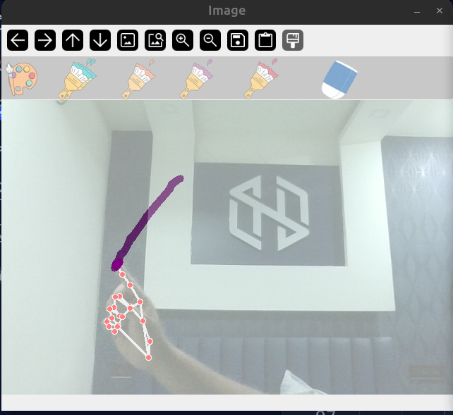 Figure 7.1: Hand detection

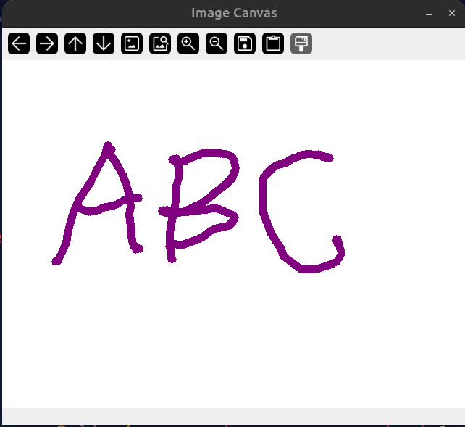 Figure 7.2: Airsketch canvas

VIII. CONCLUSION

This project presents AirSketch, a web-based gesture-driven virtual drawing application that leverages MediaPipe hand tracking and TensorFlow.js to enable touchless interaction through a standard webcam. The literature survey demonstrates that while deep learning and multimodal approaches improve gesture recognition accuracy, they often increase computational complexity and reduce real-time performance. Simpler methods based on MediaPipe provide faster responses while maintaining practical accuracy.

AirSketch adopts an efficient hand tracking and gesture detection approach that focuses on real-time interaction and ease of use rather than heavy computation. The system effectively handles practical challenges such as lighting variations and smooth stroke rendering. The implementation demonstrates that a lightweight and optimized approach can deliver a responsive and user-friendly gesture-based drawing system without specialized hardware.

Beyond its technical contributions, AirSketch has significant implications for accessibility, enabling individuals with physical disabilities to interact with digital drawing tools using only natural hand gestures. Future enhancements may include multi-hand support, gesture-controlled undo/redo functionality, stroke smoothing algorithms, and integration with cloud-based storage for saving and sharing drawings.

IX. REFERENCES

[1] H. Chang, P. Ren, B. Zhang, D. Li, T. Han, H. Zhang, L. Xie, H. Chen, and E. Yin, "OMG-Bench: A New Challenging Benchmark for Skeleton-based Online Micro Hand Gesture Recognition," Cornell University / arXiv, 2026.

[2] J. Moreira, "Dynamic LIBRAS Gesture Recognition via CNN over Spatiotemporal Matrix Representation," 2026.

[3] R. Vasavi, N. Rahul, A. Snigdha, K. J. Moses, and S. V. Simha, "Painting with Hand Gestures using MediaPipe," International Journal of Innovative Science and Research Technology (IJISRT), 2022.

[4] A. Swathi, "Air Canvas Hand Tracking," Journal of Emerging Technologies and Innovative Research (JETIR), 2024.

[5] H. Mahmud, M. M. Morshed, and Md. et al., "A Deep Learning-based Multimodal Depth-Aware Dynamic Hand Gesture Recognition System," ResearchGate, 2022.

[6] A. Sharma, A. Mittal, S. Singh, and V. Awatramani, "Hand Gesture Recognition using Image Processing and Feature Extraction Techniques," ResearchGate, 2020.

[7] J. Qi, L. Ma, Z. Cui, and Y. Yu, "Computer Vision-based Hand Gesture Recognition for Human-Robot Interaction: A Review," SpringerNature, 2023.

[8] A. Morajkar, A. M. James, M. Bagwe, and A. S. James, "Hand Gesture and Voice-controlled Mouse for Physically Challenged using Computer Vision," ResearchGate, 2022.

[9] N. Anithadevi, S. Palanisamy, S. S. Rubini, and S. Shrestha, "MediaPipe-LSTM-Enhanced Framework for Real-Time Dynamic Sign Language Recognition in Inclusive Communication Systems," WILEY, 2024.

[10] L. Quan, Q. Guo, X. Xie, S. Chen, X. Li, and Y. Liu, "Towards Understanding the Faults of JavaScript-Based Deep Learning Systems," Cornell University / arXiv, 2023.

