Logo& Heading

CLIPS

TEXT (ON MENTAL, PHYSICAL AND NUTRITION ONLY)

IMAGES

TEXT (ON MENTAL, PHYSICAL AND NUTRITION ONLY)

QUOTE IMAGES

FOOTER

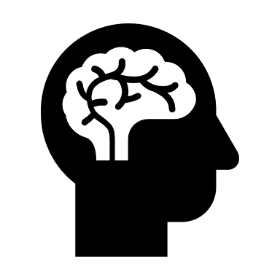LINKS