# **Milestone 3**

# Created on September 01 2020

# **Table of Contents**

1.0. Home Page

2.0. Add Anime

3.0. Edit Anime

# **1.0. Home Page**

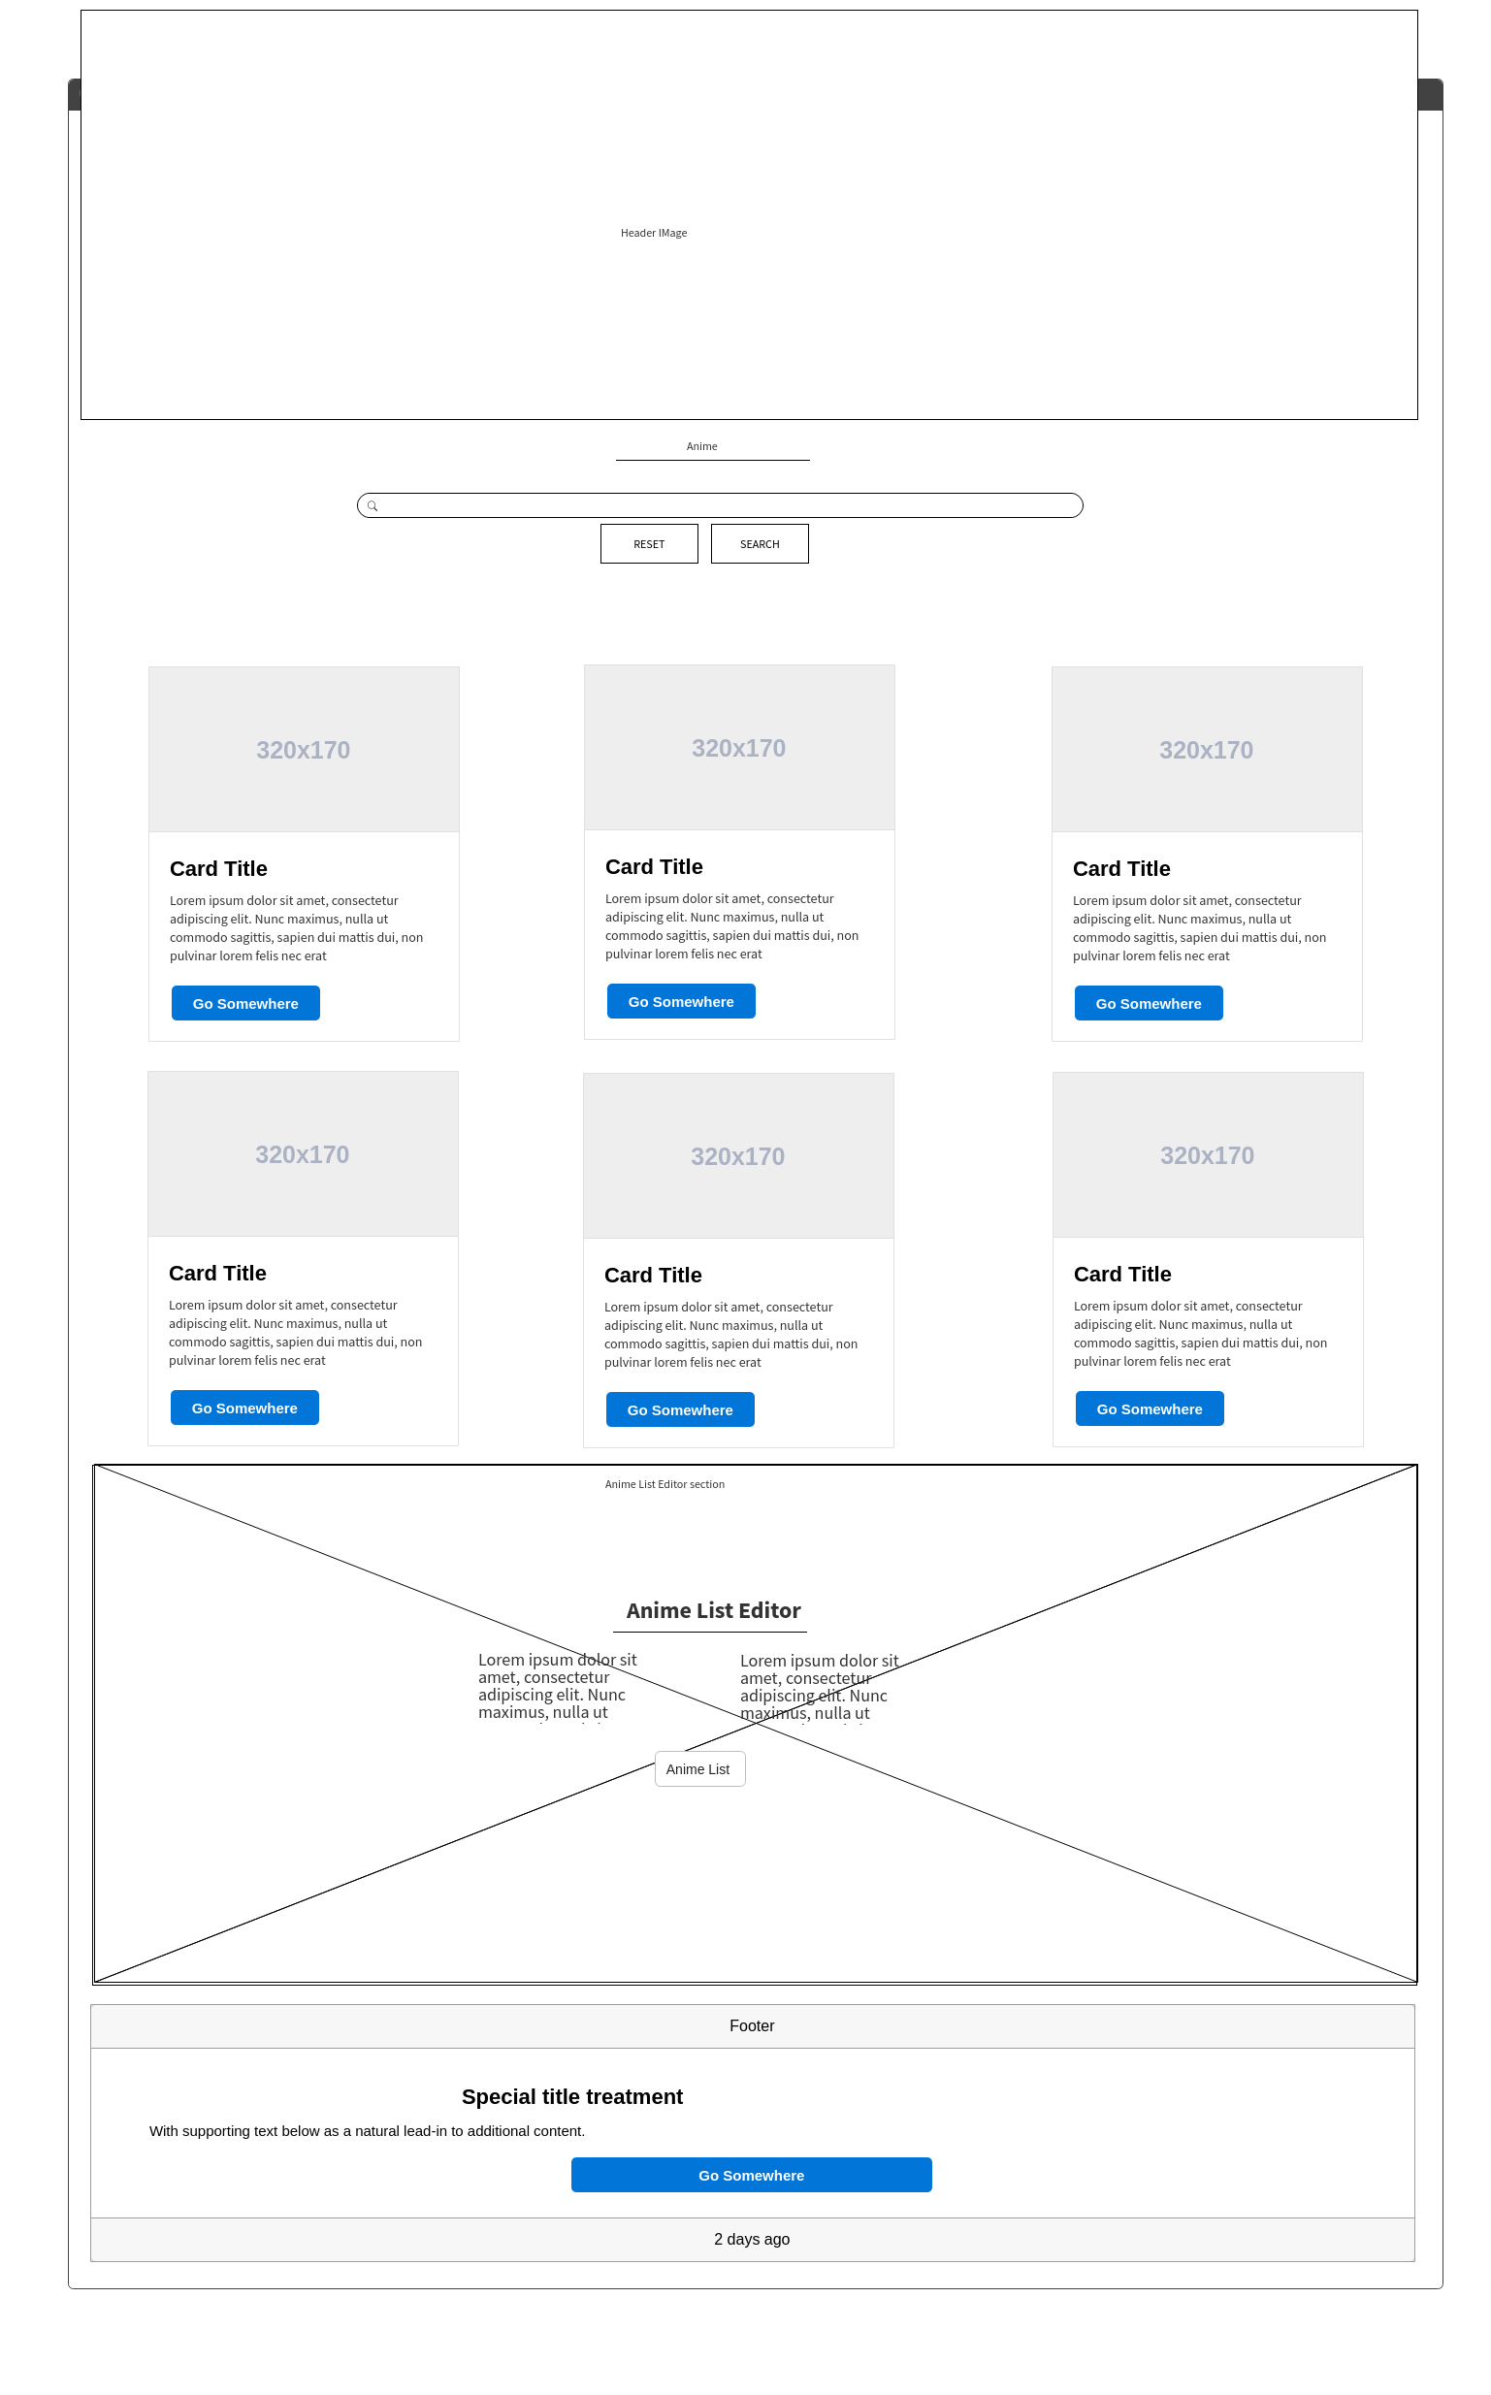

# **2.0. Add Anime**

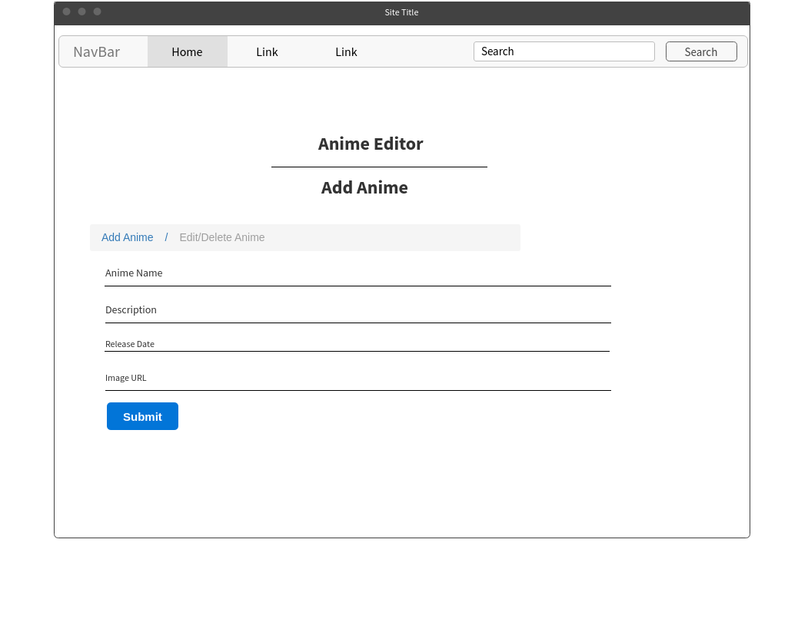

# **3.0. Edit Anime**

