**Dog Massage Pluto**

The website for dog-lovers, who want the best for their dog. Who doesn’t want a stressless and painless dog?   
Read about the sorts of dog massages available and it’s benefits, my story and other customers stories.

Link to the website: <https://kimkesdev.github.io/DogMassagePluto/>  
Link to my github: …!!!

**UX**

This website is designed for dog-owners who want to improve their dog’s health.  
 **User story**

1. Owner of an old dog which is walking difficult because of stiff muscles in his legs. After a few sessions the dog is walking more flexible again.
2. Owner of a stressed dog when seeing other dogs. Keeping another relaxed dog in the room and the stressed dog will slowly start to relax during a relaxation massage.
3. Sportive person with a sportive dog. Helping the muscles with a faster recovery during sport massage.

**Strategy**

The goal for this website is to show dog-owners how they can improve their dog’s health through dog massage and with which type of massage their dog can benefit.

**Scope**

Massage types, all benefits, about me, consult, contact and social media links.

**Structure**

Header with title and a menu.  
Types of massage with its benefits and a list with all benefits.  
An ‘about me’ section with a little bit about my working life.  
A section with information about a consult.  
A ‘review’ section with some reviews of happy dog-owners who’s dog had a massage session.  
A section with all the contact details and a contact form.  
The footer will provide my social media links and a home button.

**Skeleton**

Header: light grey background. Left the title, right the menu.  
Massage types: soft yellow background, each section with an image next to the text, text starting left on the first section, each type op massage has the opposite text-image combination.   
Title all benefits: light grey background, floot in the center.  
Text all benefits: soft yellow background, three rows with benefits.  
Title about me: light grey background, floot in the center.  
Text about me: soft yellow background, text left, image right.  
Title consult: light grey background, floot in the center.  
Text consult: soft yellow background, text right, image left, opposite of the above.  
Title reviews: light grey background, floot in the center.  
Text reviews: soft yellow background, three rows with reviews.  
Title contact: light grey background, floot in the center.  
Text contact: soft yellow background, three rows with information. Right section: contact information, center section: contact form, right section: image.  
All title font: same font family, all text font: same font family. Font and text color: dark grey.

**Surface**

Titles font family: Righteous.  
Text font family: Helvetica.  
Header, titles and footer section color = #E8E8E8 (light grey).  
Section color = Ef9EEE2 (light yellow).  
Text color = E666666 (dark grey).  
  
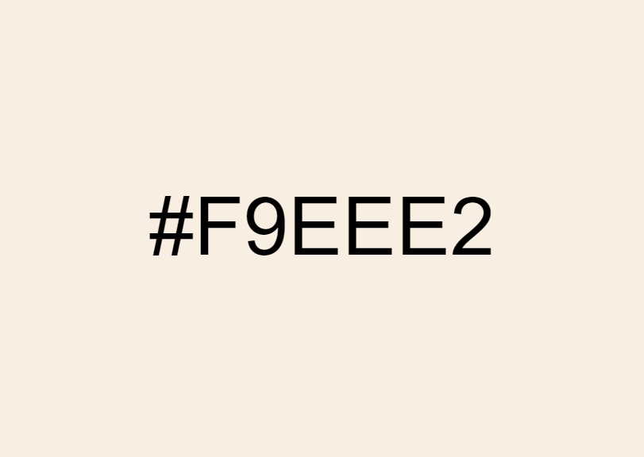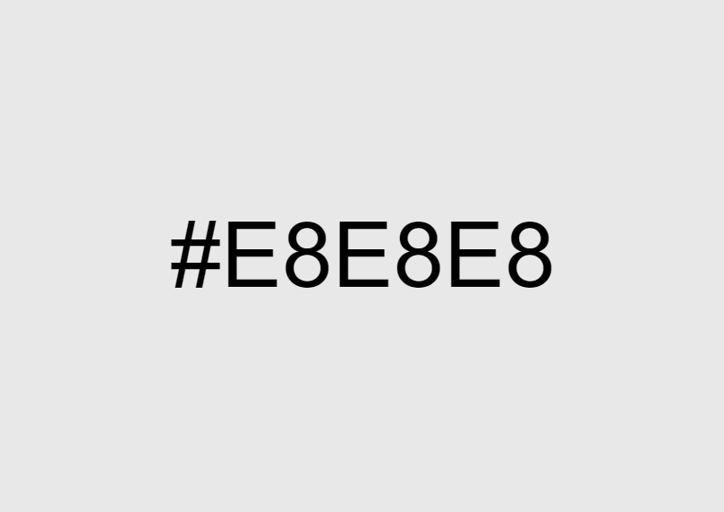

Wireframes !!!!!!

**Features**

I wanted to create a simple and friendly website, with all the information on one page.   
  
The header is very ordered, easy to read and easy to understand. The menu will lead you to the right part of the website.  
  
The first three sections are informative about the sorts of massage which are giving. They are place in one big section, because they belong together.   
  
After this section there will be every time first a title followed by the information.

In small size the navbar is collapsible and there are less images for less scrolling and more peace.

**Technologies**

**Languages**

* HTML
* CSS

**Frameworks / Tools / Libraries**

* Balsamiq, <https://balsamiq.com/> for the mockups.
* Bootstrap, <https://getbootstrap.com/> for the collapsible navbar en the footer icons.
* Google Fonts, <https://fonts.google.com/> for the font type Righteous.

**Testing**

* HTML Validator, <https://validator.w3.org/> for testing the HTML code.
* CSS Validator, <https://jigsaw.w3.org/css-validator/> for testing the CSS code.
* Autoprefixer
* Google Chrome Developer Tools

**Testing**

This website is a scrollable website with all the information on one page.  
  
The header is responsive to large and small devices. On large devices the title and full menu will be shown, while on small devices the title and a collapsible menu will be shown.  
The menu links will are internal links and will lead to the right part on the website.

The contact form has required attributes which are needed before submitting the form.

In the footer will be found the social media links, which are external links.  
The home button, will lead to the top of the website.

On small devices some pictures are gone for a more friendly to use website. There will also appear a collapsible menu with the internal links. Each row will be shown vertical instead of horizontal, form better readability.

Tested multiple browser’s (chrome, safari, internet explorer, firefox) & mobile devices (….)

**Deployment**

I started working on this project in Repl.it because I worked on it from different devices. Every time I was on my own laptop I copied everything to GitPod and pushed it to GitHub. Like this I also always had a backup, when needed.

This website starts with the: index.html, followed by the map ‘assets’, with a map of ‘images’ and a map of ‘css’. In the ’css’ map you will find the page: style.css.

**Credits**

**Content**

* The full content is made up and written by me.

**Media**

* The photos used in this website were obtained from <https://www.istockphoto.com/nl>.

**Acknowledgements**

* I used a lot of general knowledge form <https://www.w3schools.com>.