**User Stories**

*First-time visitor goals,*

***As a first-time visitor, I want some introduction to help me understand the purpose of the***

***project.***

1. Landing page has a hero-image with a small introduction to the project below the hero image.  
   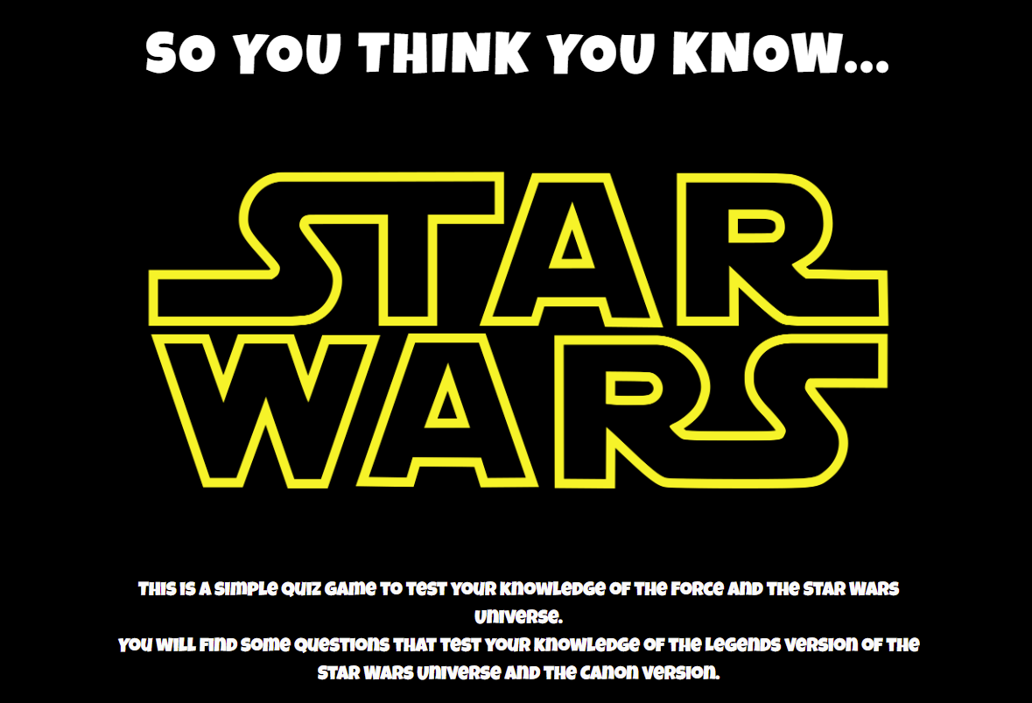

***As a first-time visitor, I want to be able to navigate to the relevant section I am looking for***

***without having to scroll.***

1. Landing page has a Navbar, that links back to the Home page, and sections of the Home page. The final link allows the user to jump straight into the quiz.



***As a first-time visitor, I want to be able to see some instructions on how to play, before starting the game.***

1. Instructions section of the Home page provides instructions on how to play the quiz.

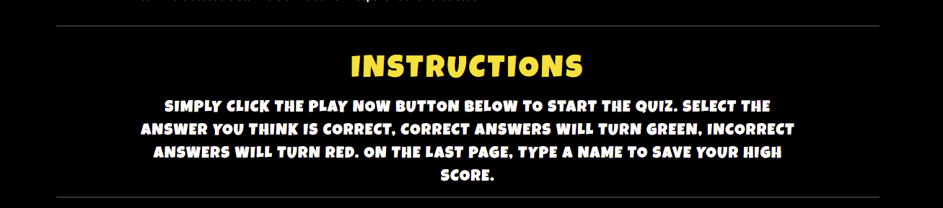

***As a first-time visitor, I would like to see some familiarity with the movies, with either sounds***

***or images.***

1. Hero-image has the original Star-Wars logo, sounds will be implemented in the future.

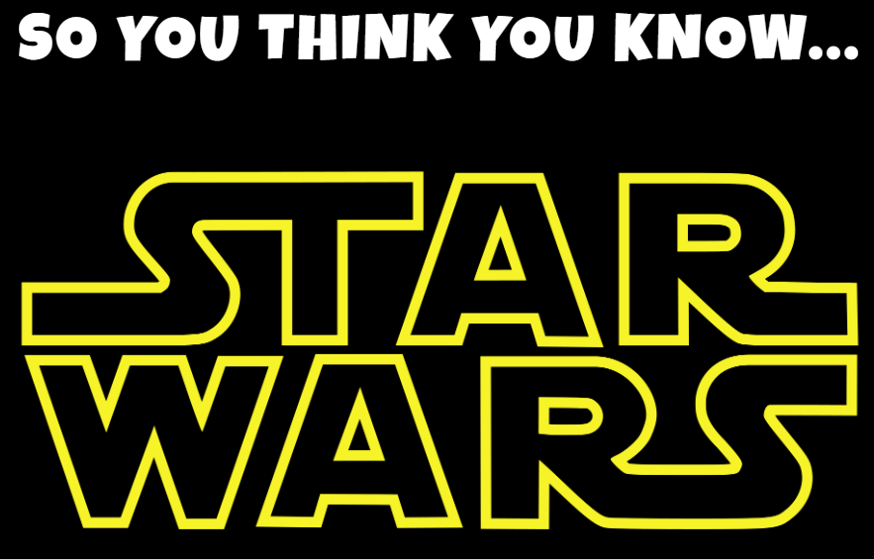

***As a first-time visitor, I would like to select an answer and know if I selected the correct or***

***incorrect answer with a visual response.***

1. Selected answers have CSS classes applied to answer containers, Correct answers are Green, Incorrect are Red. 