**Heroku Deployment**

**Heroku set-up and installation**

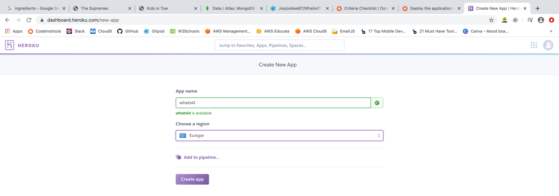

Created a new app in Heroku called whats4t

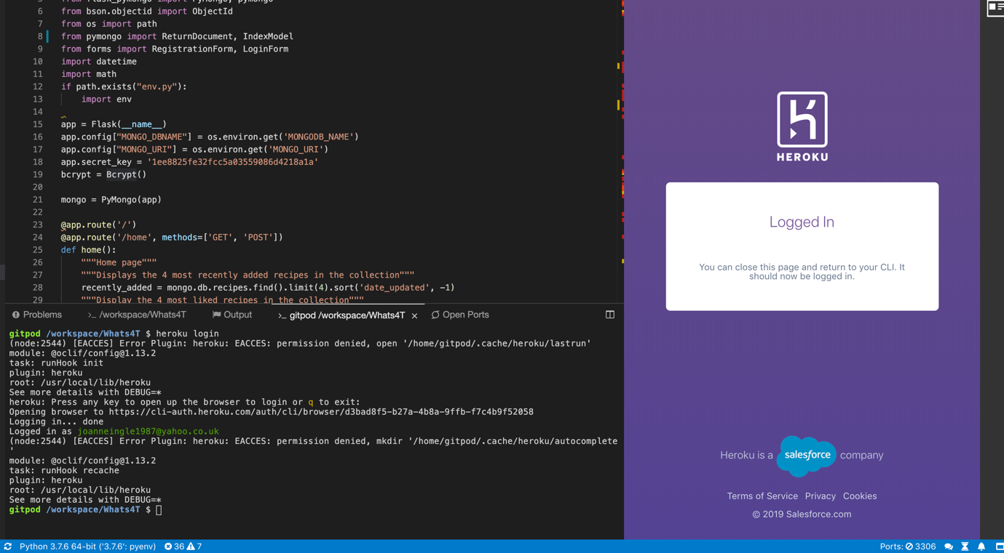

Enter Heroku login command on CLI and logged into Heroku account

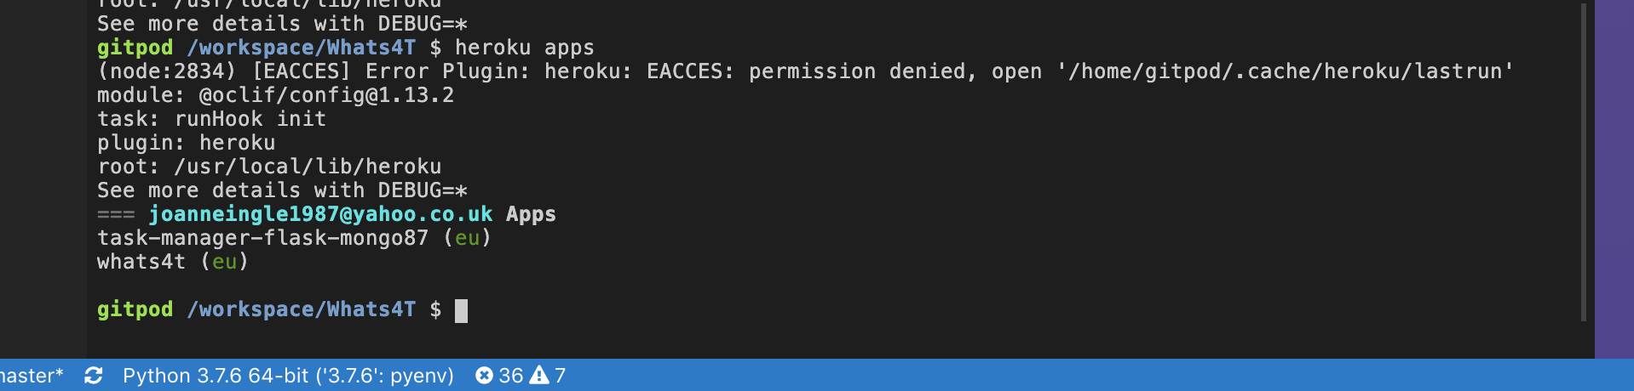

Entered Heroku apps command to check visibility of new whats4t app

Regular commits of Whats4T? files have already been made to the Whats4T GitHub repository

Associate the Heroku application as our master branch

* heroku git:remote -a whats4t

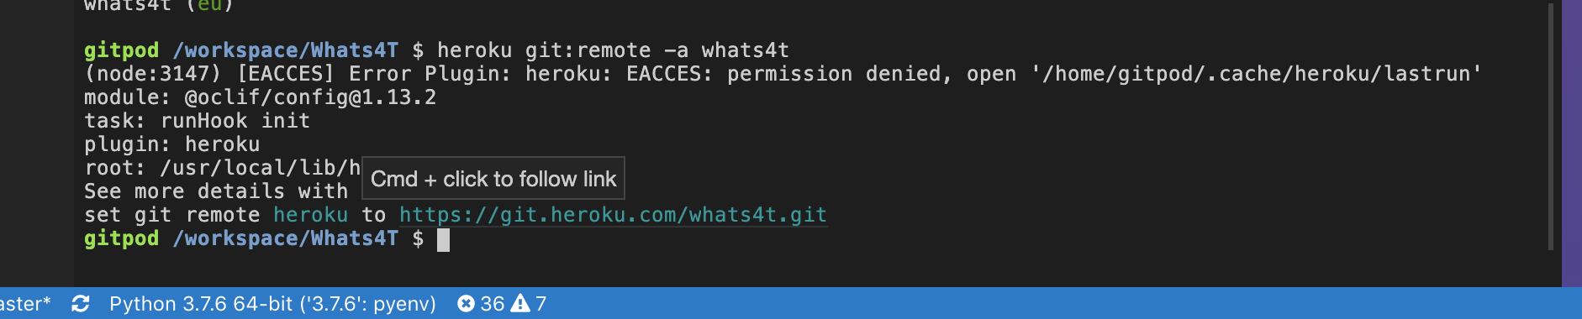

* heroku git:remote -a Whats4T

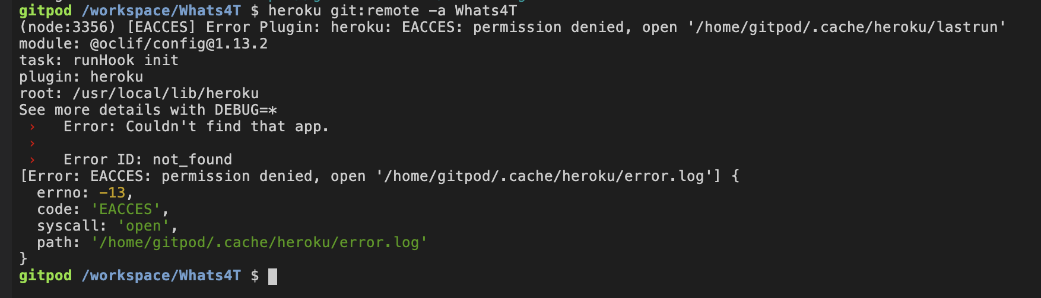

Downloaded and installed the Heroku Command Line Interface (CLI) to make it easy to create and manage Heroku apps directly from the terminal.

Install Heroku for MacOS and performed standard installation

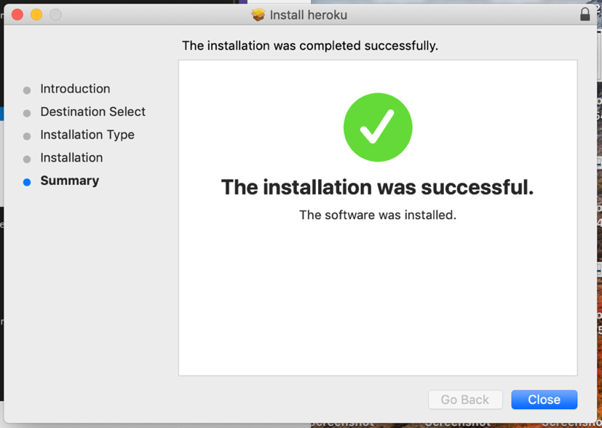

* Git push heroku master

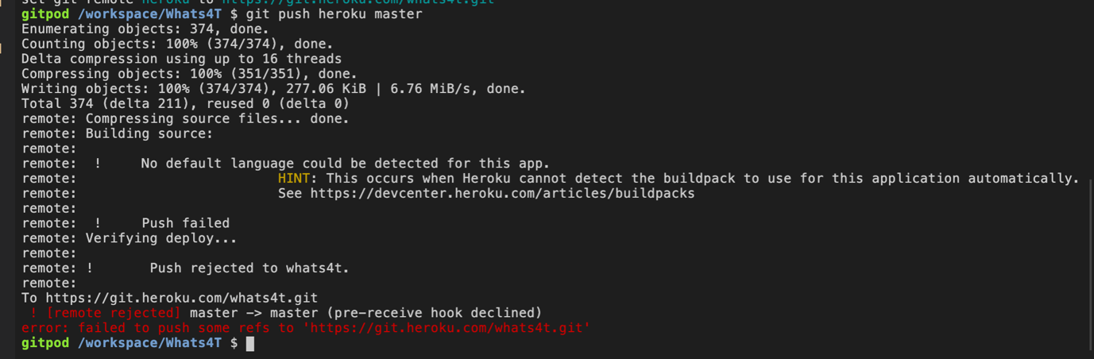

It has failed because the requirements aren’t in place

* pip3 freeze –local > requirements.txt

Add the requirements.txt to GitHub repository

* git add requirements.txt
* git commit -m “added requirements.txt”

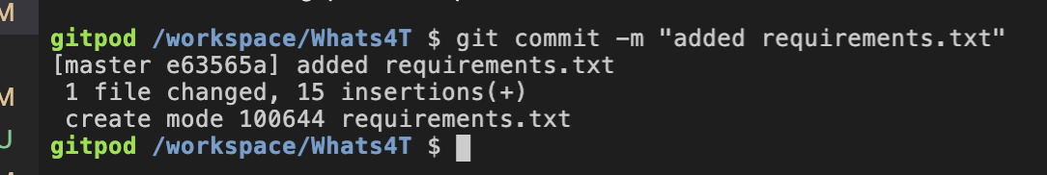

* git push heroku master

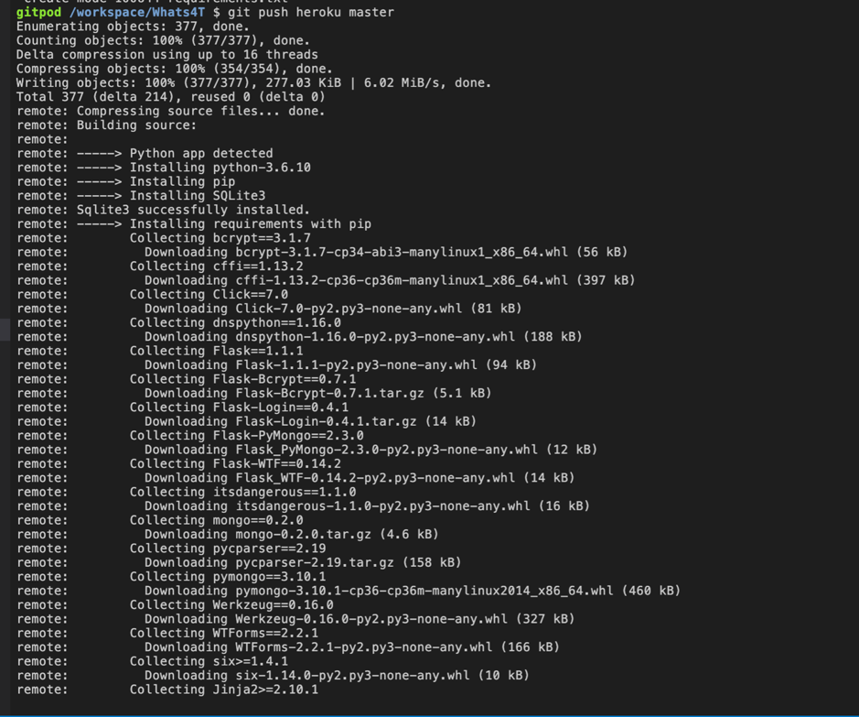

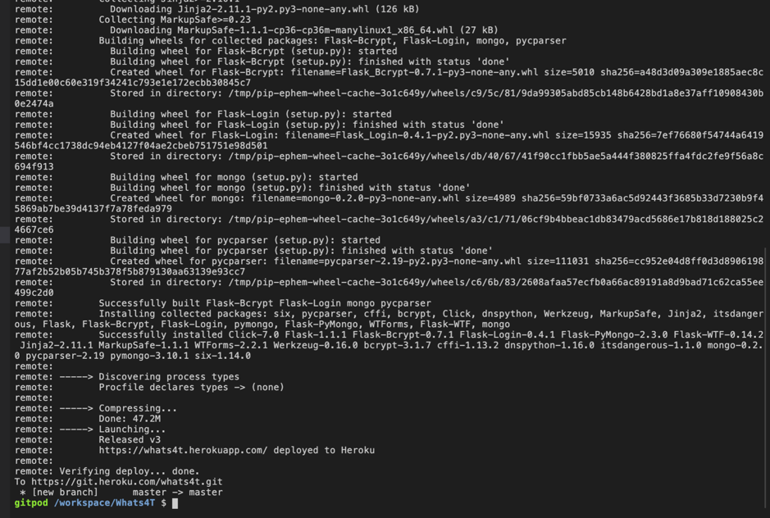

Missing Procfile – an instruction to Heroku as to which file to use as the entry point to the application

Send instruction to Procfile:

* echo web: python app.py > Procfile



Add and commit Procfile to GitHub repository

* git add Procfile
* git commit -m “added Procfile”

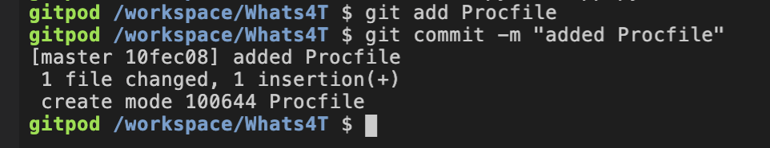

Push to Heroku

* git push heroku master

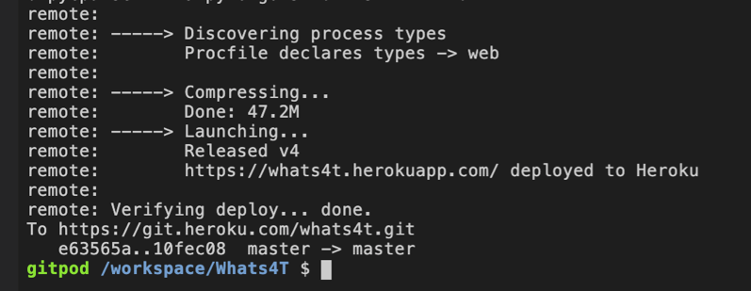

Command to run heroku application

* heroku ps:scale web=1

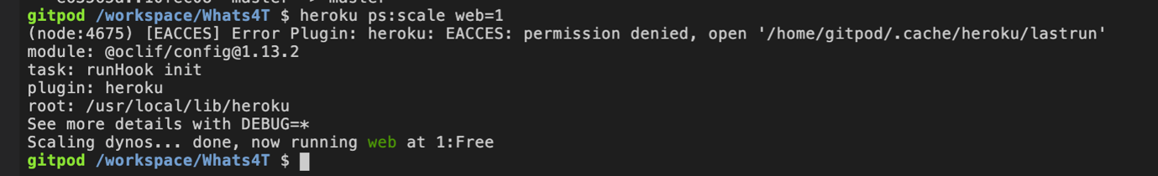

**### Config Variables**

Add config variables to Heroku under Settings

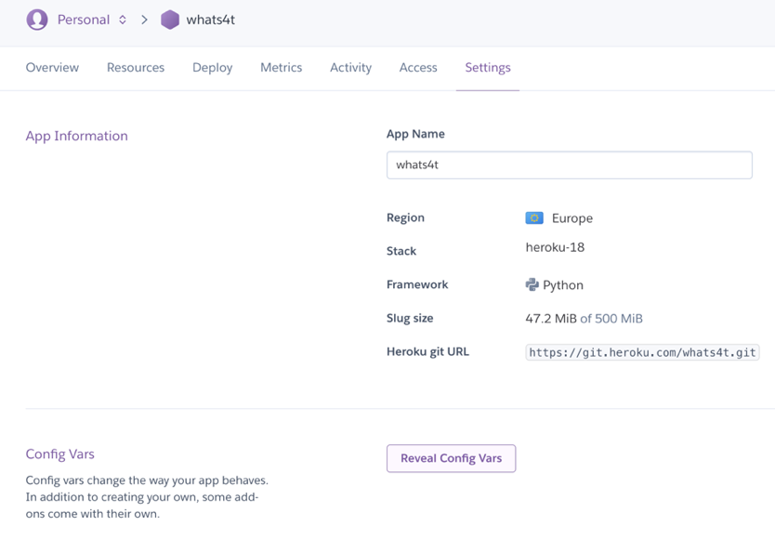

Added IP and PORT to config variables

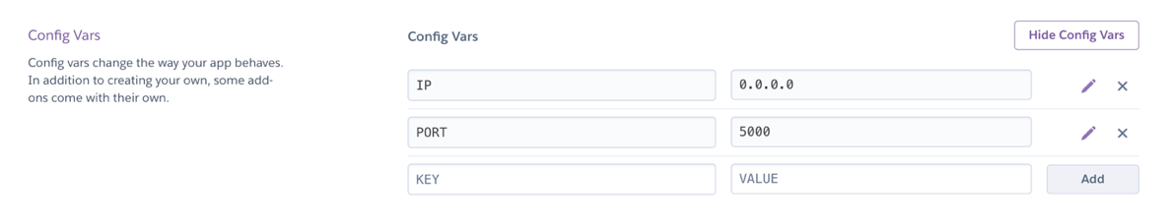

Error with running application as MONGO_URI was not added (in env.py file which is ignored by git)

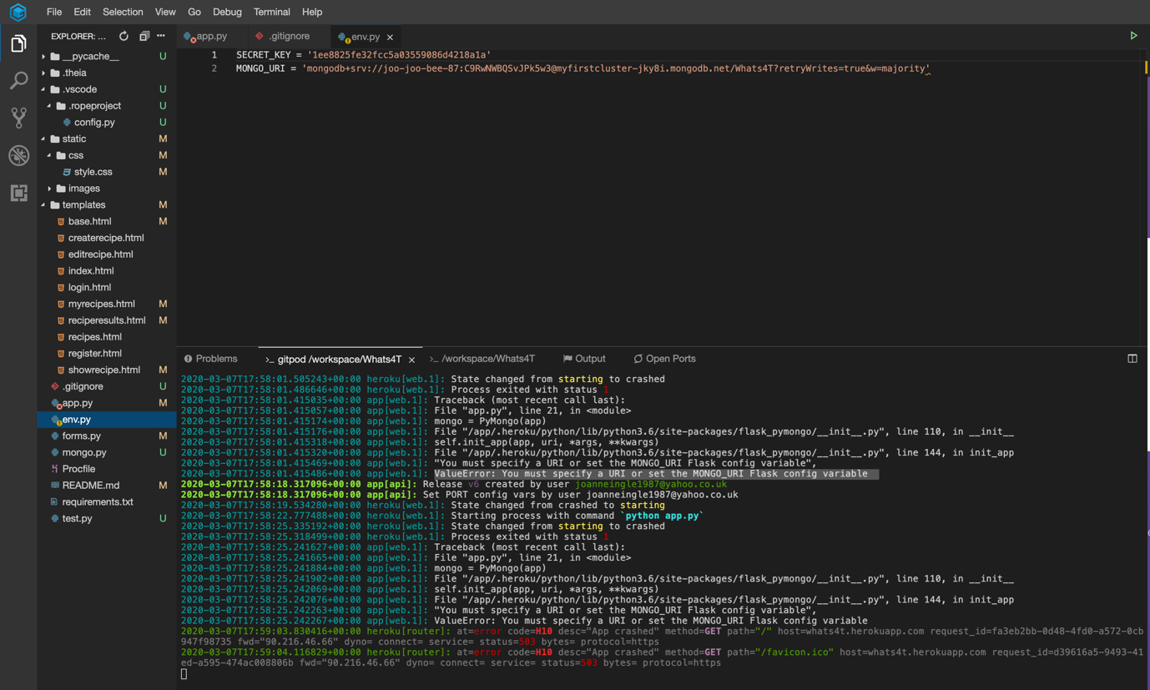

Added new MONGO_URI config variable to Heroku which resolved the error

MONGO_URI and SECRET_KEY config variables added to Heroku

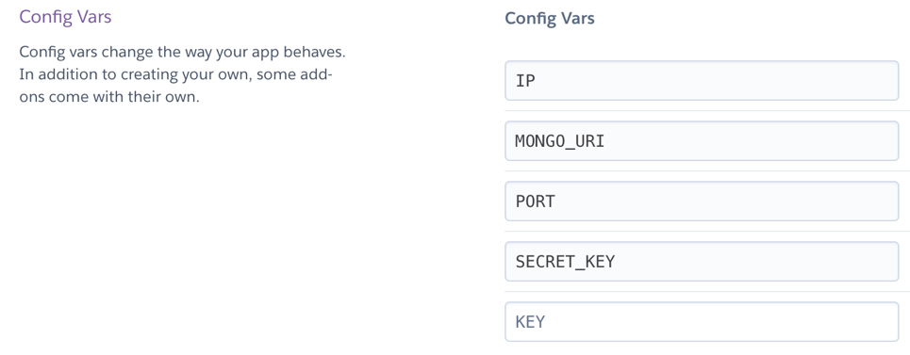

Heroku has been configured to allow automatic deployment of code to Heroku when pushed to GitHub master branch

