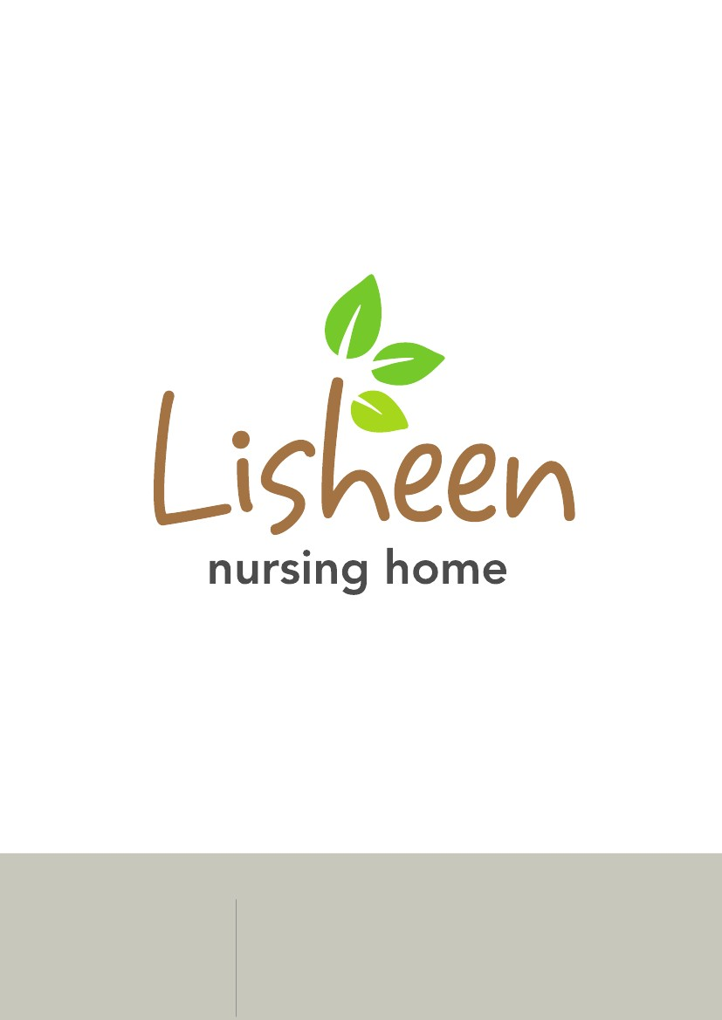
Residents Guide

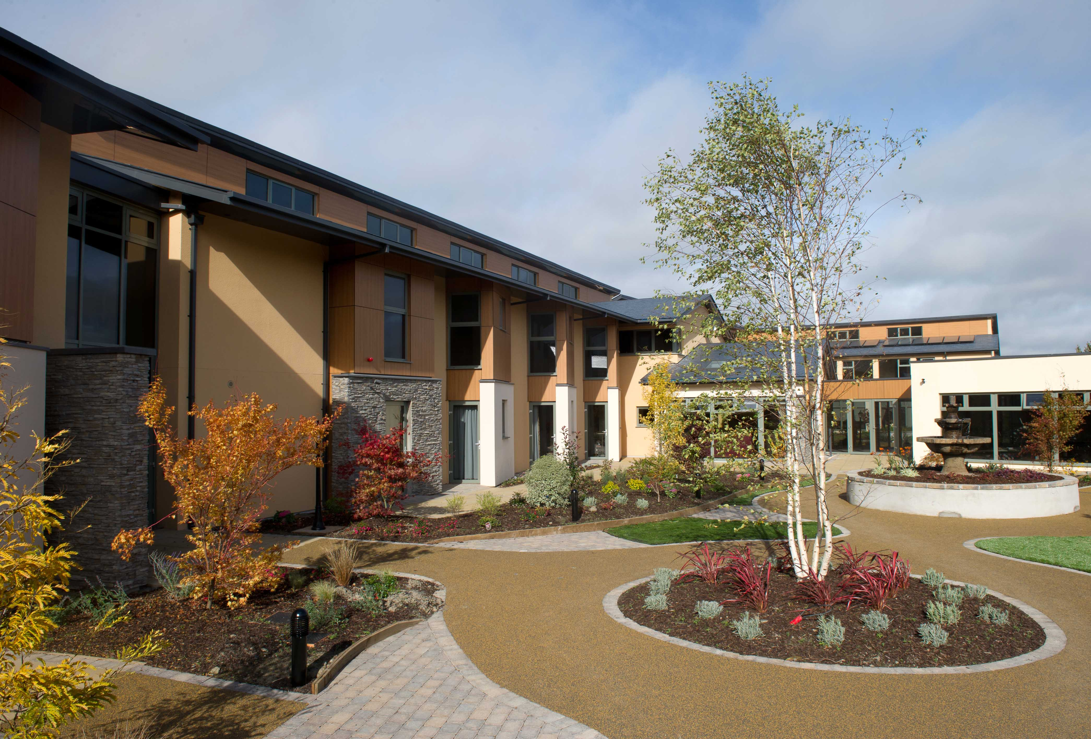
We wish to extend a warm welcome to you, your family and friends to Lisheen Nursing Home where each resident will be viewed as a unique individual, will be respected and cared for by all our staff.

Lisheen Nursing Home is a purpose-built privately-owned nursing home run by Kevin and Geraldine Joy. Lisheen has been operated by us since October 1988. Their daughter, Valerie Joy is the Person in Charge of Care and holds an MSc in Nursing. Lisheen is a two-storey building, built on a landscaped site with views of the countryside. We are located in Rathcoole Village just off the N7 in South County Dublin. Rathcoole is approximately 10 miles from Dublin City Centre, close to shops, community centre, churches and Avoca Handweavers.

Our ethos is to put the interests of the resident at the heart of our decision making and aim to provide high quality person centred nursing care to all residents of our nursing home. We will endeavour to always comply with the Health Act 2007, the Care and Welfare Regulations 2009, The National Quality Standards For Residential Care Settings for Older People in Ireland and all other relevant legislation and standards.

DATE: June 2020
Occupancy/ Resident profile: Lisheen Nursing Home has the capacity to accommodate a maximum of 118 residents. We accommodate both female and male residents of all age groups with the following care needs: General care, Young Chronic Sick, Mental and Physical Illness, Long Term care, Day care, Dementia care, Palliative care, Physical Disabilities and Intellectual Disabilities.
Accommodation:
- 92 Single Rooms
- 13 Shared Rooms, (double)
- Nurse call facilities
- Profiling Beds
- Television and telephone points in each room
- Wheelchair accessible
- Hair & Beauty Salon
- Sitting/Dining Rooms
- Prayer Room
Upon request we may provide respite / convalescent and day care to persons in the above categories, usually for 1-2 week periods or as the needs of the person or family dictates.
The bedroom sizes vary from 9.3-12.5 metres squared for single rooms to 16-20 metres squared in shared rooms. Your bedroom accommodation will be arranged with you/your representative before admission. We reserve the right to move someone from their bedroom if there is an identified risk of the resident remaining in their own room. The reason for moving will be discussed with the resident/representative.
Our sitting / living areas range in size from 17 to 55 meters squared and our dining areas range from 44.4 to 55 meters squared.

We have sitting rooms for quieter moments, reading newspapers or meeting with friends or family and a small prayer room for private contemplation. Residents or their visitors can sit or stroll in our landscaped gardens or sit inside and enjoy our landscaped internal courtyards.
Services Available:
Service | Frequency | Accessibility
Hairdresser | Monday - Friday | See price list.
Beautician | As required, by appointment. | See price list.
Laundry Service | As required. | See price list.
Chiropody | Every 3 months. As required. | Public Per HSE or Private, see price list.
Optical Care | Public: bi-annual visit or Private as required. | Public Per HSE or Private, price on request.
Dentist | As required. | Public Per HSE or Private, price on request
(Cost of the above in separate attachment). (Please inform Susan, Office Manager if you do not wish to avail of any of these services).
Activities:
Timetable may be liable to change and notice regarding changes will be posted on the notice boards.
Activity | Frequency | Accessibility
Art | Weekly | No restrictions
Bingo | Tuesday and Friday afternoon | Activities Therapists
Rosary & Prayer Service | Weekly | No restrictions
Movie Days | Weekly | No restrictions
Music & Dance | At Least Weekly | No restrictions
Reminiscence | Weekly | Activities Therapist
Gentle Exercise to Music | Daily | Activities Therapist
Nature/Garden Walks | As requested. Weather permitting | No restrictions
Drama | Monthly | No restrictions
Hand Massage | Daily | No restrictions
Refleurage | Weekly | Activities Therapist
Quizzes | Daily | Activities Therapist
Gardening | Daily. Weather permitting | Activities Therapist
Pet Therapy | Daily - Resident Dog called “Lady”  Daily - Resident Dog called “Sonny”  Daily - Resident Cat called “Banjo”  Daily - Resident Budgies called “Joey & Polly”  Daily - Resident Canary called “Perry”  Daily - Resident Fish called “Wonda”  Daily- Visiting Therapy called “Milly”  Weekly | No restrictions  No restrictions  No restrictions  No restrictions  Hairdresser  Irish Dog Therapy

We offer a wide range of activities and the programme is dependent on resident interests and personal choice. We ask residents to complete a questionnaire to ascertain preferences. Our activities aim to create a stimulating environment whilst supporting life skills and enhancing feelings of self worth and purpose.

We provide a room for families to celebrate a special event, such as a birthday or anniversary, catering facilities maybe provided for these special events. Arrangements need to be made with catering regarding time/costs etc.

Each month a drama group / live music visit the Nursing Home where they produce an interactive play / dance / sing along relative to our residents and their past experiences.
We focus on in house events throughout the year in an effort to create a fulfilling and stimulating environment for our residents to live in.

Local Community/External Facilities:
Lisheen is serviced by nearby shops, restaurants/public houses/mobile library/community halls/Avoca Handweavers, Rathcoole Park, and Liffey Valley Shopping Centre among others.
Families are encouraged to arrange occasional external activities with their loved ones but to ensure they are safe at all times and responsible for their care while not in the nursing home. Please advise staff in advance of your planned outings. Dublin Bus and Bus Eireann provide public transport to Rathcoole from City Centre and provisionally. Bus timetables are available at reception.

Resident’s religious and cultural beliefs and values are respected and accommodated. Roman Catholic Mass is celebrated weekly. Pastors of other denominations visit as required.

Admission to the nursing home shall normally be planned. We reserve the right to refuse admission to the nursing home in certain circumstances. Example of such circumstances are if the person poses a risk to the safety and welfare of other residents, our staff or visitors or if the person is unable to pay for the services provided and the HSE refuses to pay for the services provided. Emergency Admission will only take place when absolutely necessary. Emergency admissions will be informed about key aspects of the services as per a normal admission within 48 hours of admission.

Visiting Arrangements: For the privacy of our residents our visiting hours are 11:30 to 21:00. To ensure the safety of our residents we ask that all visitors sign in and out on entering and leaving the building. Lisheen Nursing Home reserves the right to impose restrictions on visiting arrangements where the visit or time of visit is deemed to pose a risk or where the resident requests restrictions.
Visitors abroad or in various parts of the country can phone during daytime hours.

We strive to prevent the spread of infection and we ask visitors not to visit if they are unwell, particularly if they have colds, flu or a stomach bug. Hand sanitizers are provided for both resident and visitors use.

Care Planning: To underpin our philosophy of care, residents when admitted to Lisheen Nursing Home will have an initial nursing risk assessment carried out within the first 24 hrs. The intention is to identify any immediate care needs including the presence of major risks requiring immediate action on admission. Following on from there, a comprehensive assessment will be carried out where information will be gathered within 7 days post admission relating to the residents health, personal and social care needs.
At all stages of this process the views of the resident will be sought. Where the resident is unable to contribute fully, the views and observations of a family member or representative will be sought. This will ensure that each resident has a care plan which addresses their individual needs, wishes and preferences. Care plans will be reviewed 4 monthly or before if the needs of the resident changes in any way.

Staffing: The organisation chart is displayed in the reception. Lisheen Nursing Home employs 160 staff.
Reporting Structure:
In the absence of Valerie Joy the Co-Director of Nursing, Geraldine Joy is in charge. In Geraldine’s absence the Clinical Nurse Manager is in charge.
Clinical Nurse Managers and the Clinical Nurse Educator report to the Director of Nursing or the Co-Director of Nursing.
Staff Nurses report to Clinical Nurse Managers and the Director(s) of Nursing.
Care Assistants report to Staff Nurses and Clinical Nurse Managers
Cook/Chef reports to Director(s) of Nursing.
Kitchen Assistants report to the Cook/Chef.
Administration staff report to the Director(s) of Nursing and the Office Manager
Housekeeping Supervisor reports to Director(s)of Nursing
Housekeeping/Laundry Staff report to the Housekeeping Supervisor
Activities Therapists report to Nurse Manager or Staff Nurse on Duty
The staff roster identifies who is on call each day/night.

Privacy and Dignity: We would like you to think of Lisheen as your home from home. Our staff will do their utmost to protect your privacy and dignity.
If you feel your privacy and dignity is being compromised, then please inform a member of staff whom you feel comfortable with.

Appointments: Appointments will be facilitated as far as is possible. Family or friends are asked to escort their relative to hospital or other outside appointments at all times. In the event of families being unable to escort their relative appointments may be re scheduled if possible by staff or arrangements can be made for staff to escort the resident using an outside transport service both of which will be at a cost to the resident or their representative.

Excursions/ Outings: Residents who are embarking on an outing with family or friends will be assisted as far as is possible but do so at their own risk. Any resident leaving the building must sign out and indicate time and with whom they are leaving. On returning residents are asked to sign back in and with whom they returned.

Dining At Lisheen Nursing Home: We try to ensure that dining here is a social experience, to be looked forward to and enjoyed by all. All our food is prepared by our well trained cooks who prepare menus which comprises of fresh, seasonal ingredients so that every meal looks and tastes delicious.
We pride ourselves in offering a balanced, nutritious diet using fresh, good quality local ingredients, to meet all our residents’ preferences and any specific dietary requirements they may have.
We provide a choice of homemade dishes and freshly baked goods which residents can choose to take in the dining room or if they prefer, in the comfort of their own room.

Resident Views: Feedback is actively sought from residents on an on-going basis. Residents are invited to join our resident’s forum where issues regarding residents are discussed. The meetings are held at least quarterly, minutes recorded and matters arising are brought to management for their attention.

Smoking Policy: This nursing home promotes a smoke free environment but if a resident wishes to smoke it is facilitated. A risk assessment is carried out on each smoker and a smoking area is provided outside Unit D with a heater. There is a designated smoking area outside for visitors who wish to smoke. The use of electronic cigarettes including rechargeable cigarettes are not permitted on the premises. Please speak to Valerie Joy for any queries in relation to this.

Valuables and Personal Belongings: Staff will take all reasonable precautions to safeguard personal property belonging to residents, however this facility does not take responsibility for loss or damage to any valuables or money that residents keep in their rooms. Valuables and monies may be kept for safe keeping on request in the office. All clothes should be marked with your name on admission. Any clothes purchased later should also be labelled as we cannot be held responsible for the loss of unmarked clothing. Please inform staff when new clothing is taken into the nursing home.

Safety: Your safety is of paramount importance to us. Resident’s safety is monitored on an on-going basis and each resident is assessed in this domain. Where a need is identified a care plan is put in place to eliminate or reduce any risk involved. Any issues arising are discussed at Management Clinical Governance Meetings.

Fire Safety Management: The staff of this Nursing Home have a statutory responsibility to take all reasonable measures to prevent the occurrence of fire and to ensure so far as is reasonably practical the safety of the residents/occupants in the event of fire occurring on the premises. Fire Safety Training and fire drills are part of our ongoing in-house education programme.

The Person in charge will maintain a Fire Safety Register and this will be available for inspection by the statutory authorities in accordance with legislation.

Other Emergencies: If you discover other scenarios/ circumstances which pose a risk to residents/ staff, please inform the nearest staff member immediately.

Closed Circuit Television (CCTV): We have CCTV with video recording in operation in all general areas. This is provided to protect the safety of all staff, residents and visitors.

Contract of Care: Every resident will be issued a contract of care upon admission into the nursing home. We would encourage residents and their representative to take the time to fully understand the terms of the Contract of Care. We would advise that they should seek independent legal and/or financial advice before signing this contract.

Comments/ Compliments and Complaints: Complaints, comments, suggestions and criticisms about services, whether oral or written will be taken seriously and handled in a sensitive , timely and effective manner which protects the rights, dignity and confidentiality of all those involved. Complaints will be dealt with through local resolution as far as is practicable. Complaints procedure is displayed at reception and the Complaints Policy is available to view.
If you have serious concerns about the operation of the Nursing home you may contact HIQA.

HIQA Inspection Reports: Can be viewed on www.hiqa.ie our centre number is 0059. A copy of our most recent inspection is attached if you have any queries with regard to this please contact the Provider or Person in Charge. The contact details for HIQA are: HIQA, Georges Court, Georges Lane, Dublin 7 - Ph: 01 8147400.
Email: concerns@hiqa.ie

Directions to Lisheen:
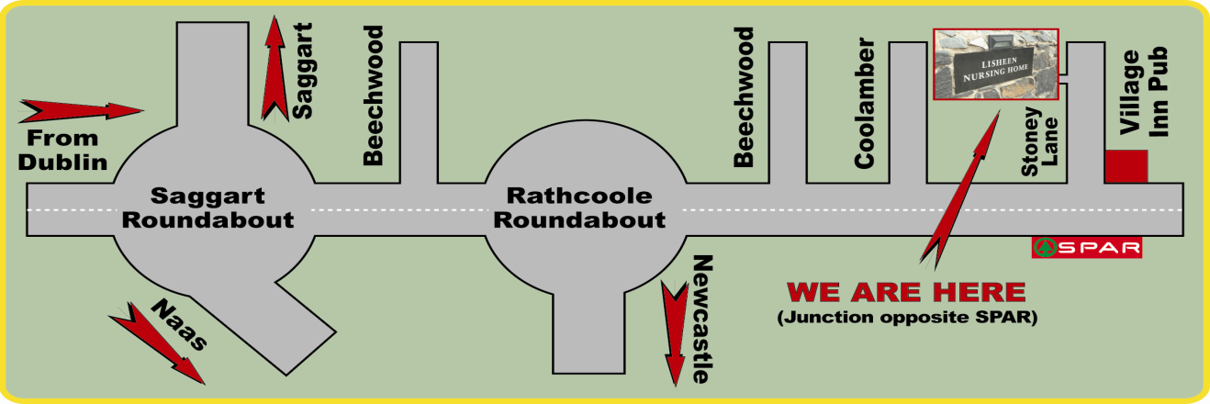
Price List

Nursing Home Services Charge:
We at Lisheen feel that social programmes, specialised mattress / cushions / seating are an essential part of the care we provide, rather than the optional extras which some state bodies consider them. Therefore, there will be a charge of €170 per month towards the cost of providing these services.

The Proprietor and the Resident agree that the Proprietor will provide the following Nursing Home Services to the Resident for the further additional remuneration as the Nursing Home Service Charge specified in Part 2 of Schedule 2 of the Contract for Care:

    - Social Programmes and Entertainment,
    - Shampoo, Conditioner & Soap
    - Phlebotomy services (where required) and transport of samples to a
Laboratory
    - Religious and Spiritual Service
    - Other individualised services / arrangements as agreed with the proprietor,
(for example; specialised mattress / cushions)

Medical Administration Charge
The GMS / Medical Card Contract principally covers the diagnosis and treatment of acute illness and unfortunately does not cover matters related to any non-acute care or HIQA compliance for those living in nursing homes. For this reason, there will be a weekly charge of €8 per resident towards the cost of providing the services outlined below.

The Proprietor and the Resident agree that the Proprietor will facilitate the following Nursing Home Services to the Resident for the further additional remuneration as the Medical Administration Charge specified in Part 4 of Schedule 2 of the Contract for Care:

    - A minimum once weekly domiciliary visit from a General Practitioner,
    - Monthly prescription administration,
    - 3 monthly medication reviews,
    - Multidisciplinary team referrals and consultations with same,
    - Blood and other specimen orders and reviews,
    - Annual domiciliary vaccination administration and
    - An out of hours service.

Price List

Cost for Provision of Private Services in Lisheen Nursing Home:

The Proprietor and the Resident may also agree that the Proprietor shall provide any or all of the following individual services* to the Resident for such further remuneration specified below. An additional charge/fee will apply for any of the above services/goods

- Physiotherapy (Private) €45 per session
- Reflexology €28 per treatment
- Chiropody / Footcare €30 per treatment

- Hairdressing: Cut & Set/Blowdry €20
Set/Blowdry €10
Gents Cut €10
Perm/Bodywave €40
Colour, Set/Blowdry(colour supplied by resident) €25
Colour,Cut & Set/Blowdry(colour supplied by resident) €30
Colour, Set/Blowdry(colour supplied by Lisheen) €50
Colour,Cut & Set/Blowdry(colour supplied by Lisheen) €55

- Specialised Personal Laundry Service: €35 per week

- Dry Cleaning Gents Suit €15
Trousers €7
Jacket €8
Cardigan €6
Shirt €4
Dress €14
Coat €14

- Incontinence Wear not supplied by the HSE : Dependent on usage (average range from €20 - €80 per month)

- Daily Delivery of Individual Newspaper : Dependent on resident choice (average €1.50 per day)

- Escorts to Hospital / Clinic Appointments: €72 minimum charge (dependent on length of time)

- Taxi services and wheelchair taxi – Dependent on distance travelled & time. Approximate prices available on request.

- Any other services that may be agreed between the Parties

The above prices are subject to change. The fees for the above will be billed monthly.

