**Brief**

I propose to build a website to promote my existing and end of course skills to recruitment companies and contractors.

**Strategy Plane**

**Culture Appropriate**

User are expected to be of a tech savvy demographic. They are presumed to have a high UI and UX knowledge and expectation.

There is also an anticipation of a playful nature and therefore a willingness to play with interface rather than to be led by the nose.

This may be considered a contentious statement, but statistically there are more males in the IT industry than there should be for a gender neutral society (ref: 1, 2). Although this is changing as of today it is statistically correct. It is therefore reasonable to assume that more males will visit the site than females. Therefore the site should have a male bias around style.

**Content relevance**

The content will focus on a graphicly strong, tech savy audience that is willing to explore the interface.

**Special Because**

The site will have a high professional graphic style and meet full css and bootstrap standards. It will be a demonstration of unusual set of skills from graphically strong and programmatically strong.

These skills together can’t be fully demonstrated via any other medium, such as print or television. Even with the digital medium, direct demonstration of abilities that cant be demonstrated on the standard job seeking sights, such as linked-in indeed or monster.

It will also allow for direct contact mechanism via CV request form.

**Why would user want this**

Users would want this to find out more about my previous work and skillsets and for employers or recruitment agents to ascertain if my skillset match their organisations recruitment need. The site can be used to contact me directly or to use my ideas as inspiration for their own work.

**What makes a good personal promotional website visit experience?**

Users apricate learning something new of value. This not only adds to their knowledge but also allows them to see the website provider as an expert in the area.

It will allow user see games that have been developed and games in development. It will also let visit sites built using various CMS’s for a variety of purposes.

**What do users expect?**

what is this?

Is this what I expected to see?

Does it look credible and trustworthy?

Does it offer what I want?

Does it look valuable enough for me to stay?

Does it look valuable enough for me to return?

What actions can I take now?

How do I learn more?

How do I contact someone?

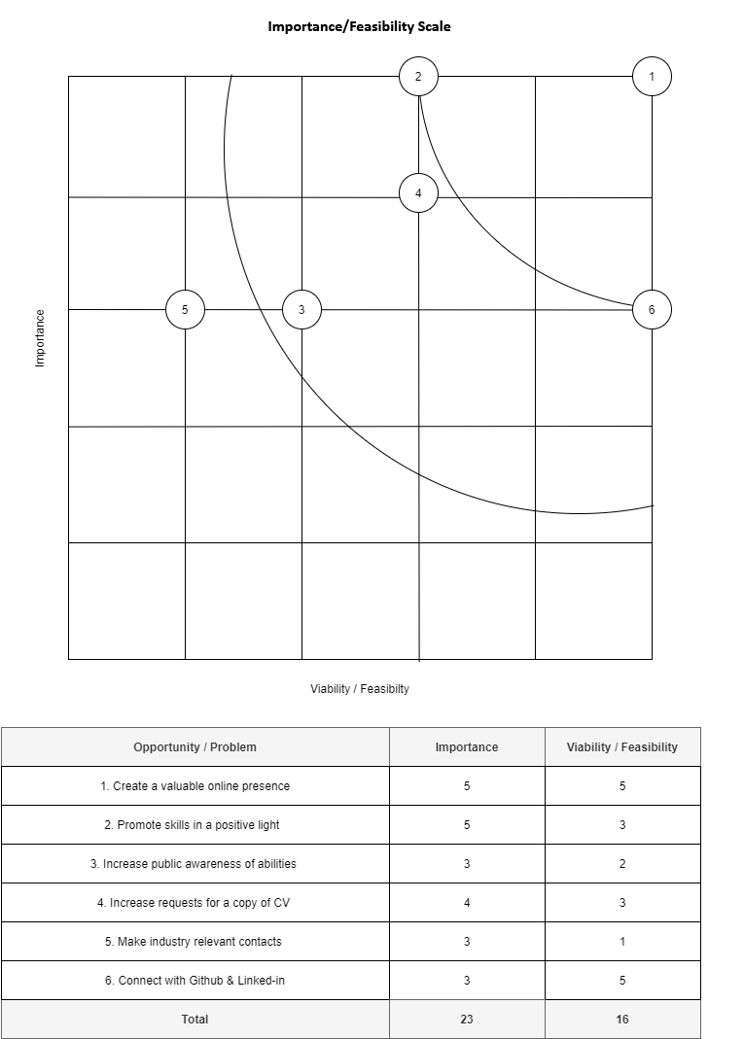

**Importance/Feasibility Scale Conclusion**

Based on the information from the above diagram I will focus on 1, 2, 3, 4 & 6.

- Create a valuable online presence

- Promote skills in a positive light

- Increase public awareness of abilities

- Increase requests for a copy of CV

- Connect with Github & Linked-in