**Structure**

**Information Architecture**

The site will be a simple tree structure of three pages from the home page, a total of four pages. It will use a horizontal navbar near the top of the page, a floating contact and social sidebar and client list in the footer.

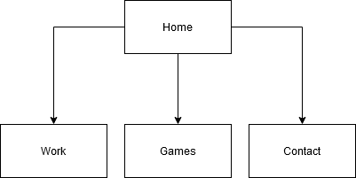

**Interaction Design (IXD)**

* Company logo, when clicked will bring the users back to the home page. Home will always be available on the top left in either mobile, tablet or desktop layouts.
* In all layout scenarios, menu headings will reflect rollover and click interactions
* The banner at the top of each page will let the user know immediately where they are in the structure.
* Page layouts on both the “CMS Examples” and “Games Examples” will change the position of the link to better suit the layout from mobile/tablet to desktop
* Request CV, GitHub and Link-in links will float on the left always:
  + To fulfil the main goal of driving traffic to make contact or further research me
  + To make it as easy as possible to connect with me.
  + Will be unobtrusive
* All large graphics showing samples of my work will scale based on screen size and will be clickable as well as the buttons accompanying them
* The request for a CV:
  + Will pop-up with a simple form that asks for their name and email address.
  + Will confirm that data entered will not be shared as per EU and GDRP legislation
  + Will include a successful submission notification on completion.