**Appendix 1 - Code Testing**

CSS -[https://jigsaw.w3.org/css-validator](https://jigsaw.w3.org/css-validator%20)

HTML - <https://validator.w3.org/nu/#textarea>

**CSS**

Style.css

The first test of the CSS identified 2 errors and 1 warning.

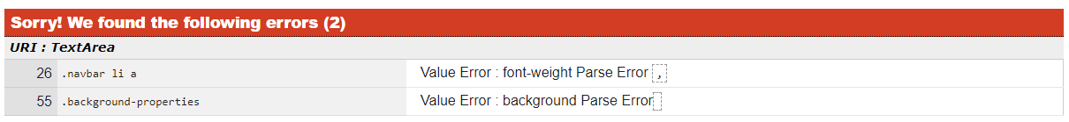



**HTML – First Test**

First testing yielded a number of errors.

Index.html -

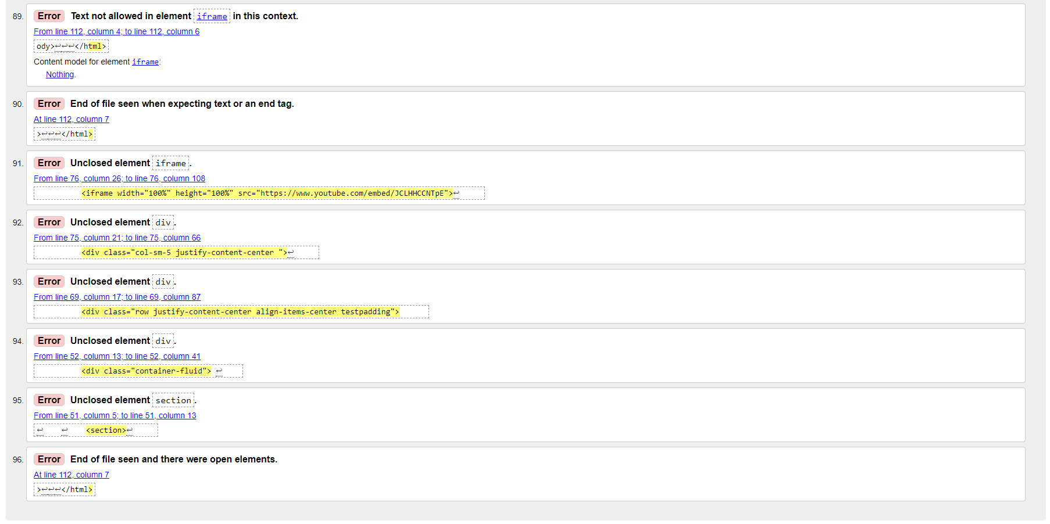

Gigs.html

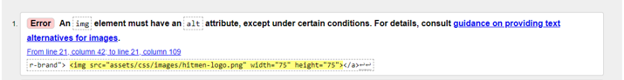

Video.html

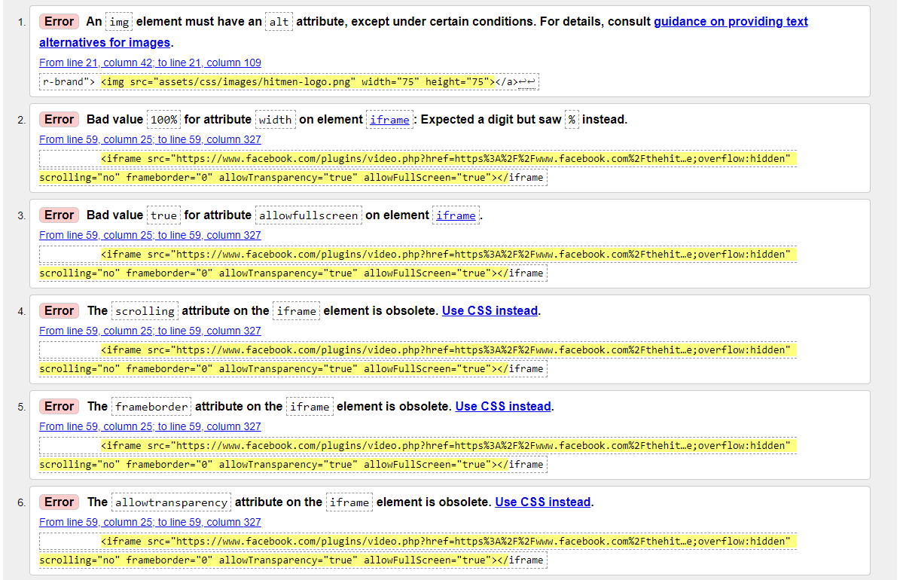

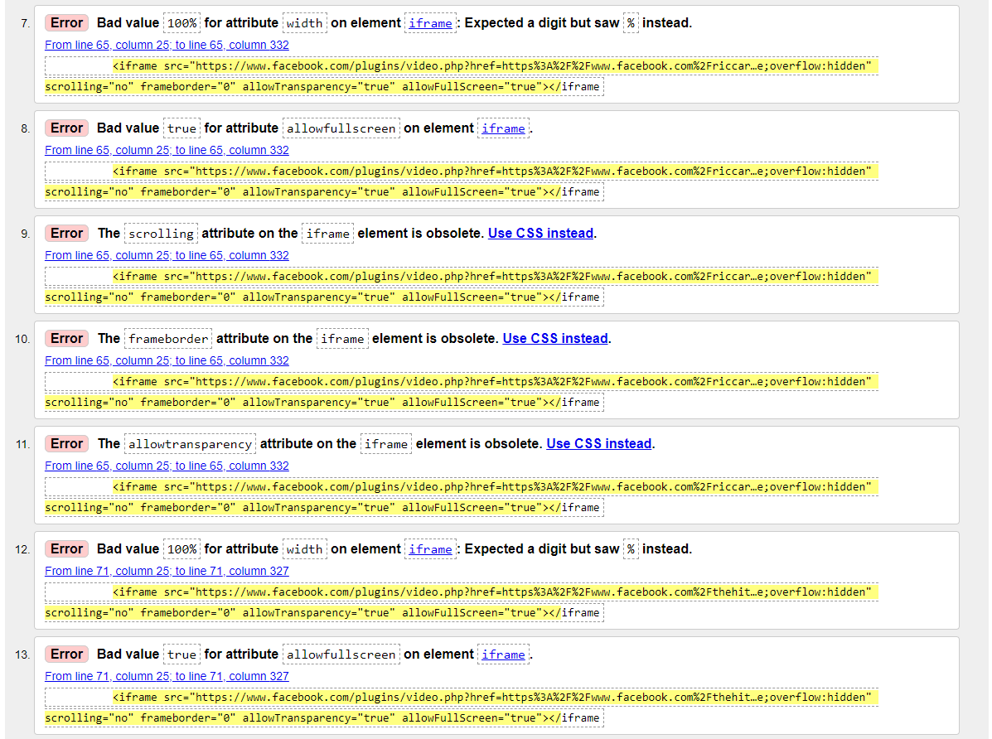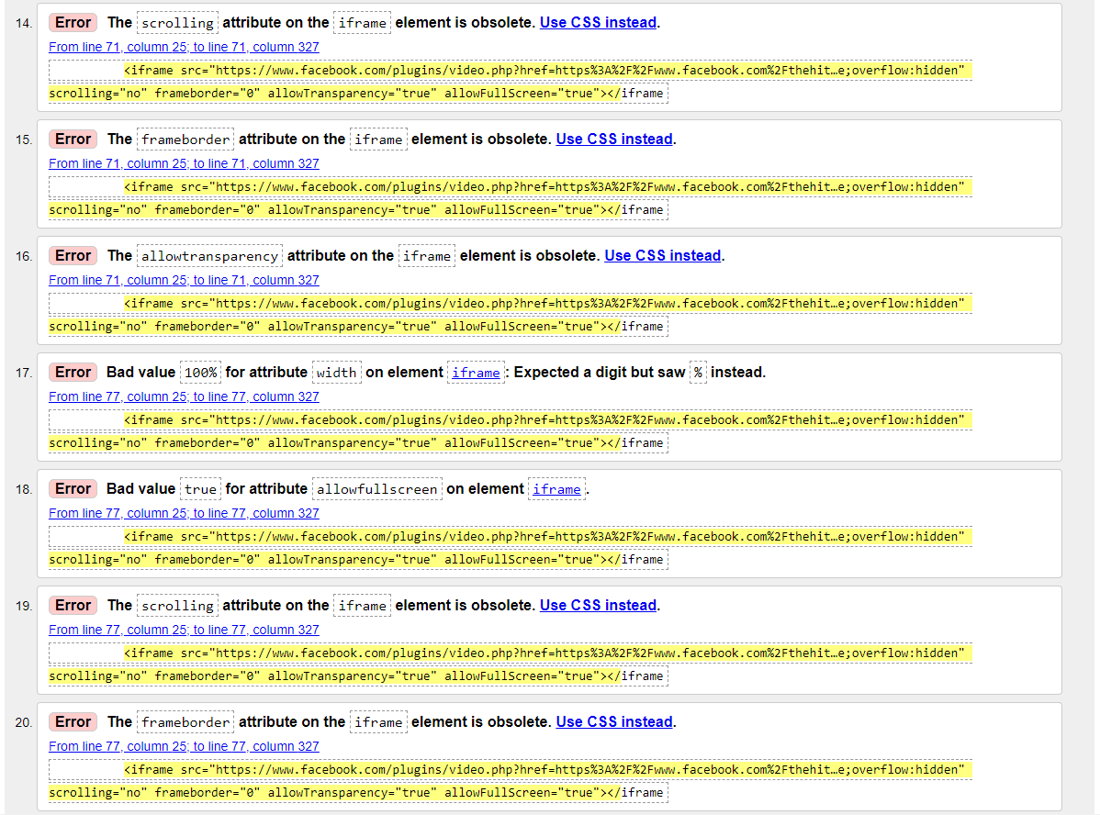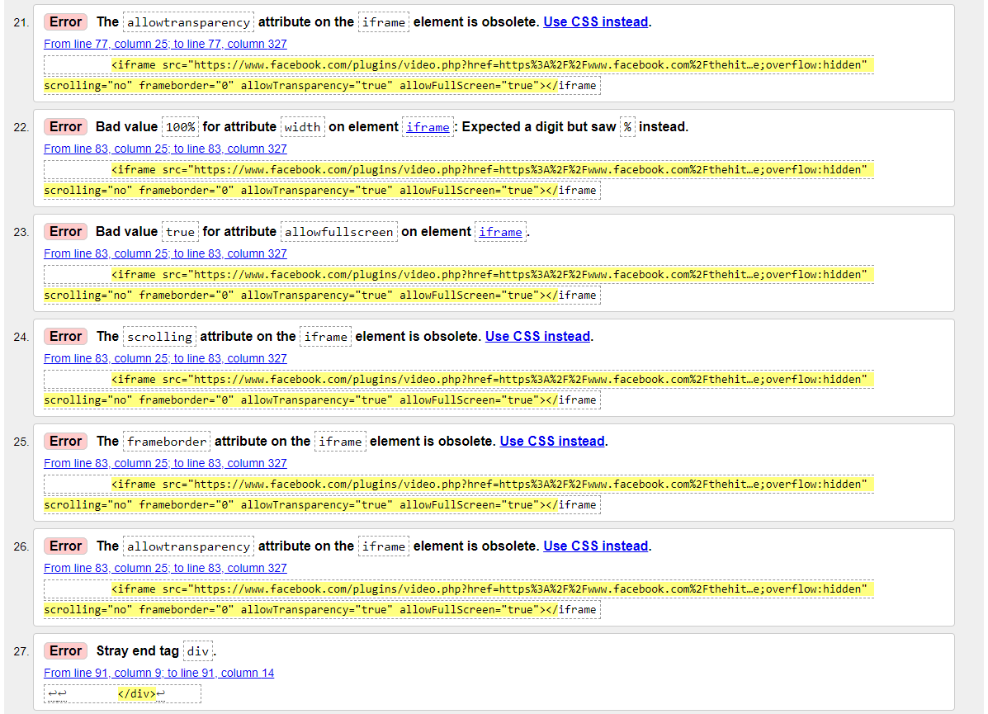

Testimonial.html

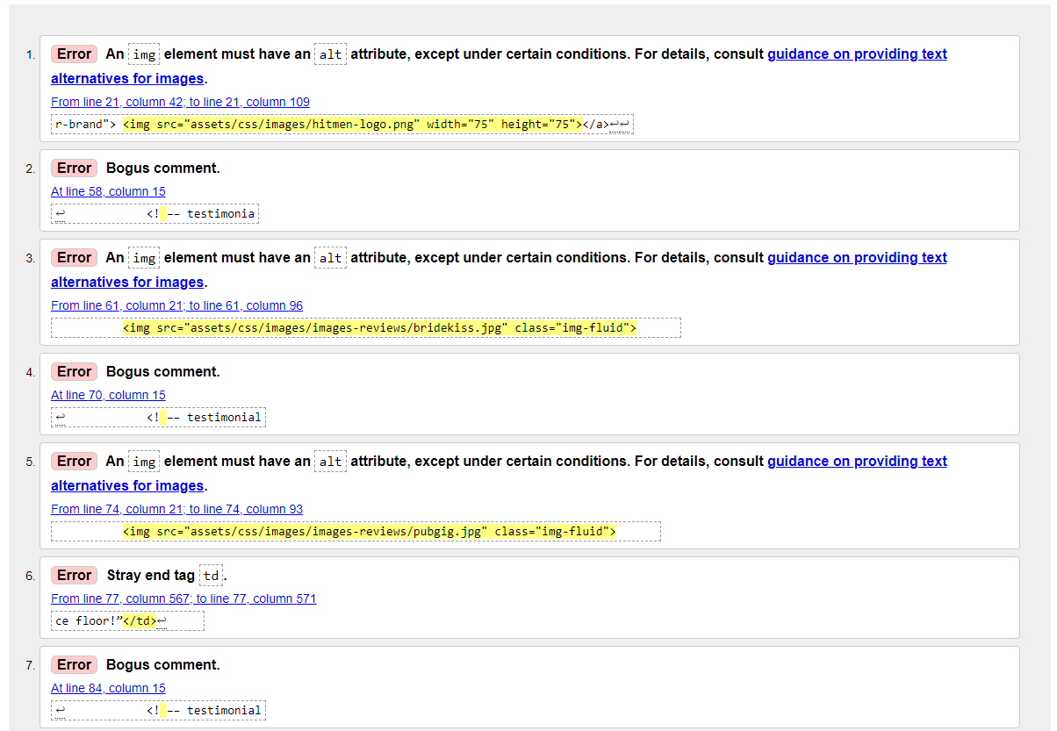

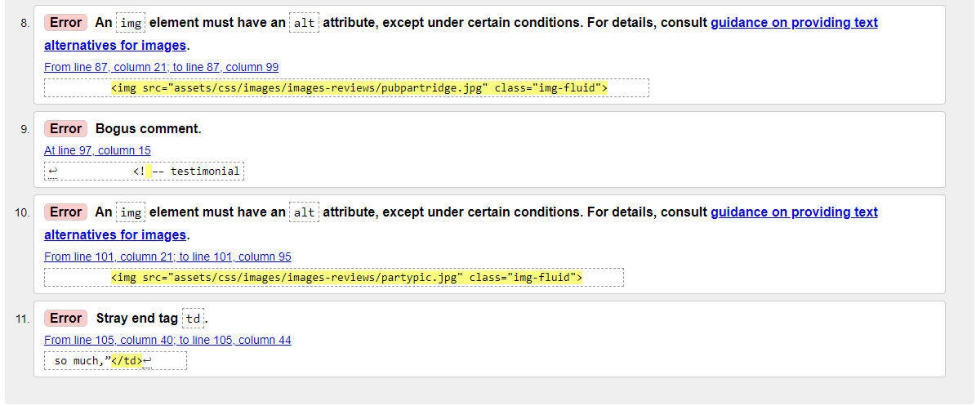

Aboutus.html



Contactus.html

