**The Richie Lohy Experience**

This is a website for people and fans to learn about the band, there music and history.

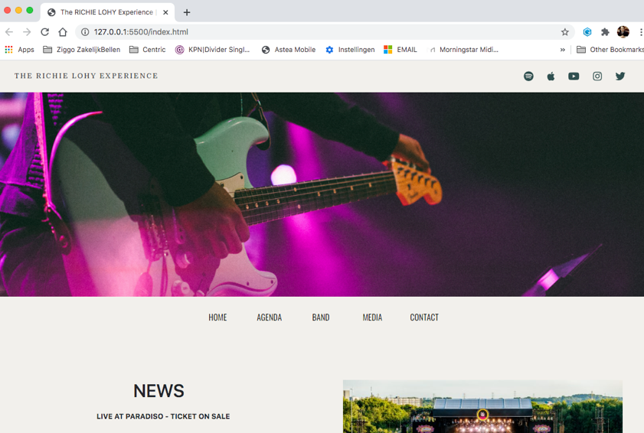

**Color Scheme**

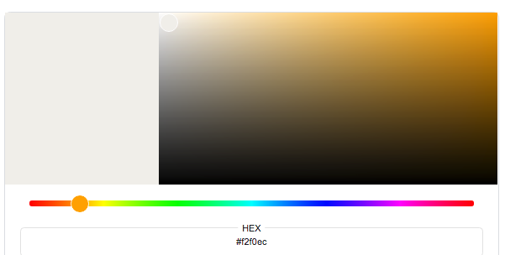

#f2f0ec as background color

black as font color

Darkslategray as font color.

**Features**

A simple page with a logo left in the navbar and sociallinks right in the nav.

1 main image, and at the bottom of the main image a menu.

And a footer with email and copyright.

5 HTML pages

1 CSS style page

7 jpg images

**Built With**

Bootstrap v4.5 - framework

Built using Bootstrap and modified with Google Inspect.

Most of the page has 2 column.

Contact page has 3 column and 1 column with a form to subcribe for the Newsletter.

Contact info to book the band, managment.

Media page has video youtube links.

**Structure**

Used Semantic markup to structure HTML code, and comment html+CSS stylesheet.

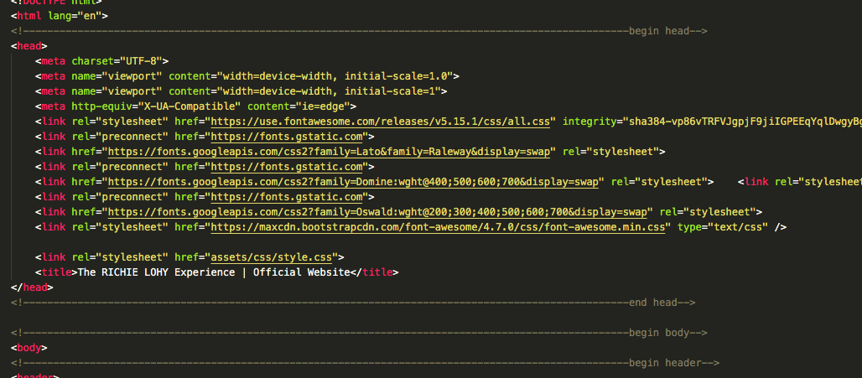

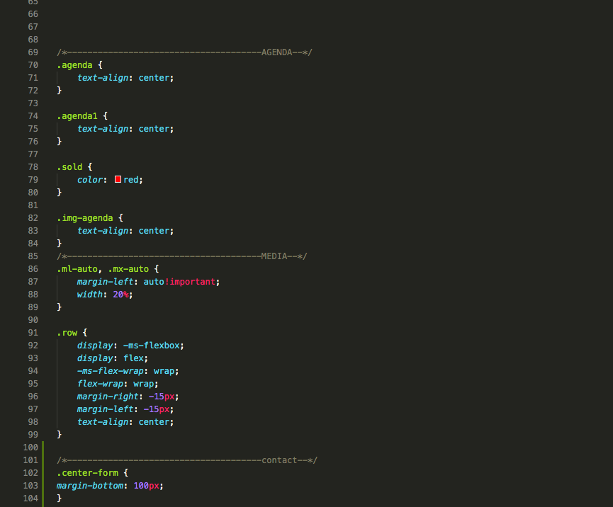

Passes true Jigsaw and W3C validator with no issues.

**Submitting**

I am late submitting, apologies for this.

I tried to make several appointments with my mentor at the time, each time he managed to cancel on the day of the appointment.

Eventually I was told that my mentor is quitting (or at least temporarily?) And that I will be assigned a new mentor.

The next appointment I could make was only after the deadline of Dec. 1.

Because of this I had to make this project without help and consultation from my / a mentor. All this passed on and consulted with Ulysses Ryan-Flynn from Student Care. He advised me to simply submit my project without the help or checking of a mentor.

So with this my project.

The photo that appears on every page is me on guitar. The photos of the CD albums and the band and all lyrics and concerts are not real but fictional.

Thanx,

Richie Lohy