# Brief

## What is required?

The client has requested that a ‘Riddle-me-this” style game is created.

Answers must be submitted in a text box using a form.

Correct answers must redirect to the next riddle.

Incorrect guesses must be stored and printed below the riddle.

The app must be accessible to multiple users at the same time.

Each player must have a username.

A leader board to keep track of all high scores.

## Who will use the application?

The app can be generalised to be played by all or can contain questions specific to a particular subject or area and be targeted towards fans/experts in that subject.

## What technologies will be used?

The application must be written in Python and can use HTML, CSS and Javascript to create a good user experience.

## How will users interact with the application?

The application will be web based and accessible through all browsers on both desktop and mobile devices.

# User stories

* As a teacher, I would like to test my class of 20 children on their multiplication tables, in order to see who still needs practice.
* As an employer, I would like to pose riddles to job candidates in an interview, in order to see who is good at lateral thinking.
* As a fan of quizzes, I would like to answer general knowledge questions, in order to see how my knowledge compares with that of others.

# Planning

## Layout

The layout of the app should remain very simple. It will begin with a landing page to welcome the user and provide basic instructions and the opportunity to enter a username. Once the username is entered the welcome page will be replaced with the questions. Once all questions have been answered the user is then presented with their results and a high score table. The opportunity will be given to play again.

## Specifics

There are several decisions required regarding the specifics of the game.

* Will there be a specific subject matter for the questions and if so what will this be?
* How many questions will the player be asked before the game ends?
* As players are given the opportunity to try again after an incorrect guess, how will the high scores be measured?
* Will the player be given the option to skip a question?
* Should it be possible for the player to select the type of questions asked?
* Should the player be able to select a difficulty level?

# Design

Initial Wireframe Mockup

Would not translate well to mobile screens:

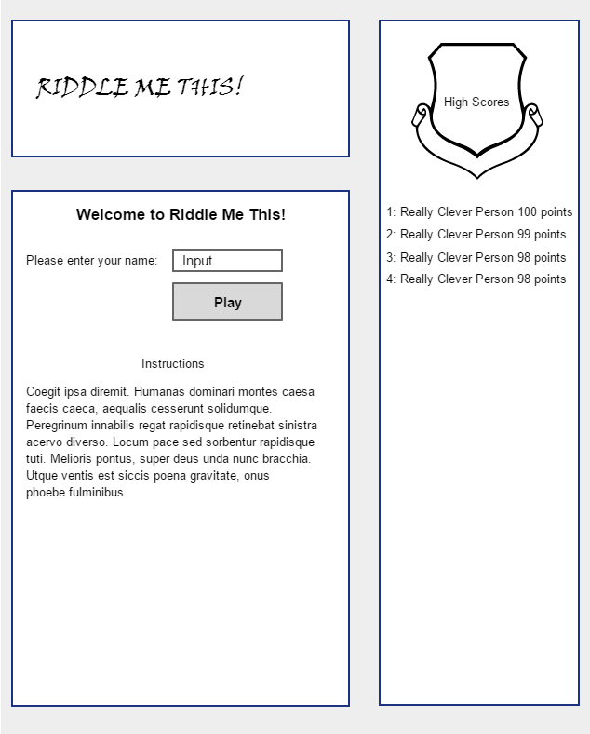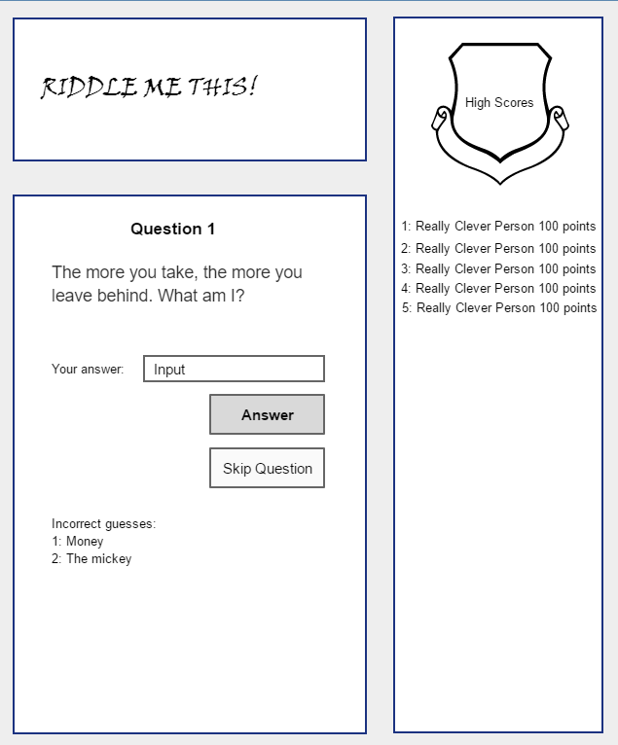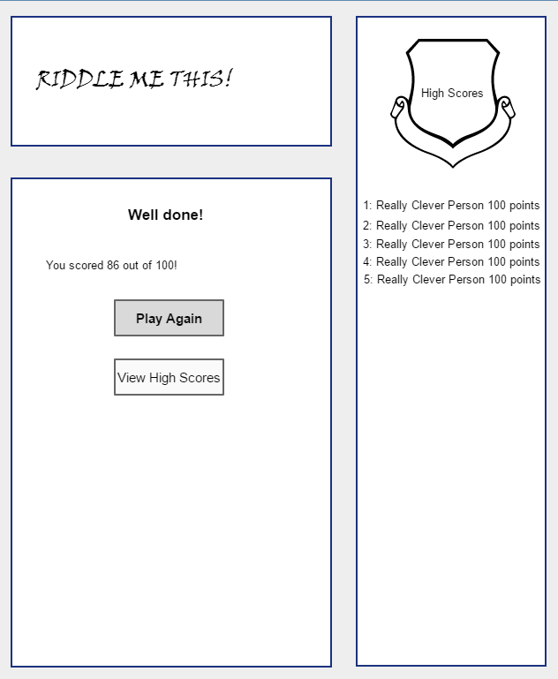

## Second Wireframe Mockup

Much easier to accommodate on all screen sizes with only minor changes:

