**Project Planning**

**Fileo**

**Strategy**

**Brief:**

Build a web application which will help small businesses and their clients manage the flow of Quotes, Purchase Orders and Invoices for any given project. The application interface should be simple and uncluttered and give the client the ability to pay from the platform once the payment cycle is complete.

**Application Spec:**

* The application should make use of a suitable Database to store information.
* The application should make use of a cloud storage solution to host PDF files for any given payment cycle.
* The application should provide a “members” login for their company. Giving the member wider access rights than their clients.
* The member should be able to manage their clients, jobs and cycles with the ability to carry out CRUD operations across them.
* The application should have a separate client account login providing access to a limited feature set of Fileo, tailored for the clients needs only.
* The application should be able to send notifications to the client and company at different stages of the application flow.
* The application should allow the user to contest or approve quotes, purchase orders and invoices.
* Both user types should be able to see a feed of payment cycles relevant to them.
* The member and client should be able to search and sort their cycles.
* The member and client should be able to upload PDF files to a cloud file hosting platform.
* The application should give the administrator the ability to remove projects and files when necessary.
* The application should provide an overview of the financial status of the user according to the total value of their cycles, and the stages they are at. For example, total value of paid cycles vs cancelled vs pending etc.
* The application should allow the client to pay for the members services through the application.

**User Stories**

**Member Needs:**

* I want to be able to login to the application using a username and password of my choosing.
* I want to be able to add clients, jobs and payment cycles for that client.
* I want to be able to provide a client with credentials so they can access the platform and view their related projects.
* I want to be able to upload quotes and invoices to the platform for clients to view.
* I want to be able to view purchase orders that the client has uploaded and be able to approve or contest the details within it.
* I want to be notified when the client approves a quote or invoice.
* I want to be notified when a client uploads a PO for me to approve.
* I want to be able to receive payment from the client and be notified once that payment has been received.
* I want to be able to see a basic overview of the my financial health in relation to my cycles in the application.
* I want the ability to sort and search all of my cycles in order to filter out the ones that are important to me at any given time.

**Client Needs:**

* I want to be able to login and view any payment cycle for a project I am involved in with a given member.
* I want to be able to approve a quote and upload my PO ready for approval by the company.
* I want to be notified when a quote has been uploaded for my approval.
* I want to be notified when a PO has been approved by the company.
* I want to be notified when an invoice has been uploaded ready for my approval.
* I want to be able to pay from the platform and complete the payment cycle.

**Scope**

**Feature Set:**

* Login, user registration field for admin and client.
* Client creation, job creation and cycle creation form.
* Profile creation form.
* Notification of client account creation.
* Search, sorting and filtering ability of cycle field.
* Porthole for cycle allowing upload of PDF files for client and member.
* Project cycle number generation for system identification of project.
* Ability to view PDF in browser.
* Ability to download PDF.
* Auto notifications of PDF uploads/views.
* Ability to contest or approve any cycle stage.
* Notification on contest or approval.
* Ability to pay once cycle is complete.
* A dashboard showing payment summaries/cycle statuses.
* The ability for a member to manage clients, jobs and cycles in simple and user friendly manner.
* A session that persists throughout the users time in the app, showing the users overall outstanding payments, completed payments, cancelled payments etc..
* A method of payment.

**Structure**

**My Original SQL Schema**

Note: While aspects of the Schema remain true, during development necessary adjustments were made to it. See original considerations below.

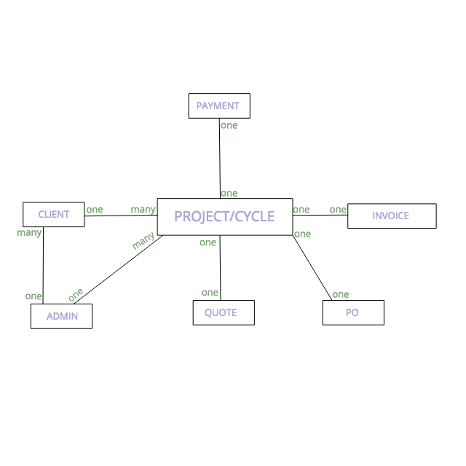

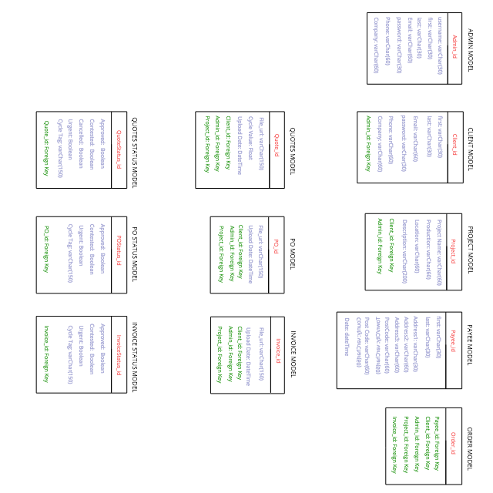

**Django App Considerations**

**Accounts App**

* Member/Client login, Member registration

**Cycles App**

* Search, Cycles feed, financial overview

**Manage Clients**

* Member CRUD operations on Client details.

**Manage Jobs**

* Member CRUD operations on Job details.

**Manage Cycles**

* Member CRUD operations on Cycle Details

**Cycle Porthole**

* Upload of files to 3rd party file hosting platform

**Cycle Status**

* Sets status of any given cycle, both overall and any individual file approval statuses.

**Profile**

* Houses profile model for members, clients, and model base class for payment information.

**Search**

* Search functionality and filtering of cycles for cycle feed.

**Notify**

* Notification Classes and functions for automatic email notification

**Payment**

* Payment views, models and functions.

**Skeleton**

See PDF in documentation folder.

**Surface**

As has been the theme of my projects, I like to keep things visually simple and uncluttered. I took inspiration for the styling of this application from sites like Tumblr, Pinterest and Twitter.

I chose to keep the choices of colour and fonts to a bare minimum in the hope of establishing a simplistic theme to the application. I made use of complimentary colours and a white font to achieve this throughout. I designed the ‘Fileo’ logo and Fileo icons in illustrator to give the application a bespoke feel and tried to keep all styles as consistent as possible.

Other than the bespoke File icons, all other icons are font-awesome icons. I tried to make use of icons where appropriate to enhance the user experience and make the pages more visually appealing.

I utilised the Tippy.js library to provide more interesting custom tooltips within the application. I used JS along with CSS manipulate buttons, form input, custom style select boxes and other form fields, as well as the scrolling effect on the registration page and other features.

**Further Ideas**

I am on the whole happy with many aspects of the application. I feel that it addresses the problems identified, and is largely simple to use.

I feel that I pushed myself to build something that fulfils a real world need, and learned a lot on the way. I feel it has improved my ability and understanding of Python and MVC frameworks. It challenged me to create a backend with multiple features I have not previously explored, such as automatic email notifications, payment, signals, class inheritance, regex, AWS integration, domain registration and domain mapping. It pushed my JS knowledge, ability to manipulate the DOM, ability custom style everything in an application and also my organisational skills.

This said, I feel the application can be strengthened on many levels as my knowledge base grows and I gain more experience.

With time I would like to incorporate the following.

1. Ability to read uploaded PDF’s and automatically assess what the value of a quote is, whether a PO value matches the value of the Quote, rejecting it without a user have to manually contest.

2. Ability to send text notifications.

3. Ability for clients to manage their own profile details.

4. Data Visualisation of financial health, and more in depth analysis than is currently offered.

5. Improved styling of cycle feed, manage clients, manage jobs and manage cycles pages.

6. More in depth testing and better code base coverage.

7. The ability for clients to keep and view a history quotes, PO’s or invoices for any given cycle.

8. The ability to pay via other means, Pay Pal etc.

9. Ability for member and client to message through Fileo.

10. The ability to upload profile images or company branding.

11. Improved search functionality.