**Strategy Plane**

Gaming news, reviews and upcoming releases website.

***Stripped Bear Gaming:***

***No-nonsense reviews for the everyday gamer.***

The website I am planning on building is a front-end only website, made for a group of likeminded individuals for whom gaming is a passion they wish to share with others.

The group currently has two reviewers, of which both are in their mid-20’s and have around 20 years of gaming experience, playing on various consoles types across multiple generations.

The primary target audience is anyone that shares the group’s passion for gaming, and wants to keep up to date with current game news, reviews/opinions, upcoming releases and recommendations.

***What’s culturally appropriate?***

Users will be gamers of all ages, with various levels of understanding of the gaming industry and of various skill levels. So the reviews need to give enough information and convey the passion of the writer, without being too technical that it will be lost on the average/casual gamer.

In recent polls the number of females that consider themselves gamers, has also increased from 40% in 2008, to 45% in 2018. The age of the average gamer is also 34, and 72% of gamers are aged 18 or over. Therefore whilst trying to appeal to all ages, the main demographic will be adults of all genders aged 18 and over.

(Facts taken from: [www.esa.com/about-esa/industry-facts/](http://www.esa.com/about-esa/industry-facts/))

***What content type would be relevant?***

Use slightly more modern fonts like “Exo” or “Roboto”.

Navigation will be user friendly and simple, will include hamburger button for mobile devices/small screen sizes.

Will also contain pictures of games, and embedded videos of other users reviews/gameplay.

***Why is this so special?***

Our site will be different from others as we are trying to present easy to understand reviews that are based on our playtime with the game. We will focus solely on the experience the reader will have, without being completely bogged down by comparing technical specs and using hard to understand gaming terms. We will also provide social links and a discord group for people that wish to connect personally with us (Looking for Teammates feature) as well as having a “Contact Us” page where people can suggest games that they’d like to see reviewed, and even open up opportunities for guest reviewers.

***Why would a user want this?***

Gaming is a tremendously popular pastime, and the audience for it keeps growing from generation to generation. The one thing that all gamers are used to though, is getting burned by a game that looks promising, but doesn’t necessarily deliver the expected experience on release. This site is about giving people no-nonsense honest reviews on how the game performs and whether it is worth the investment. It will also have videos of other people’s reviews/gameplay embedded to provide other opinions in case the user is still undecided. It will also allow for the user to find like-minded people to connect with to play the very games they are interested in. Will also allow users to actually submit requests, for the games they would like to be reviewed.

It will also offer the chance to submit guest reviews of games, with the chance of them being featured on the site.

***What makes for a good experience on review sites?***

* Honest and unbiased reviews from passionate gamers
* New/updates on current games and upcoming releases
* Clear and easy to use User Interface
* Social links to connect with the reviewers
* Contact us (chance to request/sumbit review)
* Discord group/Looking for Teammates feature (to connect gamers with other like-minded individuals)

**What does the user expect?**

* What is this?
* The user will arrive on a minimalistic page with the site/group name, slogan and a gaming related back ground image with the group logo located in an easy to see location.
* Is this what I expected to see?
* The gaming related background picture, paired with the group’s name, slogan and logo will provide visual confirmation of the content matter and purpose of website, therefore helping to make it look credible and trust worthy
* Does it offer what I want?
* The website will provide: short no-nonsense reviews, an about page to get background on the creators of the website/group, embedded videos/media to favourite youtube content creators, game news/updates/upcoming releases and a way of contacting us
* Is it valuable enough to stay?
* Entices people in with short and punchy reviews, and the chance to request games to be reviewed/send in own reviews to be featured on the site, also encourages people to join the community to meet/team up with like-minded people to play online with
* What actions can I take?
* Contact us to request a game review/ send in your own review (achieved through pop-up form)
* Connect with us on social media (social icons in footer will direct to a new tab)
* Join the discord group to meet/connect with other like-minded gamers
* Visit the reviews section
* View our favourite content creators to get their opinion on games too
* How do I contact someone?
* Through the online contact us form, or through social media.

**Trade-Offs**

|  |  |  |
| --- | --- | --- |
| Opportunity/problem | Importance | Viability/Feasibility |
| 1. Create an online presence | 5 | 5 |
| 1. Connect on social media | 5 | 4 |
| 1. Film and feature some of our own gameplay (video) | 2 | 1 |
| 1. Allow for people to request games to review/submit reviews | 4 | 4 |
| 1. Feature guest reviewer/s | 3 | 1 |
| 1. Feature our own reviews | 5 | 5 |
| 1. Link/videos for other content creator’s reviews | 4 | 4 |
| 1. Game news/updates/upcoming releases | 4 | 4 |
| **Total:** | **32** | **28** |

When creating a website, you often have to look at the features you need/want to incorporate into your website, and workout which of these is feasible to do with the time/tech/skill restraints you currently have and weigh that up against which features are actually most important. This will cause you to work out what trade-offs you might have to make when first creating your site. That’s not to say you won’t incorporate all the features in the near future, just you aren’t able to right now.

I have created a table below of all the features/aims I want to achieve, and from this I can work out what features can be implemented into the first iteration of the website, and what ones can wait to be incorporated at a later point.

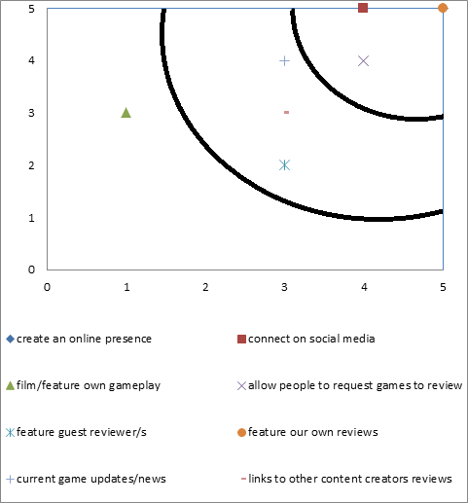

**Viability / Feasibility**

**Importance**

From the table I have created, you can see that the points I am going to focus primarily on are:

* Create an online presence
* Connect on social media
* Feature our own reviews
* Allow people to request games to review/submit reviews
* Game news/updates/upcoming releases
* Links/videos for other content creators

In the future, I would like to implement the following points/features

* Film and feature some of our own gameplay
* Feature guest reviewer/s