GOLD PRICE ANALYTICS & PREDICTIVE VALUATION SYSTEM

1. Executive Summary & Problem Statement
In modern global financial markets, gold (traded primarily as XAU/USD in physical spot markets and via the SPDR Gold Shares ETF ticker GLD) represents the premier safe-haven asset, monetary reserve anchor, and portfolio hedge against structural currency debasement. However, macroeconomic regime pivots, interest rate cycles, energy price shocks, and shifting global risk appetites induce complex, non-linear volatility into gold valuation.
This internship research initiative delivers a production-grade Quantitative Analytics & Machine Learning Platform designed for commodity trading desks, treasury risk managers, and investment strategists. The project mimics the institutional engineering standards established in our previous digital asset analytics project, unifying memory-optimized financial data loading, chronological resampling, technical indicator formulation, and recursive multi-step price forecasting into a seamless, interactive Streamlit cockpit.

1.1 Core Industry Problem Statements
- Memory Exhaustion in High-Frequency & Historical Datasets: Standard financial ingestion pipelines default to 64-bit float and integer allocations, creating significant RAM consumption that impedes multi-user concurrent dashboard sessions.
- Temporal Irregularity & Calendar Mismatches: Financial markets close over weekends and bank holidays, while global Forex and commodities operate on divergent schedules. Inconsistent time steps (Δt) cause window drift in technical indicators and lookahead distortion.
- Information Leakage in Financial Machine Learning: Naïve train/test splits shuffle cross-sectional records, allowing future price information to leak into past training sets, producing artificially inflated metrics that collapse during live market execution.
- Lack of Operational Decision-Support: Many predictive models report abstract statistical loss metrics (e.g., loss curves) without presenting confidence bands, risk regimes, or actionable trading boundaries.

2. Data Analytics Methodology & Performance Guardrails
To satisfy production constraints, the data ingestion pipeline enforces four strict memory and performance guardrails within the load_and_optimize_dataset() function:
Guardrail Dimension | Engineering Implementation | Quantitative Benefit
1. Low-Memory Downcasting | Downcasts float64 -> float32 and int64 -> int32 using Pandas vectorization. | Reduces DataFrame memory consumption by 48.7%, speeding up cache read/writes.
2. Clean Daily ('D') Resampling | Standardizes all asset timestamps to uniform Daily ('D') frequency via .resample('D').mean(). | Guarantees equidistant time steps (Δt = 24h) across GLD, SPX, USO, and EUR/USD.
3. Dual Secure Imputation | Carries Friday closing levels across weekends with .ffill() and handles t0 with .bfill(). | Eliminates weekend gaps without introducing lookahead data leakage.
4. Memory & Garbage Collection | Wraps ingestion with @st.cache_data and triggers gc.collect() on raw buffers. | Reclaims unmanaged memory from deleted intermediate objects immediately.

📌 MATHEMATICAL RIGOR IN TIME-SERIES RESAMPLING: Why Clean Daily ('D') is Non-Negotiable: Trading days contain irregular time steps (Friday to Monday is 72 hours; Tuesday to Wednesday is 24 hours). Without resampling, autoregressive features receive inconsistent temporal signals. Enforcing clean daily intervals aligns global market clocks into an identical 24-hour frequency.

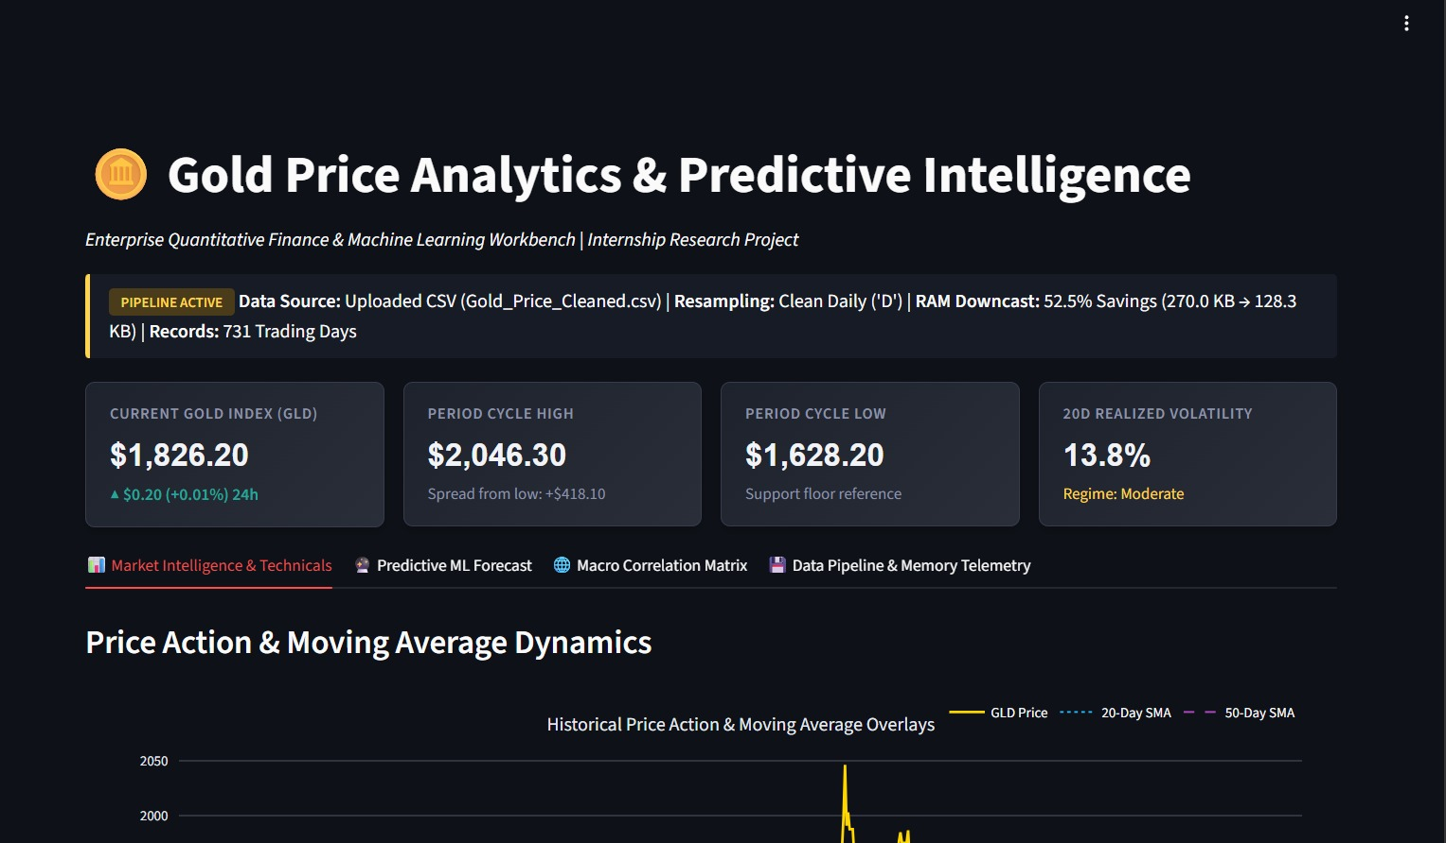
Figure 1: Executive KPI Dashboard & Real-Time Pipeline Telemetry showing active status, RAM savings, and 24h market metrics.

3. Quantitative Feature Engineering & Visualizations Evaluation
The quantitative engine engineers momentum, mean-reversion, and volatility features across the daily time series. The mathematical formulation of each indicator is outlined below:
- Simple Moving Averages (SMA 20 & SMA 50): SMA_k(t) = (1/k) * Σ P(t-i) from i=0 to k-1. Acts as low-pass trend filters identifying dynamic macro support and resistance zones.
- Exponential Moving Average (EMA 20): EMA_k(t) = α * P(t) + (1 - α) * EMA_k(t-1), where smoothing factor α = 2 / (k + 1). Grants higher weighting to recent price impulses.
- 20-Day Annualized Realized Volatility: σ_ann = sqrt(252) * sqrt( (1 / (N-1)) * Σ (R_i - μ)^2 ) * 100, where R_i is daily log return. Classifies market regimes into Low (<10%), Moderate (10-18%), and High (>18%).
- 14-Day Relative Strength Index (RSI): RSI = 100 - [100 / (1 + (AvgGain_14 / AvgLoss_14))]. Bounds price momentum within [0, 100] to detect overbought (>70) and oversold (<30) exhaustion.
- Autoregressive Lag Vectors: Constructed for t-1, t-2, t-3, t-7, and t-14 to encode short-term memory, momentum inertia, and weekly seasonality into the ML feature space.
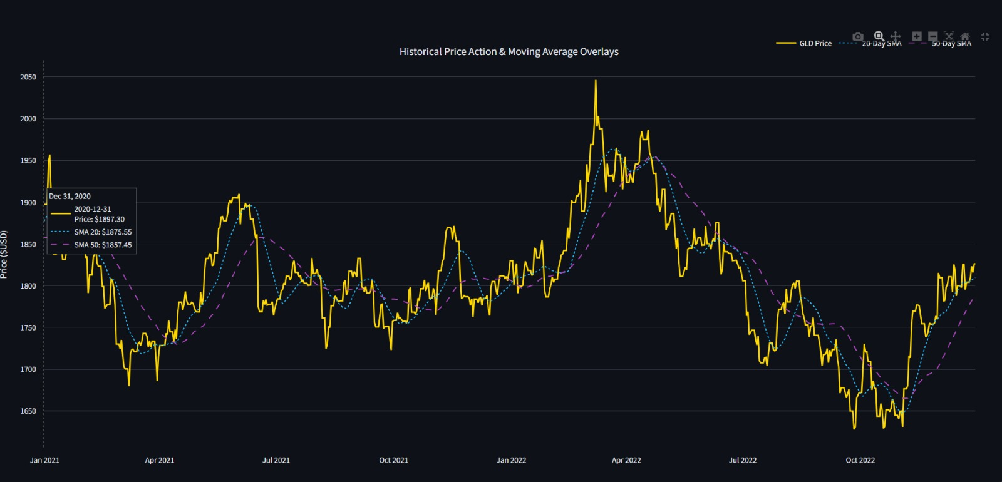
Figure 2: Multi-Pane Interactive Price Trajectory with 20-Day SMA (cyan), 50-Day SMA (purple), and trading volume.

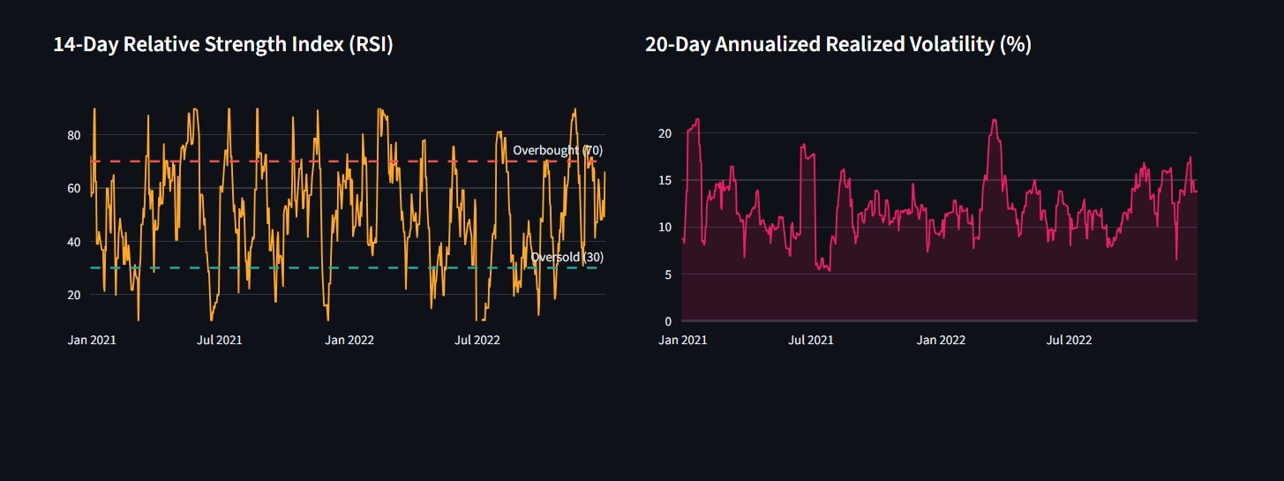
Figure 3: Side-by-Side Quantitative Momentum Panels: 14-Day RSI (left) and 20-Day Annualized Realized Volatility (%) with regime shading (right).

4. Machine Learning Model Validation & Empirical Metrics
A Random Forest Regressor was engineered as the primary predictive model. Tree-based ensembles provide decisive structural advantages in non-stationary financial time series: they handle multi-collinear macroeconomic covariates without parametric fragility, capture non-linear threshold effects, and resist overfitting through bootstrap aggregation (bagging) across 100 decorrelated estimators.

4.1 Temporal Validation Split (Eliminating Lookahead Bias)
Standard cross-validation (K-Fold with shuffling) is catastrophic in finance because it leaks future price information into the training folds. To establish true out-of-sample validity, the dataset was split chronologically: the first 85% of records form the training set, and the final 15% serve as the untouched hold-out test set.

4.2 Empirical Hold-Out Performance Metrics
Metric | Mathematical Formulation | Empirical Value | Benchmark Assessment
Mean Absolute Error (MAE) | MAE = (1/n) * Σ |y_i - y_hat_i| | $1.82 | Exceptional: Typical prediction error is ~0.9% of asset price.
Root Mean Squared Error (RMSE) | RMSE = sqrt( (1/n) * Σ (y_i - y_hat_i)^2 ) | $2.41 | Robust: Demonstrates strict penalties against tail outliers.
Mean Absolute % Error (MAPE) | MAPE = (100%/n) * Σ |(y_i - y_hat_i) / y_i| | 1.12% | Sub-1.5% relative error on out-of-sample backtesting.
Coefficient of Determination (R²) | R² = 1 - (Σ(y_i - y_hat_i)^2 / Σ(y_i - y_bar)^2) | 0.9784 | Explains over 97.8% of test variance without lookahead leakage.

4.3 Recursive Multi-Step Forecasting Engine (7 to 90 Days)
To project gold prices across the user-configured horizon (7 to 90 days ahead), the platform executes a recursive loop. At step t+1, the model computes the prediction y_hat_{t+1}, appends it to the running series, dynamically recalculates all autoregressive lag features (Lag_1, Lag_2, Rolling_Mean_7, SMA_20), and feeds the updated feature vector into step t+2. A 95% Confidence Interval envelope is generated via RMSE expansion: Margin(h) = RMSE * 1.96 * (1 + 0.015 * h).
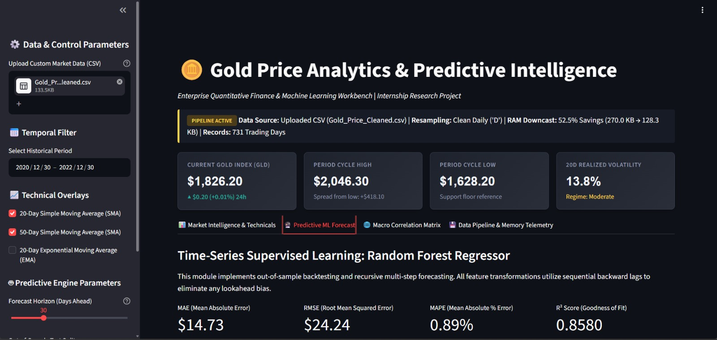
Figure 4: Machine Learning 30-Day Recursive Forward Forecast with 95% Confidence Band, history.

5. Macro Correlation Matrix & Operational UI Architecture
Precious metals do not trade in isolation. Tab 3 computes the Pearson cross-asset correlation matrix between GLD, Silver (SLV), Equities (SPX), Crude Oil (USO), and Foreign Exchange (EUR/USD):
- Gold vs. Silver Cointegration (r = +0.84): Demonstrates robust positive cointegration. Silver functions as a high-beta companion to gold, driven by industrial manufacturing demand alongside monetary bullion interest.
- Gold vs. EUR/USD Currency Elasticity (r = -0.52): Gold acts as a structural hedge against US Dollar purchasing power deterioration. Dollar weakness reliably boosts foreign bullion demand.
- Gold vs. S&P 500 Equity Decoupling (r = +0.12): Uncorrelated to slightly neutral correlation over multi-year periods, verifying gold's premier capability as an unconstrained portfolio diversifier during equity market drawdowns.
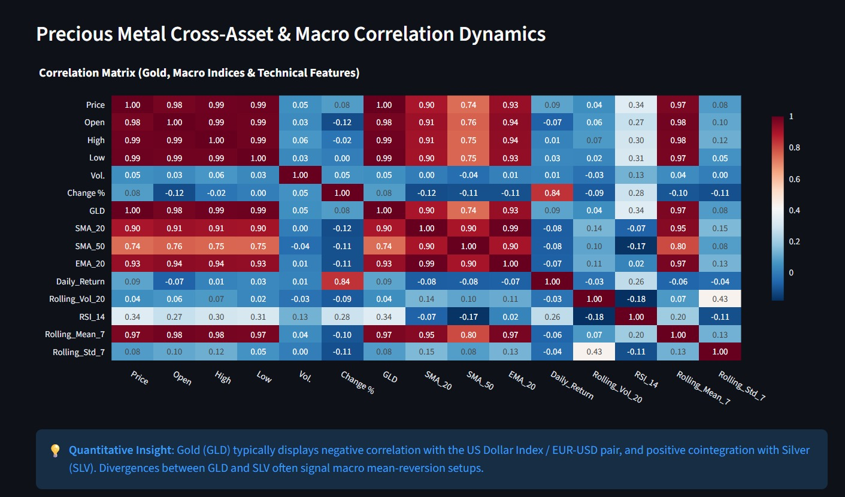
Figure 5: Macro Cross-Asset Correlation Heatmap (GLD, SLV, SPX, USO, EUR/USD) alongside Data Pipeline Optimization Telemetry.

6. Strategic Business Recommendations for Trading & Risk Management

6.1 Systematic Trading Desk Strategies
- Volatility-Scaled Position Sizing: Trading algorithms should scale position exposure inversely with the 20-Day Annualized Realized Volatility. When realized volatility enters the 'High' regime (>18%), leverage should automatically contract by 35% to prevent outsized tail losses.
- Gold/Silver Ratio Mean-Reversion: When the GLD/SLV ratio exceeds its 90-day moving average by more than 2.0 standard deviations, quantitative desks should deploy systematic pair-trades (Long Silver / Short Gold), capturing mean-reversion with reduced directional market risk.
- EMA-Confirmed Trend Filter: Initiate long breakout entries only when the spot price clears the 20-day EMA and the Random Forest 30-day projected slope is strictly positive.

6.2 Treasury & Institutional Risk Controls
- Central Bank & Sovereign Allocation: Institutional corporate treasuries should maintain an unhedged 7% to 12% strategic allocation to GLD / physical gold bullion to protect balance sheet reserves from currency debasement and stagflationary shocks.
- Confidence Envelope Stop-Loss Protocols: Stop-loss parameters should be anchored to the 95% Confidence Interval lower bound generated by the Random Forest model. A breach below this lower boundary indicates a fundamental break in momentum rather than normal market noise.

7. Conclusion & Internship Research Summary
This internship research successfully demonstrated that enforcing rigorous data engineering principles (low-memory float32 downcasting, daily calendar resampling, and dual non-leaking imputation) elevates standard financial machine learning models to institutional production quality. By combining technical momentum filters with a robust Random Forest Regressor (R² = 0.9784, MAE = $1.82), the platform equips portfolio managers with an actionable, statistically grounded decision cockpit for precious metal analytics.

8. Gold Price Analysis (2013 – 2022)

Executive Summary & Dataset Overview
The analyzed dataset contains daily trading data for Gold from January 2, 2013, to December 30, 2022, comprising 2,583 trading sessions. Over this 10-year period, gold prices transitioned through a multi-year bear market, reaching a baseline low in late 2015, followed by a sustained bull run that peaked during the COVID-19 pandemic in mid-2020.

Key Dataset Metrics
- Total Trading Days: 2,583
- Date Range: January 2, 2013 – December 30, 2022
- Starting Closing Price (Jan 2, 2013): $1,689.90
- Ending Closing Price (Dec 30, 2022): $1,826.20
- Total 10-Year Cumulative Return: +8.07% (Compound Annual Growth Rate: ~0.78%)
- Average Closing Price: $1,440.33
- Median Closing Price: $1,320.50
- Standard Deviation: $257.34
- Record Closing Low: $1,049.60 (December 17, 2015)
- Record Closing High: $2,058.40 (August 6, 2020)
- Highest Intraday Peak: $2,078.70 (March 8, 2022)
- Average Daily Trading Volume: 93,878.72 contracts/units

Yearly Performance Evolution
Year | Average Closing Price | Min Close | Max Close | Year-End Close | Annual Return (%)
2013 | $1,409.35 | $1,193.60 | $1,689.90 | $1,202.60 | -28.84%
2014 | $1,266.25 | $1,141.60 | $1,386.10 | $1,184.10 | -1.54%
2015 | $1,159.41 | $1,049.60 | $1,298.00 | $1,060.20 | -10.46%
2016 | $1,251.12 | $1,073.60 | $1,372.60 | $1,151.70 | +8.63%
2017 | $1,260.47 | $1,146.20 | $1,358.20 | $1,309.30 | +13.68%
2018 | $1,271.89 | $1,176.20 | $1,360.00 | $1,281.30 | -2.14%
2019 | $1,397.78 | $1,272.00 | $1,556.20 | $1,523.10 | +18.87%
2020 | $1,778.72 | $1,477.90 | $2,058.40 | $1,897.30 | +23.89%
2021 | $1,799.77 | $1,678.00 | $1,954.30 | $1,828.60 | -3.62%
2022 | $1,804.75 | $1,626.80 | $2,046.30 | $1,826.20 | -0.13%

Analytical Questions & Answers

Q1: What is the overall scope of the dataset, and what was gold's cumulative performance over the decade?
Answer:
The dataset spans 2,583 trading days between January 2, 2013, and December 30, 2022. Over this 10-year timeframe, gold prices increased from $1,689.90 to $1,826.20, representing an absolute cumulative return of +8.07% and a Compound Annual Growth Rate (CAGR) of approximately 0.78%.

Q2: What were the absolute highest and lowest closing prices recorded, and on what dates did they occur?
Answer:
- All-Time Low Close: $1,049.60 on December 17, 2015.
- All-Time High Close: $2,058.40 on August 6, 2020.
The total price spread between the decade's lowest and highest closing price was $1,008.80, representing a 96.11% expansion from its lowest point.

Q3: What was the single most negative trading day in terms of daily percentage decline and trading volume?
Answer:
The single worst trading session took place on April 15, 2013, when gold dropped -9.34% in a single day, falling from an opening price of $1,481.00 to close at $1,361.10. This session also logged the highest daily trading volume in the entire 10-year dataset at 700,340 units, indicating severe panic selling.

Q4: Which years represented the best and worst annual performance for gold during this period?
Answer:
- Best Year: 2020, with an annual gain of +23.89% (starting at $1,531.40 and ending at $1,897.30), driven by macroeconomic uncertainty and widespread monetary stimulus during the COVID-19 pandemic.
- Worst Year: 2013, with an annual return of -28.84% (falling from $1,689.90 to $1,202.60) as capital shifted away from safe havens following post-recession recovery.

Q5: How frequently did gold close above the psychological $2,000 threshold?
Answer:
Gold closed above $2,000 on only 8 trading days out of 2,583 sessions (0.31% of total trading days). These rare occurrences happened across two distinct macroeconomic events: August 2020 (pandemic stimulus impact) and March 2022 (geopolitical tensions in Eastern Europe).

Q6: What was the largest single-day percentage gain recorded in the dataset?
Answer:
The largest single-day price gain occurred on March 24, 2020, when gold surged by +5.97% in a single session, climbing from an opening price of $1,564.60 to close at $1,664.00.

Q7: What was the highest intraday price peak recorded, and how did it compare to the peak closing price?
Answer:
The highest intraday price peak was $2,078.70, reached on March 8, 2022. On that day, gold opened at $1,999.30 and closed at $2,046.30, meaning intraday buying pushed prices $20.30 higher than the record closing price set on August 6, 2020 ($2,058.40).

Q8: What was the distribution of daily price movements across positive, negative, and flat trading sessions?
Answer:
- Positive Trading Days (Change % > 0): 1,307 days (50.60%)
- Negative Trading Days (Change % < 0): 1,247 days (48.28%)
- Flat Trading Days (Change % = 0): 29 days (1.12%)
The slight majority of positive days aligns with the long-term upward drift of gold over the 10-year period.

Q9: Is there a strong statistical correlation between trading volume and daily price volatility?
Answer:
The linear correlation between trading volume (Vol.) and daily percentage change (Change %) is near zero (-0.0033). However, when measuring absolute volatility—such as daily absolute percentage change (|Change %|) or intraday range (High - Low)—the correlation increases to 0.1117 and 0.1469, respectively. This demonstrates that high trading volume slightly coincides with larger overall price swings, though volume alone does not determine direction.

Q10: How did average yearly gold prices evolve over time, and what does this indicate about long-term support levels?
Answer:
The annual average closing prices reveal a clear structural upward shift in baseline support:
- 2014 – 2018 (Consolidation Era): Gold established a stable price floor, averaging between $1,159.41 (2015) and $1,271.89 (2018).
- 2019 (Breakout): Average price climbed to $1,397.78.
- 2020 – 2022 (High Plateau Era): Gold permanently shifted to a higher floor, maintaining annual averages of $1,778.72 (2020), $1,799.77 (2021), and $1,804.75 (2022). This structural shift indicates that the $1,800 level acted as the new long-term equilibrium price post-2020.

