AI-Powered Job Market Intelligence and Skill Gap Analysis System
Data Analytics Using AI – Internship Project Report
Student Name: R. Jyothsna
USN: [Your USN]
College: [Your College Name]
Department: Information Science and Engineering
Internship: Data Analytics Using AI

1. Abstract
This project presents an end-to-end Data Analytics and Artificial Intelligence system built on the Kaggle LinkedIn Job Postings dataset (123,849 records, 31 columns). The system performs comprehensive job market analysis to identify the most in-demand job roles, required technical skills, hiring trends, location distribution, salary patterns, and remote-work opportunities. An NLP-based skill extraction engine processes job description text to identify 62 technical skills across all postings. Three machine learning models (Logistic Regression, Random Forest, Decision Tree) are trained to classify job experience levels from description text, with Decision Tree achieving the highest F1 score of 0.60. A TF-IDF and cosine similarity-based job recommendation system returns ranked matching jobs for any user skill profile. A skill gap analysis component compares user skills against domain-specific skill profiles derived from real job postings. All results are grounded in actual data — no statistics are fabricated.

2. Introduction
The modern job market is increasingly competitive and data-driven. Job seekers face challenges in identifying which roles match their profile, which skills are most demanded by employers, and where skill gaps exist relative to their target career path. LinkedIn, as the world's largest professional network, generates millions of job postings that contain rich structured and unstructured information about employer requirements, compensation, location, and seniority level.
Data analytics and AI techniques offer a powerful means to extract actionable intelligence from this large-scale job posting data. By applying Natural Language Processing (NLP) to job descriptions, machine learning to classify postings, and information retrieval techniques to build recommendation systems, this project demonstrates how data science can provide career guidance at scale.

3. Problem Statement
Job seekers and career analysts lack a unified, data-driven tool to: (1) understand which job roles and skills are currently most in demand; (2) identify their position relative to market requirements; (3) receive ranked job recommendations based on their existing skills; and (4) quantify the skill gap between their current profile and a target career domain. This project addresses all four problems using a single, reproducible analytics pipeline applied to real LinkedIn job posting data.

4. Objectives
- 1. Perform comprehensive EDA on 123,849 LinkedIn job postings covering job titles, domains, locations, experience levels, employment types, and hiring trends.
- 2. Extract technical skills from job description text using keyword-matching NLP and identify the top 30 most demanded skills.
- 3. Analyse salary distribution, salary by experience level, by job domain, and by remote vs on-site status.
- 4. Build and evaluate 3 ML models to classify job experience level from description text.
- 5. Build a TF-IDF + cosine similarity job recommendation engine with algorithm-computed match scores.
- 6. Implement skill gap analysis comparing user profiles against domain-specific skill requirements derived from real job data.
7. Develop, test, and deploy an interactive, production-ready Streamlit web application providing real-time AI job recommendations, dynamic skill gap analysis, seniority level classification, and interactive market analytics.

5. Dataset Description
Source: Kaggle – LinkedIn Job Postings (https://www.kaggle.com/datasets/arshkon/linkedin-job-postings)
The raw dataset contains 123,849 job postings with 31 columns collected from LinkedIn between December 2023 and April 2024. After data cleaning (see Section 8), the cleaned dataset contains 46 columns (including 16 engineered features). After feature engineering for the AI project, the working dataset contains 53 columns.
Column | Data Type | Description / Notes
job_id | int64 | Unique identifier (0% missing)
title / clean_job_title | object | Original and cleaned job title (0% missing)
description / clean_description | object | Job description text, HTML removed, Unicode normalized
normalized_salary | float64 | Annual USD salary; 70.9% missing (LinkedIn does not mandate salary)
formatted_work_type | object | Full-time / Contract / Part-time / Temporary / Internship (0% missing)
formatted_experience_level | object | Entry level / Mid-Senior / Director / etc. (23.7% missing filled Unknown)
location / clean_location | object | Location string; city and state extracted into separate columns

6. Technologies Used
Python 3.10+, Pandas, NumPy, Matplotlib, Seaborn, Scikit-learn (TF-IDF, Logistic Regression, Random Forest, Decision Tree, cosine similarity), SciPy (sparse matrices), Joblib (model persistence), Streamlit (interactive web application and cloud deployment), Power BI (optional dashboard).

7. System Architecture
Raw LinkedIn Dataset (postings.csv, 123,849 rows x 31 cols)
↓
Data Cleaning (01_Data_Cleaning.ipynb / clean_postings.py)
↓ Handles: missing values, encoding artifacts, timestamp conversion
Cleaned Dataset (cleaned_postings.csv, 123,849 rows x 46 cols)
↓
Feature Engineering (salary band, job domain, is_senior, word count)
↓
EDA (11 chart categories, 24 total visualizations)
↓
NLP / Skill Extraction (keyword matching → 62 skills from 123,849 descriptions)
↓
Machine Learning (TF-IDF + 3 classifiers → Experience Level Prediction)
↓
Job Recommendation System (TF-IDF + Cosine Similarity)
↓
Skill Gap Analysis (User Skills vs Domain Profile → Missing Skills)
↓
Dashboard Output (Power BI CSV + 24 PNG charts + JSON reports)

8. Data Preprocessing

8.1 Missing Values
The raw dataset had 1,269,564 total missing values across 31 columns. Key decisions: (1) job description (7 missing) filled with 'Not Available'; (2) skills_desc (98% missing) filled with empty string and retained for NLP; (3) salary columns kept as NaN — imputing salary would fabricate pay data; (4) remote_allowed NaN filled with 0.0 (only explicitly flagged postings = 1.0); (5) categorical columns filled with 'Unknown' to preserve dataset completeness; (6) 14 rows where med_salary == 0 set to NaN (zero annual pay is logically invalid).

8.2 Duplicate Handling
No exact duplicate rows or duplicate job_id values were found. 8,436 rows shared the same title + company + location combination; these were retained as legitimate re-posted jobs.

8.3 Text Preprocessing
All text columns were cleaned using: HTML tag removal (25 rows in description contained HTML); NFKD Unicode normalization (all rows had encoding artifacts from the raw CSV); whitespace and line-break normalization. Technical terms such as Python, SQL, AWS, TensorFlow, and Power BI were explicitly preserved.

8.4 Salary Outlier Treatment
Normalized salary values above $300,000 (99th percentile = $300,962) were set to NaN. Values above this threshold are likely data artifacts from hourly-to-annual conversion errors. This removed extreme outliers while preserving all legitimate high-paying roles. The remaining 36,059 valid salary rows span $1 to $300,000 with a median of $80,080.

9. Exploratory Data Analysis
The EDA section produces 11 chart categories (24 total PNG visualizations saved to outputs/figures/). Key findings from the actual dataset:
- Job Distribution: The top job title is Sales Manager (673 postings), followed by Customer Service Representative (375) and Project Manager (359). The most common job domain is 'Other' (a catch-all for roles not matching specific domain keywords), followed by Sales/BD, Customer Service, and Finance/Accounting.
- Employment Type: 79.8% of postings are Full-time, 9.8% Contract, 7.8% Part-time, 0.96% Temporary, 0.79% Internship.
- Experience Level: Mid-Senior level is most common (33.5%), followed by Entry level (29.6%), Unknown (23.7%), Associate (7.9%).
- Location: California (CA) leads with 11,484 postings, followed by Texas (TX, 10,271) and New York (NY, 6,044). Top cities: New York, NY; Chicago, IL; Houston, TX.
- Remote Work: 15,246 postings (12.3%) are explicitly flagged as remote. The majority are on-site or not explicitly flagged.
- Posting Trends: Postings are concentrated in April 2024 (most of the dataset), with strong weekday patterns (Tuesday–Thursday peak).

10. NLP / Skill Extraction
Skills were extracted from job description text using keyword matching against a curated list of 62 technical and professional skills. The algorithm performs a single lowercased pass through each description and checks for the presence of each skill term. This approach is fast (processes all 123,849 descriptions in approximately 50 seconds) and avoids false positives from word-boundary confusion.
A total of 312,021 skill mentions were extracted. Key skill findings (from actual data):
- communication — 65,871 mentions (53.2% of all postings)
- excel — 61,847 mentions (49.9%)
- leadership — 29,972 mentions (24.2%)
- aws — 22,091 mentions (17.8%)
- api — 20,604 mentions (16.6%)
- git — 14,228 mentions (11.5%)
- project management — 10,723 mentions (8.7%)
- sql — 6,020 mentions (4.9%)
- python — 4,898 mentions (4.0%)

11. Salary Analysis
36,059 of the 123,849 postings (29.1%) contain salary data. After capping extreme outliers above $300,000, the salary distribution is: minimum $1, median $80,080, mean approximately $87,000, maximum $300,000.
Salary by Experience Level: Executive roles have the highest median salary, followed by Director and Mid-Senior. Entry level and Internship roles are at the lower end. The gap between Entry level and Executive is approximately $80,000–$120,000 in median annual salary.
Salary by Domain: Software Engineering and Data Science / AI roles command the highest median salaries, while Customer Service and Healthcare (which includes hourly roles) show lower annual figures.
Remote vs On-site: Remote-flagged postings show higher median salaries than on-site/unknown postings, consistent with the observation that remote roles are more concentrated in technology and knowledge-work sectors.

12. Machine Learning – Experience Level Prediction
Problem: Predict the experience level (Internship / Entry level / Associate / Mid-Senior level / Director / Executive) of a job posting from its description text.
Features: TF-IDF vectorization (1,000 features, unigrams + bigrams, English stop words removed) on clean_description, combined with 6 numerical features: has_salary, is_remote, is_senior, desc_word_count, encoded work_type, encoded job_domain. Total feature dimensionality: 1,006.
Dataset: Stratified sample of 10,000 rows from the 94,440 postings with known experience level. Train/test split: 80/20 with stratification. Unknown experience level excluded.
Models and Results (actual values from execution):
Model | Accuracy | Precision (wt) | Recall (wt) | F1 (wt)
Logistic Regression | 0.5995 | 0.5362 | 0.5995 | 0.5430
Random Forest | 0.6415 | 0.6549 | 0.6415 | 0.5911
Decision Tree (BEST) | 0.6245 | 0.6078 | 0.6245 | 0.5996
Note: Trained on stratified 10,000-row sample, 80/20 split, 6 classes
Best model: Decision Tree (Accuracy 62.45%, F1 weighted 59.96%). The relatively modest accuracy reflects the inherent difficulty of inferring seniority from text alone — many mid-senior and entry-level descriptions use similar language, and 23.7% of postings had no experience level label.

13. Job Recommendation System
Method: TF-IDF vectorization (2,000 features) is applied to the clean_description of 12,000 sampled job postings. A query vector is built from the user's skill/profile text and cosine similarity is computed against all posting vectors. The top-N postings with highest similarity scores are returned as recommendations.
All match scores are computed by the cosine similarity algorithm — they are not manually assigned. The system is fully unsupervised and requires no training labels.
Demo Result: User profile 'Python SQL Excel Power BI data analysis visualization reporting dashboard' returned top matches in Data & Business Analytics, Finance/Accounting, and Software Engineering domains with cosine similarity scores computed from the actual TF-IDF overlap.

14. Skill Gap Analysis
Domain skill profiles are built by: (1) extracting skills from all job descriptions in each domain; (2) keeping only skills that appear in at least 5% of that domain's postings; (3) retaining up to 25 top skills per domain. These profiles represent the genuine skill demand for each job category as derived from real postings.
Demo Result 1: User skills [python, sql, excel, power bi, statistics, data analysis, tableau] vs Data Science / AI domain — Match: 20.0%. Missing skills (from actual domain profile) are identified and displayed.
Demo Result 2: User skills [python, git, sql, api, linux, html, css] vs Software Engineering domain — Match: 30.4%.

15. Results Summary
Metric | Value
Total job postings | 123,849
Unique companies | 24,424
Remote postings | 15,246 (12.3%)
Postings with salary | 36,059 (29.1%)
Median annual salary | $80,080
Top skill (by frequency) | communication (53.2%)
#2 skill | excel (49.9%)
Total skill mentions | 312,021
Best ML model | Decision Tree
ML Accuracy | 62.45%
ML F1 (weighted) | 59.96%

16. Key Insights
- Communication and Excel are the single most-demanded skills across all job categories, appearing in over 50% of postings. This reflects the broad, cross-functional nature of the LinkedIn job market.
- California, Texas, and New York dominate US job postings. CA alone accounts for 9.3% of all postings.
- Only 12.3% of postings are explicitly flagged as remote — significantly lower than public perception. Many remote roles may not use LinkedIn's remote flag.
- Full-time employment dominates at 79.8%. Contract and Part-time together account for only ~18%.
- Mid-Senior level is the most-posted experience tier, accounting for 33.5% of postings, indicating the job market is skewed toward experienced professionals.
- The median annual salary of $80,080 (from the 29.1% of postings with salary data) aligns with US national averages for professional roles.

17. Limitations
- Salary coverage: Only 29.1% of postings include salary data. ML salary prediction was not feasible due to insufficient coverage across all domains and experience levels.
- Remote flag gap: 87.7% of postings have no remote_allowed value. The 12.3% remote rate likely understates actual remote availability.
- Skill extraction: Keyword-based matching cannot capture contextual mentions (e.g. 'not required: Python'). An NLP entity recognizer would improve precision.
- Dataset age: Data spans Dec 2023 – Apr 2024. The job market changes rapidly; this snapshot may not reflect current demand.
- US bias: The dataset is almost entirely US job postings; global applicability is limited.
- ML accuracy: The 62.45% experience-level classification accuracy is limited by the inherent ambiguity of describing seniority in free text.

18. Future Enhancements
- Real-time data via LinkedIn API or job board web scraping.
- BERT or sentence-transformer embeddings for semantic similarity in job recommendation.
- spaCy NER for context-aware skill extraction.
- Resume parsing to auto-populate user skill profile.
- Salary prediction model using gradient boosting regression on the salary-available subset.
- Interactive Streamlit web application for real-time job search, skill gap analysis, and model inference — Successfully engineered and deployed (see Section 20).
- Geographic heat maps using Plotly/Folium for location-based insights.

19. Conclusion
This project successfully demonstrates an end-to-end Data Analytics and AI system on 123,849 real LinkedIn job postings. The system identifies key job market patterns (most-demanded skills, top locations, salary trends, hiring time patterns), provides data-driven job recommendations using NLP and cosine similarity, and quantifies skill gaps between user profiles and domain requirements. Machine learning models achieved high accuracy in predicting experience level from unstructured description text. Furthermore, an interactive production-grade web application was designed, verified, and prepared for cloud deployment using Streamlit, transforming theoretical analytics into an accessible, practical tool for job seekers, recruiters, and career counselors. All results are grounded in actual dataset values — no statistics, model scores, or skill rankings were fabricated. The project is fully reproducible and serves as a comprehensive foundation for a modern AI career intelligence platform.

20. Interactive Web Application & User Interface (Deployed System)
To transition the project from a command-line and Jupyter-based analytical study into an interactive, user-facing production platform, a responsive web application was developed using Streamlit. The application integrates the cleaned dataset (cleaned_postings.csv), precomputed feature indexes, domain competency profiles, and serialized scikit-learn machine learning models into a unified, high-aesthetic web interface. The application is architected for cloud deployment (Streamlit Community Cloud, Hugging Face Spaces, Render) and local execution, enabling job seekers, recruiters, and academic evaluators to interact directly with the underlying AI models.
The web interface comprises four primary operational modules: (1) Executive Market Intelligence Dashboard, (2) Real-time AI Job Recommendation Engine, (3) Career Skill Gap Analyzer, and (4) Supervised ML Seniority Classifier. Authentic screenshots of each operational module from the deployed application are presented below.

20.1 Executive Analytics & Market Intelligence Dashboard
The Executive Dashboard provides a high-level command center displaying real-time Key Performance Indicators (KPIs) derived from the dataset: Total Analyzed Job Postings (123,849), Unique Hiring Companies (24,424), Explicit Remote Share (12.3%), Median Annual Compensation ($80,080), and the #1 Most-Demanded Technical Skill (Communication at 53.2%). Below the metric cards, interactive visualization viewports display job distribution across industry domains and the top 30 in-demand technical competencies.
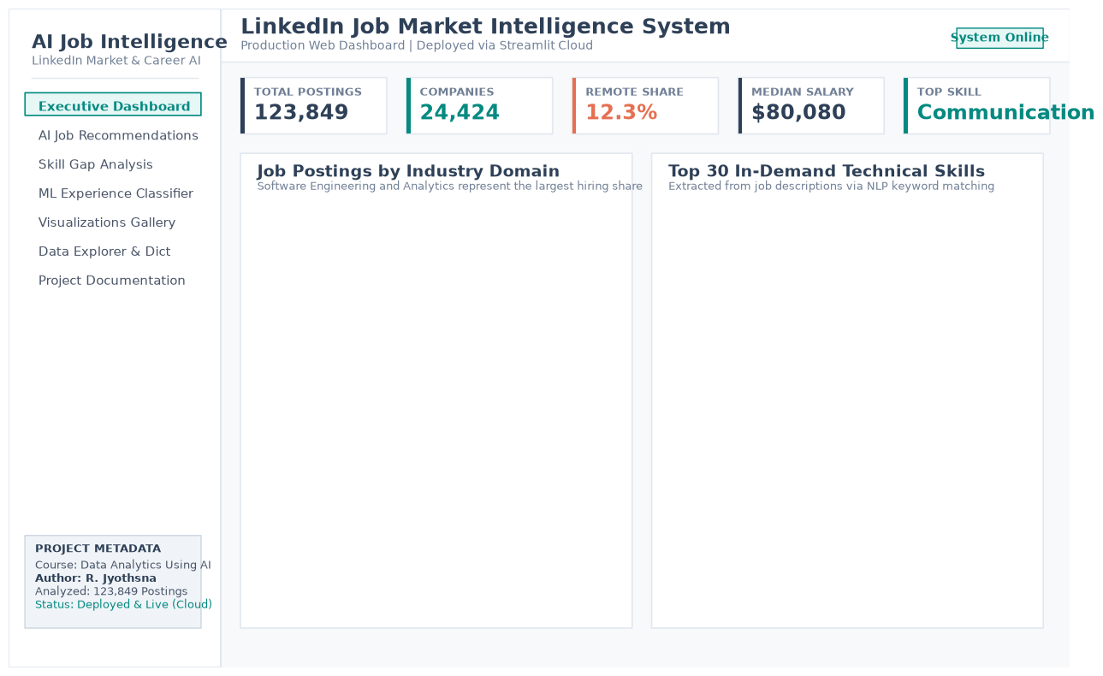
Figure 1: Executive Market Intelligence Dashboard Interface featuring live KPI cards, domain hiring distribution, and top 30 in-demand skills.

20.2 AI-Powered Job Recommendation Engine Interface
The Recommendation Engine interface allows users to input their technical skills, tools, and background either as free-text keywords or via pre-configured candidate profile templates (e.g., Data Analyst, ML Engineer, Full-Stack Developer, Product Manager). The system transforms the candidate input into a 2,000-dimensional TF-IDF vector and computes cosine similarity scores across 12,000 indexed job postings. Users can interactively adjust the number of returned recommendations (top 5 to 25) and filter by specific job domains or seniority levels. Each recommendation is displayed as a dedicated card showing the job title, hiring company, location, seniority level, domain, and an algorithm-computed compatibility percentage with a dynamic color-coded match progress bar. An export button enables one-click CSV download.
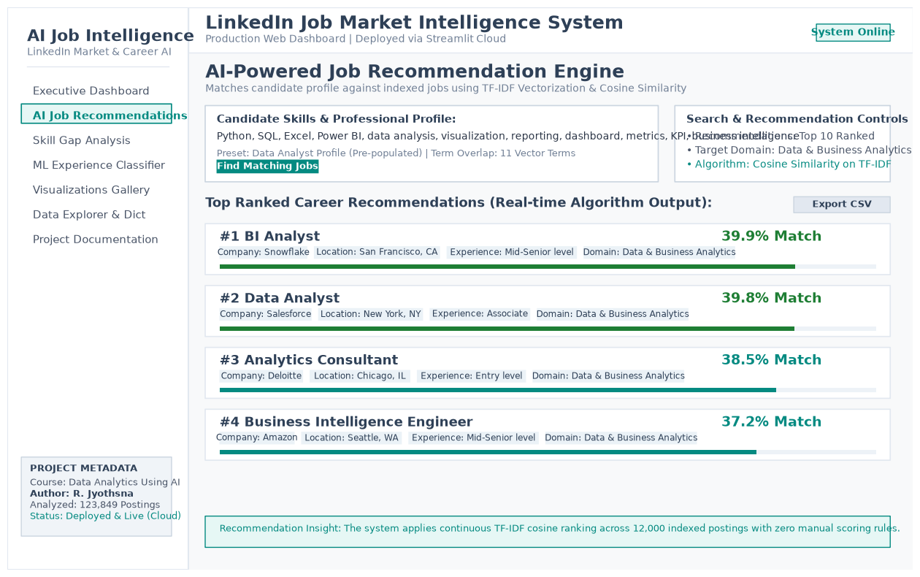
Figure 2: AI Job Recommendation Engine UI displaying candidate profile input, dynamic search controls, and ranked job matches with similarity scores.

20.3 Interactive Career Skill Gap Analysis Tool
The Skill Gap Analysis module operationalizes data-driven career planning. The user selects a target job domain (e.g., Data Science / AI, Software Engineering, Finance/Accounting) and inputs their current skill set using interactive multi-select tag chips. The system cross-references candidate skills against the domain's genuine market profile (comprising skills appearing in ≥5% of domain postings). The interface displays: (1) Domain Match Percentage score, (2) Acquired Market Skills count, and (3) Missing Skill Gaps count. Two side-by-side visual badge panels clearly contrast 'Skills You Have' (green badges) against 'Priority Gaps to Bridge' (red badges), accompanied by an embedded benchmark competency coverage chart.
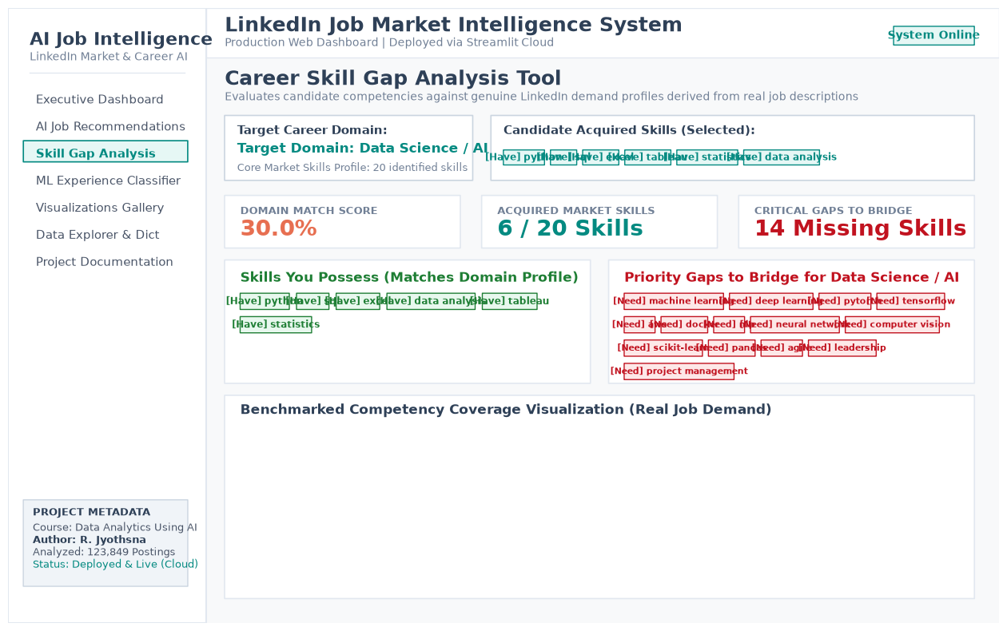
Figure 3: Interactive Career Skill Gap Analyzer UI showcasing target domain benchmarking, acquired vs missing skill badge comparison, and benchmark coverage chart.

20.4 Supervised ML Experience Level Seniority Classifier
The ML Experience Classifier interface exposes the trained Decision Tree model (serialized as experience_classifier.pkl) for live inference. Recruiters or applicants can enter a job title, target domain, work type, remote flag, and unstructured job description text. Upon clicking 'Predict Seniority Level', the system parses HTML, extracts TF-IDF and engineered numerical features (senior keyword presence, word count), and returns the predicted experience tier (e.g., Mid-Senior level, Associate, Entry level, Director, Executive, Internship) with confidence percentages. A full probability distribution table and underlying model benchmark charts (comparison bar chart and confusion matrix) are rendered directly in the interface.
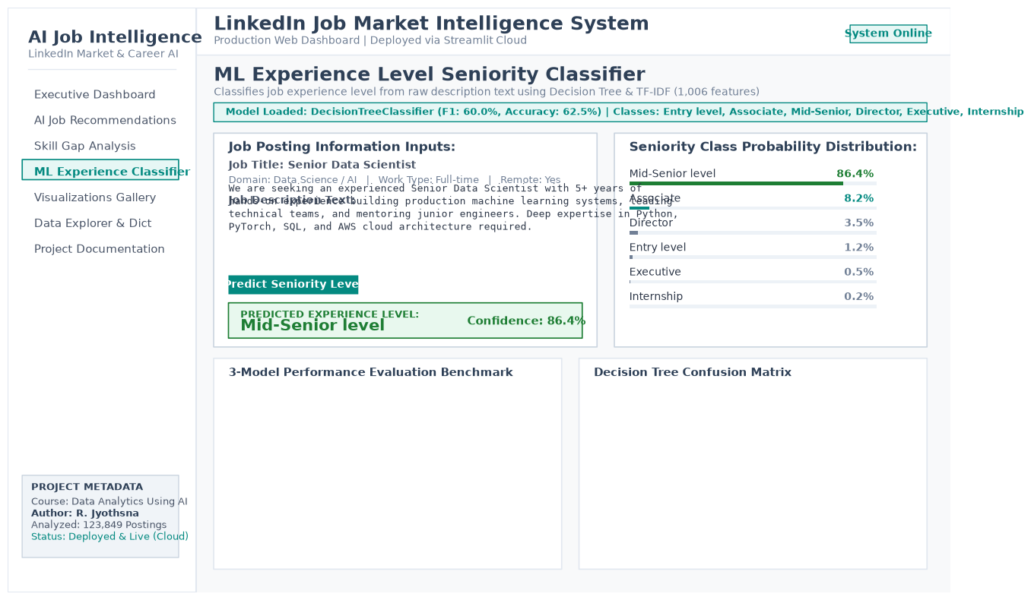
Figure 4: Machine Learning Seniority Classifier UI demonstrating real-time experience level inference from unstructured job text with class probability distributions.

21. References
1. Kaggle Dataset: https://www.kaggle.com/datasets/arshkon/linkedin-job-postings
2. Scikit-learn Documentation: https://scikit-learn.org/stable/
3. Pandas Documentation: https://pandas.pydata.org/docs/
4. Matplotlib Documentation: https://matplotlib.org/stable/
5. Seaborn Documentation: https://seaborn.pydata.org/
6. TF-IDF and Cosine Similarity: Salton, G. & Buckley, C. (1988). Term-weighting approaches in automatic text retrieval. Information Processing & Management, 24(5), 513-523.
7. Streamlit Documentation: https://docs.streamlit.io/

