Activity Diagram for Login and Subscribe

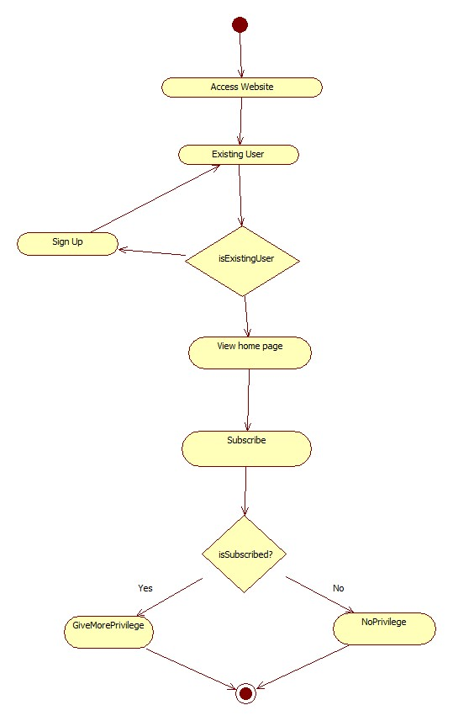

Activity Diagram for Web Scraping(Fetching Data)

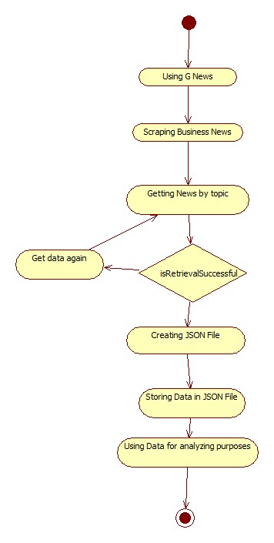

Activity Diagram for Business News Insight

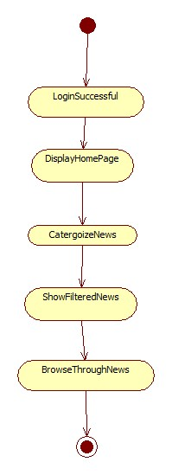

Activity Diagram for Business Charts

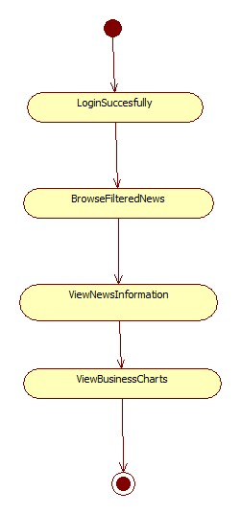

Activity Diagram for Categorizing News

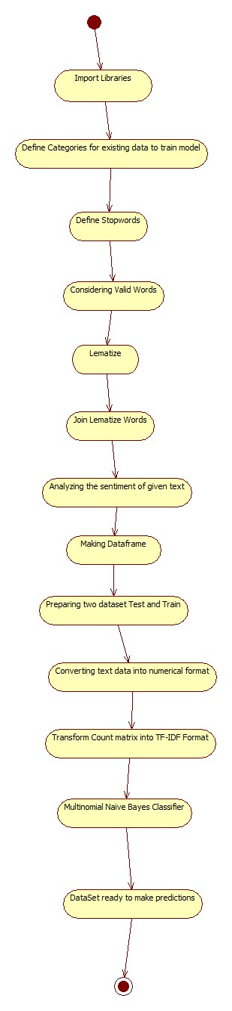

Activity Diagram for sentimental analyze of News

