Sequence Diagram for Login and Subscribe

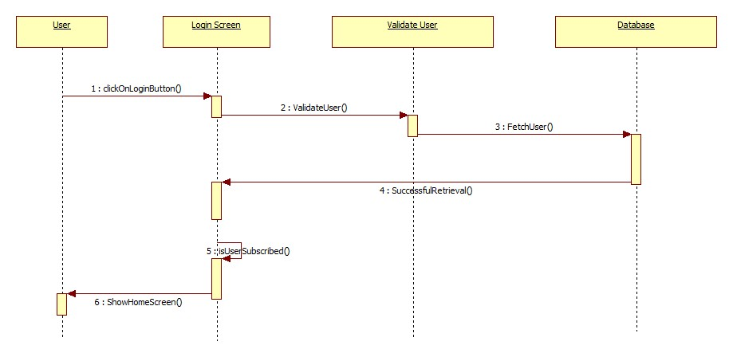

Sequence Diagram for Web Scraping(Fetching Data)

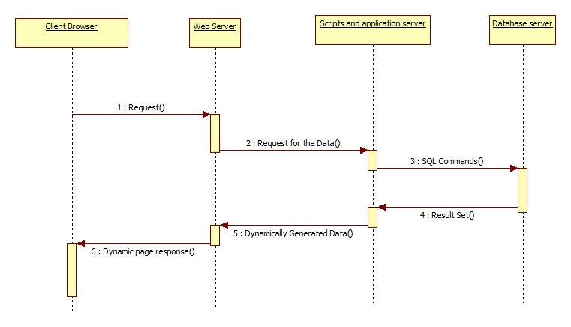

Sequence Diagram for Business News Insight

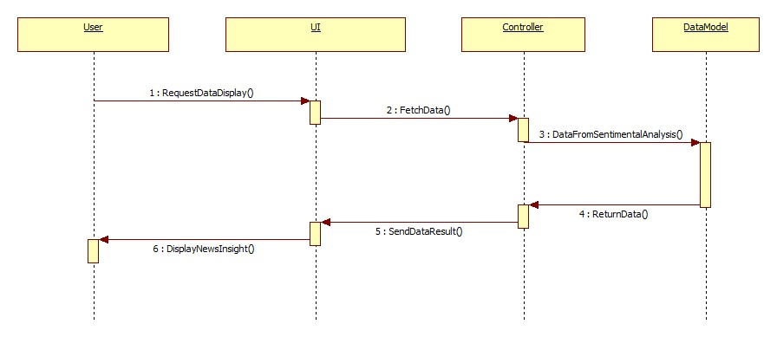

Sequence Diagram for Business Charts

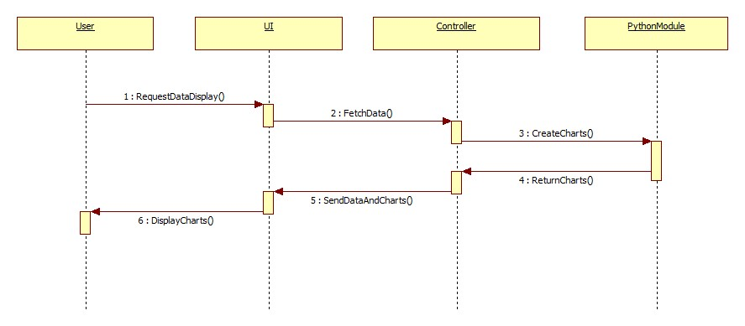

Sequence Diagram for Categorizing News

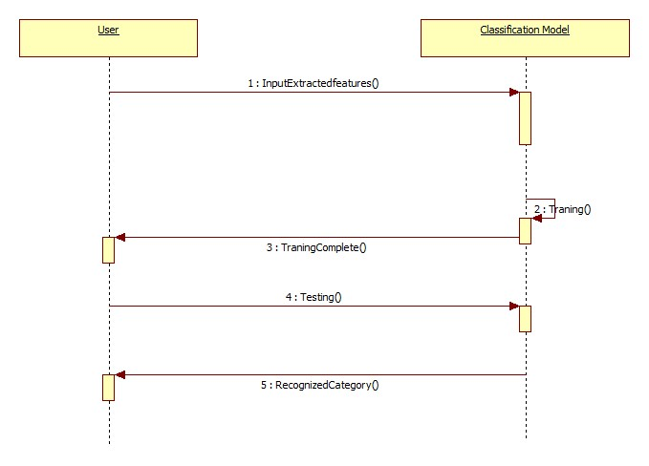

Sequence Diagram for sentimental analyze of News

