**GreenBurgas Explorer**

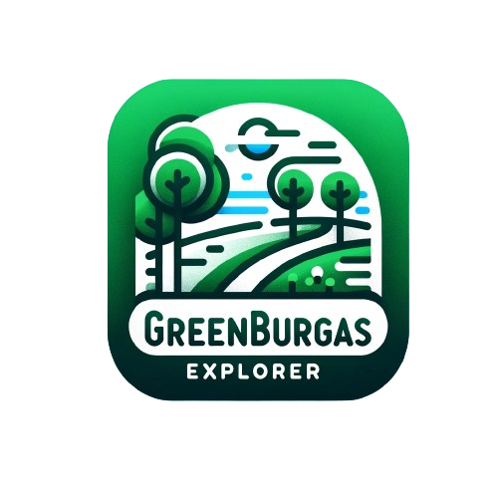

Table of contents

GreenBurgas Explorer 1

Table of contents 1

PROJECT IDEA 1

TEAM MEMBERS 1

PERFORMED TASKS 2

BLOCK DIAGRAM 3

FUTURE IDEAS 3

PROJECT IDEA

**Our projecct idea is an app that gives information using OSM.**

TEAM MEMBERS

|  |  |
| --- | --- |
| Name | Role in the team |
| Denislav Bratoevski | Scrum Triner, Back & Front-end developer |
| Yordan Zhechev | Designer |
| Georgi Kotakov | Back & Front-end develoeper |

PERFORMED TASKS

|  |  |
| --- | --- |
|  | Performed tasks |
| 1 | Add license  The license helps you with copywrite activities. |
| 2 | Add ,gitignore  Gitignore file ignores the useless for each device files. |
| 3 | Create map using OSM  The map is our main source of information. |
| 4 | Add polygons  The polygons are showing us the green spaces in Burgas. |
| 5 | Create design of the project  The Design grabs the attention from the user, we really think modern design is the best option for application like this. |
| 6 | Add comments  As developers we really think comments are the connections between the creators and other developers that want to help when we meet difficulty. |
| 7 | Add README  Important for the main information about the application. |
| 8 | Add documentation  One of the most important parts of the project, gives you the whole information for the application you should know. |

BLOCK DIAGRAM

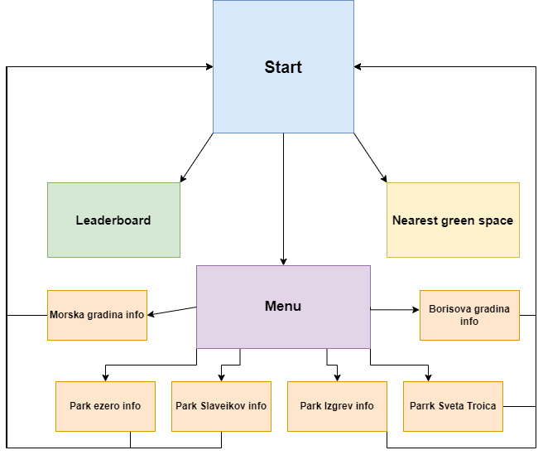

FUTURE IDEAS

|  |  |
| --- | --- |
|  | Future ideas |
| 1 | Make Feedback form using Database |
| 2 | Add more functionalities to the app |