PROJECT WORKFLOW DOCUMENT
AI-Powered Real-Time Product Price Intelligence & Recommendation System
Price Tracking, Trend Analysis, Product Matching & Explainable Recommendations
Complete Project Proposal & Consolidated Implementation Roadmap
Internship project | 72-hour MVP with advanced track
Version 1.0 | 20 September 2026

Contents
1. Project Overview 1
1.1 Executive summary 1
1.2 Business problem 1
1.3 Problem statement 1
1.4 Primary objectives 1
2. Scope and Data Principles 1
2.1 Realistic scope 1
2.2 Observed price is not a guaranteed price 1
3. End-to-End Workflow 1
3.1 Stage summary 1
4. Stage-by-Stage Detail 1
4.1 Data source strategy and ingestion 1
4.2 Standard product schema 1
4.3 Data normalisation 1
4.4 Product matching and duplicate detection 1
4.5 Product variant detection 1
4.6 Price tracking and change detection 1
4.7 Price history and trend analysis 1
4.8 Price-drop and anomaly detection 1
4.9 Cross-source price comparison 1
4.10 Feature extraction and category attributes 1
4.11 Recommendation engine 1
4.12 RAG-powered AI assistant 1
5. Real-Time Price Refresh Workflow 1
6. End-to-End User Workflow 1
6.1 Example results view 1
7. System Architecture and Technology Stack 1
7.1 Architecture layers 1
7.2 Recommended technology stack 1
7.3 Database design 1
8. Implementation Roadmap 1
8.1 72-hour MVP plan 1
8.2 Mandatory MVP deliverables 1
8.3 Advanced track 1
9. Quality, Testing and Risk 1
9.1 Testing strategy 1
9.2 Measurable success criteria 1
9.3 Risks and mitigation 1
10. Ethical and Technical Rules 1
11. Final Project Definition 1

1. Project Overview

1.1 Executive summary
The AI-Powered Real-Time Product Price Intelligence & Recommendation System is a multi-source product intelligence platform. It collects currently available product and pricing information, monitors price changes, compares prices across supported sources, identifies price trends, detects significant price movements, analyses product specifications and generates personalised product recommendations.
Instead of relying on a static dataset, the system continuously retrieves product information and prices from supported real-world sources and stores a timestamp for every price it observes. The platform combines the following capabilities:
- Live product/retail APIs or permitted feeds
- Product normalisation, matching and duplicate detection
- Historical price storage, price-change detection and trend analysis
- Product similarity and recommendation algorithms
- An interactive dashboard and a grounded AI assistant

1.2 Business problem
Consumers routinely compare the same or similar products across several online retailers before buying. This is difficult because:
- Product names differ between sources.
- Specifications are inconsistent or incomplete.
- Prices change frequently, and discounts may be temporary.
- The same product may exist in several variants.
- Historical prices are hard to track manually.

1.3 Problem statement
Develop an AI-powered system that retrieves currently available product information and prices from multiple supported sources, standardises product data, identifies equivalent products and variants, tracks historical prices, detects price changes, analyses price trends, compares products, calculates value indicators and generates personalised product recommendations.

1.4 Primary objectives
Area | Objective
Collection | Retrieve current product information and prices from multiple supported sources, avoiding dependency on a single provider.
Standardisation | Standardise product data; identify duplicate/equivalent products; distinguish variants.
Tracking | Store historical price observations; detect increases and decreases; calculate change percentages.
Analytics | Identify unusual price movements and analyse price trends.
Recommendation | Compare products on price and specifications; identify value-for-money products; generate personalised, explainable recommendations.
Traceability | Maintain source URLs and retrieval timestamps; display current and historical prices.

2. Scope and Data Principles

2.1 Realistic scope
The project must not claim to track every product or every retailer on the internet. The correct definition is:
The system tracks currently discoverable products and prices from supported APIs, permitted retailer feeds or other authorised data sources, and analyses their observed price history.

2.2 Observed price is not a guaranteed price
Price information is inherently dynamic, so the application must clearly distinguish a current observed price from a guaranteed purchase price. Every price shown in the dashboard should carry:
Displayed field | Purpose
Source | Which API or feed provided the observation
Product URL | Link back to the source listing
Observed price and currency | The price exactly as retrieved
Retrieved time / last update time | When the observation was made
Availability (where provided) | Stock status as reported by the source
Variant | Configuration the price applies to

3. End-to-End Workflow
The workflow below shows how a raw product record travels from an authorised source to the dashboard and AI assistant. Steps 6 and 7 run as two parallel branches (change detection with anomaly checking, and history with trend analysis) that rejoin at feature analysis.
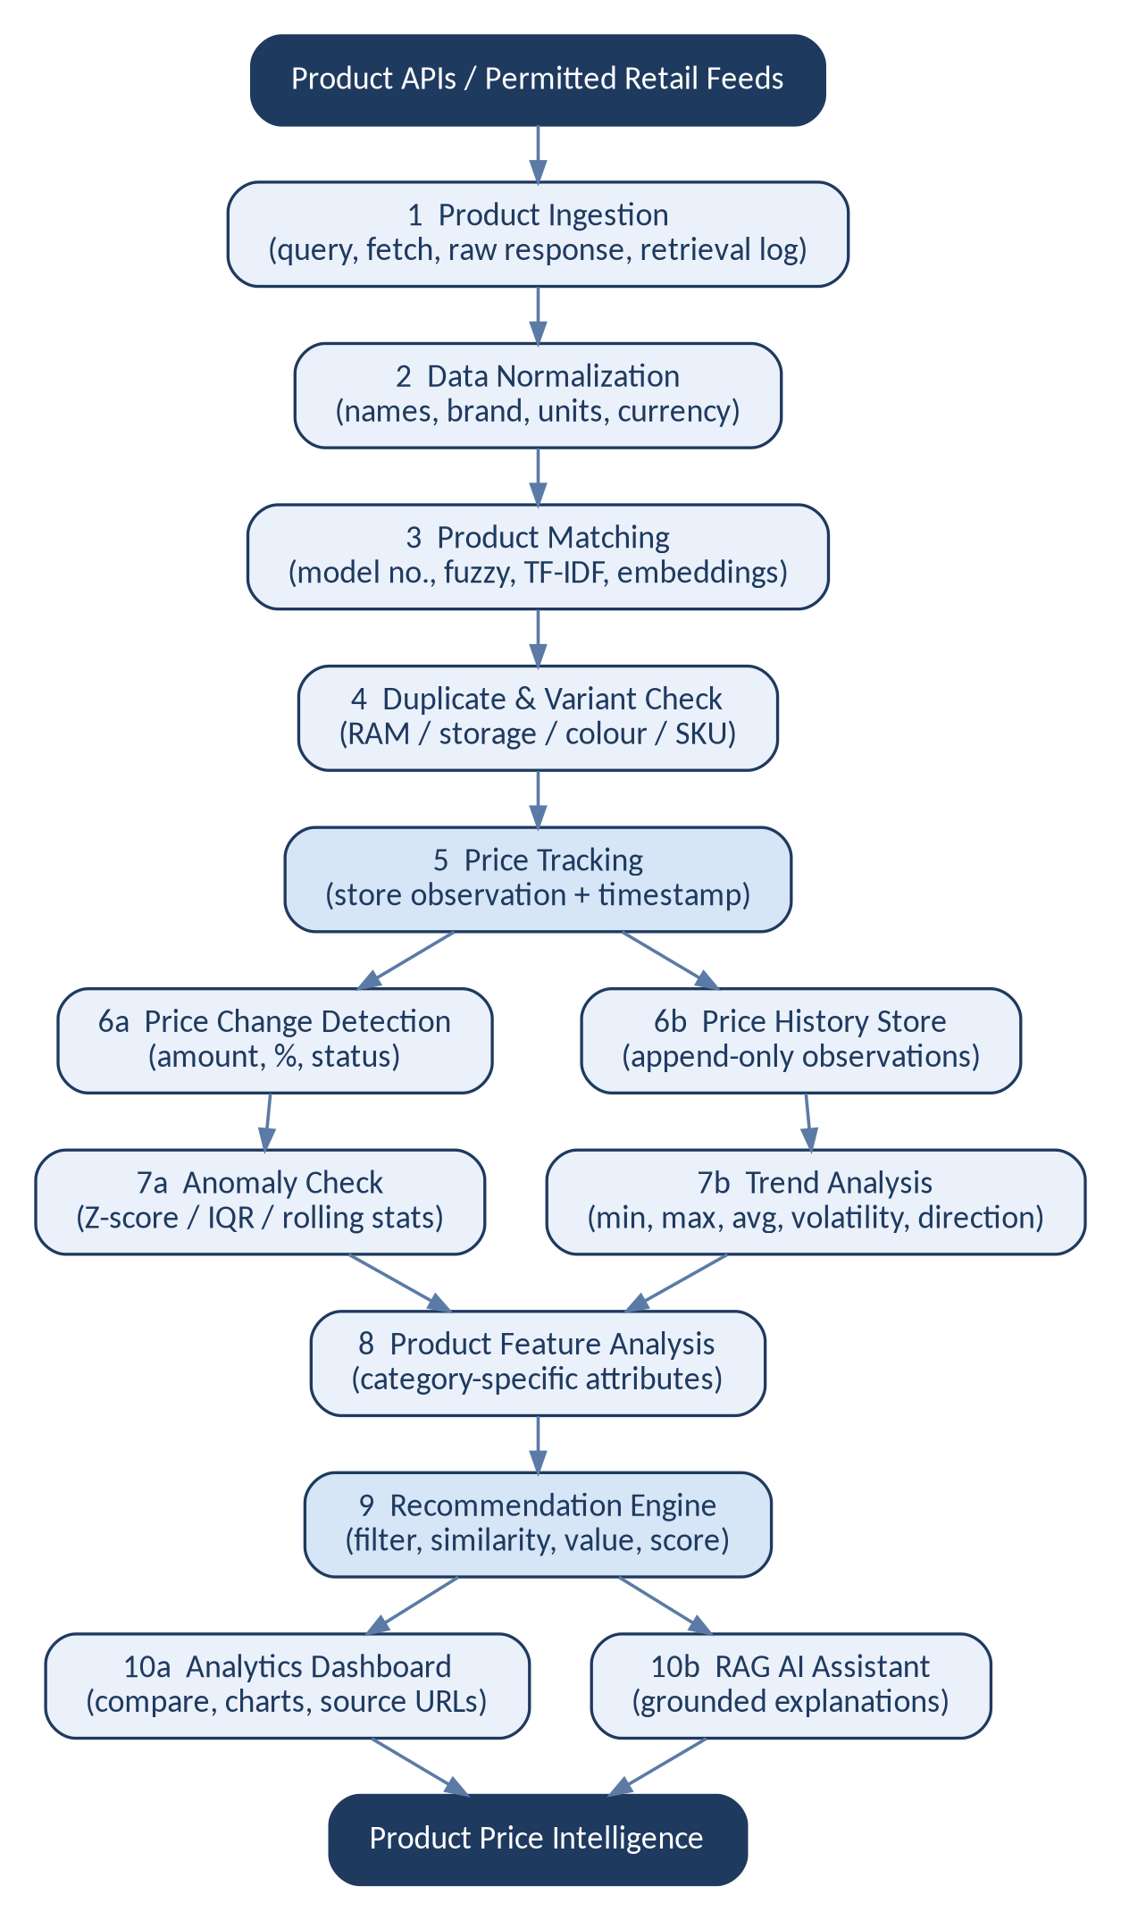
Figure 1: End-to-end project workflow

3.1 Stage summary
# | Stage | What happens | Output
1 | Product ingestion | Query supported APIs/feeds; store the raw response and retrieval log. | Raw product data
2 | Normalisation | Lowercase, strip punctuation, normalise brand, units, storage and currency. | Clean product records
3 | Product matching | Match on model number, fuzzy text, TF-IDF and semantic similarity. | Product groups
4 | Duplicate and variant check | Separate RAM, storage, colour and size configurations. | Distinct variants
5 | Price tracking | Store each observation with price, currency, source, time and availability. | Price observation
6 | Change detection and history | Compute change amount and %; append to history instead of overwriting. | Price status, history
7 | Anomaly and trend analysis | Flag unusual prices; compute statistics and trend direction. | Flags, trend labels
8 | Feature analysis | Extract category-specific attributes for comparison. | Feature vectors
9 | Recommendation engine | Filter, score and explain products against user requirements. | Ranked products
10 | Dashboard and AI assistant | Show comparisons, charts and grounded natural-language answers. | Product price intelligence

4. Stage-by-Stage Detail

4.1 Data source strategy and ingestion
A supported product or retail API is the primary structured source. Where a retailer exposes an authorised feed, it is integrated as an additional source so observations can be compared across providers. Before implementation, verify the following for each source:
1. Best Buy Product Dataset — CSV
Best Buy Product Dataset – Download CSV
It contains fields such as product name, brand, category, price, MRP, discount, availability, SKU, ratings and product URL.
This is the closest match to your Product Price Intelligence project.
2. Quick-commerce India dataset — Blinkit / Zepto / Instamart / BigBasket / DMart
QuickCommerceData – Product Catalogue & CSV Export
3. BigBasket Product & Pricing Dataset
BigBasket Dataset – CSV Sample/Download
Contains:
- Product
- Brand
- Category
- Price
- MRP
- Discount
- Availability
- Ratings
- Seller
- Product URL
- Scraped date
4. Blinkit Product & Pricing Dataset
Blinkit Dataset – CSV Sample/Download
Contains product pricing, MRP, discount, availability, category, ratings and other product attributes.
5. Free generic product CSV — easiest for testing
Datablist – Product CSV Downloads
They provide downloadable CSV datasets ranging from 100 to 1,000,000+ records, with fields such as product name, description, brand, category, price, currency, stock, EAN, availability, etc.

4.2 Standard product schema
All sources are converted into one common schema so that downstream components never depend on a provider's format.
Field | Purpose
product_id | Internal product identifier
source_product_id | Source-specific identifier
product_name, brand | Product name and brand
category, subcategory | Product classification
model_number | Model/SKU where available
variant | Size, colour, storage, etc.
description, specifications | Descriptive text and technical attributes
price, original_price, discount | Current observed price, list price and discount information
currency, availability | Currency and stock/availability
source_name, source_url | Retail/API source and product URL
retrieved_at, last_seen_at | Retrieval and last-observed timestamps
price_status | Price movement classification
product_group_id | Equivalent product group

4.3 Data normalisation
Different sources describe the same product differently. For example, "Sony WH-1000XM5 Wireless Headphones", "Sony WH1000XM5 Bluetooth Headset" and "WH-1000XM5 Noise Cancelling Headphones" should all resolve to the same model. Normalisation steps include:
- Lowercasing and removing unnecessary punctuation
- Brand normalisation and model-number extraction
- Unit standardisation: storage, weight, screen size, RAM/storage
- Currency normalisation where appropriate

4.4 Product matching and duplicate detection
Matching uses several signals in sequence rather than a single check, which reduces incorrect matches:
Step | Technique
1. Name normalisation | Clean and standardise product names
2. Brand match | Compare normalised brands
3. Model-number match | Exact model-number matching
4. Specification match | Rule-based specification comparison
5. Text similarity | Fuzzy string matching, TF-IDF, cosine similarity
6. Semantic similarity | Sentence embeddings
7. Product group | Assign product_group_id

4.5 Product variant detection
Variants must not be treated as the same purchasable configuration. A laptop offered as 8 GB / 512 GB, 16 GB / 512 GB and 16 GB / 1 TB is three distinct variants. The system identifies RAM, storage, colour, size, capacity, processor, display size, configuration and model number where available.

4.6 Price tracking and change detection
The historical price tracker is the central component. Each observation stores product_id, price, currency, source, retrieved_at and availability. For every new price:
Price Change = Current Price - Previous Price
Price Change % = (Current - Previous) / Previous x 100
Example: Previous = ₹10,000, Current = ₹8,500
Change = -₹1,500, so Change % = -15%
Status | Meaning
Price Increased | Current price is higher than the previous observation
Price Decreased | Current price is lower than the previous observation
No Change | Same observed price
New Product | No previous observation exists
Unavailable | Product is no longer available
Unknown | Insufficient price history

4.7 Price history and trend analysis
Historical observations are appended, never overwritten, so real trend analysis is possible. From the stored history the system calculates:
- Minimum, maximum, average and median observed price
- Most recent price and price-change percentage
- Price volatility and moving averages
- Trend direction: Increasing, Decreasing, Stable, Volatile or Insufficient history
Trend labels are derived from defined calculations, not arbitrary AI judgement.

4.8 Price-drop and anomaly detection
Price-drop alerts. Compare the recent price with the previous one and raise an alert when the drop exceeds a user-configurable threshold (for example, notify when the price falls by more than 10%). Example: ₹15,000 to ₹12,500 is a 16.67% drop.
Unusual movements. If a product normally sells for ₹20,000 to ₹21,000 and is suddenly observed at ₹13,500, this could be a genuine discount, a data error, a different variant, missing information or a temporary offer. The system therefore flags the observation for review instead of claiming a genuine sale. Suitable techniques are Z-score, IQR, rolling statistics and moving-average deviation.

4.9 Cross-source price comparison
When the same product is observed across sources, the dashboard lists each source with its observed price and retrieval time, and labels every value as an observed price at a specific moment because prices can change after retrieval.
Source | Observed price | Retrieved
Source A | ₹9,999 | 10:02
Source B | ₹10,499 | 10:04
Source C | ₹9,799 | 10:05

4.10 Feature extraction and category attributes
Price alone is not enough for recommendations, so the system extracts attributes using category-specific schemas:
Category | Attributes
Laptop | Processor, RAM, storage, GPU, display, battery, weight
Smartphone | Processor, RAM, storage, display, camera, battery, 5G
Headphones | Driver, battery life, ANC, connectivity, weight, microphone
All categories | Brand, model, price, rating (where available), availability

4.11 Recommendation engine
A hybrid approach is used: user preferences (budget, category, required features, preferred brand, usage) drive product filtering, then product similarity, value analysis and price/trend analysis feed a recommendation score.
Factor | Example weight
Feature match | 0.35
Budget fit | 0.25
Product similarity | 0.20
Price trend | 0.10
Availability | 0.10

Weights must be configurable and documented. They are project-defined assumptions, not universal measures of product quality.

Explainable value analysis
Rather than declaring "this is the best product", the system gives evidence-based statements, for example: this product matches 8 of your 10 selected features and its observed price is below its recent 30-day average.
Value indicators combine current price relative to the historical observed range, feature-to-price comparison, price trend and specification match.

4.12 RAG-powered AI assistant
The assistant answers questions using only the current product and price database (current price, price history, specifications, availability, source). Retrieved records are passed to the LLM, which produces a grounded response that cites the source and retrieval timestamp. Supported questions include:
- "I need a laptop under ₹60,000."
- "Show products with 16 GB RAM."
- "Which products have recently decreased in price?"
- "Compare these three products."
- "Show products whose current price is below their recent observed average."
Example grounded answer: It matches your selected requirements for 16 GB RAM and 512 GB storage. Its current observed price is ₹X, while its recent observed average was ₹Y. Price information was retrieved from [Source] at [Timestamp].

5. Real-Time Price Refresh Workflow
A scheduler queries each source at a controlled interval. Failures are logged and the last known data is retained, so an unavailable source never breaks the application. The refresh frequency must respect the provider's API limits and terms.
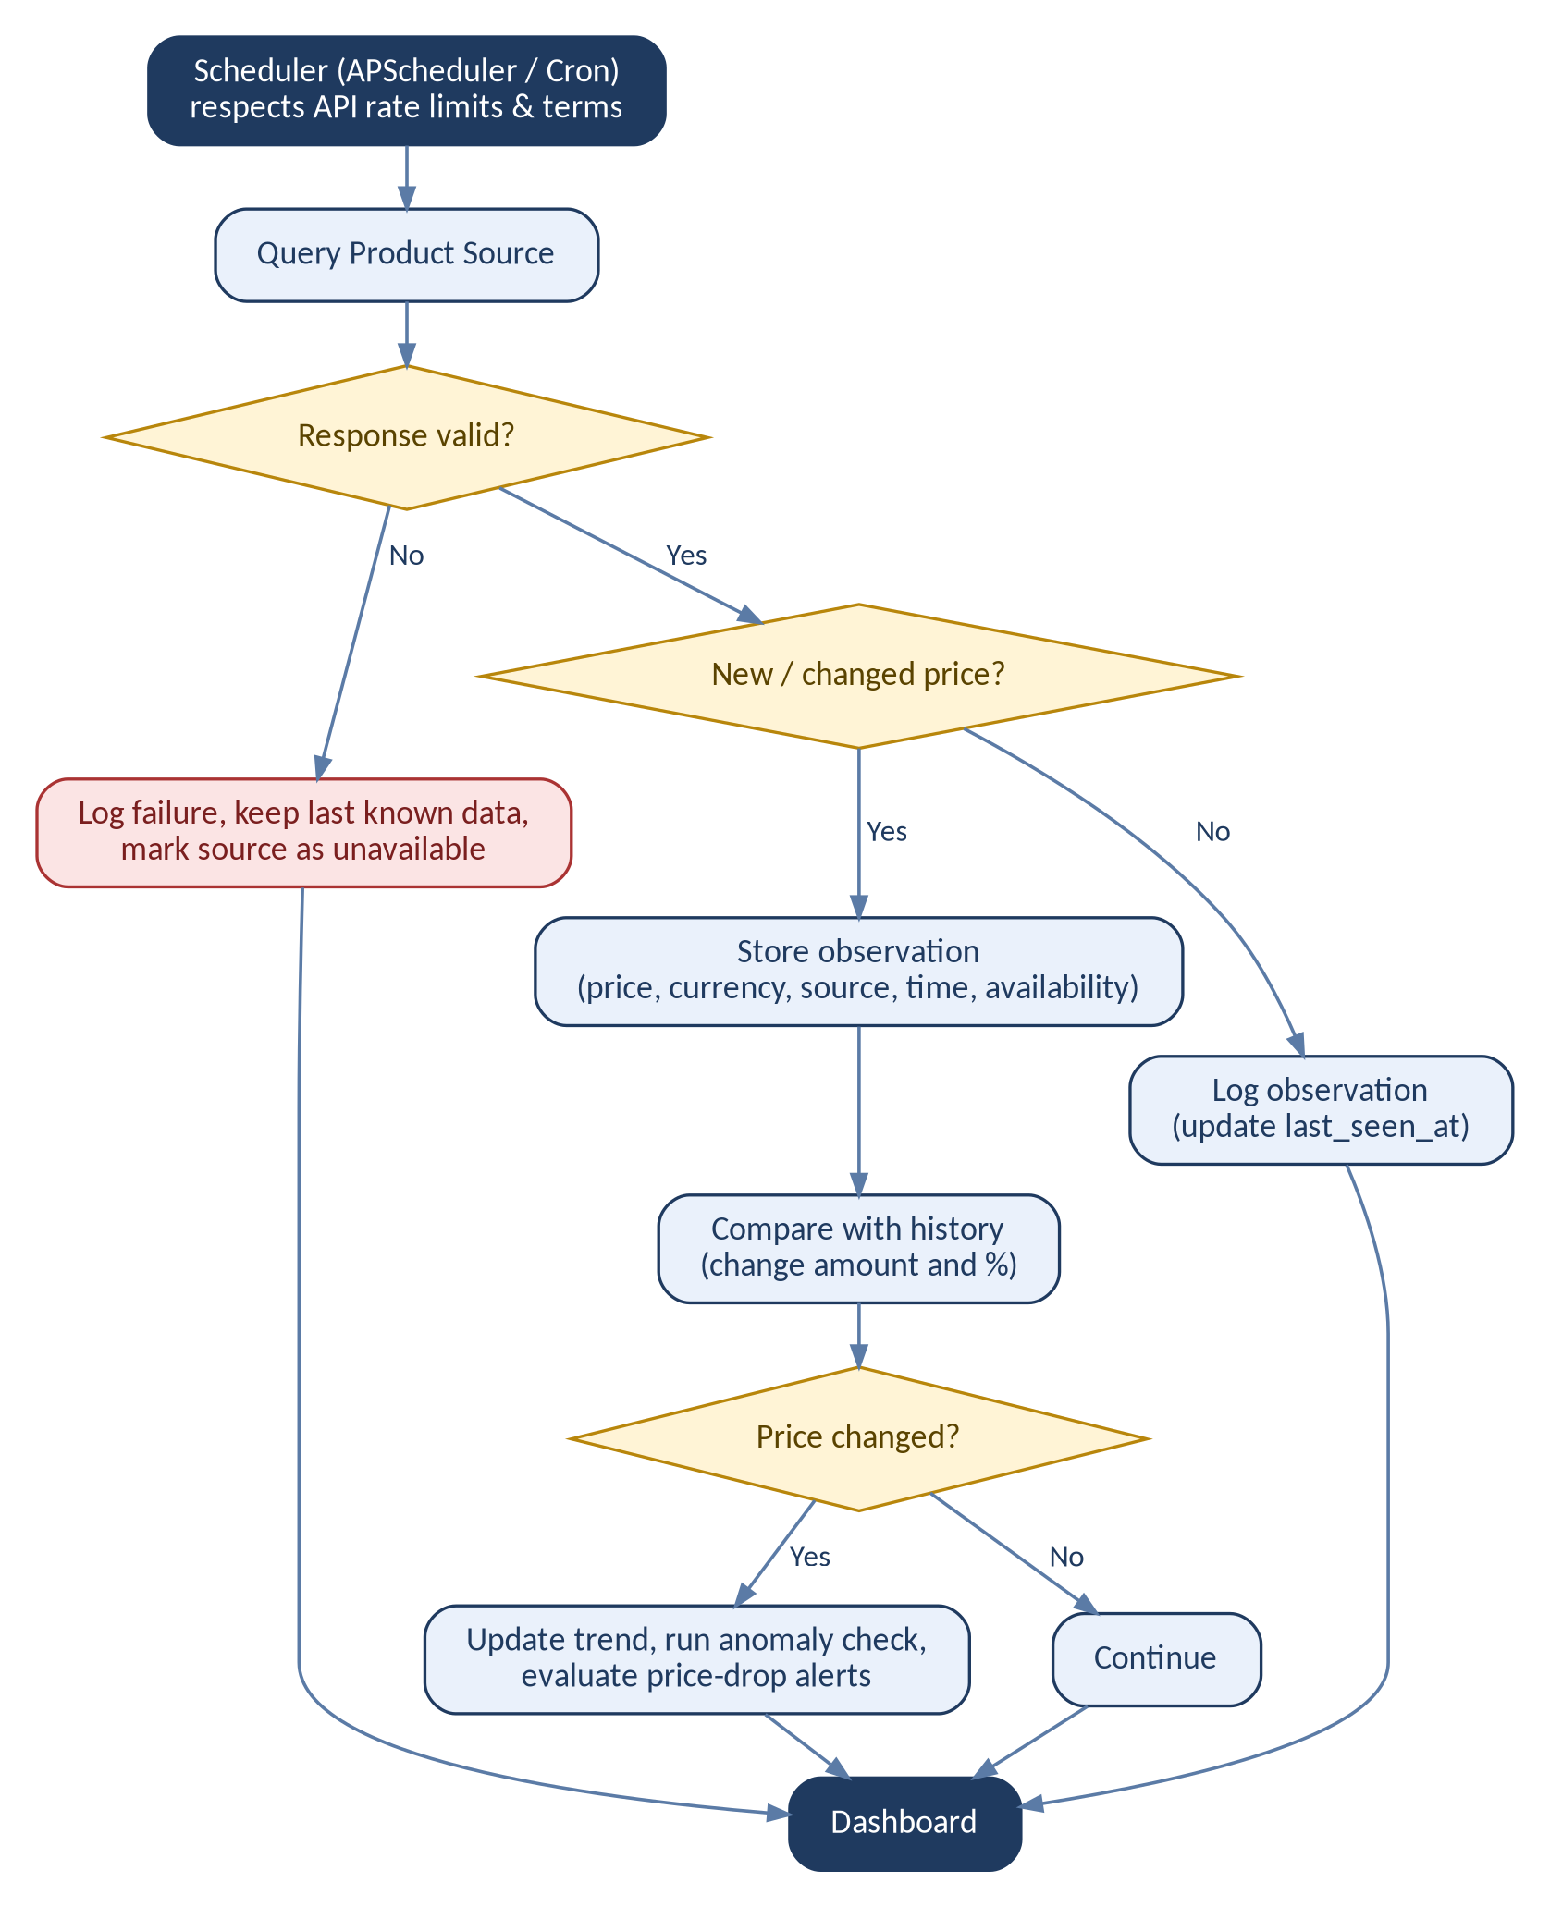
Figure 2: Scheduled price refresh workflow

6. End-to-End User Workflow
From the user's point of view, one session follows these steps:
- User selects a product category.
- User enters product requirements.
- System generates search parameters.
- Product APIs/feeds are queried and product records are collected.
- Data is normalised, equivalent products are identified and variants are separated.
- Current prices are stored and historical prices are updated.
- Price changes are calculated and price trends are analysed.
- Product specifications are extracted and products are filtered against user requirements.
- Recommendation scores are calculated and recommended products are displayed.
- Price history is shown and the user can compare products.
- The AI assistant explains recommendations.
- Source URLs and retrieval timestamps are displayed throughout.

6.1 Example results view
Product | Price | Trend | Matches requirements
Product A | ₹8,499 | Down 12% | Wireless, ANC, 30+ h battery, within budget
Product B | ₹9,199 | Stable | Wireless, within budget
Product C | ₹7,999 | Down 8% | Wireless, within budget
Product D | ₹9,699 | Up 4% | Wireless, ANC, within budget

Each result links to a price-history chart and a comparison view, and shows when the price was last retrieved (for example, 20 Sep 2026, 10:15 PM).

7. System Architecture and Technology Stack

7.1 Architecture layers
Layer | Responsibility
Web dashboard | Search, filters, comparison, price-history charts, alerts
FastAPI backend | REST API connecting the UI to search, analytics and assistant services
Product search engine | Fans out queries to API A, API B and retail feeds
Normalisation and matching | Cleaning, product matching, duplicate and variant detection
Price tracker | Stores observations and computes changes
Historical database | Price history, changes, alerts, retrieval logs
Analytics services | Price trends, anomaly detection, recommender
RAG assistant | Grounded natural-language answers over the database

7.2 Recommended technology stack
Layer | Technology
Programming / backend | Python, FastAPI
MVP frontend | Streamlit
Data processing and analytics | Pandas
Product API and feeds | Supported product/retail API; Requests / Feedparser
Database | SQLite / PostgreSQL
NLP and matching | spaCy / NLTK, fuzzy matching, Sentence Transformers
Similarity and recommendation | Cosine similarity, Scikit-learn / custom scoring
Visualisation | Plotly
Scheduling | APScheduler / Cron
Testing and version control | Pytest, Git/GitHub
Deployment | Docker + supported cloud

7.3 Database design
Table | Purpose
products | Master product information
product_variants | Product configurations
product_sources | Source URLs and providers
product_specifications | Product attributes
price_history | Historical price observations
price_changes | Detected price movements
product_categories | Product categories
user_preferences | Search preferences
product_matches | Product similarity
recommendations | Recommendation results
alerts | Price-drop alerts
retrieval_logs | API/feed retrieval history

8. Implementation Roadmap

8.1 72-hour MVP plan
Phase | Hours | Deliverables
Foundation | 0-10 | Repository, environment, schema
Product retrieval | 10-22 | API/feed integration
Data pipeline | 22-32 | Cleaning and normalisation
Product matching | 32-40 | Duplicate/equivalent detection
Price tracker | 40-48 | Current and historical price storage
Price analytics | 48-54 | Changes, trends, statistics
Recommendation | 54-61 | Filtering and scoring
Dashboard | 61-67 | Product comparison and charts
AI assistant | 67-70 | Basic grounded assistant
Testing and documentation | 70-72 | Tests, README, demo

8.2 Mandatory MVP deliverables
- Working application with live/authorised product data from at least one supported source
- Standard product schema, normalisation, matching, duplicate detection and variant handling
- Current price retrieval, historical price storage, price-change detection and trend analysis
- Product comparison and recommendation engine
- Source URL and retrieval timestamp display
- Interactive dashboard with price-history visualisation
- README, architecture diagram, test cases and documented limitations

8.3 Advanced track
Beyond the core MVP, the advanced track adds:
- Multi-source price comparison and variant intelligence
- Price-drop and personalised alerts; email and WhatsApp notifications
- Anomaly detection and category-specific recommendation models
- Semantic and natural-language product search; voice-based search
- RAG product assistant and personalised recommendation profiles
- Price-forecasting research module and automated daily reports
- Docker and cloud deployment

Optional price forecasting
Possible models are moving average, exponential smoothing, ARIMA, Prophet and XGBoost with engineered time features. Forecasts must be presented as model estimates with appropriate uncertainty, never as guaranteed prices.

9. Quality, Testing and Risk

9.1 Testing strategy
Category | Examples
API / feed | Success, timeout, invalid credentials, valid and unavailable feed
Parsing | Missing price or name fields
Normalisation | Different product-name formats
Matching and variants | Same product from two sources; different RAM/storage configurations
Price and history | Increase, decrease, unchanged; multiple observations
Trend and anomaly | Increasing/decreasing/stable trends; unusual price
Recommendation | Budget and feature matching
Dashboard | Search, filter, compare
Failure and database | External source unavailable; duplicate observations
End-to-end | Full retrieval-to-recommendation workflow

9.2 Measurable success criteria
Area | Criterion
Retrieval | Retrieve current product data from a supported source
Automation | Automatically refresh product observations
Standardisation | Convert source data into a common schema
Matching and variants | Identify equivalent records in test cases; distinguish configurations
Price tracking | Store historical observations and calculate movement correctly
Trend and comparison | Generate trend statistics; compare sources and products
Recommendation | Generate requirement-based recommendations with reasons shown
Traceability and freshness | Display source, product URL and retrieval timestamp
Usability and resilience | Demonstrate the full workflow; handle an unavailable source

9.3 Risks and mitigation
Risk | Mitigation
API unavailable | Use multiple supported sources
API rate limits | Caching and controlled refresh
Prices change rapidly | Store retrieval timestamps
Duplicate products or variants | Product matching; model/SKU/specification matching
Incorrect product matching | Combine multiple matching signals
Missing price | Mark as unavailable/incomplete
Incorrect discount information | Preserve source fields
Data anomaly | Statistical anomaly detection
AI hallucination | Ground recommendations in the database
Availability changes | Store observed availability
Restricted retailer | Use authorised APIs/feeds only
Limited development time | Prioritise the MVP
Historical data unavailable | Build history through scheduled collection

10. Ethical and Technical Rules
- Use only authorised APIs, feeds or permitted data sources; do not rely on unauthorised scraping.
- Respect provider terms and rate limits.
- Preserve source attribution and product URLs.
- Do not fabricate prices or invent discounts.
- Do not claim a product is available when availability is unknown.
- Display when each price was retrieved.
- Clearly distinguish observed prices from guaranteed purchase prices, and never guarantee a price will remain available.
- Do not present price predictions as certainty.
- Do not claim complete retailer coverage.

11. Final Project Definition
The AI-Powered Real-Time Product Price Intelligence & Recommendation System is a multi-source product intelligence platform that continuously retrieves currently available product and pricing information from supported APIs and permitted feeds, standardises and matches product records, distinguishes variants, maintains historical price observations, detects price changes and unusual movements, analyses price trends, compares product specifications and prices, and generates explainable personalised product recommendations through an interactive dashboard and AI assistant.
Recommended internship title: AI-Powered Real-Time Product Price Intelligence, Price Trend Analysis & Recommendation System

