Home Network Lab Guide

Beginner-Friendly Cybersecurity & Networking Lab Setup

Prepared as a step-by-step guide with resources, configurations, and roadmap.

# Introduction

This is a renewed PDF version of the Home Network Lab Guide.

# Setup Guide

Follow the detailed steps inside to build your network lab.

# Network Diagram

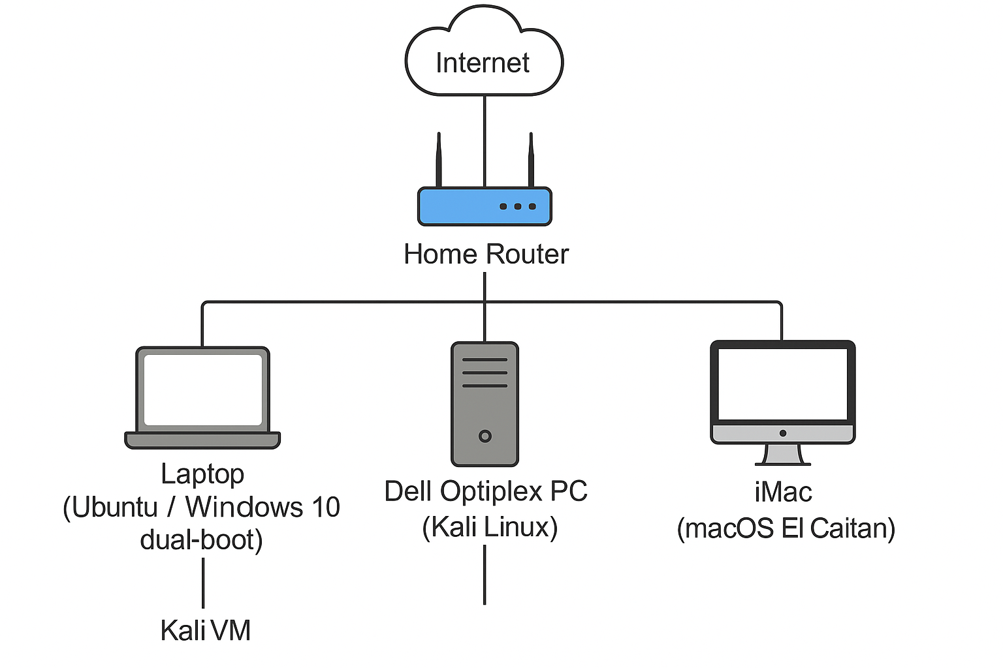

Figure: Home Lab Network Topology