**Submission Date:**

February 15, 2018

**ITA Project Report 1:**

15CO211 - B. Vasudha

15CO239 - R. RuhiTaj

15CO253 - Y. M. Greeshma

***Introduction:***

A calendar which is similar to the traditional calendar, but it has software linked in each date. The crawler gets activated as we click on the date. The crawler in beautiful Soup of Python starts searching for the coding competitions online, all around the world. Hence, when we want to code previous or current competitions of different websites on any particular date or code marathons, we can just click on the date and access the competitions. We can also view competitions organized in future on any date as announced by the competition. We plan to sort or arrange these competitions based on duration of these competitions (hours/weeks/years). Hence it has a great usage in today’s digital world, where coding is of maximum priority.

***Literature Survey:***

Although the idea is a completely new one, the inspiration to the idea comes from a company that collects the data of a particular product from all the other online shopping companies and makes the process of online shopping easy and cheap.

***Design:***

The idea in itself is an entirely new one. So, we build the crawler, front end, back end and website structures from scratch. The website would contain a calendar decorated by other links and methods supporting competitive coding environment.

***Implementation:***

*Web Development:* Django Framework, Python, Java Script

*Front End:* HTML, CSS, AJAX, Java Script

*Back End:* MySQL, Java Script

*Crawling:* Beautiful Soup in Python

The two snapshots given below show the Home page.



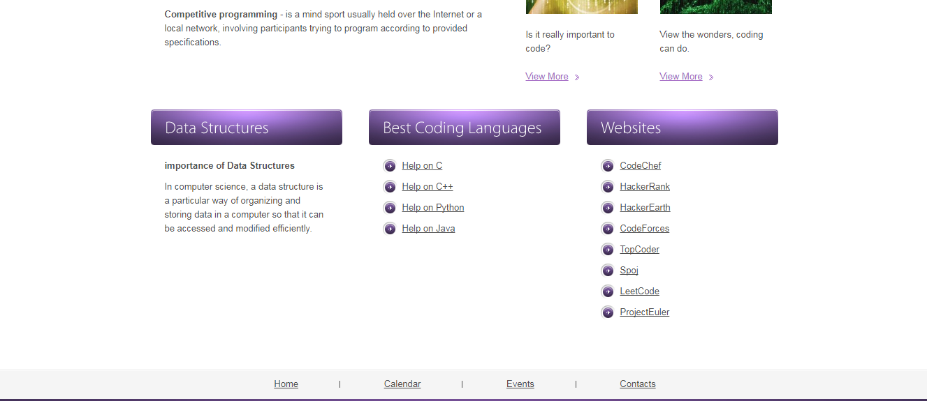

The two snapshots given below show the Calendar page.

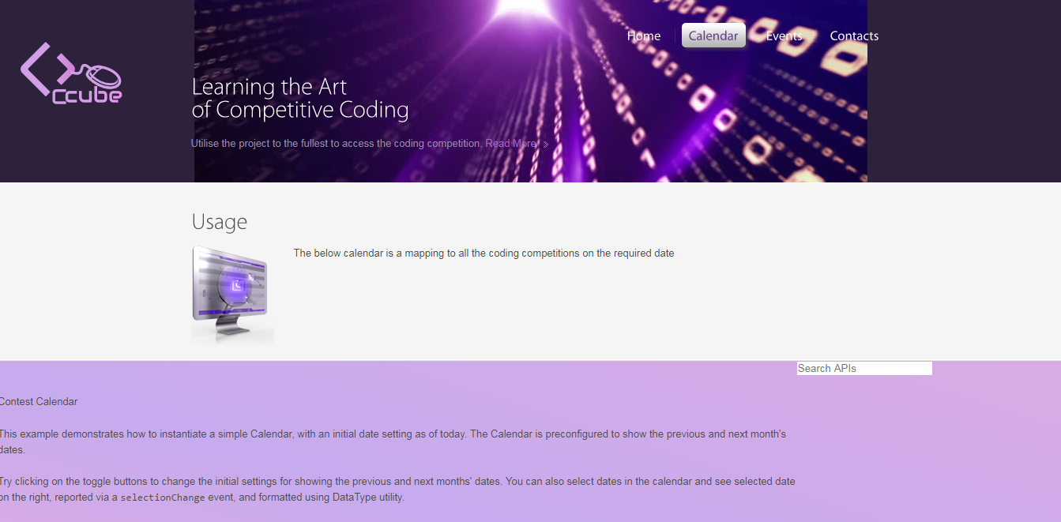

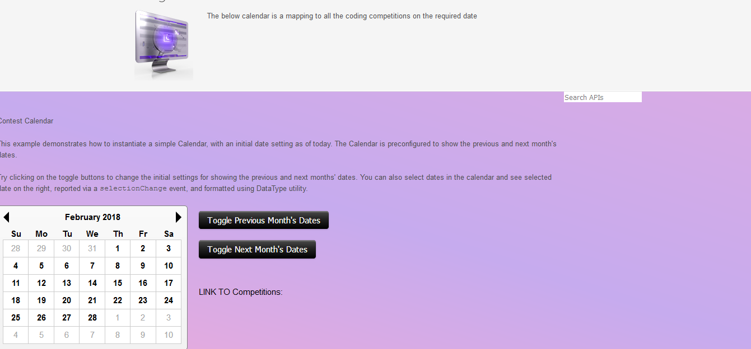

The snapshot given above show the Events page.

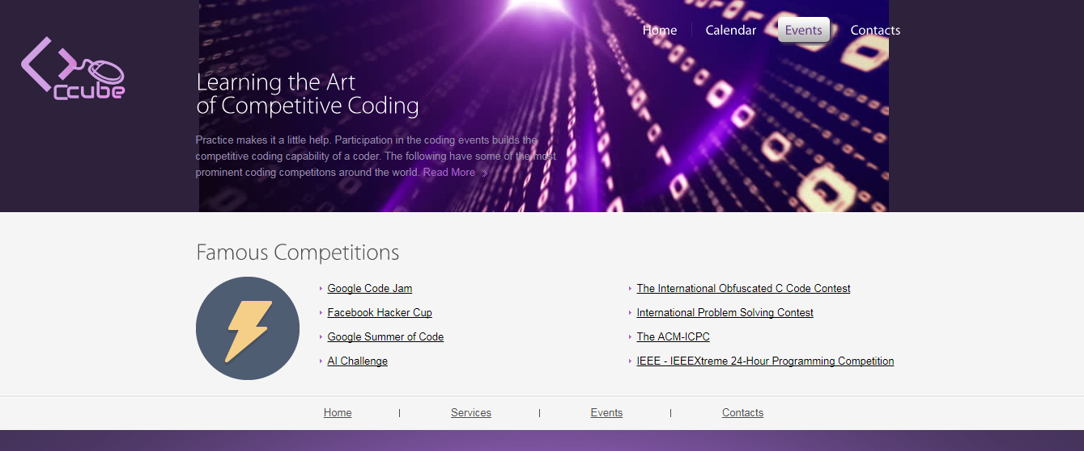

The snapshot given above show the Contacts page.



***Work done so Far:***

Front end of the website is prepared using HTML, CSS, JavaScript and AJAX. Data from websites has been collected by crawling from different websites like spoj, codechef, hackerrank, hackerearth, codeforces, leetcode, techgig. But, we have completely functional codes and; data to some of these websites and have to work on the websites.

***Work yet to be done***:

Web Crawling from the other websites and collection of data into database. It requires linking the designed front end to the back end using Django in Python. Before linking the data to the back end, the website needs to be sorted in the database for convenient querying of the data, to sort or arrange the data into back end and hence to the front end.