Day – 01 Linux Commands

* Touch:- Create a file – Empty File
* Echo:- Create a file with some content
* Cat:- Shows the content of the file
* Nano:- Opens the nano editor
* Vi:- Opens the Vi editor
* MV:- Move file from one place to another
* Mkdir:- Create a folder or directory
* Rmdir:- Removes the folder or directory
* Cp:- Copy the file content from one to another
* History:- Shows all the commands which have been already run.

Note:- >> is used to append the file content and prevent from overwritten.

* 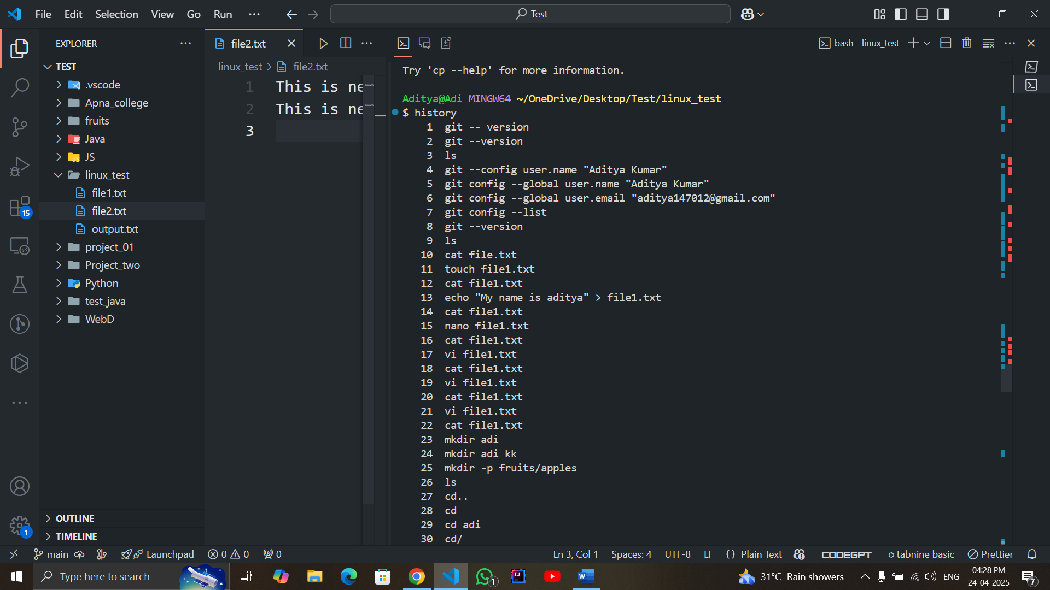

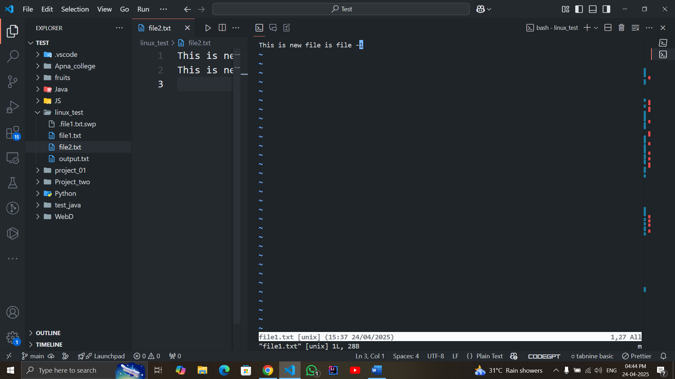

Today’s Tasks

1. Create a directory and few files in it.

Ans:- mkdir test

Touch file1.txt

Touch file2.txt

.

.

And so on

1. Rename one of the file.

Ans:- mv data.txt report.txt

1. Create multiple files in a single command.

Ans:- Touch file1.txt file2.txt file3.txt

1. Combine multiple files in a single command and redirect their output to a single file

Ans:- Cat file1.txt file2.txt > Output.txt

Day – 2 Task - Number System

* 1 bit number

Range – 1

Possible combination – 2 ^1 = 2

* 2 bit number

Range – (0 – 3)

Possible combination – 2 ^2 = 4

* 3 bit number

Range – (0 – 7)

Possible combination – 2 ^3 = 8

* 4 bit number

Range – (0 – 15)

Possible combination – 2 ^4 = 16

* 5 bit number

Range – (0 – 31)

Possible combination – 2 ^5 = 32

* 6 bit number

Range – (0 – 63)

Possible combination – 2 ^6 = 64

* 7 bit number

Range – (0 – 127)

Possible combination – 2 ^7 = 128

* 8 bit number

Range – (0 – 255)

Possible combination – 2 ^8 = 256

Quiz

1. A
2. C
3. A
4. A
5. C
6. –
7. A
8. A
9. C
10. C
11. A
12. A
13. A
14. B
15. A
16. A
17. A
18. A
19. A
20. –
21. A
22. A
23. A
24. –
25. –
26. A
27. C
28. –
29. –
30. A
31. A
32. A
33. –
34. –
35. A
36. A
37. C
38. A
39. –
40. –

Daily Task:- Find the two program and how it works in microcontroller

* Add program

Mov A, #08H - # is used to assign for immediate values and H is used to denote Hexadecimal values

ADD A, #05H

End – Stops for further accepting values

* Sub Program

Mov A, #08H

SUBB A, #05H – BB is used to perform carry add

End