***HTML***

❖ **WWW Architecture:**

* World Wide Web, which is also known as a Web
* Web is a collection of websites or web pages stored in web servers and connected to local computers through the internet.
* These websites contain text pages, digital images, audios, videos, etc.
* Users can access the content of these sites from any part of the world over the internet using their devices such as computers, laptops, cell phones, etc.
* The WWW, along with internet, enables the retrieval and display of text and media to your device.



* A web page is given an online address called a Uniform Resource Locator (URL).
* A particular collection of web pages that belong to a specific URL is called a website, e.g., *www.facebook.com*, *www.google.com*, etc.

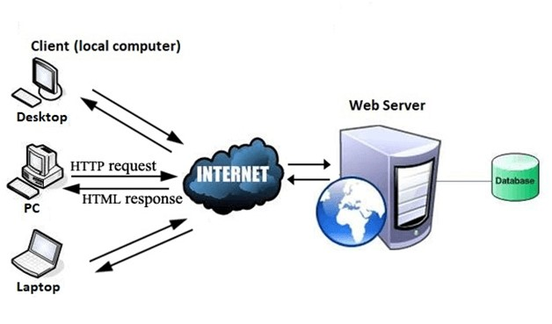

**[Architecture of www]**

* **Fundametals of HTML:**

* + HTML stands for HyperText Markup Language .
  + HTML is used to create web pages and web applications.
  + HTML is widely used language on the web.
  + We can create a static website by HTML only.
  + Technically, HTML is a Markup language rather than a programming language.
  + HTML is used to design any webpages.
  + HTML File Must be save with **“.html”**  extension.

|  |  |
| --- | --- |
| **Element name** | **Description** |
| <b> | Bold the text. |

<html>

<head> <tittle> …… </title>

</head> <body>

….. different html tags …….

</body>

</html>

* **Text Formatting Tags:**

**1.<b>:**

**Description:**

This tag are used to display a text in bold phase.

**Example:**

<b>hello how r u?</b>

* **Marquee Tag:-**

▪ **Description:**

* + - * The **Marquee HTML** tag is a non-standard HTML element which is used to scroll a image or text horizontally or vertically.

|  |  |
| --- | --- |
| <strong> | It highlight the text in bold phase. |
| <i> | It display the text in italic form. |
| <em> | It highlight the text and display content in italic. |
| <mark> | This tag is used to highlight text with yellow background color. |
| <u> | This tag is used to underline text. |
| <strike> | This tag is used to draw a strikethrough on a section of text. |
| <sup> | It displays the content slightly above the normal line. |
| <sub> | It displays the content slightly below the normal line. |
| <big> | This tag is used to increase the font size by one conventional unit. |
| <small> | This tag is used to decrease the font size by one unit from base font size. |

* + - * In simple words, you can say that it scrolls the image or text up, down, left or right automatically.

▪ **Example:**

**<marquee** width="100%" behavior="scroll" bgcolor="pink"**>**

This is an example of a scroll marquee...

**</marquee>**

|  |  |
| --- | --- |
|  | |
| **Attribute** | **Description** |
| Behaviour | It facilitates user to set the behavior of the marquee to one of the three different types: scroll, slide and alternate. |
| Direction | defines direction for scrolling content. It may be left, right up and down. |
| Width | defines width of marquee in pixels or %. |
| Height | defines height of marquee in pixels or %. |
| Hspace | defines horizontal space in pixels around the marquee. |
| Vspace | defines vertical space in pixels around the marquee. |
| Scrolldelay | defines scroll delay in seconds. |
| Scrollamount | defines scroll amount in number. |
| Loop | defines loop for marquee content in number. |
| Bgcolor | defines background color. It is now *deprecated*. |

**Property Of Marquee Tag:**

* **List Tag:**

**Description:**

• There are 3 type of list available in html.

**Order List**

**UnOrder List**

**Definition List**

**1. Order List:**

* + - * + Order list define the list as an order wise like,
        + **Numeric order**
        + **Alphabetic order**
        + **Roman latter order**

* + - * + Order list create by <ol> tag.
        + You want to assign type property with <ol> tag.
        + Type property set three values like either 1 or A or I.
        + List of items are define by <li> tag.

**2. Unorder List:**

* + - * + UnOrder list define the list as a Symbolic notation

* + - * + UnOrder list create by <ul> tag.
        + You want to assign type property with <ul> tag.
        + Type property set following 3 values.
        + **Square**
        + **Circle**
        + **Oval**
        + List of items are define by <li> tag.

**3.Definition List:**

* + - * + Definition list define terms and description format.
        + Definition list define by <dl> tag.
        + Definition term define by <dt> tag.
        + Definition data define by <dd> tag.

* **Image Tag:** 
  + Image tag are used to display any type of image in your browser.
  + Image are create by <img> tag.
  + Image path are set by src property.

* + Example:
  + <img src=”d://a1.jpg” name=”image1” />

* + **Link Tag:**
  + Link tag are provide by <a> anchor tag.
  + Link tag are used to create dynamic page.
  + <a> tag have 2 property like,
  + Href=”path”
  + Target=”_blank” / ”_parent”/ ”_top”.

* + Example:

<a href=[https://www.google.com“](https://www.google.com/) target=”_blank” />

* **Frame Tag:** 
  + HTML <frame> tag define the particular area within an HTML file where another HTML web page can be displayed.
  + A <frame> tag is used with <frameset>, and it divides a webpage into multiple sections or frames, and each frame can contain different web pages.
  + Example:

<frameset rows=”50%,30%,*”> <frame src=”abc.html”/>

|  |  |
| --- | --- |
|  | |
| **Tag** | **Description** |
|  |  |
| <table> | It defines a table. |
| <tr> | It defines a row in a table. |
| <th> | It defines a header cell in a table. |
| <td> | It defines a cell in a table. |

<frame src=”xyx.html”/>

<frame src=”a1.html”/>

</frameset>  **Table tag:**

* + **HTML table tag** is used to display data in tabular form (row * column). There can be many columns in a row.
  + We can create a table to display data in tabular form, using <table> element, with the help of <tr> , <td>, and <th> elements.
  + In Each table, table row is defined by <tr> tag, table header is defined by <th>, and table data is defined by <td> tags.

**HTML Table Tags**

* + Table rows are merge by “rowspan” property.
  + Table columns are merge by “colspan” property.
* **Form Tag:** 
  + An **HTML form** is *a section of a document* which contains controls such as text fields, password fields, checkboxes, radio buttons, submit button, menus etc.

<

caption

>

It defines the table caption.

* + An HTML form facilitates the user to enter data that is to be sent to the server for processing such as name, email address, password, phone number, etc. .

* + **Controls of Form tag:**

|  |  |  |
| --- | --- | --- |
| **controls**  **name** | **Description** | **Example** |
| Textbox | Accept single line input | <input type=”textbox” name=”fname”/> |
| TextArea | Accept Multiline input | <textarea cols=20 rows=3 name=”address”/> |
| Emailbox | Create email format textbox | <input type=”email” name=”e1”/> |
| PasswordField | Create password base textbox | <input type=”password” name ”/> |
| Checkbox | Create a multiple selection from option | <input type=”checkbox” name=”cricket” checked/> |
| RadioButton | Create only one selection from option | <input type=”radio” name=”gender”/> |
| File | Validate for  attach any type  of file | <input type=”file” name=”file1”/> |
| Button | Create normal button | <input type=”button” name=”ok” value=”ok”/> |
| Submit | Create button and submit form detail to server | <input type=”submit” name=”submit” value=”submit”/> |
| Selection Box | Create list type selection box | <select name=”city”> <option name=”baroda”  value=”baroda”>baroda</option>  <option name=”rajkot”  value=”rajkot”>rajkot</option>  </select> |