THE POLITICS OF FORMATION
  - Chule “KK” Papiyana and the Making of a Generation
By Zola Pinda
Some people are remembered for the offices they held. Others are remembered by the people they helped to form. Chule “KK” Papiyana belongs to the second category.
I knew KK as a friend, a mentor and a comrade, at a time when student politics was not a rehearsal for public life. It was public life, conducted under pressure and with real consequences.
To write about him now is not simply to offer a tribute to a departed comrade. It is to examine a form of political education that shaped a generation of black students in the last years of apartheid and the difficult dawn of democracy. The central question is not whether KK held important positions. It is what he taught those of us who worked with him — about reading, organising, argument, discipline, leadership and the responsibilities that accompany political conviction.

THE WORLD THAT FORMED US
The late 1980s and early 1990s were a period of political change and uncertainty. Apartheid was weakening, but it remained intact. Liberation movements were moving towards legality, while the shape of the post-apartheid order was still contested. For students, the question was therefore not only whether apartheid would end, but what would replace it and who would be prepared to build the new order.
SANSCO emerged from debates within black student politics about political direction, organisational independence and the relationship between Black Consciousness and the Congress tradition. Its formation in 1986 reflected a movement already thinking about how student organisation should respond to a changing political environment.
By the time SANSCO entered its final negotiations with NUSAS, years of resistance, repression, internal debate and practical organising had accumulated. The 1991 merger was therefore more than an administrative arrangement. It was a debate about the political character of the student movement and its place in the emerging democratic order.
KK came of age inside these debates, where political conviction had to be matched by organisation and argument.
By November 1987, KK was president of the Black Students Movement at Rhodes and had been detained by the security police. His detention became a campus issue, demonstrating how closely student politics had become connected to the wider struggle. His political education was therefore not abstract. It was formed under conditions in which ideas, organisation and personal risk were inseparable.
Contemporary recollection places him among young organisers working across the Eastern Cape, including the establishment of COSAS branches. Rhodes therefore represented not the beginning of his political education but another stage in it: a new intellectual and organisational environment in which experience acquired under repression could meet the formal study of politics, history and journalism.
KK did not arrive at Rhodes as a political beginner. By the time he came to Grahamstown in 1986, he had already experienced the consequences of political commitment. He had been expelled from Fort Hare in 1985 for anti-apartheid activities and had already learned something about organising under conditions of repression.
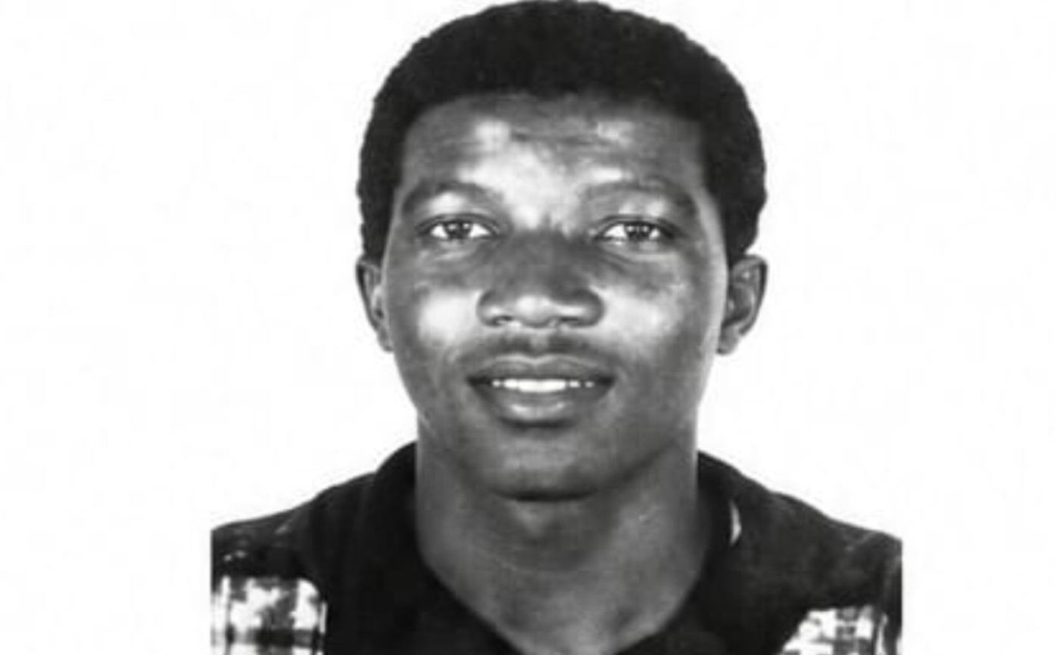
Chule “KK” Papiyana — archival head-and-shoulders portrait.

KK ARRIVED ALREADY FORMED
KK's political formation had already been tested at Fort Hare. He was expelled from the university in 1985 for anti-apartheid activities and subsequently experienced detention and police harassment. When he arrived at Rhodes in 1986, he brought that experience with him. Rhodes was therefore not the beginning of his political education; it was a new setting in which an already formed political consciousness encountered formal study, journalism and a different organisational environment.
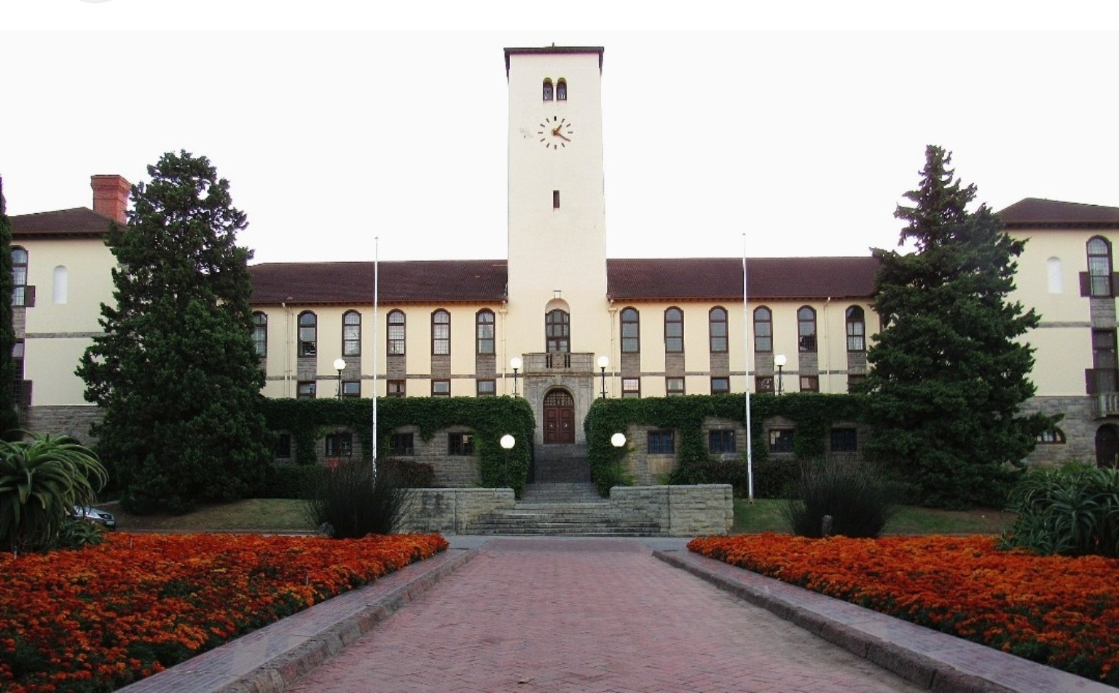
Rhodes University — the setting for the political and intellectual formation described in this essay.

THE UNIVERSITY AS A POLITICAL CLASSROOM
Rhodes presented a particular contradiction for black students. It was an elite institution with a strong liberal academic tradition, while the surrounding Eastern Cape was experiencing political upheaval and state repression.
For us, the university presented two demands at once: master the academic curriculum and understand the institution we were trying to change.
My own formation happened in more than one classroom. At Rhodes I studied politics and journalism in an intellectual environment shaped by teachers such as Gavin Stewart, Terence Beard, Roger Southall and Don Pinnock. The university taught us to interrogate ideas, institutions and evidence; the movement required us to test those ideas in practice.
Gavin Stewart was particularly important to my understanding of journalism. He brought newsroom experience into the classroom and insisted on professional standards, accuracy and the responsibilities of the craft. That discipline mattered in a political environment where information itself was contested.
Professor Beard represented another intellectual tradition: political philosophy, liberal thought and opposition to apartheid. Roger Southall brought political economy, labour and the study of changing South African politics into sharper focus. Don Pinnock’s work across journalism, sociology and criminology encouraged a way of seeing politics through the social conditions in which people actually lived.
These were not interchangeable influences. Their significance was that they gave us intellectual tools.
KK operated in another classroom — the movement itself. He took political ideas into meetings, residences, negotiations and the long roads between campuses. The two forms of education were mutually reinforcing. The university taught us to interrogate politics; the movement required us to test those ideas in practice. KK helped connect political theory to political conduct.

KK AND THE DISCIPLINE OF LEADERSHIP
KK was not the loudest person in the room; he did not need to be. He listened, weighed an argument and then spoke with a precision that usually moved the discussion forward.
What distinguished him was intellectual discipline. He challenged sloppy reasoning. He pushed younger comrades to read more seriously, argue more rigorously and understand the institutions they were confronting.
He understood that anger on its own was not enough. It had to become thought, organisation and a programme that people could carry.
That principle shaped the way he approached student politics. A campaign could not be reduced to a slogan. A demand had to be understood. An opponent had to be understood. The institutional machinery behind a decision had to be understood.
I remember KK insisting that black activists at Rhodes could not afford academic mediocrity in the name of political commitment. The lesson I remember most clearly was that we had to “conquer the book and the street simultaneously.” The principle was unmistakable: political activism did not excuse intellectual laziness.
That was important because the university itself was an object of political struggle. To challenge institutional racism effectively, one had to understand statutes, committees, budgets, governance structures and the language through which institutions defended themselves.
KK’s political education was therefore practical. He wanted activists who could think, organise and explain.
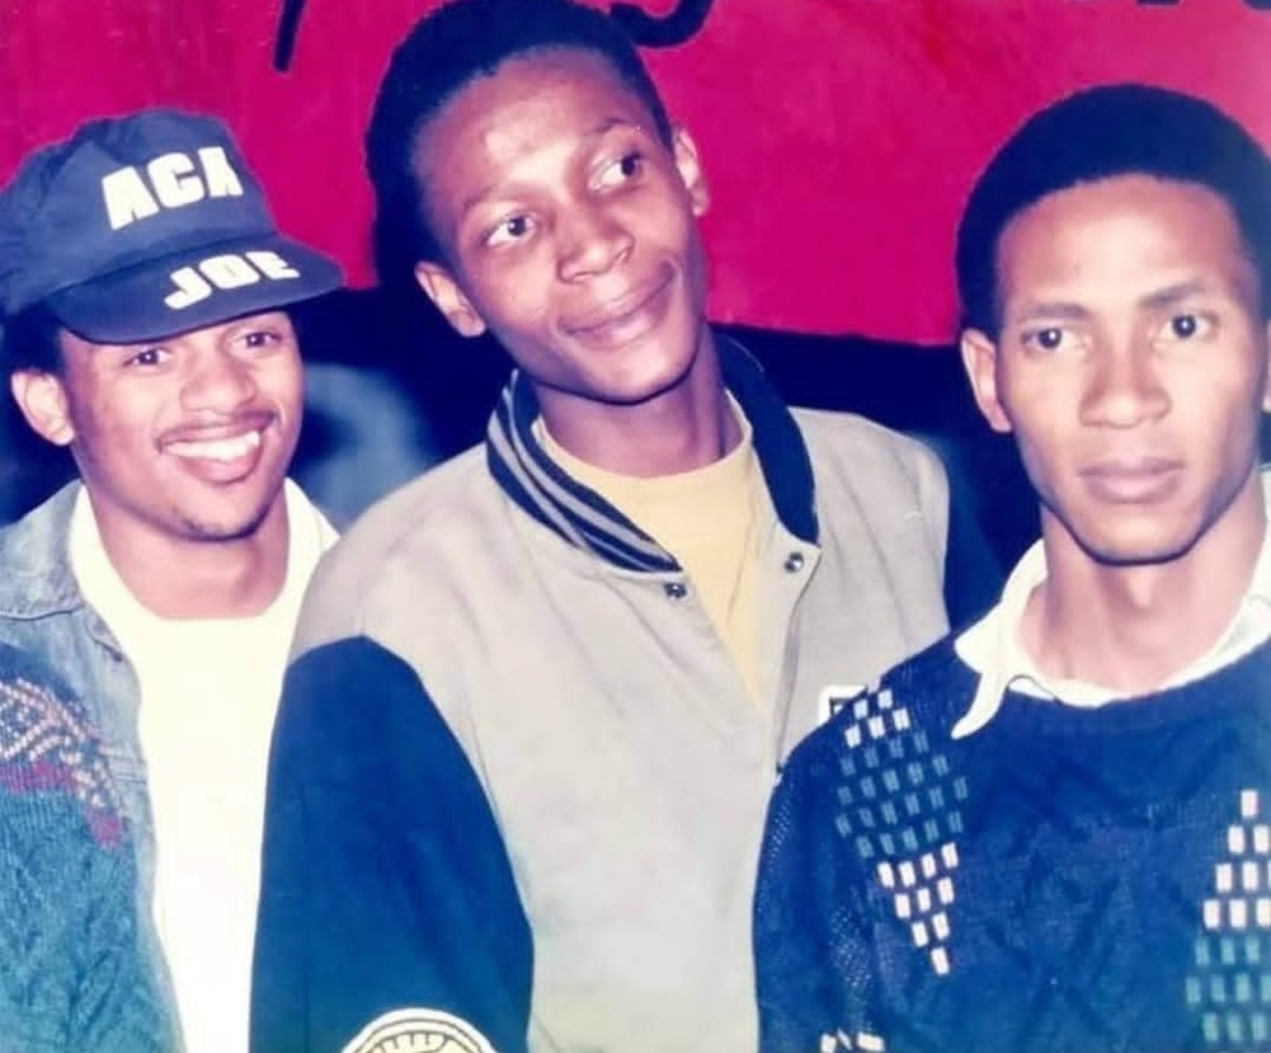
A student-era photograph from a generation whose friendships, debates and journeys helped shape South Africa’s political transition.

FROM CAMPUS POLITICS TO THE NATIONAL STRUGGLE
The Black Students Movement at Rhodes connected campus politics to the wider struggle. Student residences, SRC offices, lecture halls and informal political meetings became places where questions of race, access, curriculum, dignity, worker solidarity, state repression and democratic participation were debated.
The SANSCO affiliate at Rhodes was proscribed under apartheid regulations in December 1988, and police raids on SANSCO and SRC offices demonstrated that student politics was not being treated by the state as harmless campus activity.
KK understood that the student movement was not a self-contained world. SANSCO operated within the wider mass democratic movement and maintained an important relationship with the UDF. Campus struggles connected to community struggles; student politics connected to the national question.
That wider political ecology matters when remembering KK. His influence cannot be understood simply through the titles he held. It has to be understood through the political education he provided inside a movement that was itself trying to understand what kind of democratic future it wanted.

1991: THE POLITICS OF FORMATION IN PRACTICE
The culmination came at Rhodes in September 1991.
About 600 students from 129 tertiary institutions gathered from 1 to 6 September under the banner “Towards a Single Non-Racial Student Organisation”. The discussions that produced SASCO were substantive and, at times, heated. Questions of organisational structure, African leadership, working-class leadership, women’s leadership and the character of the new organisation were not side issues. They went to the identity of the movement that was being created.
KK served as a political commissar during this process. In that role, as I remember it and as historical accounts record, he helped summarise debates, clarify positions and keep political argument connected to organisational purpose.
The title carried a particular responsibility in the tradition from which we came. It involved political education, coherence and discipline. The significance of KK’s contribution lies there. He could operate inside disagreement without treating disagreement as disloyalty. He understood that unity required argument, not the suppression of argument.
The formation of SASCO therefore provides one of the clearest examples of the kind of politics KK practised: serious engagement with competing positions, patience with political education, and an insistence that tactical decisions remain connected to principle.
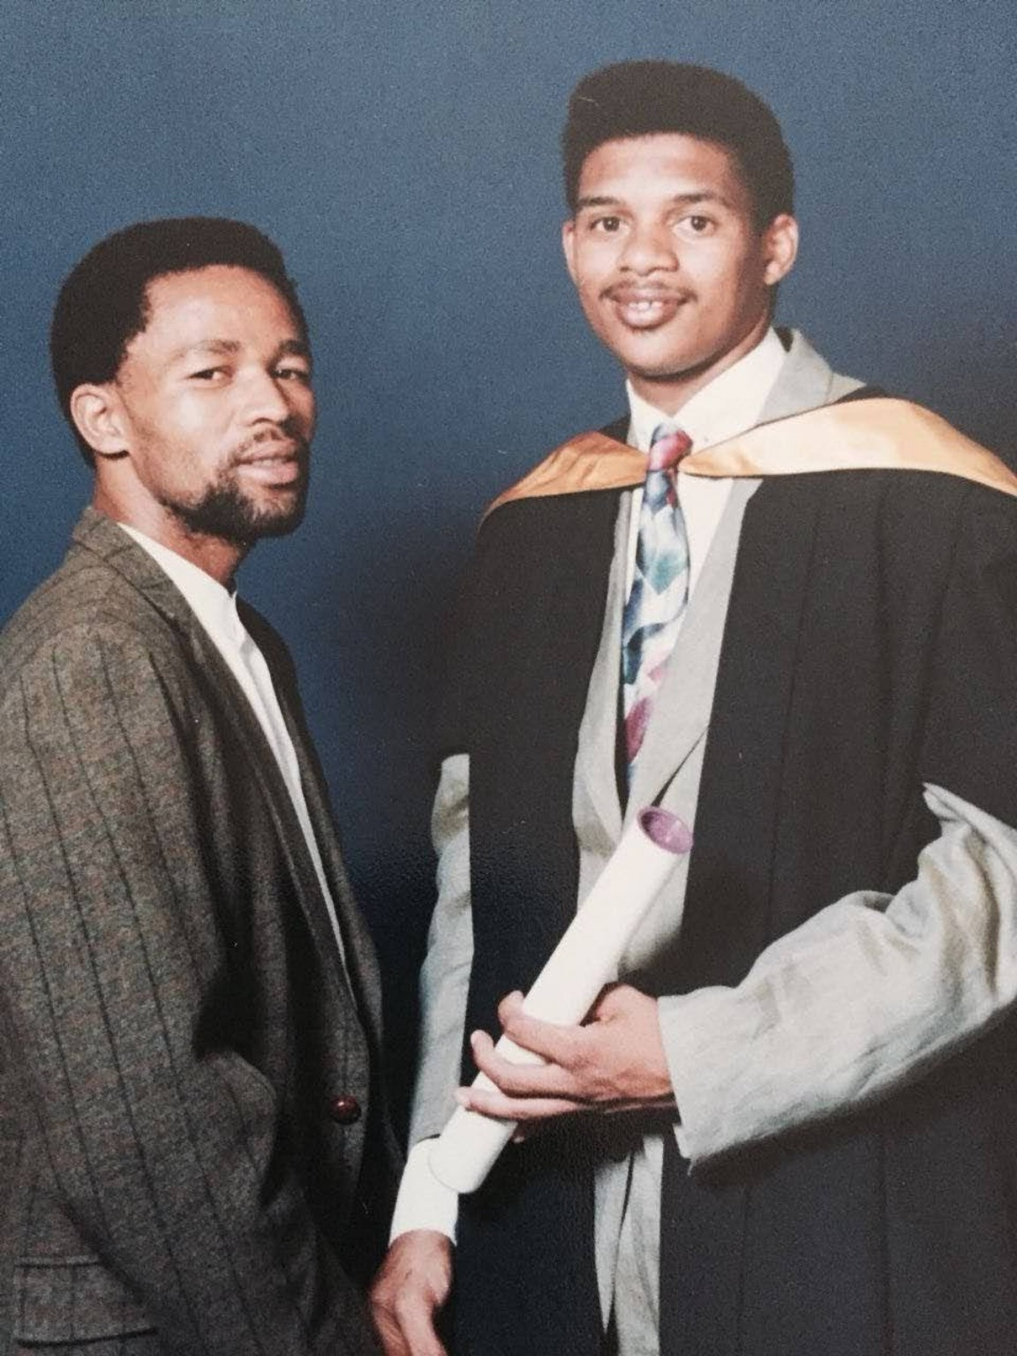
Zola Pinda with Lincoln Mali at Rhodes University during the 1993 graduation ceremony — a moment marking the transition from student activism into the responsibilities that followed.

THE RED GOLF: POLITICS ON THE ROAD
Mzwandile “Tswai” Poswa carried a similar connection between institutions. After his political formation at Fort Hare, he came to Rhodes with what I remember as a bag full of democratic promises — a belief that the political future being debated by students could become a lived reality. Rhodes University's account records his Fort Hare years, his SANSCO activism and his subsequent role in the Rhodes SASCO branch during the 1991 formation of the new organisation.
KK and I were political comrades, but our friendship went beyond politics. I only came to understand much later that our family backgrounds carried an unexpected thread of familiarity: in our family understanding, the Papiyana lineage is associated with the Gxarha tradition and the wider Pondoland country around Ntabankulu. I came from the rural Peddie side of the Eastern Cape, where self-sustaining farming was part of lived experience. KK used to tease me about being the grandson of a peasant farmer. It was the teasing of a friend who knew where I came from.
Some of the most important political education of that period did not happen behind a podium.
There was a little red Golf Chico. In that car, KK and I, together with the late Bongani Gxilitshe, Lincoln Mali and the late Mzwandile Poswa — known to us as Tswai Radebe — travelled the long roads of the Eastern Cape and beyond.
We went to Johannesburg for national congresses, and to Alice, Mthatha and campuses across the region where SANSCO and later SASCO branches needed support, strategic guidance or simply the presence of comrades from Rhodes.
We were young, but we were not unaware of the risks. The country was still under apartheid rule. Activists were detained, organisations were restricted and political violence was part of the landscape. I remember those journeys less as heroic adventures than as work that had to be done.
In the boot were books and political documents: Fanon, Biko, the Freedom Charter, ANC and SACP discussion papers and SANSCO material. The political arguments did not stop when meetings ended. The road became another seminar.
Conversation moved from political theory to the mechanics of organising: SRC elections, memoranda to university management, curriculum reform, negotiation and strategy.
KK’s intelligence was most visible in those ordinary moments. He did not need to perform it. It emerged through the quality of his questions, the calmness of his reasoning and the seriousness with which he treated political work.
Those journeys also remind me that political formation was collective. Bongani, Lincoln, Tswai and the others were not background figures. They were part of the same generation being schooled in politics, organisation and responsibility.

THE GENERATION BESIDE KK
One cannot remember that generation honestly without remembering those who are no longer here.
Mike Koyana, Kgomotso Masebelanga, Mvuzo Mbebe, Luthando Myataza “Takes”, Mzwandile “Tswai Radebe” Poswa, Bongani Gxilitshe and others belong to the wider story of that political formation.
Kgomotso Masebelanga, elected the first Secretary-General of SASCO at the founding conference, was later murdered in 2003. Mike Koyana, who had been central to SANSCO and to the 1991 political moment, is also gone.
These losses should not turn the article into a catalogue of names. Their importance is that they remind us that movements are built by people whose later public visibility varies, but whose contribution at the moment of formation can be decisive.
KK belongs within that generation, but this article is not an attempt to place him above his comrades. It is an attempt to understand what was distinctive about his contribution.

THE DISCIPLINE OF POLITICAL EDUCATION
KK's method was not confined to formal meetings. Political education happened in conversation, in preparation for a debate and in the discipline of asking what lay behind an immediate dispute.
He encouraged reading because he understood that movements could not rely indefinitely on inherited slogans. Fanon, Biko, Freire and Marx were not simply names to be cited. They offered different ways of thinking about power, consciousness, organisation and social change. ANC and SACP documents brought those theoretical questions into the concrete political tradition within which many of us were operating.
The important point was not that every activist had to arrive at the same intellectual conclusion. It was that activists should be able to explain why they believed what they believed.
That distinction mattered at Rhodes. A student leader who could mobilise a crowd but could not explain a position was vulnerable to the next argument. KK wanted something more durable. He wanted people who could think under pressure.
That is also why he was demanding about academic performance. The university was an institution of knowledge and power. To abandon academic seriousness in the name of activism was, in his view, to surrender one of the very tools that students were trying to democratise.
The phrase I remember — “conquer the book and the street simultaneously” — captures that philosophy. The book represented study, evidence and intellectual preparation. The street represented organisation, struggle and public responsibility. Neither was sufficient on its own.
What I learned from KK was also a method of preparing people. Before a difficult meeting, he wanted us to know the facts, anticipate the opposing argument and understand what could and could not be conceded. He taught us that persuasion was not the same as surrender, and that firmness was not the same as shouting. A leader had to know when to press an argument, when to listen and when to bring people with him. That may sound elementary now, but in the political environment of the time it was a valuable discipline. It turned activism from an expression of conviction into a practice of political responsibility.

THE POLITICS OF NON-RACIALISM
The debates around the creation of SASCO also require a little intellectual distance from the hindsight of the present.
Non-racialism was not a slogan that everyone interpreted in exactly the same way. It emerged from a history in which apartheid had organised political, social and economic life through racial classification. The question was therefore how to build a democratic organisation that rejected racial domination without pretending that the consequences of racial power had somehow disappeared.
This was part of the seriousness of the 1991 debates. Questions about African leadership, working-class leadership, women's leadership and organisational structure reflected competing understandings of how historical inequalities should be addressed within a new political formation.
KK's contribution has to be understood within that argument. His role was not to make disagreement disappear. It was to help people work through disagreement without losing sight of the larger political objective.
That is a different conception of leadership from the one that equates authority with having the last word. It is closer to political education: helping people understand why a position matters, what its consequences are, and what compromises can be made without abandoning principle.
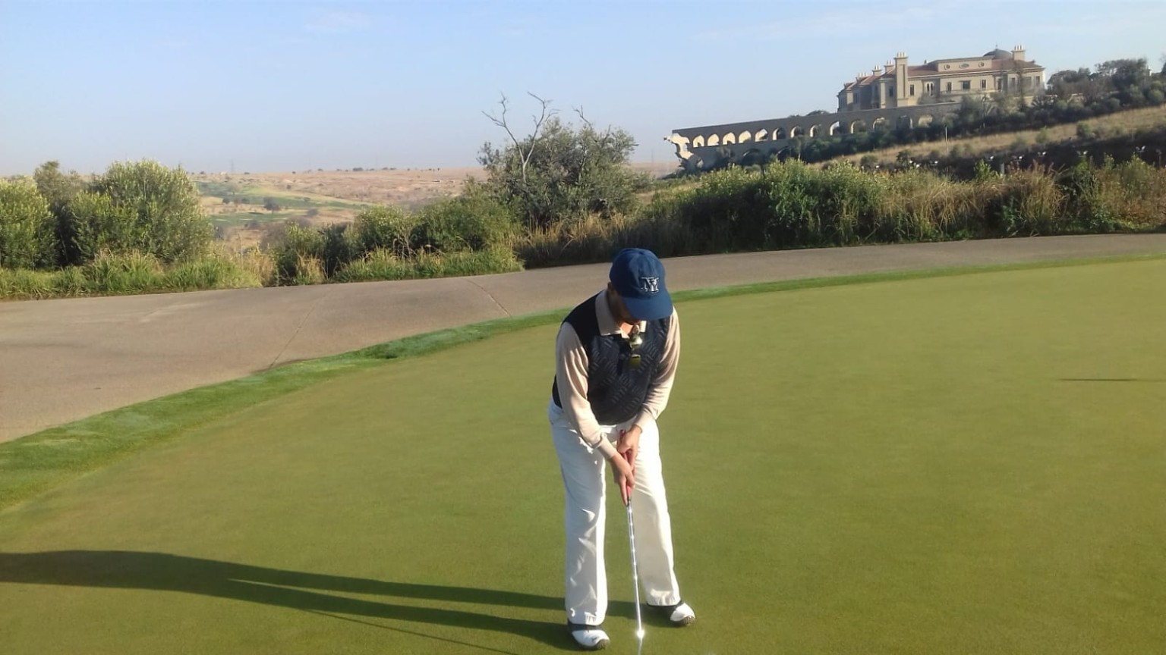
A later moment on the golf course — friendship and conversation continuing beyond the political years.

THE PEOPLE BESIDE KK
It is important not to turn KK into a solitary political hero. The movement that formed us was collective, and the people around him were part of his political education as much as he was part of theirs.
Bongani Gxilitshe brought intellectual curiosity and organisational discipline to our travelling circle. Lincoln Mali moved fluently between campus, community and national structures. Mzwandile “Tswai Radebe” Poswa carried a quieter organisational reliability. Mike Koyana represented another strand of the student leadership that was negotiating the transition toward a single non-racial organisation.
There were also people whose contributions were made in less visible ways: branch organisers, residence activists, campaigners, students who drafted memoranda, those who attended late-night meetings and those who returned to their campuses carrying decisions that had been reached at national gatherings.
That is why I resist the temptation to measure the generation only by the positions people later occupied. Political formation happens before a résumé records it. The student who learns to chair a difficult meeting, the activist who learns to negotiate with an institution, the organiser who learns to explain a political decision to ordinary members — all are acquiring the skills of public life.
KK understood that process.

FROM RESISTANCE TO GOVERNMENT
The arrival of democracy changed the political question without making the question of leadership disappear.
For our generation, liberation created responsibilities that resistance had not required in quite the same form. A movement could define itself against an unjust system. A democratic government had to build institutions, allocate resources, manage competing interests and deliver services within a constitutional order.
That is why the opportunity to learn from Popo Molefe mattered to me. It was not simply exposure to a senior political figure. It was exposure to the mechanics of government.
We had to learn that a political intention could be defeated by an administrative weakness. A good policy still required a budget. A public commitment still required a department capable of implementing it. A government could inherit the legitimacy of liberation and still fail if it did not develop the competence to govern.
That lesson belongs naturally beside KK's teaching. His emphasis had always been preparation. Molefe's intervention showed what preparation meant when responsibility moved from mobilisation into government.
The continuity was striking: first learn to understand the institution; then learn to use institutional power responsibly.

A wider landscape from the golf course — another setting for friendship, reflection and conversations beyond formal political life.

THE STANDARD OF POLITICAL FORMATION
That is what I find myself measuring against the present. I am not nostalgic for my youth. I am asking a harder question about what happened to the culture of political formation that produced it.
The political generation that formed us did not invent the idea that leadership required intellectual preparation. There was an older tradition within the liberation movement, represented in different ways by Oliver Reginald Tambo and, later, Thabo Mbeki, in which political leadership demanded engagement with history, political economy, institutions, strategy and the wider world. Intellectual seriousness did not make these leaders infallible, nor did education prevent political error. But it established an important principle: political responsibility required the capacity to think.
Perhaps this is why, looking back from thirty years of democracy, I have become increasingly conscious of what we were being taught — and of the tradition from which that teaching came.
The danger in writing about political figures from the liberation generation is that memory can become either hagiography or dismissal. The first turns people into saints. The second reduces them to the imperfections of their organisations or the failures of the political era that followed.
Neither approach helps us much.
KK is more interesting when remembered as a political educator — a person working within the limitations and contradictions of his time, but serious about the standards by which political work should be judged.
He did not teach that every political decision would be correct. He taught that decisions should be thought through. He did not teach that disagreement was a weakness. He taught that disagreement should be handled politically. He did not teach that leadership meant permanent visibility. He demonstrated that much of leadership is preparation carried out when nobody is watching.
That is the part of his example that has stayed with me.

WHY KK STILL MATTERS
KK never lived to experience that transition. He died in 1991, before the first democratic election. We have had three decades to experience what he did not. That gives those of us who knew him a responsibility that he cannot exercise himself: to ask whether the political education we received remains adequate to the country we eventually inherited.
Why write at length about a student political educator from more than three decades ago?
Because South Africa’s present difficulties are not only institutional or economic. They are also questions of political culture: how leaders are formed, how movements educate their members, how institutions are understood, and what happens when ambition becomes detached from preparation and ethics.
KK’s example does not provide a ready-made answer to every contemporary problem. It offers something more useful: a standard against which political formation can be considered.
He believed that young activists should read. They should understand institutions. They should argue carefully. They should organise. They should learn to negotiate without surrendering principle. They should understand that leadership is a responsibility before it is a position.
That is the lesson I carry from him.
I write this as a journalist who was also a participant in that student movement and who has had more than three decades to think about what those years produced. The university gave us intellectual tools. The movement tested them. KK showed us what political discipline looked like when those ideas had to be put to work.
He was my friend, my mentor and my comrade.
We travelled together in a little red car, with books and political documents in the boot. We argued, learned, organised and moved from one meeting to another. What stayed with me was not a particular title. It was a habit of mind: read before speaking, understand the institution before challenging it, prepare people rather than merely impress them, and do the work whether or not a title follows.
That is the politics of formation.
And that is why remembering KK is not nostalgia. It is an invitation to ask what kind of political education South Africa requires if democracy is to remain more than an arrangement of institutions.
The answer begins with the same principle he taught us: serious politics begins with serious preparation.

ABOUT THE AUTHOR
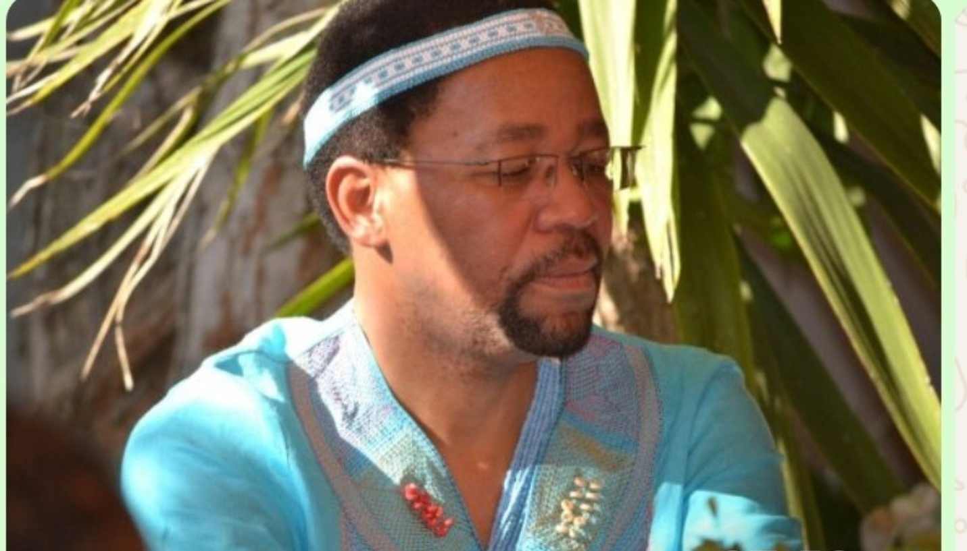
Zola Pinda — author portrait.
Zola Pinda is a South African journalist, political writer and Executive Principal. His formation spans Rhodes student politics, journalism, public administration and institutional leadership.

