Log Percentiles – Version 3

## Prerequisites

* JDK8 or later
* Apache Maven
* Ensure JAVA_HOME environment variable is set and points to your JDK installation
* Spark 2.3.1
* Scala 2.11
* Upload access logs into hdfs path : /tmp/test

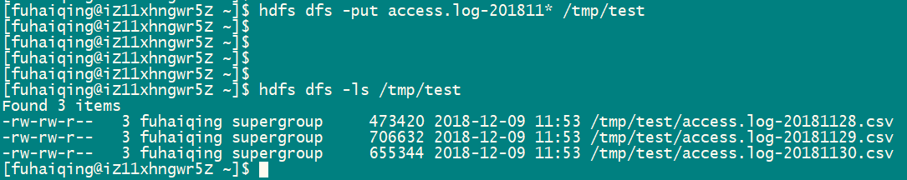

## Solution

Similar as version 2 except spark does in parallel.

## Configuration

Refer to spark configuration

## Execute

Compile source code by maven or use pre-compiled jar file in target folder, then submit spark job or run in spark shell

