SADC Medicines Procurement Information and Work Sharing

**Manual**

Version 3.0

**Draft – 10 December 2014**

Compiled by SARPAM (www.sarpam.net).

Comments are welcome, and should be sent to: SADC Pooled Procurement Interim Management Team

Acknowledgements

Since the 1st design and launch of what is now called the SADC Medicines Database in 2012 numerous changes have been made based on comments of users and stakeholders from all SADC countries and beyond over the two years of its existence. It would be too much to ask to name all the contributors but one could say that it has become a real SADC product. The version 3 of the Manual is meant to follow the same path, i.e. to be tested together with the two regional e-platforms for medicines procurement information and work sharing that it describes:

1. SADC Medicines Database (SMD at <http://med-db.medicines.sadc.int/>); and
2. SADC Pooled Procurement Network (PPN at <http://ecs.sadc.int/ppn/>)

Thanks to DFID for its financial support to make the SMD and PPN a reality.

All users are invited to send comments to

SADC Pooled Procurement Interim Management Team

10 December 2014

Table of Content

1. Introduction 5

2. Users’ access 5

3. SADC Medicines Database 6

3.1 SMD Objectives 6

3.2 SMD Datasets 6

3.3 SMD Tabs 12

3.3.1 Home 12

3.3.1.1 Recent procurements by Member States 13

3.3.1.1.1 Cost calculation tool 14

3.3.1.1.2 Transaction details (login only) 14

3.3.2 Medicines 15

3.3.3 Country reports 16

3.3.4 Admin (login only) 17

3.3.4.1 Users (for administrator only) 17

3.3.4.2 Medicines 18

3.3.4.2.1 Dosage forms 18

3.3.4.2.2 Available medicines 19

3.3.4.2.3 Benchmarks prices 19

3.3.4.2.4 Form options 19

3.3.4.2.5 Incoterms 19

3.3.4.2.6 Unit of Measure 19

3.3.4.2.7 Containers 19

3.3.4.2.8 Manufacturer 19

3.3.4.2.9 Supplier 19

3.3.4.2.10 Procurements 19

3.4 Populating SMD with data and information 19

3.4.1 Selection of Medicines 19

3.4.2 Data population modules 20

3.4.3 Data validation 20

3.5 Stepwise Instructions on How to navigate and manage information on the SMD: What would you like to do? 21

3.5.1 View prices on the SMD for benchmarking with prices from other countries 21

3.5.2 Check how much money would be saved for a specific quantity of a high value product by comparing with reasonable prices that other countries paid. 21

3.5.3 Check if the source of a particular product that was supplied to another SADC country at a competitive price is a trusted quality source in the purchasing country (check registration status of the products) 22

3.5.4 Check for a product of interest from any country, details of its procurement transactions including the supplier and manufacturer details. (Note that this function is for registered users only). 22

3.5.5 Find out more about a particular product from the country that contributed its price information by contacting the NMPA officials of that country or via a community discussion 22

3.5.6 Find out about other resources with similar objectives to those of SADC Medicines Database 23

3.5.7 Find out details about all products that a particular country has purchased recently and has contributed information thereof to the SMD 23

3.5.8 Find out details of products that a particular country has historically purchased and contributed their procurement data to the SMD. 23

3.5.9 Edit an incomplete or erroneously inputted entry on the SMD 23

3.5.10 Update your country’s procurement information with new data from a recent procurement tender or request for quotations 24

3.5.11 Update your country’s procurement information by creating a new procurement record that was non-existed before on the SMD 25

4. SADC Pooled Procurement Network 26

4.1 PPN Objectives 26

4.2 PPN Datasets 26

4.3 PPN Tabs 26

4.3.1 Home 26

4.3.2 Discussions 27

4.3.2.1 Start discussion 27

4.3.3 Library 28

4.3.4 Calendar 28

4.3.4.1 New event 29

4.3.5 Members 29

4.3.6 Help 30

4.4 Stepwise instructions on how to use the PPN: What would you like to do? 30

4.4.1 View an ongoing or an older discussion on the PPN website: 30

4.4.2 Create a discussion for others to comment on 30

4.4.3 Upload a document or tool to share with others 31

4.4.4 Find and download a file from the library. 31

4.4.5 Contact a particular PSM expert in another country whose contact details you do not know 31

4.4.6 Respond to a discussion on the PPN. 31

5. SMD and PPN future opportunities 34

Annex 1, Overview of Management issues from the SADC Pooled Procurement Member States Meeting, Benoni, South Africa, 2013 35

Annex 2, Profiles SMD and PPN Management and Focal Persons 37

# Introduction

The 1st phase of the implementation of the SADC Strategy for Pooled Procurement of Essential Medicines and Health Commodities (SADC 2012) focusses on:

1. **Information sharing** on medicines prices, quality and sources in order to create substantial cost savings; and
2. **Work sharing**, i.e. exchanging and discussing best practices, regulations and tools among Member States, to strengthen the Member States’ pharmaceutical procurement and supply management systems.

This document is the 3rd version of the design, objectives, structure, management and user guidelines for the SADC Medicines Database (SMD at <http://med-db.medicines.sadc.int/>) and the SADC Pooled Procurement Network (PPN at <http://ecs.sadc.int/ppn>), the two regional e-platforms for medicines procurement information and work sharing that were developed by SARPAM in consultation with users and stakeholders in the SADC countries. It is a work in progress where the features of both e-platforms will be further extended in 2015.

The overall objective of the information sharing e-platform, the SADC Medicines Database (SMD at <http://med-db.medicines.sadc.int/>), and the work sharing e-platform, the SADC Pooled Procurement Network (PPN at <http://ecs.sadc.int/ppn>), is to increase access to essential quality medicines by sharing information regarding methods, costs, sources and quality of pharmaceutical procurement transactions in SADC countries.

# Users’ access

The PPN is for members only. The SMD includes both open and closed sections. Information and data that is inherently public in nature, such as medicines registers and tender awards resulting from public procurement, are part of the open sections of the SMD. All other information, like details of suppliers and manufacturers are only to be accessed after authorised login.

Staff in National Medicines Procurement Agencies (NMPAs) and senior technical staff in the pharmaceutical departments (especially when involved in national health planning and budgeting) will have access to all sections of the SMD. Other users –in principle with access to the open SMD sections only- may be:

* Ministries of Health, Finance and Trade, Parliament, Medicines Regulatory Authorities, public procurement oversight bodies (Procurement Authorities) may use the platform as source of information and expertise on pharmaceutical procurement;
* Prescribers and funding agencies for the development and maintenance of standard treatment guidelines and selection of essential medicines and commodities;
* SADC Secretariat;
* Civil Society Organisations, to assess whether their own procurement agency is performing well compared to its peers and internationally, and using the information to advocate for appropriate actions, as well as checking on prices in private pharmacies;
* International development organisations;
* International organisations working in the field of procurement or benchmarking prices;
* Researchers and training institutions.

# SADC Medicines Database

## SMD Objectives

The specific objective for the SMD is for SADC countries to improve procurement results, with emphasis on reducing costs.

This objective will be achieved through the SMD by making available

1. prices, sources and quality of medicines procured by the national medicines procurement agencies (NMPA) in SADC countries;
2. information on the registration status of medicines in SADC Member States as well as in PIC/S countries and in the WHO Prequalification Programme;
3. information on prices and sources of medicines in publicly available global medicines databases (see <http://haiweb.org/medicineprices/international-medicine-prices-sources.php>);
4. analytical tools to benchmark prices and calculate potential cost savings; and
5. contact details of the suppliers and manufacturing sites.

Options for extension of the scope of SMD include making available:

1. Information on medicines shortages (for example as done by Canada Health)
2. Information on the Essential Medicines Lists in SADC countries

The SMD, featuring both open (= publicly accessible) and closed sections, aims to become the prime information source for the following institutions and people in SADC countries:

1. National Medicines Procurement Agencies (NMPAs) for planning and budgeting their procurement, bench marking tenders, finding medicines sources and information on costs and quality and sharing information on suppliers’ performance;
2. Suppliers (both distributors and manufacturers) to identify market opportunities for their products and to establish if their products and services comply with the regional PPSM Standards; and
3. Stakeholders (such as politicians and senior staff of health institutions, prescribers, patients, civil society organisations) to find key information on medicines public procurement transactions in their country and in the region, and where available, globally.

## SMD Datasets

The SMD currently contains two interrelated datasets:

1. Database of medicines prices and procurement quantities for each country; and
2. Directory of medicines suppliers and manufacturers with contact details.

Other sets to be added are:

1. The Database of registered products in the region for a specified set of medicines;
2. Database with prices taken from and links with existing global medicines datasets; and
3. A library with publicly available documents from the region as well as globally (either the documents themselves or links to publicly available websites that contain these documents)
4. the contact details of SPPS, as the managing entity and of focal persons in SADC Member States who may be contacted should further information be required

A compilation of country specific contextual information assisting in the adequate interpretation of price information is provided through mouse-overs. Table 1 - 5 below lists the contents of the databases a to c.

Table 1: Basic product information that identifies a unique generic (prefilled or used to apply for inclusion of a product in the database)

| **GENERIC** | | |
| --- | --- | --- |
| **Data field** | **Description** | **Comments** |
| **Generic name (INN)** | International Non-proprietary Name - the shortened scientific name based on the active ingredient. WHO is responsible for assigning INNs to pharmaceutical substances. INN is a unique name that is globally recognised and is public property. INNs are used to facilitate the identification of pharmaceutical or active pharmaceutical ingredients. A non-proprietary name is also known as a generic name. [1] [2] | Where a medicine contains more than one active ingredient, each active ingredient is listed. |
| **Strength** | This indicates the strength of a medicine which advises how much of the active ingredient(s) is (are) present in each dosage form. [3] | e.g. 25mg/ml  Where a medicine contains more than one active ingredient, the strength for each active ingredient listed |
| **Dosage form** | This describes the physical form that a medicine is produced and dispensed in. [4] | Dosage forms are pre-listed as defined for this Database, i.e. capsule/tablet, cream, ear drops, eye drops, inhaler, injection, liquid, ointment, pessary, powder, suppository and suspension/syrup |
| **Unit of Measure** | The unit used for price comparisons | Units of Measure are pre-listed as defined for this Database, i.e. capsule/tablet, dose, each, g, mcg, mg, ml, pessary and vial |
| **Notes** | This provides for cases where further details of the product can be added, such as scored tablet, powder for injection, etc. |  |
| ATC/DDD coding | The Anatomical Therapeutic Chemical (ATC) classification system and the Defined Daily Dose (DDD) as a measuring unit have become the gold standard for international drug utilization research. The ATC/DDD system is a tool for exchanging and comparing data on drug use at international, national or local levels.[5] |  |

Table 2: Product- manufacturing site combination

| PRODUCT- MANUFACTURING SITE COMBINATION | | |
| --- | --- | --- |
| **Data field** | **Description** | **Comments** |
| **Product name** | Manufacturer brand name or generic name – name manufacturer where applicable.[6] | In cases where there is no specific name the generic name is used followed by –name manufacturer. The brand name or generic name – name manufacturer ties the product to a specific manufacturer. |
| **Pack size** | This describes the contracted pack size, i.e. number of Units of Measure, and specification to which the pack price refers. |  |
| **Manufacturer name** | Natural or legal person with end responsibility for the manufacturing of a product. |  |
| **Manufacturer’s site address** | The address of the plant where the product has been manufactured (i.e. has the responsibility for the quality of the end product coming out of the plant). | Please provide the physical address and area/postal code. |
| **Manufacturer website** |  | |
| **Contact person** |  | |
| **Phone number** | Please include international dialling code. | |
| **Alternative phone number** | Please include international dialling code. | |
| **E-mail address** |  | |
| **Manufacturer’s in-country representative (local agent) or applicant** | The local company or legal entity which represents the manufacturer and applies for and maintains registration of the product. | This information is country specific. |
| **Registration status (yes/no)** | Has this product been allowed in your country by means of market authorisation? | Note: this is only applicable to countries that register medicines.  Market authorisation refers to a licence issued by a medicines regulatory agency approving a medicine for market use based on a determination by authorities that the medicine meets the requirements of quality, safety and efficacy for human use in therapeutic treatment. [7] |
| **Registration number  (country specific)** | When medicines are approved by a country’s regulatory authority (e.g. the Medicines Control Council (MCC) in South Africa) they are allocated a unique registration number. [8] | This registration number is country specific.  e.g. A/7.1.4/123 or 44/7.1.5/345. |
| **Application date** | This date indicates the date that the applicant applied for the registration of a particular product. | This field will not be compulsory but may be used to measure any changes in registration times |
| **Registration date** | This date refers to the above registration, and indicates the date that a medicine was included in the Register in a country. |  |
| **Registration expiry date** | This date indicates the date that the registration expires on. |  |

Table 3: Supplier information

| **SUPPLIER INFORMATION** | |
| --- | --- |
| **Data field** | **Description/Comments** |
| **Supplier name** | Persons or company providing medicines on request. Suppliers include manufacturers, distribution actors and (parallel) traders. [9] |
| **Supplier address** | Please provide the physical address and area/postal code. |
| **Manufacturer (y/n)** | Indicate yes or no |
| **Applicant for registration (y/n)** | Indicate yes or no |
| **Website** |  |
| **Contact person** |  |
| **Phone number** | Please include international dialling code. |
| **Alternative phone number** | Please include international dialling code. |
| **E-mail address** |  |
| **Alternative e-mail address** |  |
| **Has your national NMPA prequalified this supplier?** | Indicate yes or no. |
| **Manufacturer authorisation** | If not a manufacturer, indicate whether or not the supplier is formally appointed by the manufacturer as a supplier for medicines/products produced by the manufacturer. |

Table 4: Procurement transaction information

| **PROCUREMENT TRANSACTION DETAILS** | | | |
| --- | --- | --- | --- |
| **Data field** | **Description** | | **Comments** |
| **Procurement country** | Name country that provided the data |  | | |
| **Generic name & strength** | See table 1 |  | | |
| **Dosage form** | See table 1 |  | | |
| Product name | Manufacturer brand name or generic name – name manufacturer where applicable.[10] | In cases where there is no specific name the generic name is used followed by –name manufacturer. The brand name or generic name – name manufacturer ties the product to a specific manufacturer. | | |
| **Procurement period** | Time frame indicated by month-year for which the procurement is valid with a minimum default period of 12 months 2014 or specified with starting and ending date (month-year), e.g. June 2014 –May 2016. | Information about actual number of months | | |
| **Terms** | The international trade term applicable to the contracted price. | Prelisted: CFR, CIF, CIP, CPT, DAF, DAP, DAT, DDP, DDU, DEQ, DES, EXW, FAS, FCA, FOB | | |
| **FOB/EXW Price per pack size (USD)** | The price used for comparisons; this either provided as such or has been calculated by subtracting a certain percentage (10 to 20%) from the price with Incoterms that include transport and/or insurance and/or other costs | FOB or EXW | | |
| **Procurement quantity** | The number of packs contracted at the specified unit price. |  | | |
| **Pack size** | This describes the contracted pack size, i.e. number of Units of Measure, and specification to which the pack price refers. |  | | |
| **Unit of Measure** | The unit used for price comparisons | Units of Measure are pre-listed as defined for this Database, i.e. capsule/tablet, dose, each, g, mcg, mg, ml, pessary and vial | | |
| **Container** | Bottle, blister or otherwise | Pre-listed: bottle, container. blister/strip, ampoule, vial, syringe, bag, tube, sachet | | |
| **Pack price** | Price per pack size in the currency mentioned under Transaction currency (see below) |  | | |
| **Unit price** | Price per Unit of Measure |  | | |
| **Transaction currency** | Currency as per contract | Pre-listed: all currencies used in region | | |
| **Source** | Name and date of file from which the information was extracted |  | | |
| **Supplier** | All information in Table 3. |  | | |
| **Manufacturer** | All information regarding the manufacturer’s site as stated in Table 2 |  | | |
| **Quality information** | All information regarding:   1. registration in the country of purchase 2. link to any other quality information such as approved by WHO-PQP and PIC/S member |  | | |

Table 5: Contextual information

| **CONTEXTUAL INFORMATION**[11] | |
| --- | --- |
| **Data field** | **Description** | |
| **Population** | Estimated population and year. | |
| **GNI/capita** | PPP in international $ and year (refer to WHO Word Health Statistics). | |
| **PCP** | Link to Pharmaceutical Country Profile report | |
| **National Medicines Regulatory Authority** | Name and link to website. | |
| **Public sector procurement agency** | Full name and link to website. | |
| **NMPA status** | e.g. MOH department, public company, NGO. | |
| **NMPA website** | Link to NMPA website. | |
| **Annual public sector pharmaceutical procurement budget in USD** | Including all relevant on-budget budget lines (e.g. including vertical programmes, NMPA, districts, hospitals as adequate). | |
| **Average tender lead time** | Number of months from selection and quantification up to contract award; for open or restricted ICB only. | |
| **Tender currency/ies** |  | |
| **Payment terms/modalities** | e.g. Letter of Credit, other forms of pre-payment against performance guarantee, on account (XX days). | |
| **Local preference** | % figure and requirements applicable to local preference. | |
| **Import duties and taxes** | % figure as applicable. | |
| **Average cost for freight & insurance** | % figure. | |

## SMD Tabs

### Home

The SMD website opens at the home page which contains an introduction and is the starting page to search for information on specific products. It also includes a list of procurement transactions that were recently added.

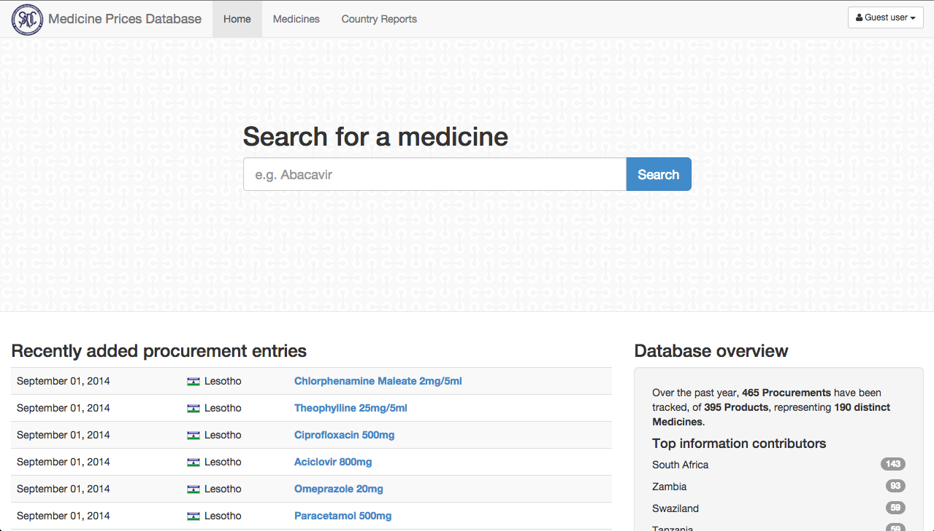

The main menu tabs are

* Home
* Medicines
* Admin
* Country reports

Library [will be further developed in 2015]

Contacts [will be further developed in 2015]

Important links [will be further developed in 2015]

Users normally start **searching for a product** by typing any string of letters in the search-box. Generics (name+strength) appear for those items whose name includes the string of letters. Select a product by clicking on it.

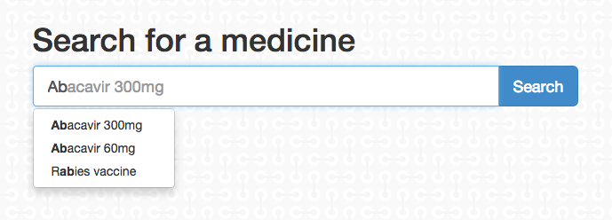

Select the generic name strength leads to the page Recent procurements by Member States.

### Recent procurements by Member States

A search guides the user to the page with Recent procurements by Member States.

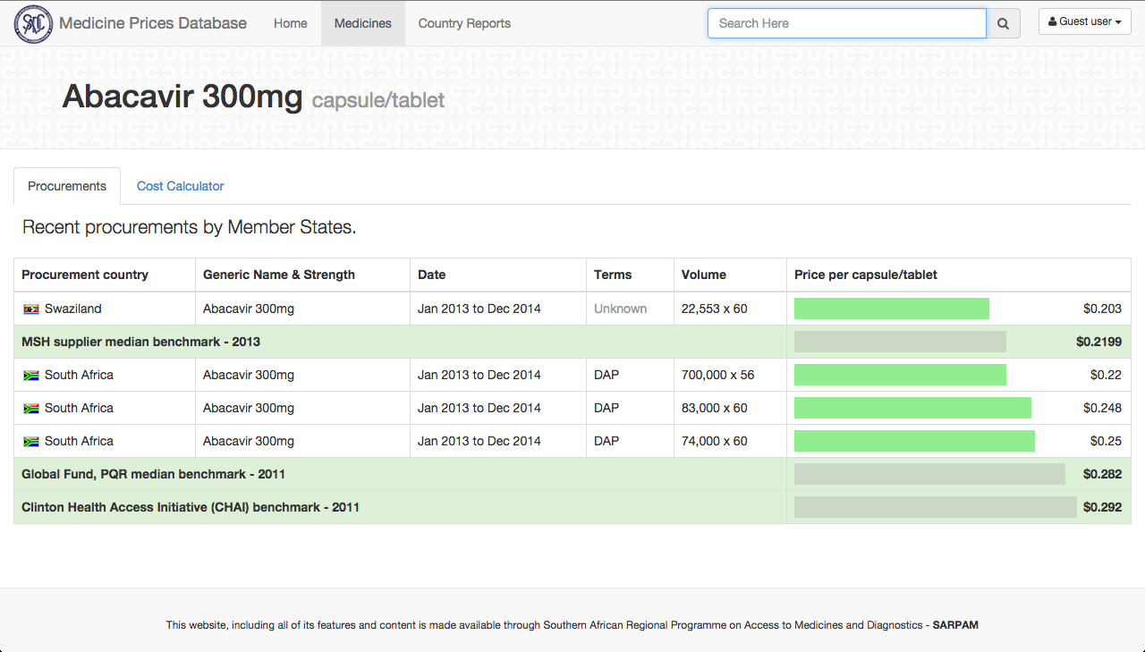

The page shows current procurement transactions per country per particular product sorted from the lowest to the highest price per Unit of Measure. The procurement period is the time frame indicated by month-year for which the procurement is valid with a minimum default period of 12 months 2014 or specified with starting and ending date (month-year), e.g. June 2014 –May 2016.

This page gives a quick overview of the procurement with the lowest cost per Unit of Measure. These costs may be compared with international prices published in global Medicines Prices Databases. Currently, the MSH suppliers’ median prices have been included. In due time information from other Databases may be included.

Selection of the Cost calculator will lead to the Cost calculation tool (3.3.1.1.1).

Clicking on one of the transactions will lead to the page Transactions (3.3.1.1.2).

### Cost calculation tool

By using Tab Cost calculation users can calculate the cost difference for a required quantity of the particular product for a price of the user’s choice (mostly the historic price paid or the price on a certain bid or quotation). This feature may be used when budgeting for procurement or when a price has to be validated against the regionally available prices and global benchmarks.

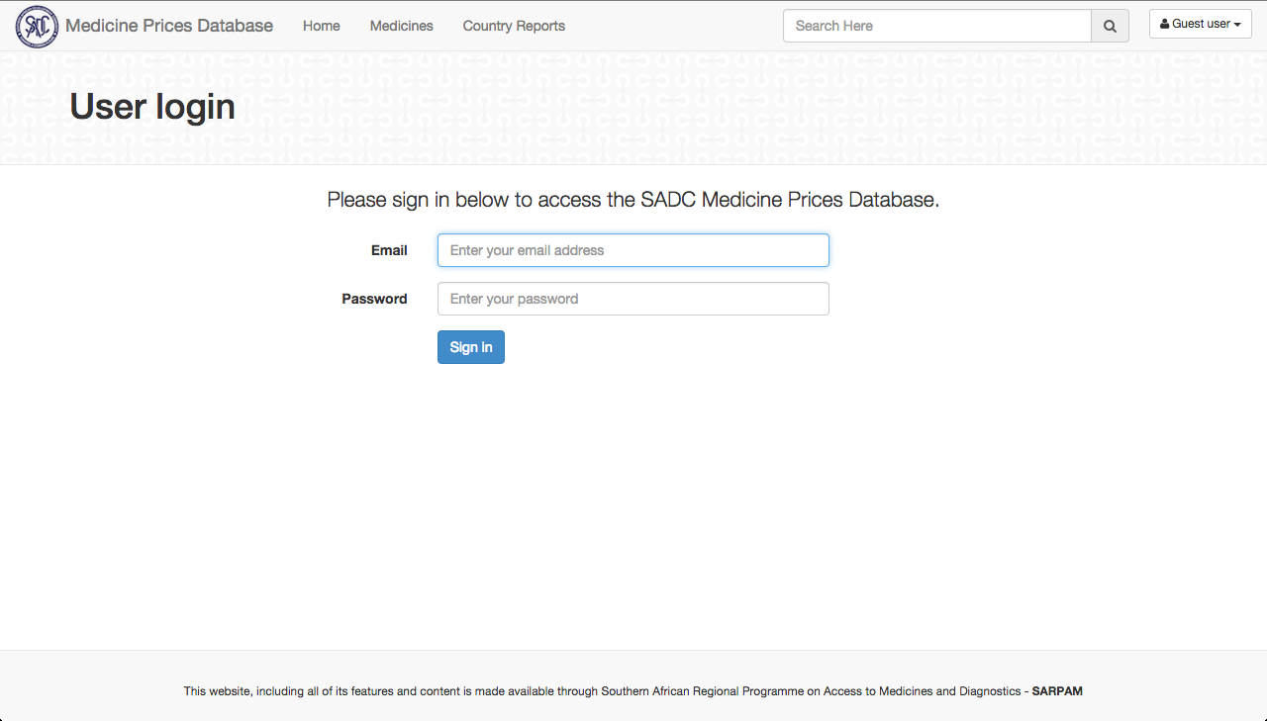

The tool provides the opportunity to quickly compare costs of a certain transaction (product, pack size, number of packs) with existing transactions showing the sub sequential differences in costs in actual amount of funds, i.e. – (minus) when your transaction is less costly and + (plus) when not.

### Transaction details (login only)

After logging in the page Transaction details opens.

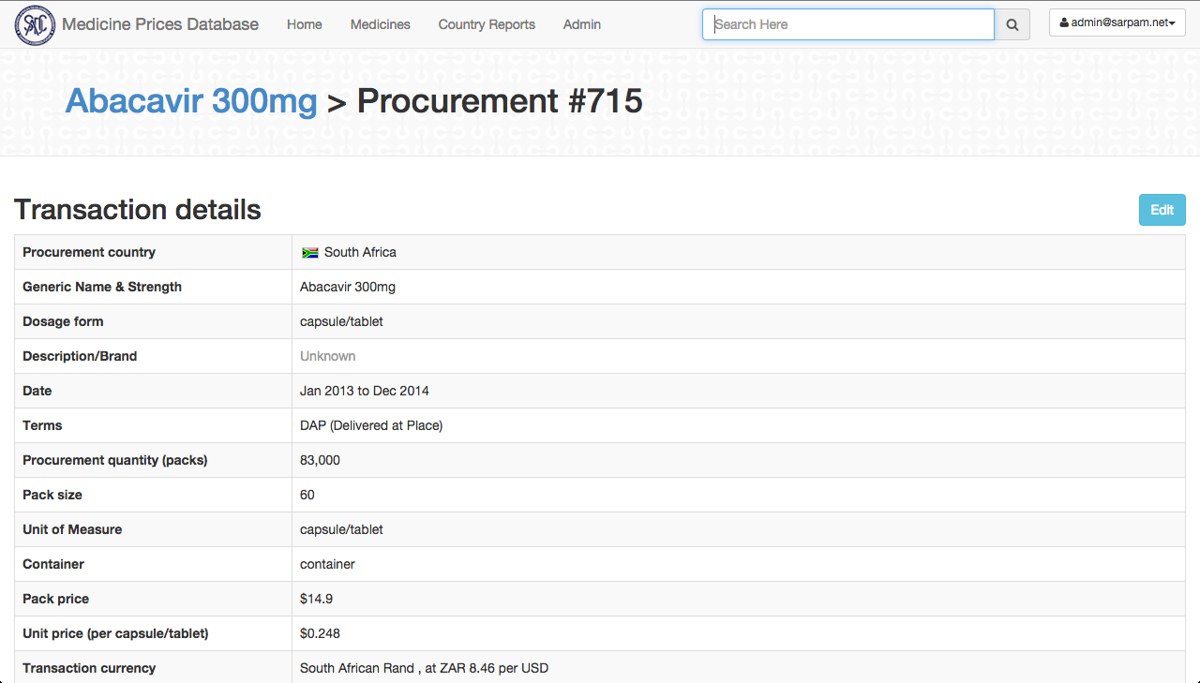

The page Transaction details shows the details of the

1. product (description, pack size, costs, etc.);
2. supplier (name, address, contact details)
3. manufacturer (name, address, contact details)
4. registration in country of procurement (registration number, validity, etc.) [will be further developed in 2015]
5. other quality information (WHO PQP, PIC/S country registration) with link where to find further details [will be further developed in 2015]. To avoid duplication of information as well as to guide procurement officers, the portal will provide links to other useful websites (e.g. PIEMEDS, HAI, MSH international price indicator, wholesalers’ and suppliers’ websites, etc.) and existing pharmaceutical PSM and quality assurance (QA) programs in the Member States.

(See Table 4 for more details)

### Medicines

The Tab Medicines next to Home leads to the page Medicines currently supported. This page gives an overview of all generics (name+ strength) that may be found in the Database.

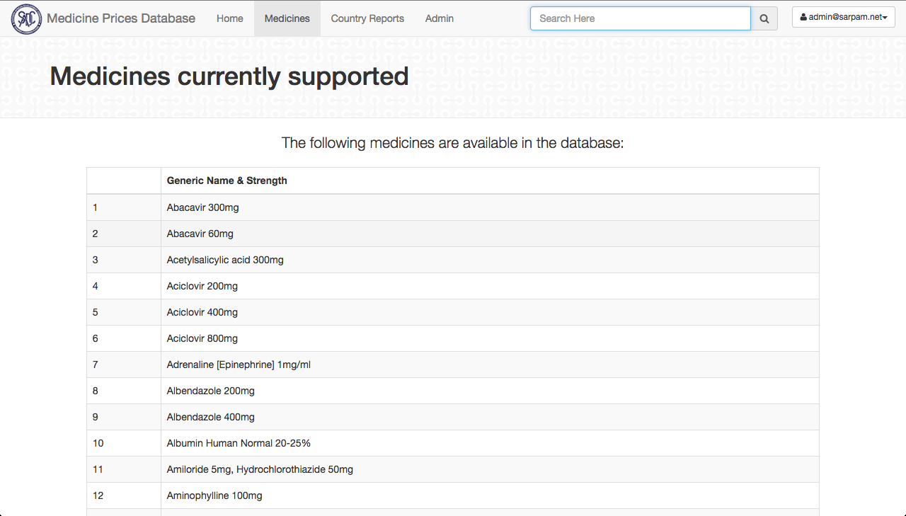

### Country reports

The Tab Country reports next to Medicines leads to the page Country Savings Potential, which shows the total value of all procurement transactions per country and the amount of possible savings in case the transactions had taken place using the products with the lowest costs in the Database.

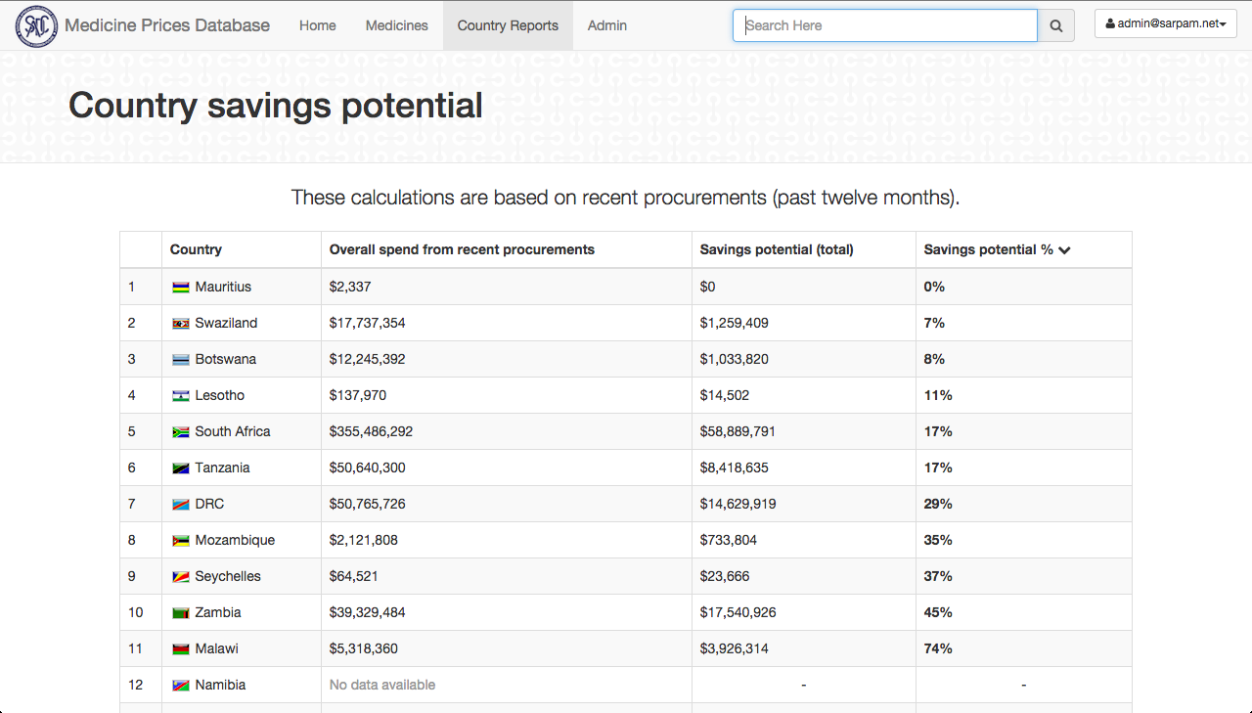

Clicking on one of the countries leads to the page All transactions per country. Subsequent clicking on one of the generics will lead to all transactions for that generic per country. Finally, clicking on a certain transaction leads to the details of that transaction on the page Transaction details.

You can download all the procurements data for a country, straight to an Excel spreadsheet.  Click on Country Reports, you'll see a list of countries. Then click on the one you're interested in, and you'll see a summary of all the medicines they have bought, and how much they spent on them. But, if you just want to see all the individual procurements for that country, click on the Procurements tab, and there you'll find a button Download .xlsx.

### Admin (login only)

The Tab Admin next to Country reports leads to the page that provides the following options

* Users (for administrator only)
* Medicines
* Form options
* Manufacturer
* Supplier
* Procurements

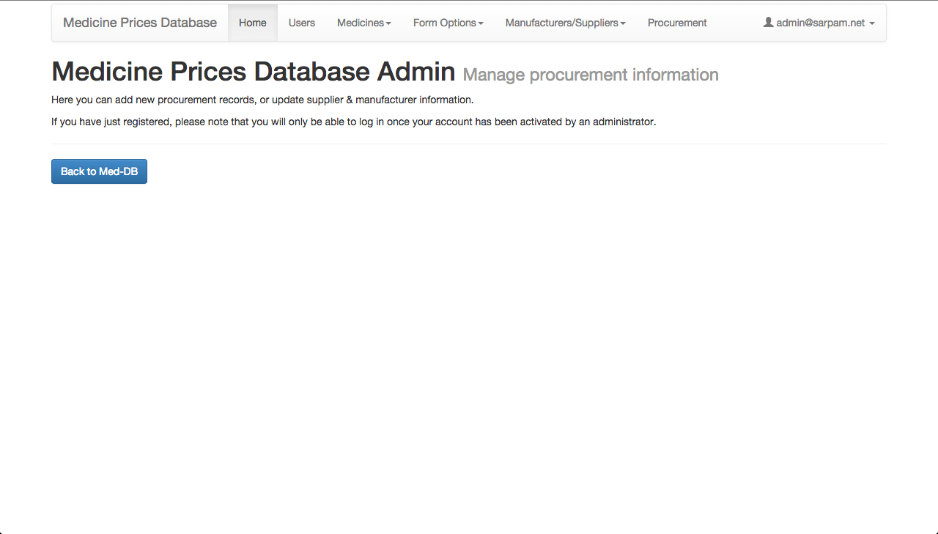

### Users (for administrator only)

The page Users contains all registered users with user name and password. Users can be added or deleted.

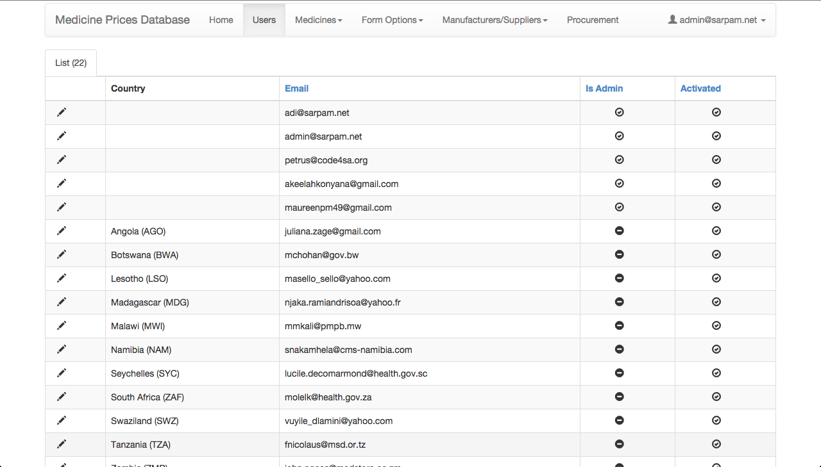

### Medicines

The Tab Medicines shows the following three options:

### Dosage forms

The page shows all the possible dosage forms.

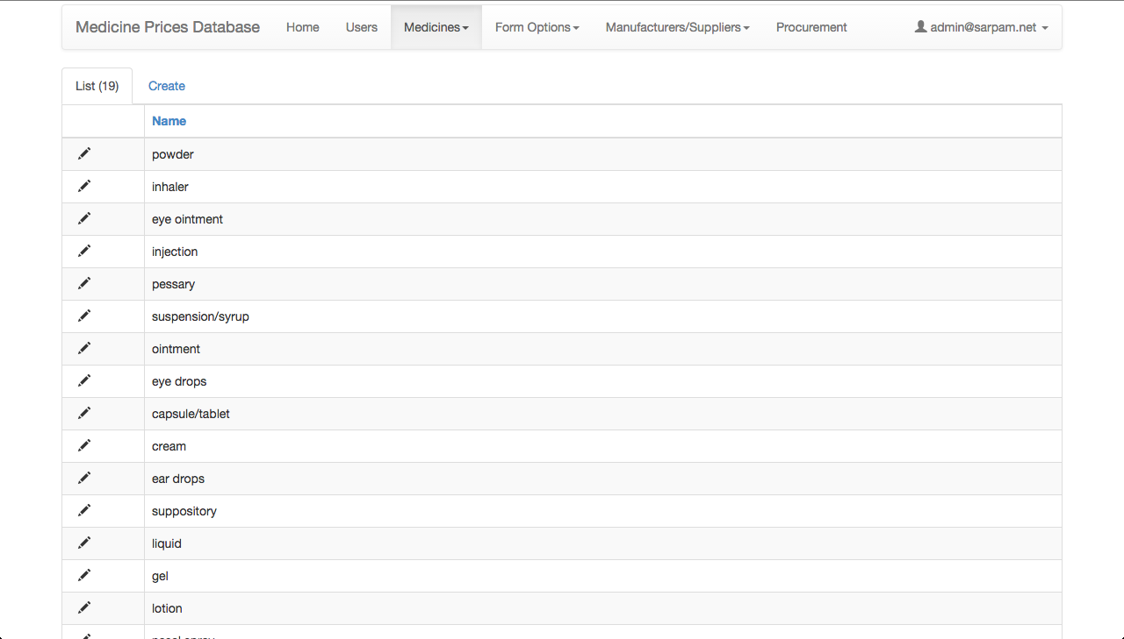

New dosage forms may be added by using Create on this page

### Available medicines

The page shows all available medicines (generic name + strength) with their Dosage forms and Units of Measurements. New medicines may be added by using Create on this page.

### Benchmarks prices

The page shows all available Benchmarks (generic name + strength +dosage forms) with their Name (=source global database) Price, Units of Measurements and Year. New benchmarks may be added by using Create on this page.

### Form options

The Tab Form options shows the following three options:

### Incoterms

The page shows all available Incoterms (see Table 4), in full and their abbreviations.

### Unit of Measure

The page shows all available units of measure (see Table 4).

### Containers

The page shows all available containers (see Table 4).

### Manufacturer

This page shows countries and manufacturers’ names. [similar to Supplier below]

### Supplier

This page shows name supplier, address, website and contact person.

### Procurements

This page lists all procurement transaction. New transactions can be uploaded using Create.

## Populating SMD with data and information

### Selection of Medicines

At the start-up of the Database in June 2012 the baseline dataset collected during the 2010 PMA study for 50 tracer medicines was used.[12] Data was collected for these 50 items plus a number of items that were preferred by NMPAs in Member States. In July 2014 there were 181 different medicines with an average of 4.2 procurement transactions from NMPAs in 13 SADC countries. Priorities established by representatives in Gaborone during the MS Consultation Meeting in August. 2011 are:

1. “*High volume and high expenditure products (small decrease in prices will result in large savings)*
2. *Medicines needed to treat high prevalence diseases (HIV and AIDS, Malaria, TB, Maternal Child and Women’s Health and Reproductive Health; Non-Communicable Diseases) - more economic gains due to decrease in lost days due to illness)*
3. *Medicines included in >50% of the SADC MS national EMLs (ensure MS ownership)*
4. *Medicines where the average price paid by MS > International Drug Price Indicator price (best chance for cost savings due to achieving lower prices)*
5. *Medicines that are difficult to source due to small quantities/speciality (when pooling the needs, suppliers expected to become more interested in supplying)*
6. *Multisource medicines should be a priority (with competition, i.e. minimum of 3 to 5 products for a particular medicine on the market) (more opportunities for lowering of prices*.”

This way, regional priority diseases (burden of disease, public health relevance; specific focus on maternal and reproductive health and child health) are ensured to have been addressed. Over time, there will be no limit and more products which have the interest of MS may be added to the information database.

Several MS have indicated that the SMD should include both medicines and health commodities.

### Data population modules

The existing modules for populating the SMD are

1. focal persons in the Member States using the upload mechanism under Admin 🡪 Procurements 🡪 Create;
2. automatically, via a script that talks directly to the NMPA’s own databases, to be installed by a technical person and in agreement between parties involved; and
3. using data collection forms (MS Excel file with tables 1 to 6).

The SPPS, as manager of the PP e-platforms, may even ‘translate’ data provided through publications for tender results, although these publications often prove to lack key information on the sources and quality of the products.

Alternatively:

1. Search for a medicine on <http://med-db.medicines.sadc.int/>

2. Look at the price comparison for that Medicine

3. Click on one of the procurements in the price comparison

4. This takes you to the Procurement detail page, after logging in.

5. On the Procurement detail page, click on Edit to go straight to the Admin page for either the Transaction details, the Supplier, or the Manufacturer.

### Data validation

A technical team of pharmaceutical procurement experts follows established procedures for approval of the data and information uploaded onto the Database prior to the information becoming visible to the public.

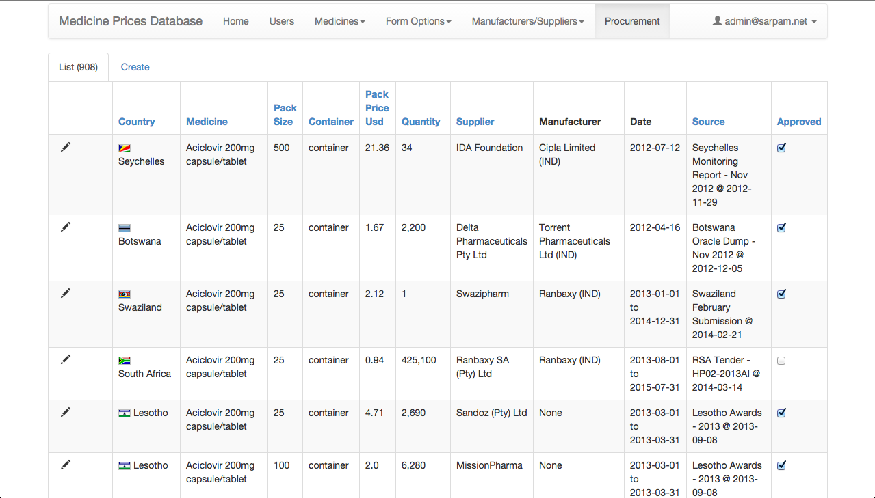

## Stepwise Instructions on How to navigate and manage information on the SMD: What would you like to do?

### View prices on the SMD for benchmarking with prices from other countries

1. Open your internet browser and go to <http://med-db.medicines.sadc.int/>. It is advisable that you bookmark this page for ease of access anytime you want to view product prices, sources and quality information on the SMD.
2. You can search for the product that you are looking for by typing any part of its name in the search box. The SMD will pull up suggested products from where you can select the product.
3. Alternatively, click on the **Medicines** menu adjacent to the **Home** menu.
4. From the alphabetically arranged list of products, scroll down to the product you are looking for and click on it to view the information.

### Check how much money would be saved for a specific quantity of a high value product by comparing with reasonable prices that other countries paid.

1. Select on the SMD the product that you would like to calculate potential cost savings for by following the steps described in 5.3.1, how to “View prices on the SMD for benchmarking with prices from other countries”.
2. Next to the **Purchases** tab, look for the **Cost Calculator** tab and click on it. You will see a few of the low cost products displayed and a field where you can enter your information as shown in the example picture below:

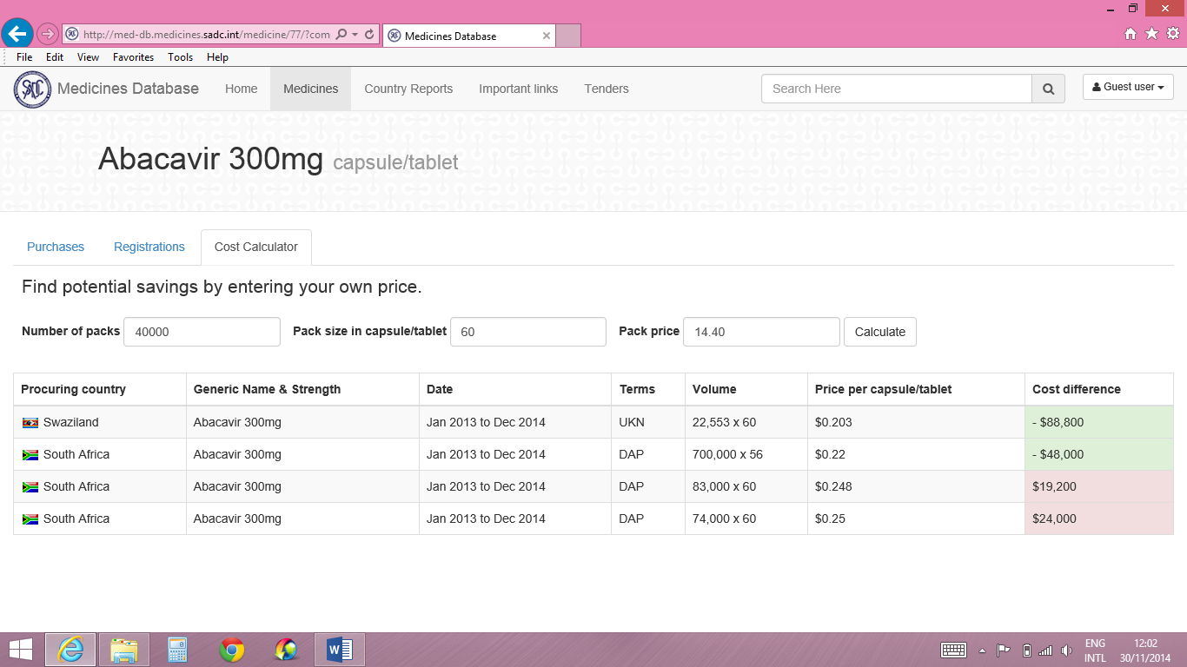

1. Enter the number of packs of the product you would like to compare costs, the pack size and the price per pack, and click **Calculate**. *[Note that sometimes the page jumps back to the* ***Purchases*** *tab after clicking* ***Calculate****. Just go back to the* ***Cost Calculator*** *tab to view the results]*.
2. The field of **Cost Difference** will display the potential cost saving (indicated in negative number) if your price is higher than the benchmark price. A positive number result indicates that your price is lower (or better) than the displayed benchmark price.

### Check if the source of a particular product that was supplied to another SADC country at a competitive price is a trusted quality source in the purchasing country (check registration status of the products)

1. Select on the SMD the product that you would like to view its registration information by following the steps described in 5.3.1, how to “View prices on the SMD for benchmarking with prices from other countries”.
2. Next to the **Purchases** tab, look for the **Registrations** tab and click on it.
3. You will see the countries in which this product is registered based on the manufacturer and the manufacturing site address.

### Check for a product of interest from any country, details of its procurement transactions including the supplier and manufacturer details. (Note that this function is for registered users only).

1. Select on the SMD the product that you would like to view its detailed procurement information by following the steps described in 5.3.1, how to “View prices on the SMD for benchmarking with prices from other countries”.
2. From the price entries from the different countries, select the price from a country that you are interested in.
3. When prompted, enter your Username and Password and click **Sign In**. (Alternatively, you can sign in via the login field on the top right corner of the SMD at any time prior to being prompted to sign in).
4. You can now view **Transaction Details** for this product. Scroll down to view contact details of the Supplier and the Manufacturer of this product.

### Find out more about a particular product from the country that contributed its price information by contacting the NMPA officials of that country or via a community discussion

1. On the SADC Medicines Database (<http://med-db.medicines.sadc.int/>), go to the **Important Links** menu.
2. Find the link to the SADC Pooled Procurement Network (PPN) and click on it to open the PPN website.
3. Follow the steps described in 4.4.5, how to “Contact a particular PSM expert in another country whose contact details you do not know”, if you would like to contact an individual person in that country, or follow the steps in 4.4.2, how to “Create a discussion for others to comment on”, if you would like to start a discussion with procurement experts in the Pooled Procurement community.

### Find out about other resources with similar objectives to those of SADC Medicines Database

1. On the SADC Medicines Database (<http://med-db.medicines.sadc.int/>), go to the Important Links menu.
2. Search the links that you find on the page and click on the link of your choice. You will be directed to the described website.

### Find out details about all products that a particular country has purchased recently and has contributed information thereof to the SMD

1. On the SADC Medicines Database (<http://med-db.medicines.sadc.int/>), go to the Country Reports menu.
2. You will now view a table of the list of countries, their overall spend for the year, and total potential cost savings, if any.
3. Click on the country that you are interested in to view details of the products. When prompted, enter your Username and Password to access the restricted site.
4. You will now view the Overview tab which contains the list of all recently purchased products, their overall spend and potential savings.
5. If you would like to view details of any of the products, click on the product and you will be taken to the Price comparison page.

### Find out details of products that a particular country has historically purchased and contributed their procurement data to the SMD.

1. Follow steps 1 to 3 of 3.5.7, how to “Find out details about all products that a particular country has purchased recently and has contributed information thereof to the SMD”.
2. Next to the **Overview** tab, look for the **Purchases** tab and click on it.
3. You will now view all the individual procurement transactions for that the different products that the country has contributed to the SMD, whether they are approved for display on the public site or not.
4. You may download the information on all the products into a Microsoft Excel Sheet by clicking on the blue **Download .xlsx** icon at the top right corner of the Purchases tab.
5. If you would like to view details of any on the products, just click on the product and you will be taken to the **Transaction Details** page for the product where you can also view supplier and manufacturer contact details.

### Edit an incomplete or erroneously inputted entry on the SMD

Note: This procedure updates information on a particular product which has previous procurement transaction data from a specific country on the SMD. Editing information of an existing product overwrites the previous data on that particular record. Previous information will be deleted from the database. The procedure is useful for correcting errors on a particular record from your country that has already been approved for display to the public on the SMD.

**Procedure:**

1. Sign in to the SMD with your user email address and password
2. On the **Home** page Search for, or, on the **Procurements** page, scroll down to the particular medicine whose information you would like to change and click on it
3. On the price information comparison page, click the record for your country that you would like to change. This will take you to the **Transaction Details** page where you can also see **Supplier** and **Manufacturer** details for that product
4. On the **Transaction Details** page click on the blue **Edit** button on the right of the page. If you would like to edit details of the Supplier or the Manufacturer, scroll down and click the adjacent blue **Edit** button. This will take you straight to the relevant page in the **Admin** portal where the details fields will become activated, ready for editing
5. Edit the fields whose information you would like to add or change
6. When you are done, click **Submit** and the administrator will review your record before approving it for display to the public.
7. If you would like to edit another field, go back to the **Transaction Details** page for the same product to select the next field you would like to edit. Follow procedure 4 to 6.
8. If you would like to inspect the new record prior to approval, click the **List** tab on the same **Procurements** page. Scroll to the last page and to the last product on the page to view the created record. If not satisfied, you can edit the information again by clicking on the **Edit Icon** (a pencil) on the left-most column of the record and submit again for approval.
9. When the record has been approved, you can view it on the public display site of the SMD. To exit the Admin portal, click the **Home** tab of the Medicine Prices Database Admin portal and click the blue **Back to Med-DB** button.

### Update your country’s procurement information with new data from a recent procurement tender or request for quotations

This procedure adds new procurement information on a product that was purchased in a previous procurement transaction, for instance, a previous procurement cycle. This procedure will create new data on the product while retaining the data on the previous transaction. The new data will be displayed as the more recent information on the product. The procedure is useful for updating procurement data on the SMD to keep it current.

Procedure:

1. Log on to the SMD with your user email address and password
2. Go to the **Admin** main tab and click the **Procurements** tab. This will land you on the **List** of procurements tab.
3. Next to the **List** tab is the **Create** tab. Click the **Create** tab and it will display active fields in which you can enter new procurement information.
4. Edit each field with new procurement information. Fields with drop-down menus have pre-created information on the SMD. If on the drop-down menus you are unable to find relevant information even after searching, it means there is no such information on the database. Follow the procedure described in 3.5.11, how to “Update your country’s procurement information by creating a new procurement record that was non-existed before on the SMD” in orderto create information relevant to those drop-down menus prior to completing the procurement transaction data.

Note: The Product field is a drop-down field where you pick an already coupled Product-Manufacturer combination. If you do not find this combination available, click Cancel and follow steps 12 to 17 of the procedure in 3.5.11. Otherwise proceed to step 5.

1. Add all the information for the transaction and, when finished, click **Submit**
2. To inspect the new transaction prior to approval, click the **List** tab on the same Procurements page. Scroll to the last page and to the last product on the page to view the created record. You can edit the information if not satisfied by clicking in the **Edit Icon** (a pencil) on the left-most column of the record and submit again for approval.
3. Click the **Home** tab of the Medicine Prices Database Admin portal.
4. Click the blue **Back to Med-DB** button to exit the Admin portal and go back to the public portal of the SMD to view the finalised information of the new record displayed on SMD. It will appear among the **Recently added procurement entries**.

### Update your country’s procurement information by creating a new procurement record that was non-existed before on the SMD

This procedure creates a completely new record on the database, a product that could previously not be found on the database using the search function. The result of the procedure will be an addition of a new distinct product on the SMD

**Procedure:**

1. Log in to the SMD with your user email address and password
2. Click the Admin main tab. This will display these tabs:
   1. Medicines
   2. Forms options
   3. Manufacturers/Suppliers
   4. Procurements
3. To create a new medicine on the e-platform, go to the **Medicine** tab.
4. On the drop-down menu select Available Medicines and look for the name of the medicine you are looking for.
5. Otherwise, click the adjacent **Create** tab, to define the generic name of the new medicine.
6. If the unit of measure for the new medicine is not available on the drop-down menu under the **Create** tab, click **Cancel** to stop the process.
7. Go to the Forms Options tab in procedure 2. On the drop-down menu select **Unit of Measure**
8. On the **Create** tab define the Unit of Measure for your product and click **Submit**.
9. Return to the **Medicine** tab in procedure 2 and go through procedure 3 and 4. When finished, click **Submit**.
10. Go to the **Manufacturer/Supplier** tab in procedure 2. From the drop-down menu, check if the manufacturer details are already present on the **List** tab. Otherwise click the **Create** tab to enter details of the new supplier.
11. Click **Submit** when finished
12. Click the **Manufacturer/Supplier** tab again and on the drop-down menu select **Product**. This field will enable you to couple the product you created or selected with the manufacturer you created or selected.
13. If the Product-Manufacturer couple is not available on the **List** tab, click the adjacent **Create** tab.
14. On the active fields, select the Medicine, Manufacturer and Site that should already be available as created in procedures above. Enter the trade name on the Description field, or check the **Is Generic** checkbox if there is no trade name for the product.
15. Enter registration information for your country for the Product-Manufacturer-Site combination if available
16. Click **Submit** when finished.
17. Now go to the **Procurements** tab in procedure 2
18. Follow the procedure described in 3.5.10 for “Update your country’s procurement information with new data from a recent procurement tender or request for quotations” in order to complete procurement transaction information for the new product.

# SADC Pooled Procurement Network

## PPN Objectives

The specific objective for the PPN is for SADC countries to:

1. Improve the existing practices up to the level of agreed regional standards of pharmaceutical procurement and supply management (SADC 2014)[13].

This objective will be achieved through the PPN by making available

1. A platform for exchange of expertise among NMPA staff and stakeholders;
2. Library with PPSM guidelines, tools and standards as well as existing legislation and regulations and studies of pharmaceutical PSM;
3. A platform for publication of tender notifications and tender results; and
4. A database of expert PPSM staff in Member States.

The PPN, featuring closed sections only, aims to become the e-platform for sharing existing legislation and regulations, procedures, methods, tools and expertise between the following institutions and people in SADC countries:

1. National Medicines Procurement Agencies (NMPAs);
2. Ministries of Health pharmaceutical departments; and
3. National Medicines Regulatory Authorities.

## PPN Datasets

The work-sharing platform aims to encourage the sharing of practical experiences and facilitate the development and maintenance of good practices in pharmaceutical procurement. The services include:

* Discussion, a facility for virtual meetings, exchange of expertise, queries and discussions;
* Library, a document repository to make available relevant documents (legislation, regulations, procedures, tools, study reports, PPSM experts databank, etc.);

Priorities and developments are expected to emerge from user requirements after a number of MS begin to regularly use the system.

## PPN Tabs

### Home

The PPN website opens at the home page which contains an introduction and is the starting page that leads to the following interfaces:

* Home
* Discussions
* Library
* Calendar
* Members

Figure: The SADC PPN Home Page showing different tabs

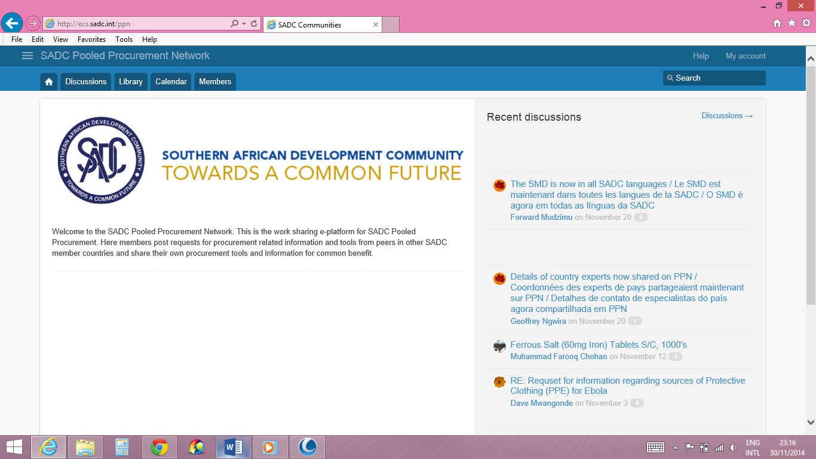

The Tab Discussions in the main menu or in the top right corner also leads directly to the page Discussions.

### Discussions

At the page of Discussions messages may be posted or earlier discussions may be viewed.

Figure: The SADC PPN Discussions Page

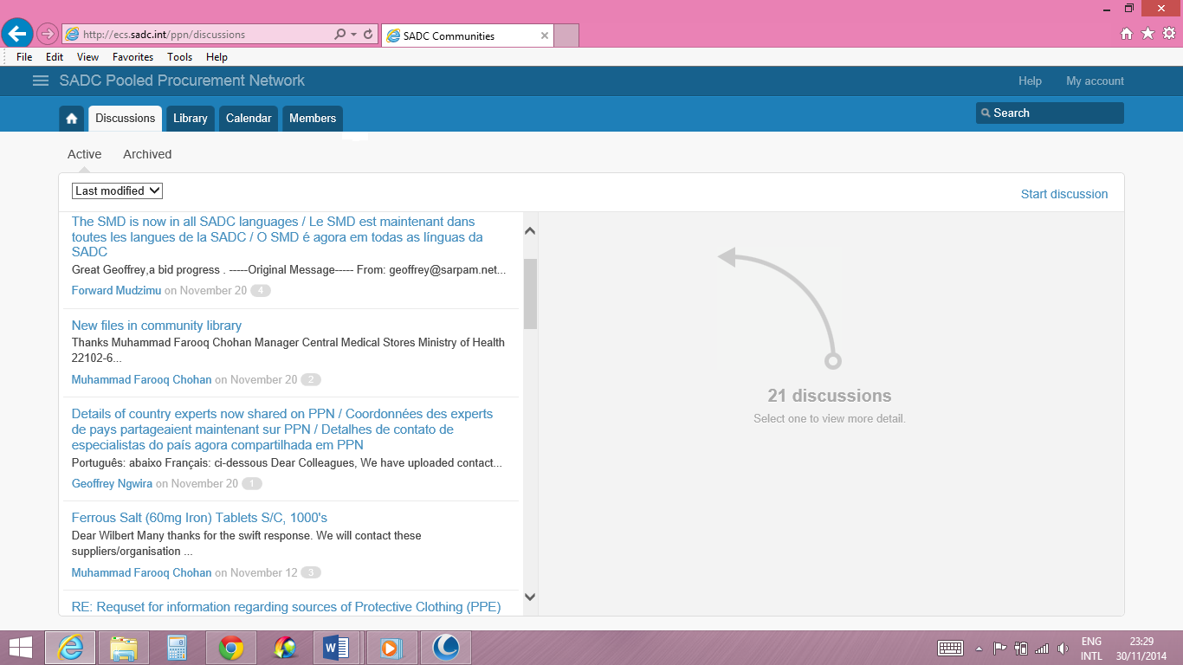

There are two ways to make a posting:

1. In reply to existing postings; and
2. A new posting which is possible by using the button Start Discussion.

### Start discussion

The Start discussion field is meant to create and send a new posting. It pops up when one clicks the Start discussion link on the Discussions page.

Figure: The SADC PPN Start Discussion field

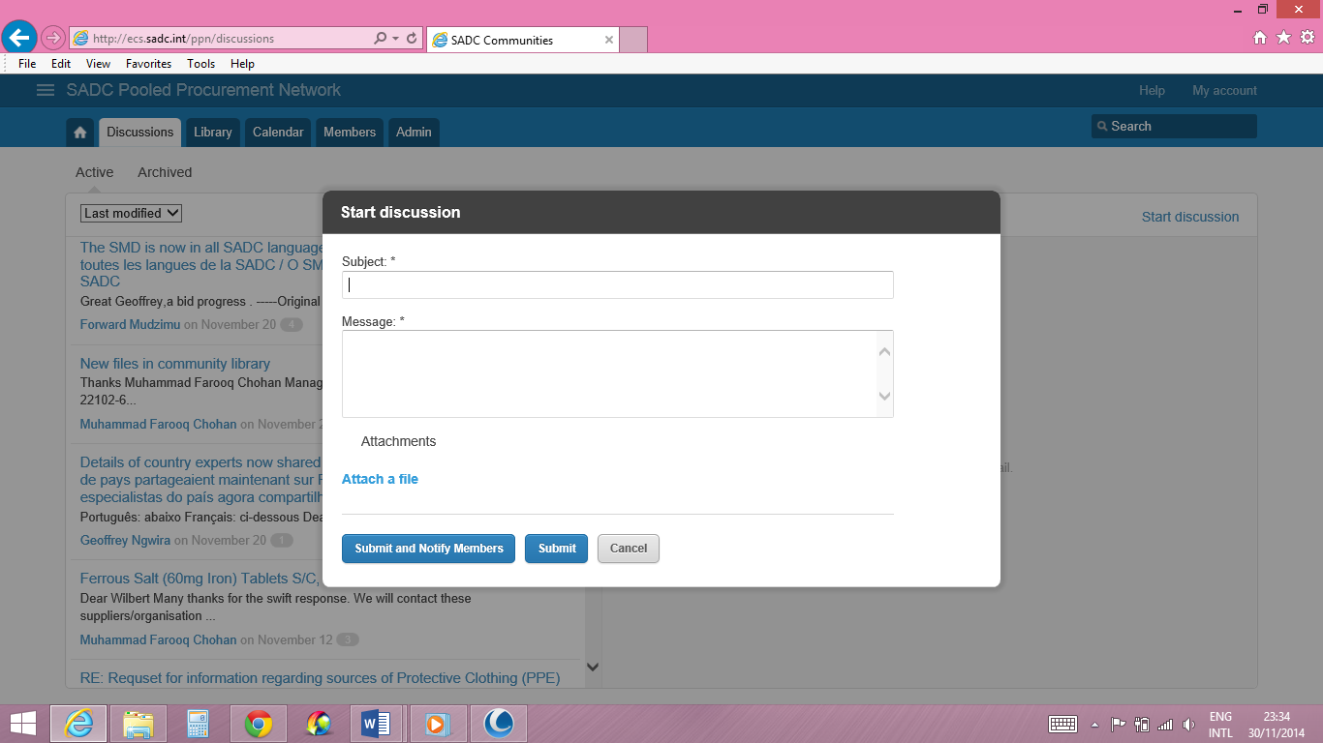

### Library

The Library allows for uploading of important and relevant documents. Such documents could include procurement agencies Standard Tender Documents and related Standard Operating Procedures; national public procurement laws and regulations; tools used at procurement agencies, for example, supplier monitoring; and product specifications.

Relevant sub-sites, search functions, links and an automatic e-mail notification system that informs registered e-platform users about newly uploaded documents will be included as required.

Figure: The SADC PPN Library Page showing different folders into which documents and tools are deposited

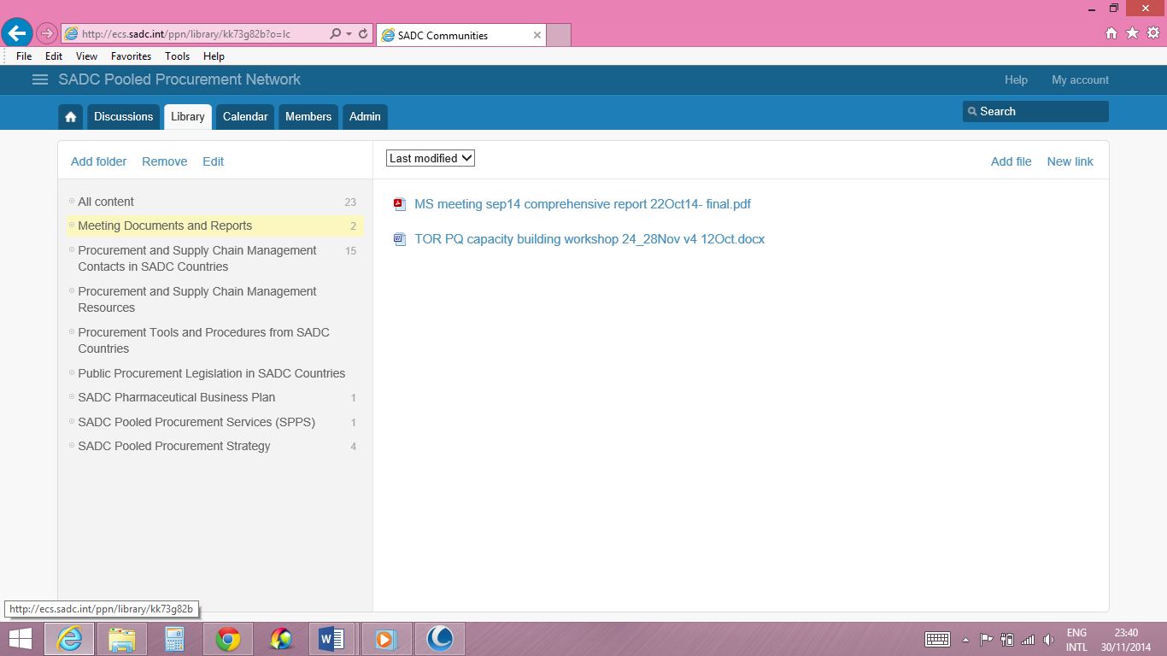

### Calendar

The Calendar shows upcoming events including their details. New events may be uploaded using New event.

Figure: The SADC PPN Calendar Page

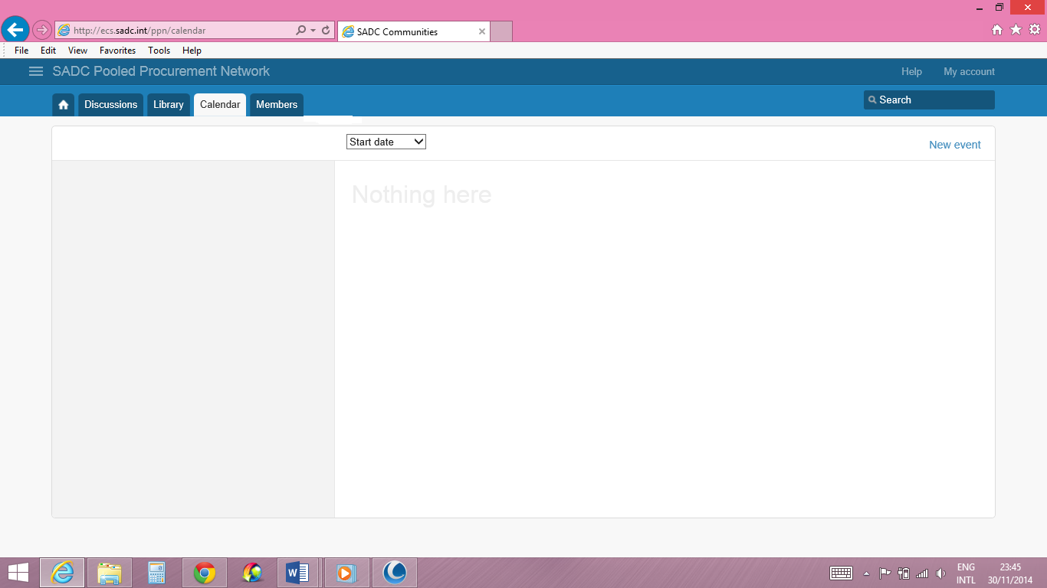

### New event

Information details on the event can be filled on the New Event field and sent for approval.

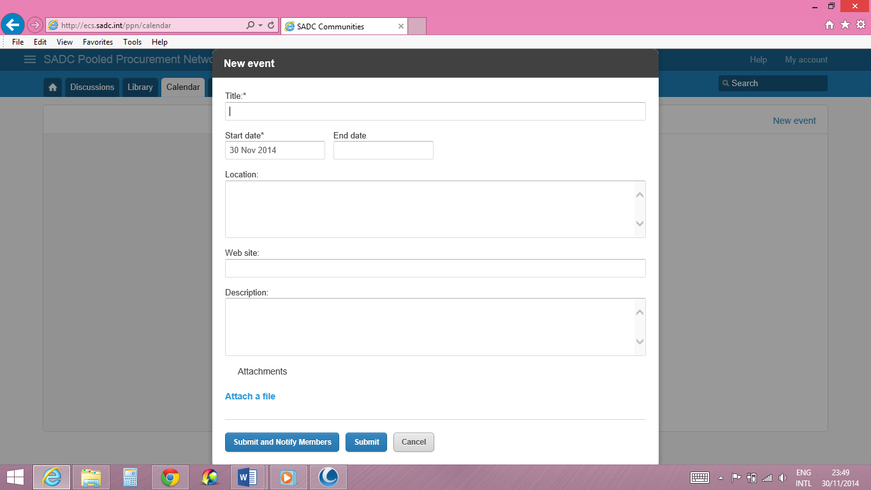

Events may include meetings and workshops, training courses as well as tender notifications and publications of tender awards.

### Members

The page Members shows all members email addresses and their countries. My account gives the opportunity to include member profiles.

Figure: SADC PPN Members Page

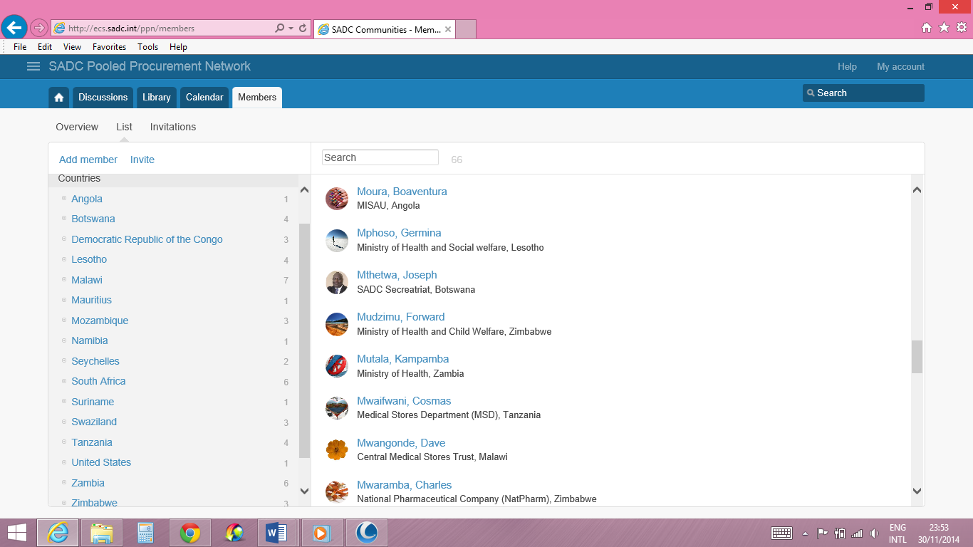

### Help

To learn more about the SADC PPN, use the Help menu on the top right corner of the PPN website.

## Stepwise instructions on how to use the PPN: What would you like to do?

### View an ongoing or an older discussion on the PPN website:

1. Open your internet browser and go to <http://ecs.sadc.int/ppn/>. (It is advisable that you bookmark this page for ease of access anytime you want to participate in discussions on the PPN).
2. When prompted, enter your username and password
3. From My Communities, select Pooled Procurement Network
4. To view active or archived discussions, click on the Discussions tab. Active and archived discussions are displayed on the left pane of the page.
5. Click on the discussion of interest and view the contributions of members on the topic on the right pane. Note that each contribution is assigned a number starting from 1 going forward.
6. To reply to a contribution, click on Reply under the number of the contribution.
7. Enter your message on the resultant pop-up field and click Submit

### Create a discussion for others to comment on

1. Open your internet browser and go to <http://ecs.sadc.int/ppn/>. It is advisable that you bookmark this page for ease of access anytime you want to participate in discussions on the PPN.
2. When prompted, enter your username and password
3. From My Communities, select Pooled Procurement Network
4. Click on the Discussions Tab to display the discussions page.
5. On the top corner of the right pane, click Start Discussion
6. On the field that pops up, enter the Subject of the discussion, the detailed message and attach any files you may want to attach for the discussion
7. When you are satisfied with the posting, click Submit and wait for the Moderator to release the message to the community.

Please note that the Moderator may edit your message depending on necessity and in accordance with the norms and values of the community.

### Upload a document or tool to share with others

1. Open your internet browser and go to <http://ecs.sadc.int/ppn/>. It is advisable that you bookmark this page for ease of access anytime you want to participate in discussions on the PPN.
2. When prompted, enter your username and password
3. From My Communities, select Pooled Procurement Network
4. Click on the Library tab to enter the library
5. Depending on the type of document you would like to share, select the appropriate folder on the left pane of the page. In case the folders are obscured by a file download field, close the download field by clicking on the X icon and the folders will be displayed again.
6. While in the appropriate folder, go to the top corner of the right pane and click on Add File if the file is on your computer or click on New Link if the file is hosted on another website.
7. In the field that pops up, select the file which you would like to attach from your computer or enter the details for the website link, if you are sharing an internet link.

### Find and download a file from the library.

1. Open your internet browser and go to <http://ecs.sadc.int/ppn/>. It is advisable that you bookmark this page for ease of access anytime you want to participate in discussions on the PPN.
2. When prompted, enter your username and password
3. From My Communities, select Pooled Procurement Network
4. Click on the Library tab to enter the library
5. Inspect and select the appropriate folder on the left pane of the page depending on the type of document you would like to download. In case the folders are obscured by a file download field, close the download field by clicking on the X icon and the folders will be displayed again.
6. When the appropriate folder is selected, the files in that folder will be displayed on the right pane. Scroll up and down the files and select the desired file.
7. If you cannot find the file you would like, you can ask members of the community for it by following the instructions on how to create a discussion on the PPN.

### Contact a particular PSM expert in another country whose contact details you do not know

1. Open your internet browser and go to <http://ecs.sadc.int/ppn/>. It is advisable that you bookmark this page for ease of access anytime you want to participate in discussions on the PPN.
2. When prompted, enter your username and password
3. From My Communities, select Pooled Procurement Network
4. Click on the Library tab to enter the library
5. On the left pane, select a folder called Procurement and Supply Chain Management Contacts in SADC Countries. In case the folders on the left pane are obscured by a file download field, close the download field by clicking on the X icon and the folders will be displayed again.
6. While in the selected folder, scroll up and down the country files on the right pane and download the file for the country you are interested in.
7. In the downloaded country file, select the details of the appropriate person based on their designation and contact them using appropriate media.

### Respond to a discussion on the PPN.

1. Members can participate in ongoing discussions on the PPN through two means; the first is by replying to emails that are sent to all members each time one contributes to the discussion; and the second is by directly participating on the PPN website. Both ways have the same effect.
2. To participate in a discussion when you receive an email, simply reply to the email. If on the other hand you would like to contact the PPN administrators, send an email according to instructions at the bottom of each email you receive from PPN.
3. To participate directly via the PPN website, follow the instructions described under the topic of how to View an ongoing or an older discussion on the PPN website.Oversight, Management and Monitoring

The 2013 Member States on Pooled Procurement formulated a number of recommendations that should apply to the SMD. They are presented in Annex 1 together with their actuals status. The meeting advised to form the PPSM Technical Working Group with senior NMPA staff and experts in setting up a management structure. This PP WG will be in charge of all management functions regarding SMD and PPN until the SADC Pharmaceutical Procurement Services (SPPS, i.e. the Pooled Procurement Coordinating Mechanism named in the PP Strategy) takes over. Support by SARPAM may end when the programme closes down, which is currently planned for December 2014.

It is suggested that usage information will be collected and discussed periodically. This information can include the number of registered users, the number of page views per day, the number of discussion threads per period, and the number of users participating in discussions. Usage can also be determined per country (e.g. which countries show the most e-platform activity), and per type of stakeholder/respondent (e.g. procurement agencies’ e-platform activity compared to regulatory authorities’).

More importantly, users of the system should be interviewed to understand its usefulness to their daily work. There is already anecdotal evidence indicating cost savings due to sharing of procurement prices within SADC.

For the medium term it would be useful to do an assessment of whether and how the procurement information and work sharing e-platform contributed to improved pharmaceutical procurement efficiency amongst participating procurement agencies. This should include an assessment of supplier behaviour as a consequence of making procurement information public[14].

There is a focal person contact person in each Member State who is responsible for compiling and submitting the data on a regular basis. This contact person is usually senior manager of the NMPA or Ministry of Health.

Management of the SMD and PPN will be an integrated part of the detailed work plan (activities, persons responsible, and timeline), budget and a resource plan.

English, will be used as an initial language for the platform. Decisions will be taken on how to address the needs of the French and Portuguese speaking countries.

Explanations on the data fields have been included in the database to assist stakeholders and respondents in the interpretation of findings. The databases have levels of authority, so that confidential information (for example on suppliers performance) may be protected from public access.

At a later stage, complying with the aims of the Strategy for Pooled Procurement, preferential suppliers and the results of price negotiations will be published which will provide the option for Member States’ procurement agencies to actually order against.

# SMD and PPN future opportunities

This methodology provides the principles and basic contents for the start-up of the procurement information and work sharing e-platform. Staff needs to be appointed to be in charge of the implementation of the work plan and will report back to the PPWG at regular intervals. Discussions will be held to monitor progress and to establish a way forward to expand the e-platform, ensure sustainability, and measure the e-platform’s impact on procurement operations at country-level. Possible steps are provided below.

**Expansion of the e-platform content and functionality**

A balance between the amount of data required and the work load for participating respondents related to data collection and documentation needs to be established. Expansion of data fields would ideally be initiated through the identification of additional needs by the stakeholders and e-platform users.

The following data items should be considered for addition to future rounds of data collection:

* results of monitoring of supplier performance and supplier ratings;
* specific tender/contract conditions such as lead times and requirements for shipment (air/sea);
* products with identified quality problems;
* an expanded list of medicines; for this the criteria developed in the Gaborone meeting may be used (see annex)
* databases from other regions median procurement prices as reference (e.g. EAC, WHO WPRO);
* results of negotiated prices for the region;
* Drug shortages
* EDLs of all MS
* a mobile application for offline access to the databases.

# Annex 1, Overview of Management issues from the SADC Pooled Procurement Member States Meeting, Benoni, South Africa, 2013

**On the e-medicines info sharing mechanisms**

| **Recommendations** | **Status** |
| --- | --- |
| For sustainability purpose the platform should be simple, web –based and hence MS can self-sustain. Hence each country should have its code to access information | An upload function is in place for NMPAs to use which makes the upload at any time possible |
| Frequency of updating information: It is worth noting that MS should understand that their obligation is not only to extract but more important is to share information ( Give and take) | Id. |
| Minimum posting is on quarterly basis/ Information should be submitted quarterly (or bi-annually), if there are any problems or alerts, it could be done as and when the situation occurs/arise/ Updating of procurement information should be done quarterly or bi-annually (subject to the procurement officer’s views) | Id. |
| As part monitoring and having updated information time validity of each posted information be given | Included under Procurement Period |
| Platform owned by MS/ Member states owns the platform, hosted at SADC Secretariat | Done |
| Be coordinated by country chairing SADC on rotational basis | Will be addressed in Business Case for Pooled Procurement coordination for the coming 4 years |
| Access information will be to MS having access code for each | Done |
| Information should be submitted electronically | Done |
| Where MS do not have access to e-mail, SARPAM to provide the technical support | Done; however, will need to be handed over before closing down of SARPAM in Dec-14 |
| A recommendation that there be a focal person in each MS gathering the information and a regional coordinator collecting for the whole region | Done; however not formally confirmed by SADC or PSs yet |
| Member states to appoint a focal person for data collection | Id. |
| Regional Coordinator will be managing the e-platform activities | PP PACT Lead in charge |

**On the e-medicines info sharing challenges**

|  |  |  |  |
| --- | --- | --- | --- |
| **Problem** | **Strategy** | **Responsibility** | |
| Procurement Prices | | | |
| Split tenders resulting in different prices | Submit all information for each price and supplier for split tenders | | Focal persons  Done |
| Price varies with procurement method e.g. tender, or off-tender/buyouts | Submit only for normal tenders | | Focal persons  Done |
| Pack sizes  High volume items | Submit all information including different pack size and volumes | | Focal  persons  Done |
| Different currencies | Include exchange rate with US$ at time of opening tender | | Focal persons  not done |
|  | Include option to select different currencies | | E-platform administrator  Done |
| Incoterms | | | |
| Different incoterms | Standard factor/approach to convert different incoterms to standardize incoterm on e-platform | | E-platform administrator Done |
| Different shipment methods | Specify shipment methods | | Focal persons |
| Procurement Volumes | | | |
| Which volumes should be specified?  i.e. Tender – forecasting volumes (estimate) or actual volumes purchased ?? | 1. Record the volume at time of tendering i.e. volume linked to the price; 2. Submit annual volumes purchased against specific procurement price | | Focal persons  Done |
| Registration Status | | | |
| NO problems with supplying information | MS should indicate whether product is registered or not, or state Quality assurance system used e.g. prequalification | | Focal persons  not done |
| Delays in registration of products | Recommendation MRAs to consider registration in other MS for expediting registration | | Medicines Regulatory Authorities / Pharmacy Departments  not done |

# Annex 2, Profiles SMD and PPN Management and Focal Persons

[will be further developed in 2015]

1. WHO Glossary: [http://whocc.goeg.at/Glossary/PreferredTerms/International%20non- proprietary%20name](http://whocc.goeg.at/Glossary/PreferredTerms/International%20non-%09proprietary%20name)
2. WHO, 2011: <http://www.who.int/medicines/services/inn/en/>
3. FDA, 2009: <http://www.fda.gov/Drugs/informationondrugs/ucm079436.htm>
4. FDA, 2009: <http://www.fda.gov/Drugs/informationondrugs/ucm079436.htm>
5. WHO Collaborating Centre: <http://www.whocc.no/>
6. WBI, 2011: Using a multi-stakeholder approach to improve governance in pharmaceutical procurement by Marianne Schürmann.
7. WHO Glossary: <http://whocc.goeg.at/Glossary/PreferredTerms/Marketing%20authorisation>
8. SA Pharmaceutical Journal, 2011: <http://www.sapj.co.za/index.php/SAPJ/article/viewFile/967/1029>
9. WHO Glossary: <http://whocc.goeg.at/Glossary/PreferredTerms/Supplier>
10. WBI, 2011: Using a multi-stakeholder approach to improve governance in pharmaceutical procurement by Marianne Schürmann.
11. WBI, 2011: Using a multi-stakeholder approach to improve governance in pharmaceutical procurement by Marianne Schürmann.
12. SARPAM (2010), SADC Pharmaceutical Market Analysis, January
13. Draft SADC PPSM Standards February 2014
14. WBI, 2011: Using a multi-stakeholder approach to improve governance in pharmaceutical procurement by Marianne Schürmann.