horizontal line

# Congolese Professionals Network

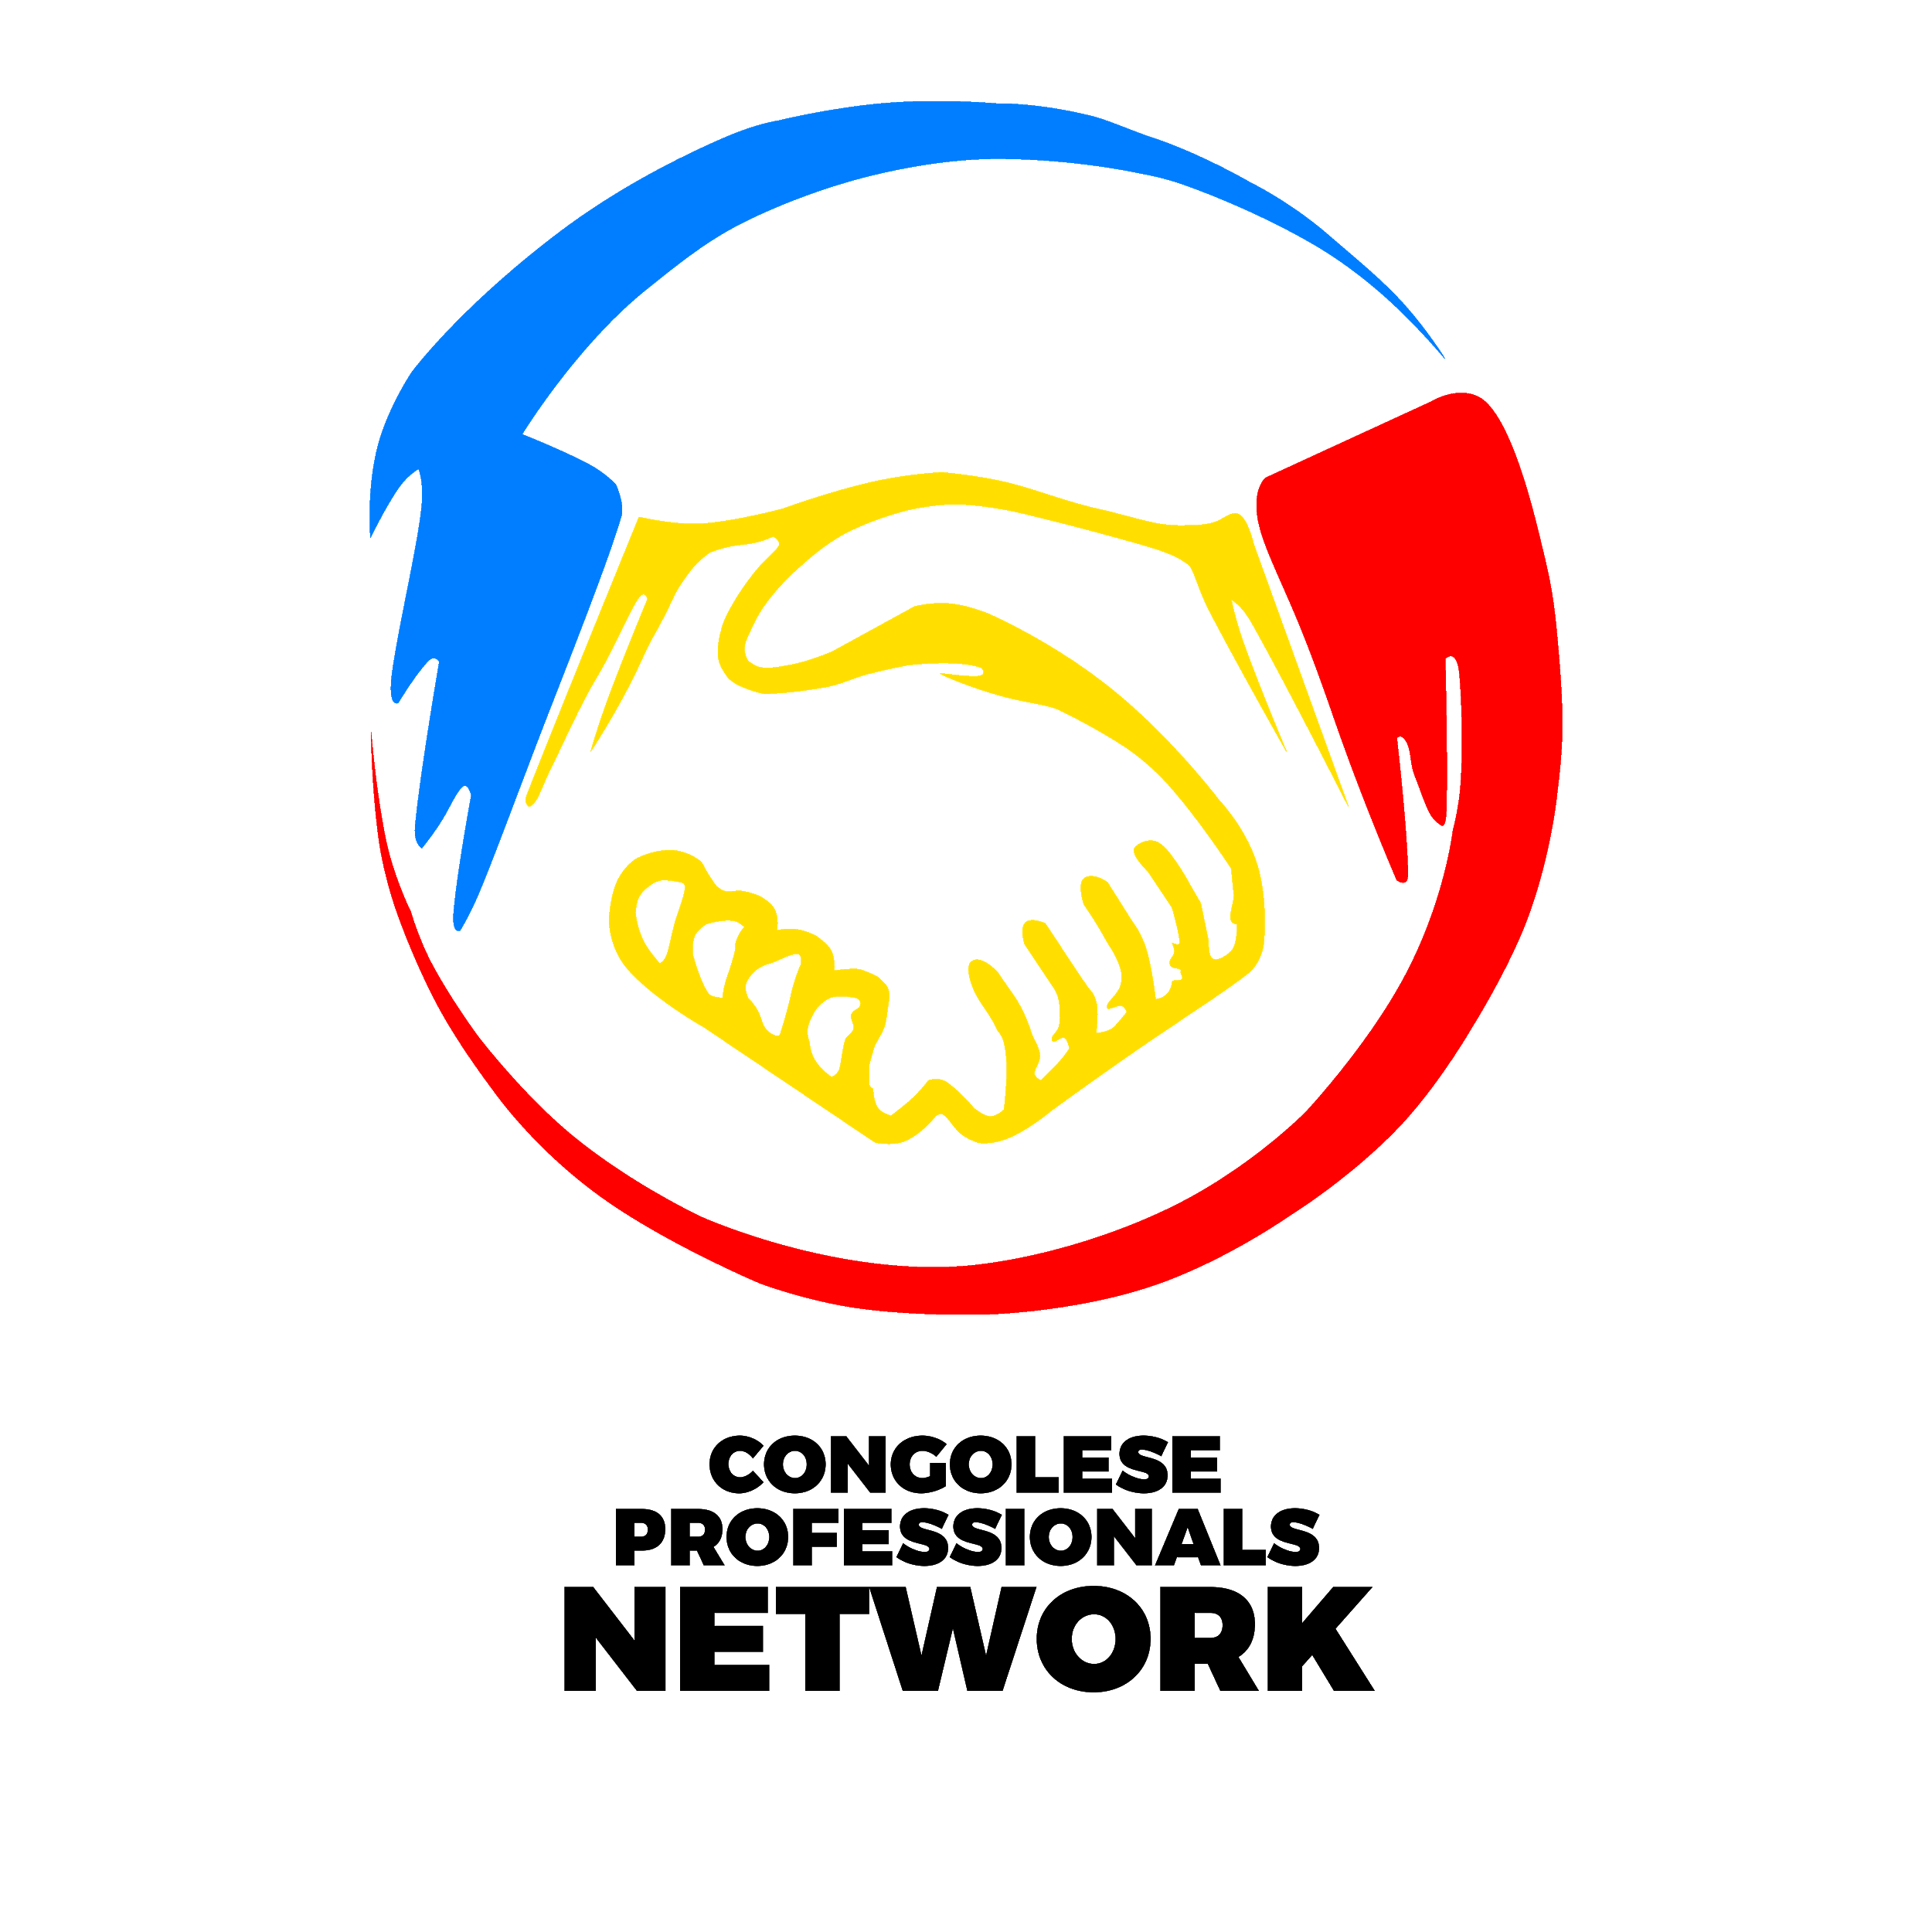

In a world of confusion and panic, a gap that has always been a topic of conversation within the Congolese community was analyzed and filled by a group of Young Congolese Professionals in South Africa. Through a mutual interest in seeing the community thrive, the 243_Pro_Network (NPO) known as the “Congolese Professionals Network” was born.

horizontal line



## The bigger picture

Quite often the question of what our bigger picture or driving force is has come up. And simply put, we would like to establish a platform and ecosystem where the skills and services of the various professionals in our community can be identified and ultimately consumed. At first, we wanted it to be for young professionals but as we have grown we have come to realise that we can all benefit from exposure to professionals from all walks of life, from the 1st year student to the individual in senior management.

Imagine a gateway that brings us all together and facilitates the opening of smoother and easier lines of communication between like-minded people. But we have managed not to be limited to professional individuals only but also businesses, investors and even job seekers and recruiters. We position ourselves to be the platform where Congolese entrepreneurs, self-employed, business owners and professionals can interact and grow as a collective.

We plan and hope to be a platform where your needs as individuals can be one click away. Our focus as we see them right now are:

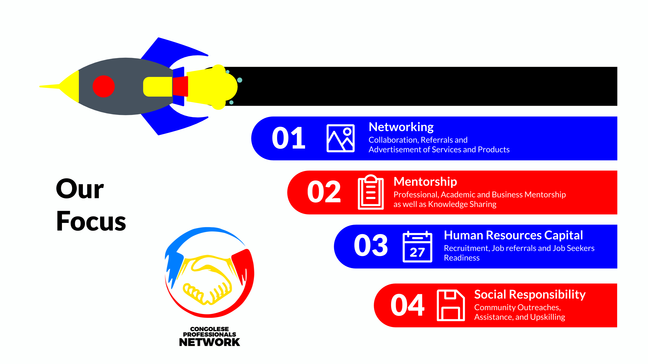

Each level of services’ focus differs from the next, but the goal remains the same; empower the individual to make positive changes in our community. Our efforts are bearing fruits in the ever-growing database called the “yellow book” and the different social media efforts and engagements we have initiated since our inception.

We got inspired by the concept of economy of agglomerations and also by observing how the various communities around us were operating and uplifting each other.

We decided to get started and get better as we go.

Our team is young, dynamic and well balanced. From our founder, Mr Bob Kabeya, a civil engineer to the two co-directors of the NPO, Miss Melissa Muleba, Financial Manager and heading our marketing drive, and Mr Tim Muepu, Actuary Scientist and Risk Manager, heading our compliance, risks and business mentorship division. We also have vibrant team players in our core team as well as a few advisors assisting us as we grow. Mrs Emilia Luhonda (CA, SA), handling our finance and funding division; Miss Clarice Ngandu is in charge of our operations, data management and security; Mrs Deborah Disanka heading our human capital and recruitment department; Mr Emmanuel Lumbayi who is heading our technical and IT division and finally Dr Nahomie Mukendi who is in charge of our social responsibility division. The team of advisors assisting us is formed by Mr Willy Mutondo, Mr Patrick Ngoie (CA, SA), and Mr Mark Mpasa.