季度：
t=[1 2 3 4];
PM1=[239049.5 147081 119251.8 210859];
PM2=[188581.9 114966.2 105826.2 202334];
PM3=[190451 111344 98132 192837.36];
t1=1:0.01:4
PM11=interp1(t,PM1,t1,'spline');
PM21=interp1(t,PM2,t1,'spline');
PM31=interp1(t,PM3,t1,'spline');
x1=plot(t,PM1,'bo');
hold on
x2=plot(t1,PM11,'b-')
hold on
x3=plot(t,PM2,'r*')
hold on
x4=plot(t1,PM21,'r-')
hold on
x5=plot(t,PM3,'k+')
hold on
x6=plot(t1,PM31,'k-')
hold on
legend([x1 x3 x5],'2014','2015','2016')
title('PM季度含量')
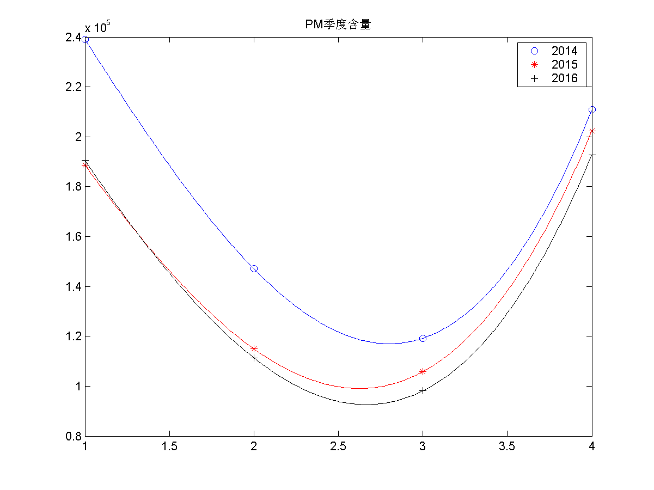
每年的pm含量

x=[2014,2015,2016];
y=[2436.39,20892.10,19529.73]
bar(x,y,0.3)
xlabel('年份');
ylabel('总PM含量');
title('年度PM含量')
