Final assignment
Data engineering ⇒ collect data + process & store it

One hot encoding:
https://www.youtube.com/watch?v=InZ0n2knz1E
from sklearn.calibration import LabelEncoder labelEncoder = LabelEncoder() print(df["ocean_proximity"].value_counts())

Test train split
Test train split methods: (https://www.linkedin.com/pulse/data-splitting-strategies-machine-learning-swapnil-sharma/, https://www.baeldung.com/cs/cross-validation-k-fold-loo)
- random
- stratified sampling
- k-fold cross validation
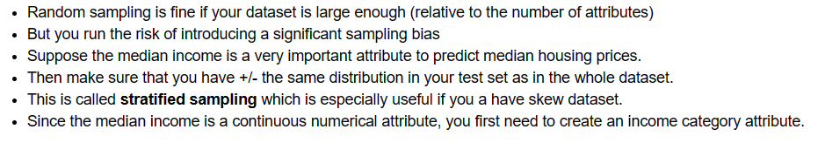
X_train, X_test, y_train, y_test = train_test_split(X, y, test_size=0.2 ,random_state=42, stratify=y)
I wanted to use stratify
but couldn’t because even after changing the test size to lower or higher numbers I couldn’t get a good distribution match between test and train set, here is the error I encountered

Impute missing values (https://www.youtube.com/watch?v=m_qKhnaYZlc)
Single variant:
simple imputer (missing values): ⇒ takes the mean/medium/mode to fill in

Multi variant:
Takes other factors into account ⇒ maybe age is co-related to fare?
Ex: iterative imputer and KNN imputer
Iterative imputer: makes a regression model using the other things and then makes predictions
kNN imputer: finds the closest values of the other factors(x) and averages the dependent factor(y). You need to choose a hyper parameter
https://www.quora.com/I-am-learning-about-imputation-in-data-science-Is-KNN-imputer-or-iterative-imputer-considered-to-be-the-better-imputation-method-Or-is-it-situational#:~:text=1y-,My,-take%20is%20that
I am choosing to delete all the missing values rows

Outlier management
https://www.linkedin.com/advice/3/what-pros-cons-different-outlier-removal-techniques

Test train split and outlier management
https://medium.com/@megha.natarajan/scaling-data-before-or-after-train-test-split-35e9a9a7453f#:~:text=Scaling%20after%20the%20train%2Dtest,of%20your%20model's%20performance%20metrics.

Standardisation and outlier management
https://stats.stackexchange.com/questions/415704/should-you-standardize-your-variables-before-or-after-removing-outliers

Scaling:
Standardization
Normalization

Feature selection:
High correlation so we choose one. Total bedrooms has a high correlation with everything so I chose that.

