Thesis Plan: AI‑Driven Government Expenditure Optimization Using Regression & Markov Decision Processes

Ambrose Asiimwe  
M.A. Digital Innovation, Hanyang University ERICA  
Supervisor: [Insert Name]  
Date: [Insert Date]

# Executive Summary

This thesis examines how Artificial Intelligence—specifically regression analysis and Markov Decision Processes (MDPs)—can enhance the efficiency of Uganda’s public‑sector budgeting. By marrying historical data‑driven forecasts with sequential decision modelling and Monte Carlo stress tests, the study delivers a replicable framework for adaptive, evidence‑based fiscal planning. Expected outputs include a validated hybrid model, policy dashboards, and recommendations that align with Uganda’s digital‑governance agenda while remaining transferable to other developing economies.

# Background & Context

## Comparative Perspective

Developed economies increasingly deploy data‑centric budgeting tools (e.g., Singapore’s Smart Nation dashboard, the U.S. GAO’s risk‑adjusted forecasts). Uganda still relies on manual allocations, leading to under‑execution and inefficiencies. This research addresses that gap.

## Relevance to Uganda’s Smart‑Governance Agenda

AI‑driven budgeting directly supports goals of transparency, responsiveness, and value for money in Uganda’s Integrated Financial Management System (IFMS).

# Problem Statement

Persistent under‑utilisation of funds across MDAs indicates suboptimal allocation strategies. Existing models fail to learn from past performance, resulting in budget deviations, delayed releases, and missed development targets.

## Implications

In Health and Education, unspent allocations translate to reduced service delivery; in Agriculture, they hamper food security. Optimising allocation decisions is therefore both a fiscal and social imperative.

# Literature Review Summary

Prior studies showcase AI use in fiscal modelling—e.g., U.S. GAO Monte Carlo applications and Singapore’s dynamic allocation engines. However, integration of regression, MDPs, and Monte Carlo in Sub‑Saharan contexts remains sparse.

# Theoretical Foundation

The work draws on Rational Choice Theory, Bellman’s Dynamic Programming, and classical Regression Theory to frame budgeting as a sequential, reward‑maximising process under uncertainty.

# Conceptual Framework

Historical budget data feed a preprocessing engine; regression pinpoints drivers of execution; an MDP encodes decision states, actions, and rewards; Monte Carlo simulations stress‑test policies; outputs guide optimal allocation paths.

# Methodology

## Data Collection

10+ years of sector‑level budget PDFs parsed via pdfplumber.

## Feature Engineering & Regression

OLS, Ridge, Random‑Forest models benchmark expenditure predictors.

## MDP Design

States: (Sector, GDP‑ratio bucket, Release tier); Actions: Maintain / ±5 %; Reward: Exec‑rate minus deviation.

## Monte Carlo Simulation

1 000‑5 000 scenario episodes per policy to capture shocks.

# Sample Dataset Features

|  |  |  |
| --- | --- | --- |
| Feature | Description | Example |
| Approved Budget (UGX) | Total allocated funds | 4,200,000,000 |
| Released Budget (UGX) | Funds actually disbursed | 3,800,000,000 |
| Actual Expenditure (UGX) | Money spent | 3,600,000,000 |
| Execution Rate (%) | Actual / Released ×100 | 94.7 % |
| Deviation | Released − Actual | 200,000,000 |

# Work Plan & Timeline (Narrative)

The study spans February to mid‑October 2025. Data collection ended in April; regression modelling runs May‑June; MDP design and Monte Carlo simulations run concurrently July‑mid‑August; evaluation occupies mid‑August to mid‑September; writing, revision, and defense preparation conclude by 19 October.

## Figure X: Project Gantt Chart (Feb – Oct 2025)

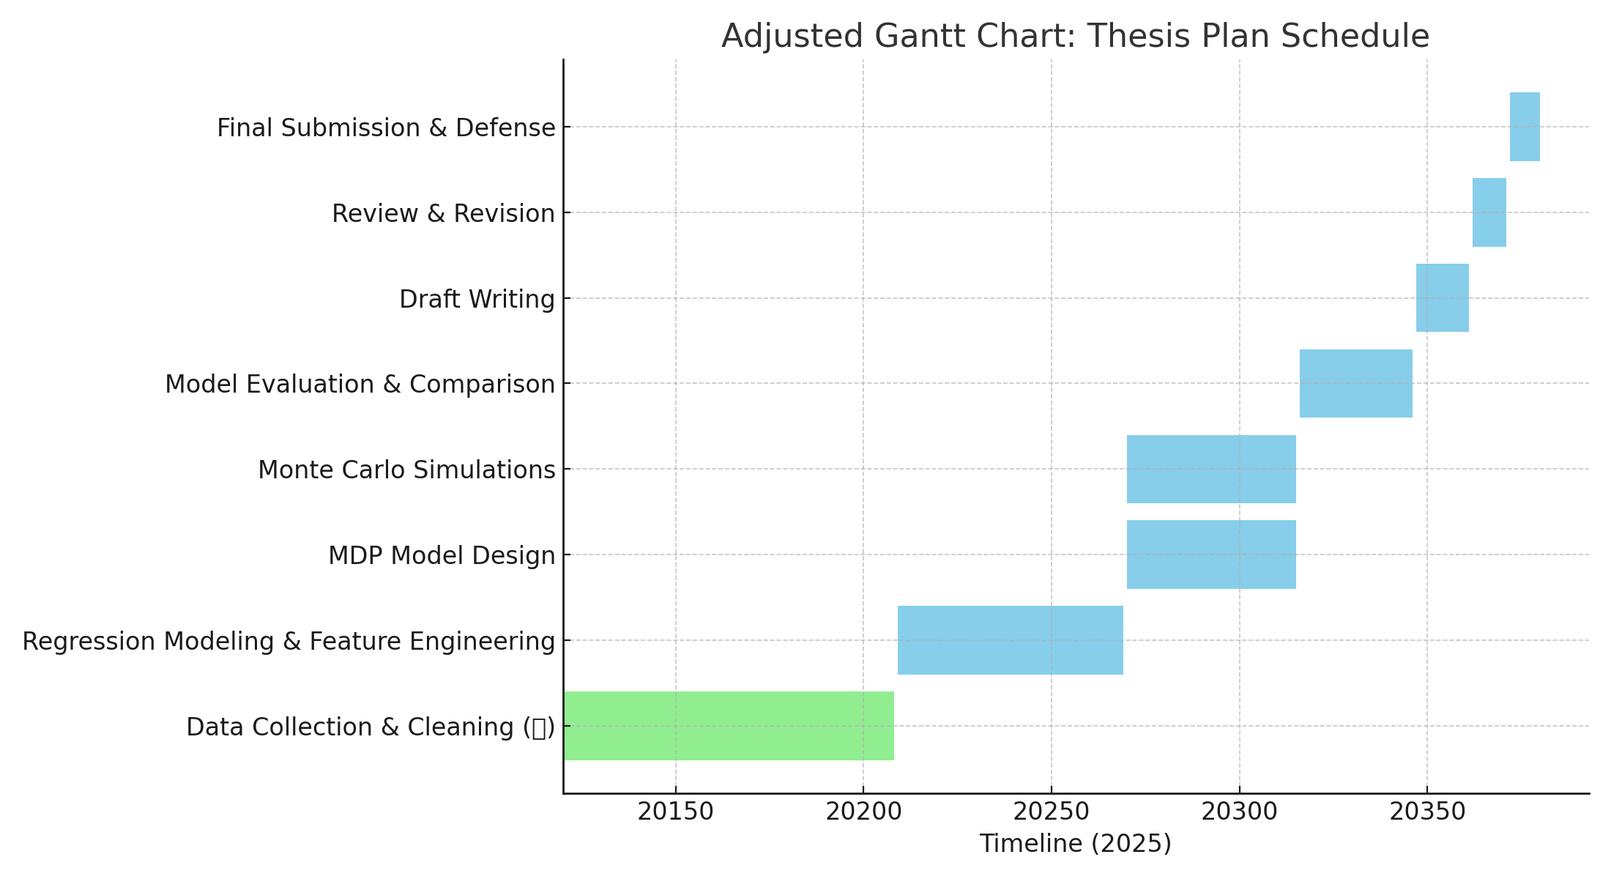

Figure X. Timeline of thesis tasks showing concurrent MDP & Monte Carlo phases and completion deadline 19 October 2025.

# Anticipated Challenges & Mitigation

- Data gaps → apply imputation  
- MDP complexity → start with sector models  
- Interpretability → dashboards & SHAP  
- Scalability → modular code

# Expected Outcomes

Hybrid AI model, improved execution KPIs, dashboard prototype, and policy guidelines.

# Contributions

Practical: smarter allocation; Academic: expands AI‑PFM literature; Policy: transparent evidence‑based budgeting.

# Ethical Considerations & Limitations

Public data usage, bias checks, context‑specific generalisability, and need for human oversight.

# Stakeholder Impact

Benefits Ministry of Finance, MDAs, development partners, and citizens through improved budget reliability.

# Model Justification

Regression offers interpretability; MDP models sequential decisions; Monte Carlo quantifies uncertainty.

# Appendix A – Work Breakdown Structure (WBS)

See prior detailed WBS lists for Tasks 1–8.