SNHU: CS-340 Client/Server Development

Module 5 – Python Module for CRUD

Matthew Bandyk

Below are screenshots of the Python testing script running in Jupyter Notebooks:

1. **Connecting to Database:**

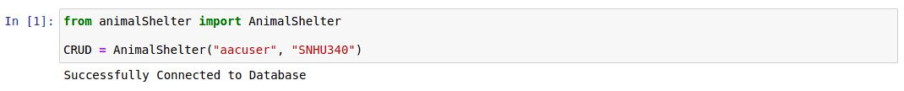

1. **Create in CRUD - Creating new Document (Yes and No):**

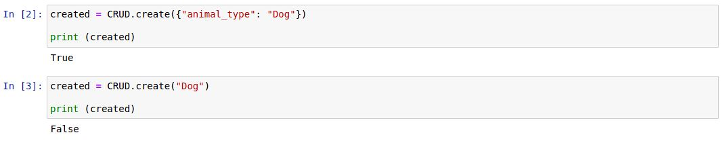

1. **Read in CRUD - Running query on Database (single key/value pair)**

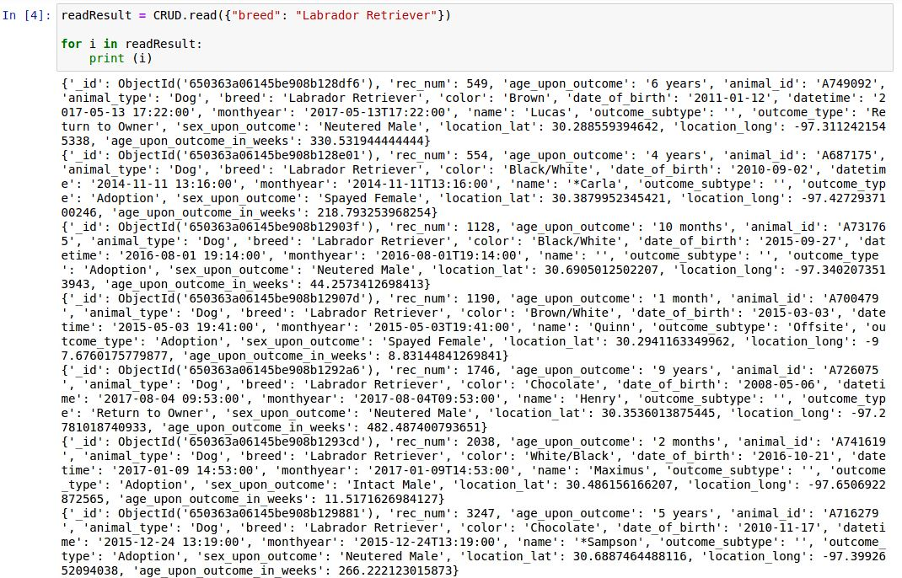

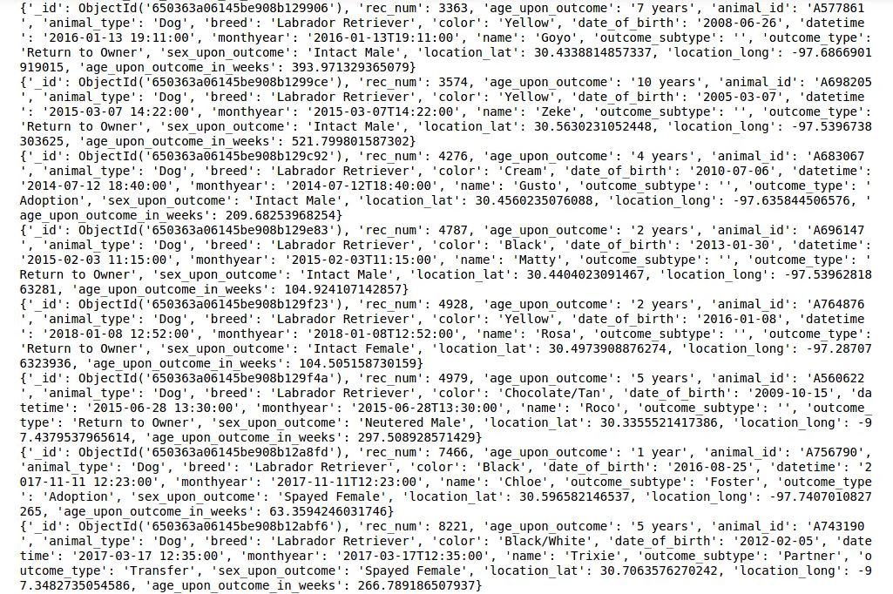

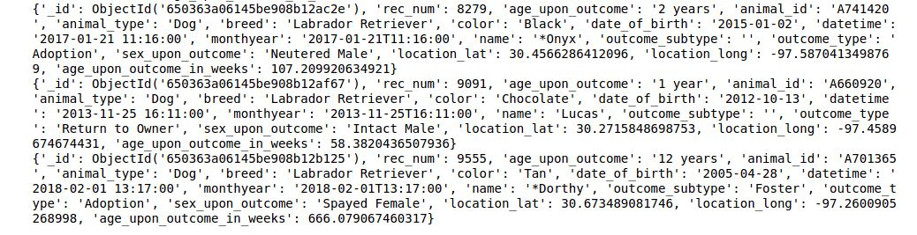

1. **Read in CRUD – Running Query with 2 key/value pairs**

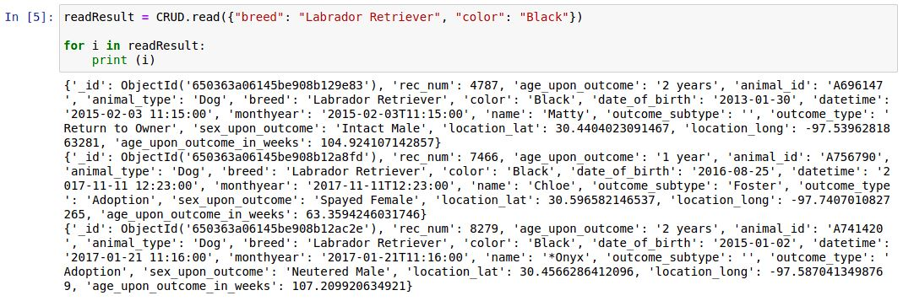

1. **Read in CRUD – Running Query with no results**

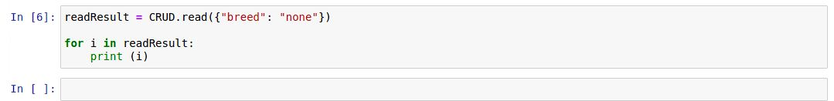

1. **Update in CRUD – Update single Document**

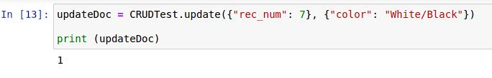

1. **Update in CRUD – Update none**

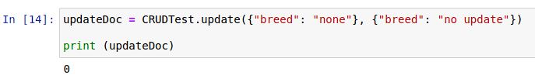

1. **Update in CRUD – Not Key/Value pair**

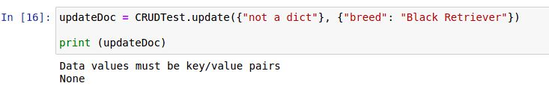

1. **Update in CRUD – Update many Documents**

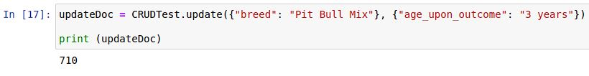

1. **Delete in CRUD – Delete single Document**

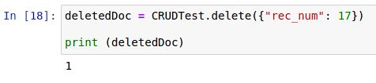

1. **Delete in CRUD – Delete many Documents**

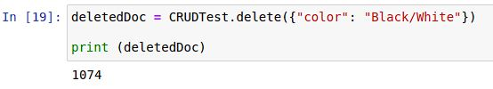

1. **Delete in CRUD – None/ Not Key/Value pair**

