INTRODUCTION
Next.js is a full-stack React framework used to build modern web applications. It extends react with features that makes apps faster, more scalable and better SEO friendly. Next.js offers a lot of features that is not inbuilt in react like SSR, SSG, File-based routing, Image Optimization and the biggest support is API Routes. It combines both frontend and backend capabilities in a single project allowing developers to keep all the code into a single project or code base. It was built on react.
Tech Foundation of Next.js
- React to handle all the UI component-based system which mainly include Frontend
- NodeJS to run server-side logic for API routes and SSR.
- Webpack/SWC for bundling and compilation.
- Vercel platform for deployment.
Why Next.js was created?
In React, components rendering is handled in the browser (Client-Side Rendering) this causes several challenges: -
- Poor SEO: Search Engine see a blank page initially because content loads only after JS runs or load in the browser. This creates a new Problem which is
- Slow First Page Load: Users waits for the entire JS bundle to arrive and get downloaded before user gets to see anything.
- No built-in routing: Developers has to manually configure the routing for the pages across project using React Router DOM NPM package.
- Performance tuning: In react, we need to manually turn the performance of the project like code splitting or image optimization which increases extra code lines as well as deviate developers from focusing on business logic.
To solve and counter the problems that developers face using react for their project, Next.js was introduced.
- To solve the Client-side Rendering problem – Next.js introduced SSR and SSG rendering types.
- To solve the Poor SEO problem – Next.js has a feature of Pre-rendered HTML which improves the SEO.
- To solve the manual routing problem – Next.js introduced the file-based automatic routing.
- Next.js not only solve the react based problem but also server-side problem by introducing API routes inside the same project
Next.js was not created to replace, it was created to make react based apps faster, SEO-Friendly and production-ready apps by introducing server-side rendering and many built-in optimizations that react lacks.
How Web Pages Load in the Browser (HTML, CSS, JavaScript)
When we open a website, the browser first downloads the HTML file, which contain the basic structure of the page. As the browser reads the HTML, it detects the linked CSS files and JavaScript files. CSS is then downloaded and applied to the elements for styling after which JavaScript file is downloaded and executed to add logic for the elements and make it user interactive. During the whole process there are two internal structuring happens: -
- DOM (Document Object Model) – this is created from the content present in the HTML file
- CSSOM (CSS (Cascading Style Sheet) Object Model) – this is created from the content present in the CSS file.
These structures are combined to form a Render Tree, which the browser used to project the content on the screen or paint pixels on the screen (in phrase form).
How React Pages Load in the Browser
React applications are typically Single Page Applications (SPA) which is browser loads one main HTML file, usually index.html, which contain almost empty content, just a div whose id is root.
<div id=” root”></div>
Instead of server sending full HTML (that is content present in the HTML file), it sends an empty HTML file and after which an JavaScript bundle (dist folder that is created during build in vite) takes control which means without this build file the empty HTML file worth nothing so first HTML file is sent and after that JS bundle is downloaded which creates the page in the browser at client side.
- Browser loads index.html
- Browser loads React JavaScript files (bundle.js)
- React attaches itself to #root in the HTML
- React creates and manages the UI entirely using JavaScript
- React builds a Virtual DOM – a lightweight copy of the real DOM
- When changes happen, React updates only the required parts of the real DOM.

Virtual DOM and Real DOM
The real DOM is the actual structure of the webpage that the browser creates from HTML. It represents every element as an Object in a tree-like structure.
Characteristics of Real DOM
- Directly connected to UI in the browser
- Updating it is slow, especially when large parts of the UI changes
- For every change that happens forces browser to recalculate styles, rebuild layout and repaint the screen
- It works best with small updates but is very slow for the frequent updating site or pages.
The Virtual DOM is a lightweight JavaScript representation of the Real DOM created by the libraries like React. It’s like a copy of real DOM kept in memory, not on the screen.
Characteristics of Virtual DOM
- Created and managed by react
- Fast to update
- Allows react to compute the most efficient way to update the Real DOM
- Helps improve performance in apps with frequent UI changes.
How real and virtual DOM work together
- Before update – React creates a new Virtual DOM version and for every change react re-renders the component into a new Virtual DOM tree.
- Diffing – React compares the old Virtual DOM with the new Virtual DOM for changes.
- Reconciliation – React finds the minimal set of real DOM updates required to reflect the change. After that only the changed elements are updated on the screen.
Comparison
Feature | Real DOM | Virtual DOM
Where it lives | Browser | Memory
Speed | Slow to update | Fast to update
UI update | Repaint entire affected area | Update only changed parts
Used by | All website | Library like React
Efficiency | Low for frequent changing websites or pages | High efficiency via diffing
control | Direct manipulation | React manages updates

Types of Rendering
There are 5 types of rendering menthods:
- CSR – Client-Side Rendering
- SSR – Server-Side Rendering
- SSG – Static Site Generation
- ISR – Incremental Static Regeneration
- DPR/Streaming – Dynamic/Partial Rendering (Next.js 13+)
Client-Side Rendering (used by react apps only)
- Browser loads a blank HTML file containing <div id=” root>.
- Loads a large JavaScript bundle.
- React executes in the browser and builds UI.
- Everything (content, logic, rendering) happens inside the browser
PROS
- Very interactive apps
- Fast Navigation after first load
- Great developer experience
- No Server processing required for each request
CONS
- Slow First page load
- Poor SEO
- Heavy on Browser resources
- Not ideal for low-performance devices or slow networks
Server-Side Rendering (used by Next.js apps)
- Each request goes to a server
- Server runs React code and generates complete HTML
- Browser receives HTML and display UI immediately
- Then JS loads to make the page interactive (hydration)
PROS
- Amazing SEO
- Very fast first page load (HTML arrives ready)
- Great for dynamic data that changes often
- Good for Social media preview.
CONS
- Slower server response time because server must render page on every request
- More server expense as all load is on server
- Hydration process adds extra JS cost on browser
- If not optimized, it is not ideal for high-traffic apps
Static-site Generation (used by Next.js at build time for building HTML)
- Pages are pre-rendered into HTML at the build time.
- Browser loads the already built HTML which is extremely fast
- JS loads later for interaction which components.
PROS
- Fast Loading speed (CDN caches HTML)
- Extreme cheap and scalable
- Great SEO
- Minimal server cost cause pages are served as static files
CONS
- Data becomes stable until next build due to which it is not suitable for fast data changing websites.
- Large sites mean longer build times
Incremental Static Regeneration (hybrid of SSR and SSG in Next.js)
- Build static pages like SSG but regenerates pages in the background after a timer.
- Users always get a fast static version with fast content updation automatically.
PROS
- Speed of SSG but freshness like SSR
- Great for blogs, products and news pages
- No big rebuilds
- Scalable and SEO friendly
CONS
- Slight delay before updating the appeared content.
- Revalidation logic must be configured
- Not suitable when data must be real-time

DPR/Streaming SSR (Dynamic Rendering + Server Components)
- Rendering is split between server components and client components
- Server Streams HTML in chunks
- Brower starts showing layout before everything is ready
PROS
- Extremely fast perceived performance
- Less JavaScript sent to the browser
- Great for complex UIs
- Enables React Server Components (RSC)
CONS
- More complex architecture
- Requires modem hosting
- Debugging becomes tricky.

Client-Side Rendering (CSR)
Client-Side is a web rendering strategy where the most of the HTML is generated in the client-side browser using JS, and not by the server. So, in this case browser downloads the minimal HTML page and JS bundle needed for the page then JS is used to update the DOM and render the page. When the application is first loaded or rendered, the user may notice a delay before full page is loaded and this is because the page isn’t fully rendered until JS bundle is fully downloaded, parsed and executed.
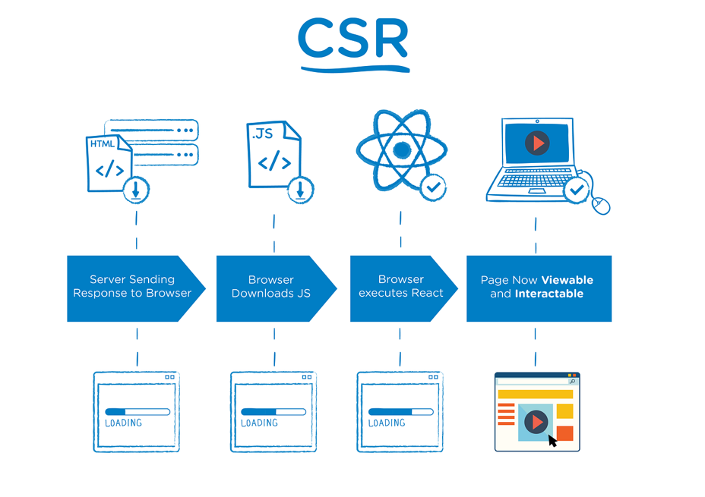
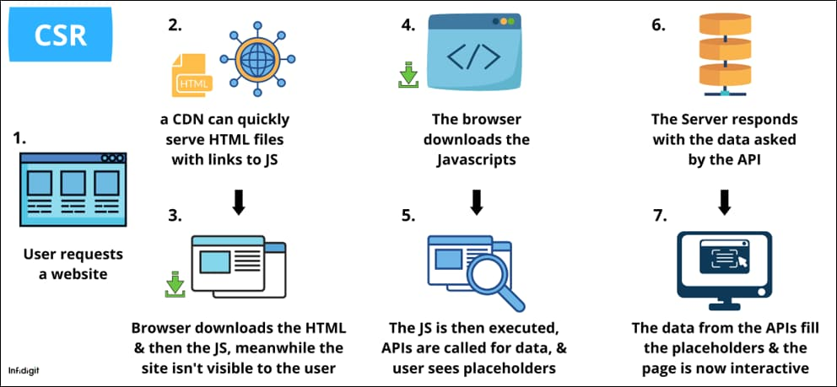
After the Page is loaded for the first time, navigating to other pages on the same site become faster, as only necessary data is now needed to be fetched and it can be re-rendered without a full-page refresh.
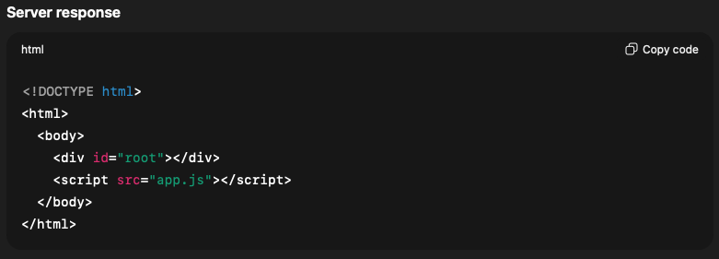
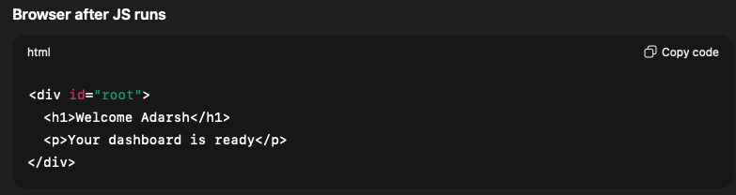
Why Client-Side Rendering come into existence and What happened after CSR?
Before CSR, Web was primarily relied on SSR (server-side rendering), where server was responsible for generating the complete HTML for a page.
Problem 1: Every click on the webapp reload a full page and these pages are sent from the server on every request which result in UX experience slow and clunky. This type of rendering was fine for blogs and static sites but not work web apps.
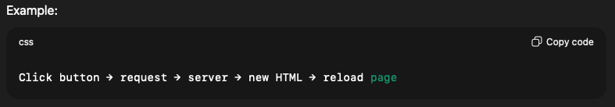
After: Solved the full page reload making only data to change not the page reload and updating DOM dynamically using JS.
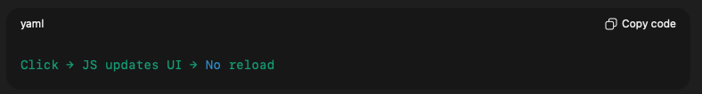
Problem 2: Poor User experience for web apps like dashboards, email client or admin panel as they weren’t interactive and can’t handle complex UI state and was slow.
After: CSR helps make states live in the browser and give instant feedback with smooth animation and transition improving user experience. This enabled apps like Gmail or Google Maps to work like desktop apps.
Problem 3: Server has to handle every request and perform lots of operation like fetching data, render HTML pages (Important), inject templates or sending full pages cause server to throttle something and had to manage high traffic causing high server cost.
After: Now server has to act as an API and return JSON reducing major work load. Browser will handle rendering for server which reduced CPU usage on server and made horizontal scaling easy.
Problem 4: Tight coupling of frontend and backend which made code maintenance hard and create problems in scaling
After: Decoupled frontend and backend so each of them can now focus on given task so from here frontend means JS app and backend means Api server. This separation enabled independent deployment possible and, in some case, same server can be used for multiple clients.
Problem 5: Slow development speed as a small UI change needs backend update causing designers to depend upon backend engineers.
After: we got frontend framework and using these we were able to make component-based UI and reuse the same logic with Hot reload. React massively improved developer productivity.
HOW Client-Side Rendering works
When client request for website the server sends almost empty HTML to the client side and then JS bundle is sent to the client side where browser builds UI using Javascript.
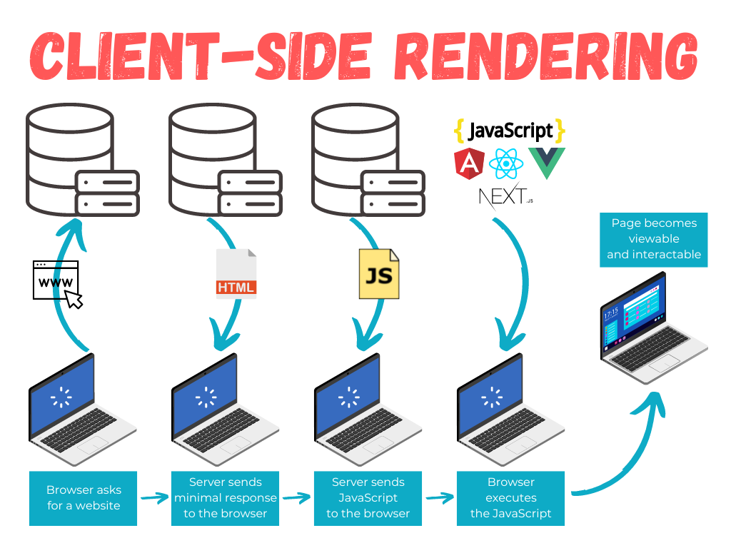
Step by step working with example
- Browser request for a page “Get /dashboard”
- Server responds with empty HTML shell. No real content yet.
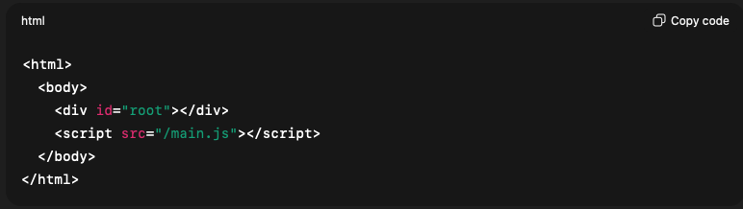
- Then using the link JS bundle is loads and executes after being sent by server. In this process App state is initialized and router starts
- Then data is fetched if we have API calls
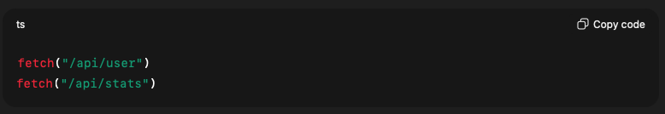
- DOM is then created dynamically making UI render in the browser and makes page visible.
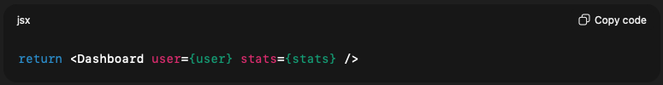
- Navigate through different routes (SPA behavior) and now data changes with no page reload and only JS and data updates.
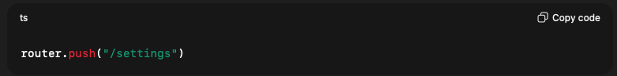
How to check if a page is CSR
- View Page Source
Right click on page -> select view page source and if you see no meaningful content
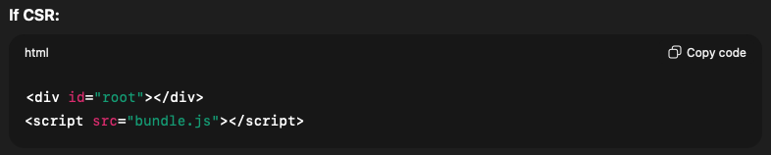
If you see meaningful content before JS runs then it’s not CSR
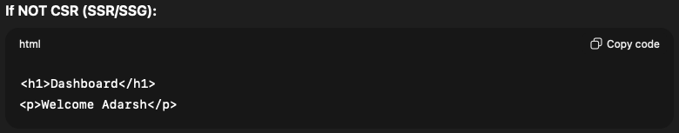
- Disable JS
In chrome DevTools – Settings-> Disable JS -> Reload. If black page then CSR and if content is still visible then not CSR.
How to check CSR in Next.js
- When we see “use client” on the top of the page
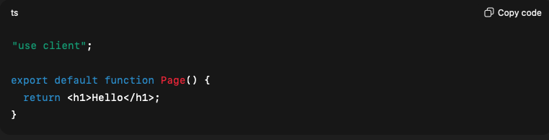
- When we see a use of React Hooks like useEffect + fetch. Data is fetched only on client which means it is CSR
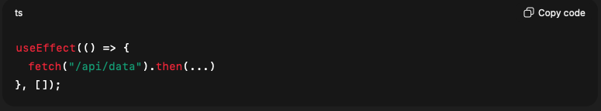
- The use of ssr: false this makes a component to act as pure CSR component.
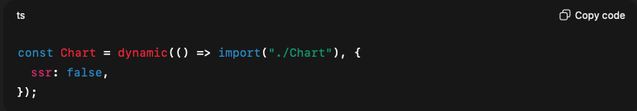
What are the Advantages and Disadvantages of CSR
- Advantages
- Smooth, App-like user experience
- Fast Navigation after the initial load
- Highly interactive UI
- Reduce server load
- Clear scalability of frontend and backend
- Better scalability for high-traffic apps
- Faster frontend development with component-based architecture
- Easier integration with real-time features
- Disadvantages
- Slow initial page load
- Poor SEO compared to SSR/SSG
- Black screen risk before JS loads
- Completely dependent on JS
- Heavy JS bundle size
- Increase browser memory usage
- Harder to debug initial render issues
- Security risk if sensitive logic is handled on client
Real world Example
- Gmail – Pure CSR after login like infinite scroll or real-time notification
- Google Maps – impossible without CSR like drag, zoom, search instantly

