Introduction
Redis is an in-memory data structure store. It stores data in RAM instead of disk, which makes it extremely fast-often microseconds, compared to milliseconds for databases. It is generally used to make applications faster, scalable, and more reliable. It’s kind of a RAM-based memory for applications. Redis stands for Remote DIctionary Server. It is not a replacement for DB but it is a performance accelerator. It is a Key-Value store
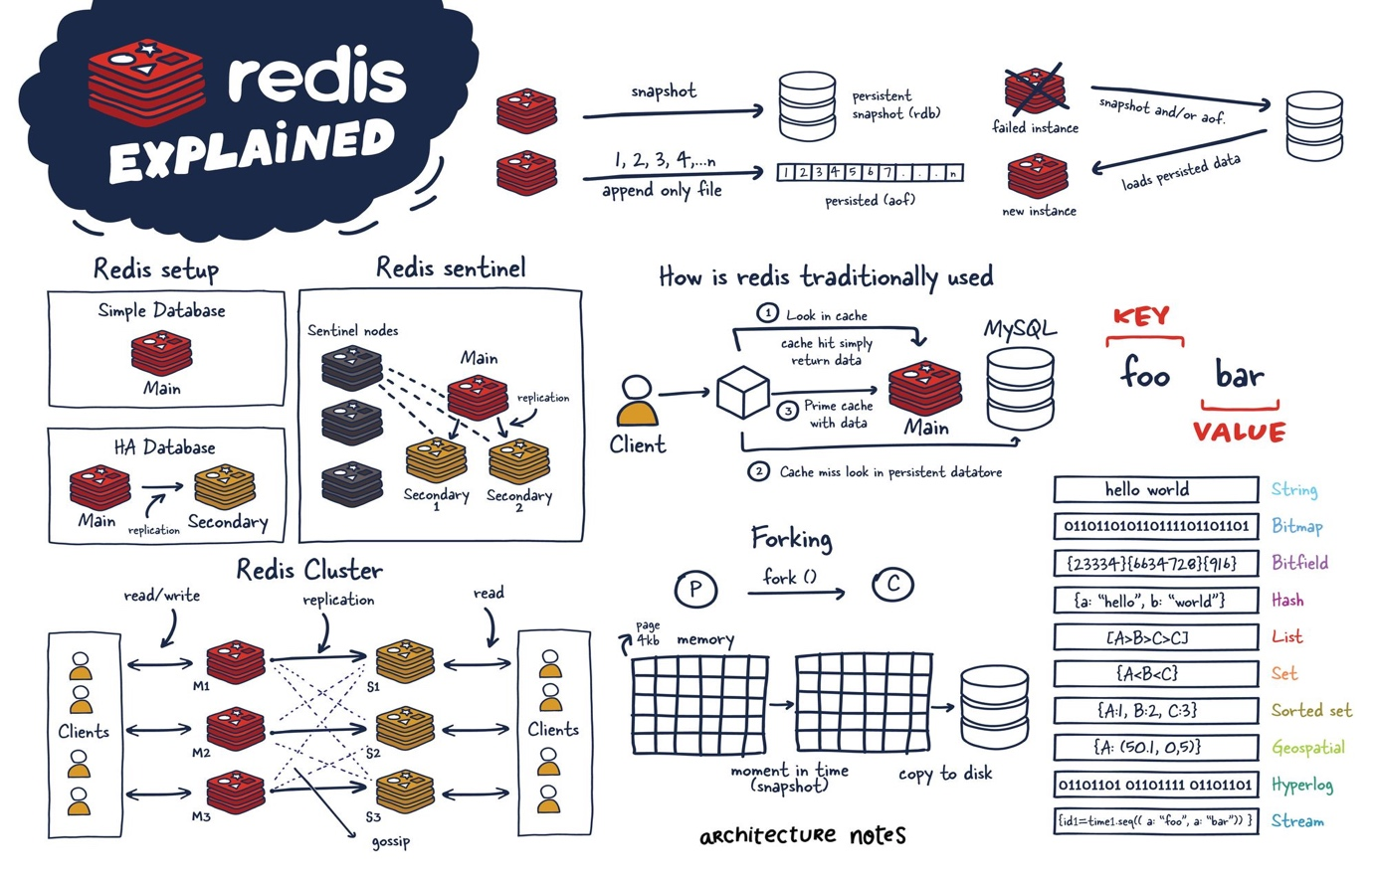
Why was Redis Created?
Problem (Why fetch the same data from disk every time when I can keep it in memory?)
As websites and applications grew:
- Databases became slow under heavy read load.
- Repeated queries for the same data wasted resources.
- Scaling databases vertically was expensive.
- Users expected real-time response.
Traditional databases were not built for millions of reads per second. They store data on disk and as we all know disk is slow compared to RAM. They were not built for real-time counters and sessions.
Before Redis was introduce, the basic request flow in the most applications followed a simple request pattern: Client → Backend → Database → Backend → Client
Each request hits the database directly, even if the requested data was exactly same as the previous requests. This led to the execution of same database queries thousands of times repeatedly causing overloading on the database unnecessarily. As time passed, databases became a single bottleneck in system performance. Scaling database to handle high read traffic was expensive hardware upgrade. This contributed to high latency, causing slower response time and poor user experience.
For Example: If 10,000 users hit the same endpoint, DB executes 10,000 identical queries making systems resources like Disk I/O + locks + CPU Usage skyrocket.
Solution: Redis (Remote Dictionary Server)
Redis introduced in-memory caching, solving multiple problem. The problems are listed below with solution how Redis solved: -
- Database Overloading due to same query execution
Redis: Cache frequently accessed data in memory
- Session Stored in DB and for every session request, database is accessed
Redis: Sessions are stored in memory for instant access reducing database hit for session access.
- Distributed Systems Coordination
Redis: It provides Distributed locks, Rate limiting, Feature Flags etc.
- Real-Time Features that were hard before
Redis: With Redis these features implementation are now easy
Due to Redis a new flow was introduces called Cache-Aside Pattern. In this pattern
App asks Redis for the data and if data exists, the request is immediately returned and if data doesn’t exist, data is fetched from database and is stored in the Redis to fulfill future requests for the same data.
It eliminates repeated execution of the same queries which drastically reduces database load and prevent database from becoming a single bottleneck. By offloading read-heavy traffic to Redis, databases can focus on being the source of truth rather than a performance layer. This approach enables horizontal scaling at a much lower cost, improves system reliability under high traffic, and significantly reducing latency--- resulting in faster responses.

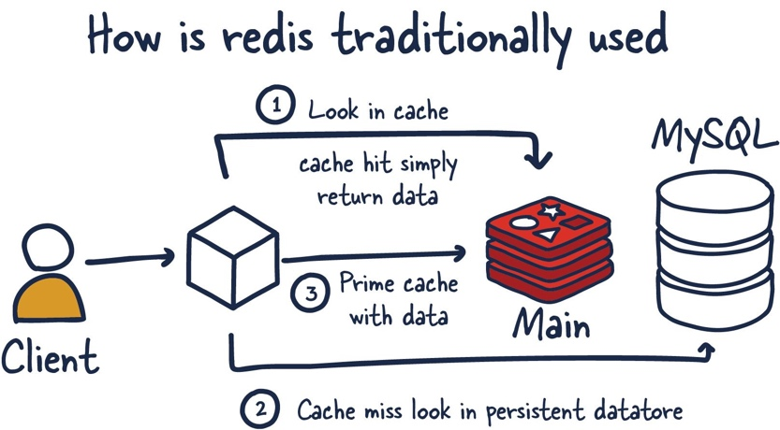

Why Is Redis so Fast?
Redis is so fast because it stores data inside RAM and it avoids disk I/O during read operations. Due to use of RAM to store data, the performance is ~100x to 1000x faster then database. It uses single-threaded, event-driven architecture as a result it can perform Millions of Ops/sec. There are no locks and no context switching. It uses optimized data structure and doesn’t use rows to store.
Redis Data Structures
Redis data structures are the native ways Redis stores and operates on data in memory. Unlike traditional databases that stores everything as rows and columns, Redis stores data as high-level data structures and gives built-in commands to works with them efficiently. Redis understands the data and provide optimized operations for it. Instead of storing only plain strings, Redis allows values to be stored as specialized data structures, enabling fast, atomic and concurrency-safe operations. These data structures run in-memory (RAM).
Why It Exist?
The traditional databases stores data in rows and columns and require complex queries and are slow for real-time operations and Redis data structures solves this by providing native operations for each data structures and eliminating race conditions by offering extremely low latency.
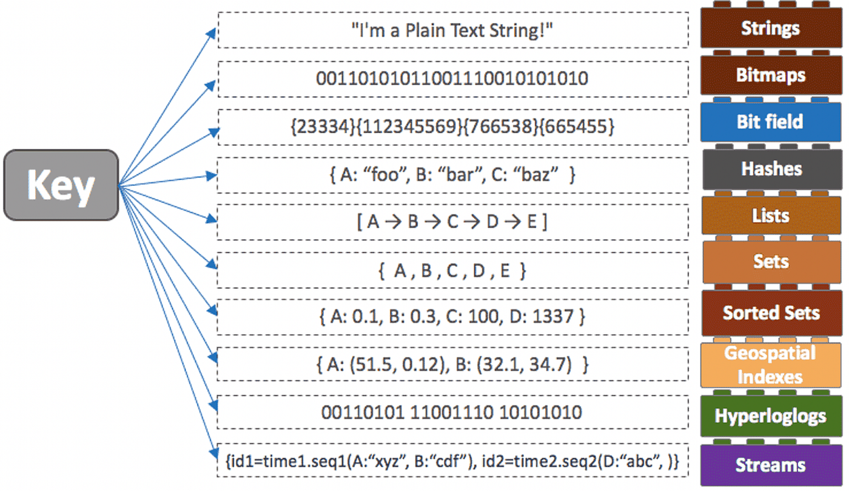
Redis Data Structures are given below: -
- String – It stores text, numbers or binary data.
Use Cases: Caching API responses, Session tokens and counters
Example: - SET user:42:name “Adarsh”, GET user:42:name
Advantages – Atomic counter and no race conditions
- Hash – It stores fields-value pairs, similar to an object or JSON.
Use Cases: User Profiles, Configurations, Objects without joins
Example: - HSET user:42 name “Adarsh” email adarsh@mail.com, HGET user:42 email
Advantages – Partial updates, memory efficient, Faster than storing full JSON strings
- List – An ordered list of values
Use Cases: Queues, Background jobs, Message buffers
Example: - LPUSH jobs “send_email”, RPOP jobs
Advantages – Perfect for producer-consumer models
- Set – An unordered collection of unique values
Use Cases: Unique visitors, Online Users, Permissions
Example: - SADD online_users 42, SISMEBER online_users 42
Advantages – Fast membership checks
- Sorted Set (ZSet) – It stores data like a set, but each value has a score used for ordering.
Use Cases: - Leaderboards, Rankings, Priority queues
Example: ZADD leaderboard 1200 “player1”, ZRANGE leaderboard 0 9 WITHSCORES
Advantages – Real-time ranking, Top-N queries are extremely fast
- Bitmap – It uses bits (0/1) to store Boolean data efficiently
Use Cases – Feature flags, daily active users, Login tracking
Example- SETBIT user:active 42 1, GETBIT user:active 42
- Stream – It is an append-only log data structure
Use Cases – Event Streaming, Message queues, Activity logs
Example- XADD orders * user_id 42 amount 999
Advantages – Persistent, Consumer groups supported, Ordered event processing
Redis data structures are important as it replaces complex SQL logic and reduces database load, simplify system design which improve application performance.
Redis data structures are built-in, in-memory data types that provide fast, atomic and scalable solutions for common application pattern such as caching, counters, queues, sets, and leaderboards.
If Redis Uses RAM… Won’t Data be lost?
Redis handles this using Persistence. As we know it’s an in-memory first, but it writes to disk intelligently using Persistence strategies. It operates on RAM for speed but writes to disk for recovery.
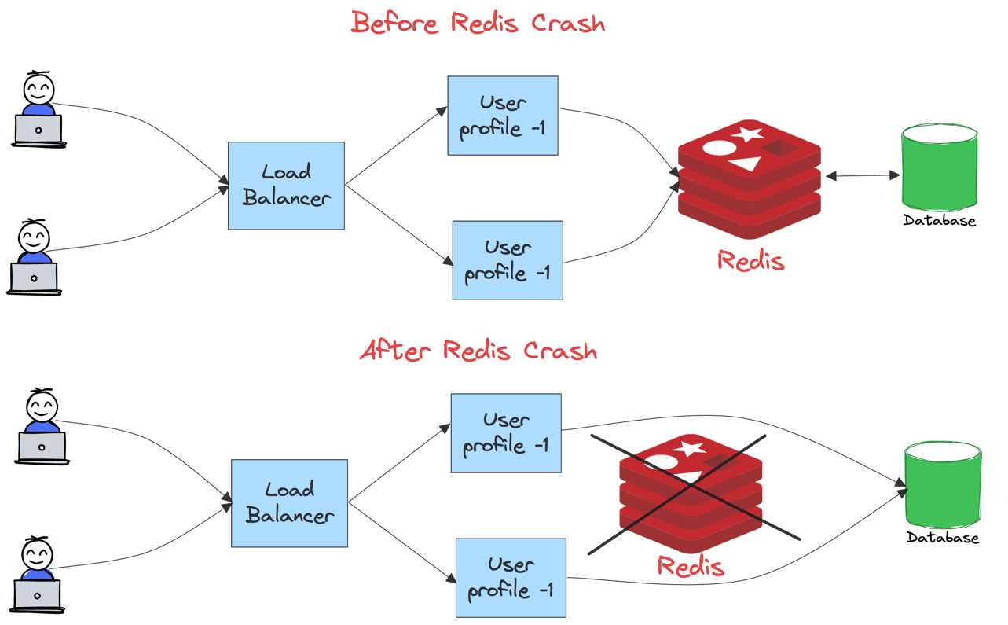
Redis persistence answer the most famous question “If Redis crashes or restarts, how much data can I recover?”

Redis provides three type strategies:
- RDB (Snapshots)
- AOF (Append only File)
- RDB + AOF (Hybrid – production standard)
Before learning about these strategies, we need to know what type of problem it is solving: -
As we know Redis data lives in RAM so multiple situations can happen where RAM can be wiped:
- Redis crashes
- Server reboots
- Pod restarts problem in K8
- Power failure
So Redis needs a way to rebuild memory from disk when it restarts and This is called Persistence.
- RDB (Redis Database Snapshot) – Take a photo of Redis memory and save it to disk.
How It works?
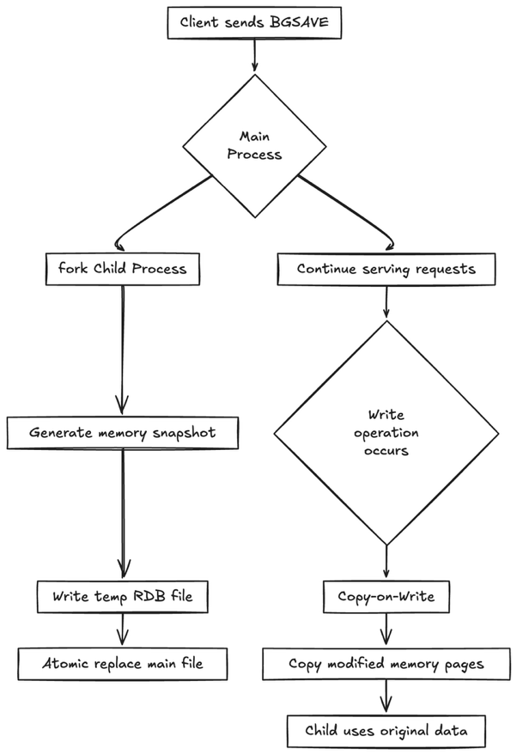
Instead of continuously writing every change to disk, Redis periodically takes a complete snapshot of the entire in-memory dataset and stores it as a single binary file (dump.rdb).
This snapshot represents the Redis’s state at that particular point of time. So now if Redis crashes, it can now reload this snapshot to reconstruct the dataset in the memory.
It was designed for speed, simplicity and minimal runtime overload, not for zero data loss.
Normally, it continuously accepts read/write commands from clients and process them in RAM entirely. Even if persistence is enabled, Redis doesn’t stop serving traffic. This process of RDB snapshots happens in the background not affecting the performance in normal conditions.

RDB snapshots are triggered based on the configuration rules defined in redis.conf.
```
save 900 2
save 300 10
save 60 1000
```
This config file means it takes a snapshot if 2 key changes in 900 seconds or 10 keys changes in 300 seconds or 1000 keys change in 60 seconds.

Redis tracks the number of write operations since the last snapshot. One a condition is met, Redis schedules the RDB save. These rules allow Redis to balance between data safety and performance when load increase, snapshot occur more frequently during heavy write traffic and less often when load is low or idle.

How this Snapshot process takes place
When it’s time to create a snapshot, Redis calls a Linux system call fork (). This creates a child process that is an almost exact copy of the parent process in Redis. The fork () is a OS-level process not a Redis feature.
- Parent Process -> continues serving client requests
- Child Process -> responsible for persistence and RDB process.
This child process and this kind of separation is critical that allow Redis to persist the data without blocking the client operations or the traffic requests.

How does the child process work?
When Linux system call fork () happens, memory is not copied instantly rather the process relies on OS’s mechanism called COW (Copy-On-Write) mechanism.

