**Project SunnyWalk – Web Application**

**Project Specifications - Backend**

* **Introduction**

To develop a web app that can advise users on what the best times are for them to take their daily walks which would maximise their intake of sunshine.

* **Technology/Tools used -** 
  + Java
  + Spring Framework
  + Postman
* **Architectural Design**

User 2

(Tablet)

User 3

(Laptop)

User 4

(Desktop)

User 1

(Mobile)

Frontend (SunnyWalk App)

API

Backend

Server on AWS

* **Table Structure**

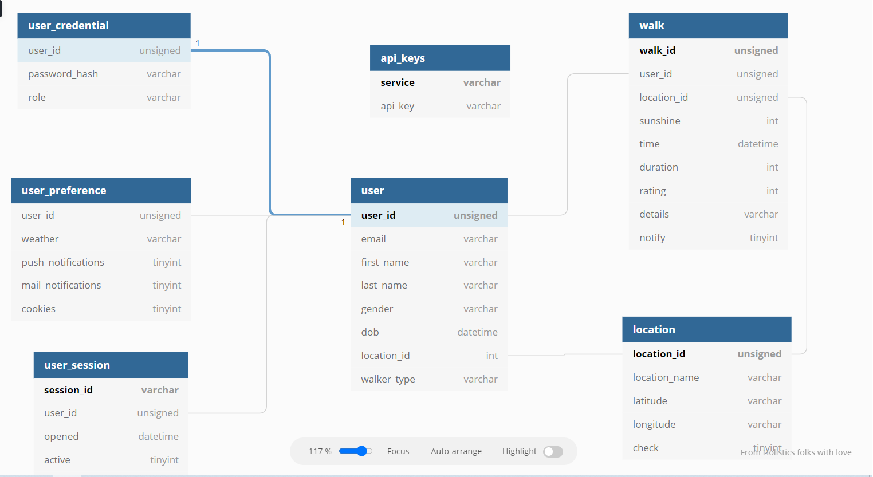

* **Class Diagrams (Model) – Following are the Java classes that are used to reflect the database tables -**

|  |
| --- |
| **: User** |
| userId (int)  email(String)  firstName (String)  lastName (String)  gender (String)  dob(Date)  locationId (Int)  userType(String) |
| register ()  edit () |

|  |
| --- |
| **: UserCredential** |
| userId (int)  passwrodHash(String)  role (String) |
|  |

|  |
| --- |
| **: UserSession** |
| sessionId(String)  userId (int)  opened(Date)  active(Boolean)  ipAddress (String) |
|  |

|  |
| --- |
| **: UserPreference** |
| userId (int)  weather(String)  pushNotifications(Boolean)  mailNotifications (Boolean)  cookies (Boolean) |
|  |

|  |
| --- |
| **: Walk** |
| walkId (int)  userId(Int)  locationId (Int)  weatherType(String)  time (Date)  duration (Int)  rating(Int)  details(String)  notify(Boolean) |
|  |

|  |
| --- |
| **: Location** |
| locationId(int)  locationName(String)  latitude(String)  longitude(String)  check(Boolean) |
|  |

|  |
| --- |
| **: Apikey** |
| service(String)  apiKey(String) |
|  |

* **Controllers**
  + **Session/Authorization Controller**

Setting up HTTP requests for Login and Register screens

* + **User Controller**

Setting up HTTP requests for User functions

* + **Walk Controller**

Setting up HTTP requests for Walk details

* **JSON file structure**

The data to be uploaded into the tables and also to be viewed in the frontend is stored in the form of JSON files in the below sample format -

[

    {

        "userId": 1,

        "email": "marius.grigore@gmail.com",

        "firstName": "Marius",

        "lastName": "Grigore",

        "gender": "Ambiguous",

        "dob": "2016-11-01T12:45:23.000+00:00",

        "locationId": 1,

        "userType": "Dog walker"

    },

    {

        "userId": 2,

        "email": "ciaran.cullen@gmail.com",

        "firstName": "Ciaran",

        "lastName": "Cullen",

        "gender": "Male",

        "dob": "2016-11-01T12:45:23.000+00:00",

        "locationId": 2,

        "userType": "Roller skater"

    },

    {

        "userId": 3,

        "email": "susan.luebke@gmail.com",

        "firstName": "Susan",

        "lastName": "Luebke",

        "gender": "Female",

        "dob": "2016-11-01T12:45:23.000+00:00",

        "locationId": 1,

        "userType": "Wheelchair user"

    },

    {

        "userId": 4,

        "email": "sriranjini.srinivasa@gmail.com",

        "firstName": "Sriranjini",

        "lastName": "Srinivasa",

        "gender": "Female",

        "dob": "2016-11-01T12:45:23.000+00:00",

        "locationId": 1,

        "userType": "Buggy"

    }

]

* The backend structure is being deployed in AWS environment.