YAML
- Rename or remove the “Application.properties” file with “Application.yaml”
- Format is of space not tabs

#spring.application.name=01_CustomerService
#spring.datasource.username=root
#spring.datasource.password=root123
#spring.datasource.url=jdbc:mysql://localhost:3306/customer_db
#spring.datasource.tomcat.driver-class-name=com.mysql.cj.jdbc.Driver
#
#logging.file.name=logs/customers.log
#
#springdoc.swagger-ui.enabled=false

spring:
application:
name: "01_CustomerService"
datasource:
username: root
password: root123
url: jdbc:mysql://localhost:3306/customer_db
driver-class-name: com.mysql.cj.jdbc.Driver

springdoc:
api-docs:
enabled: false

logging:
file:
name: logs/customers.log

#Custom Properties - Used in application
build:
version: "1.0"

Access Custom properties from “Application.yaml” file
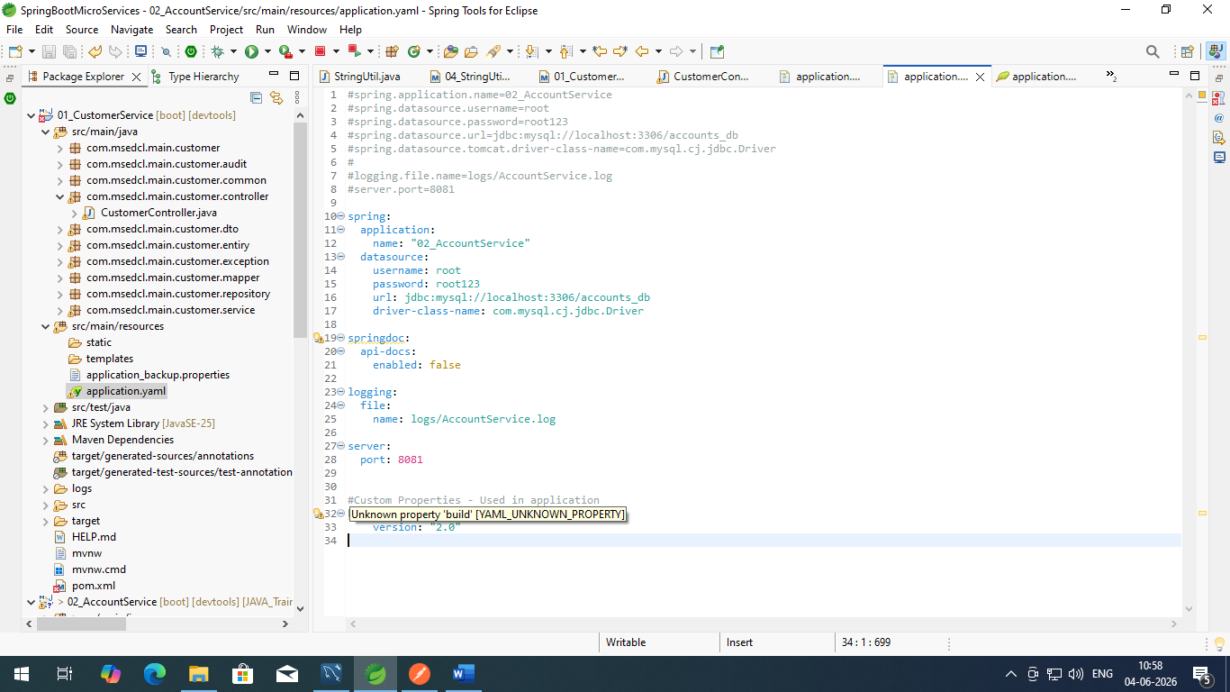

@Validated
@Slf4j
@RestController
@RequestMapping("customerapi")
//@AllArgsConstructor //To Access the property from application.yaml file comment this and create new constructor with 1 parm of CustomerService
public class CustomerController
{
private final CustomerService customerService;

public CustomerController(CustomerService customerService) {
super();
this.customerService = customerService;
}

@Value("${build.version}") //To Access the property from application.yaml file
private String buildVersion;

@GetMapping("build-version")
public ResponseEntity<String> printBuildVersion()
{
return ResponseEntity.status(HttpStatus.OK).body(buildVersion);
}

URL : http://localhost:8080/customerapi/build-version
Method : GET
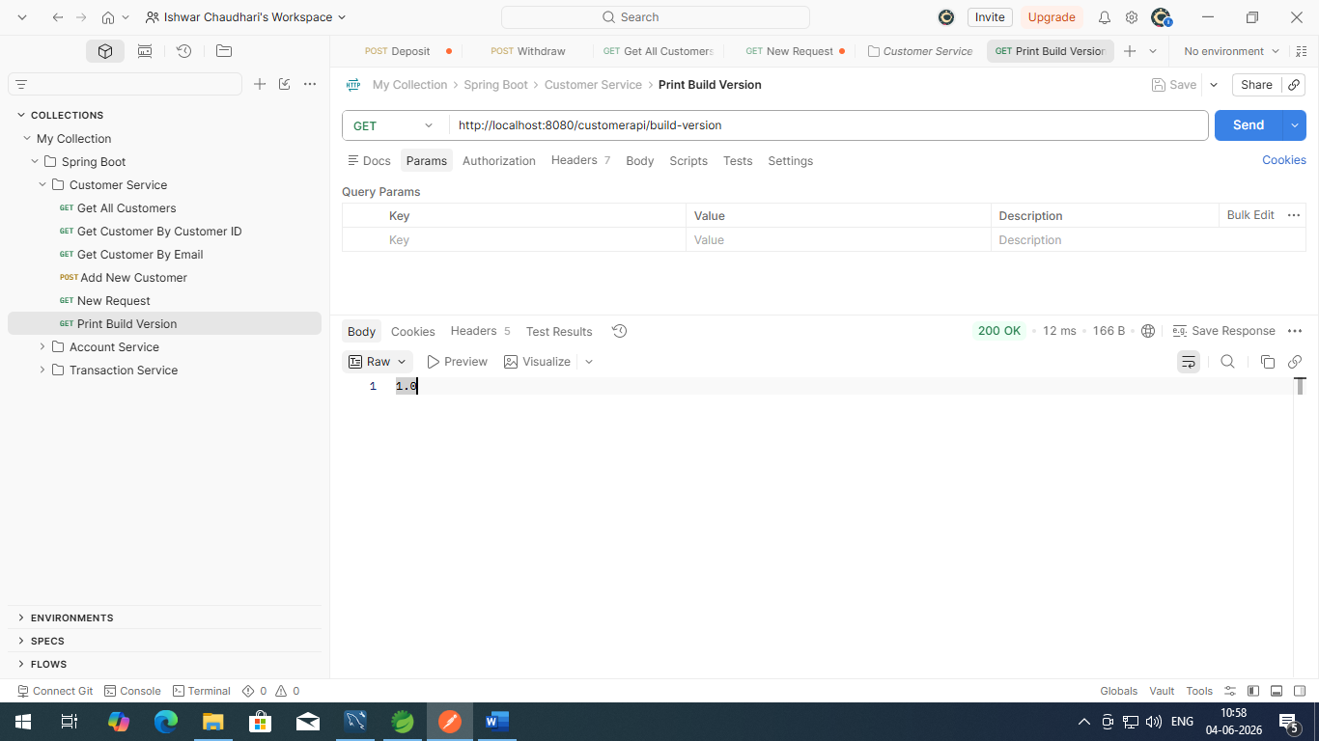

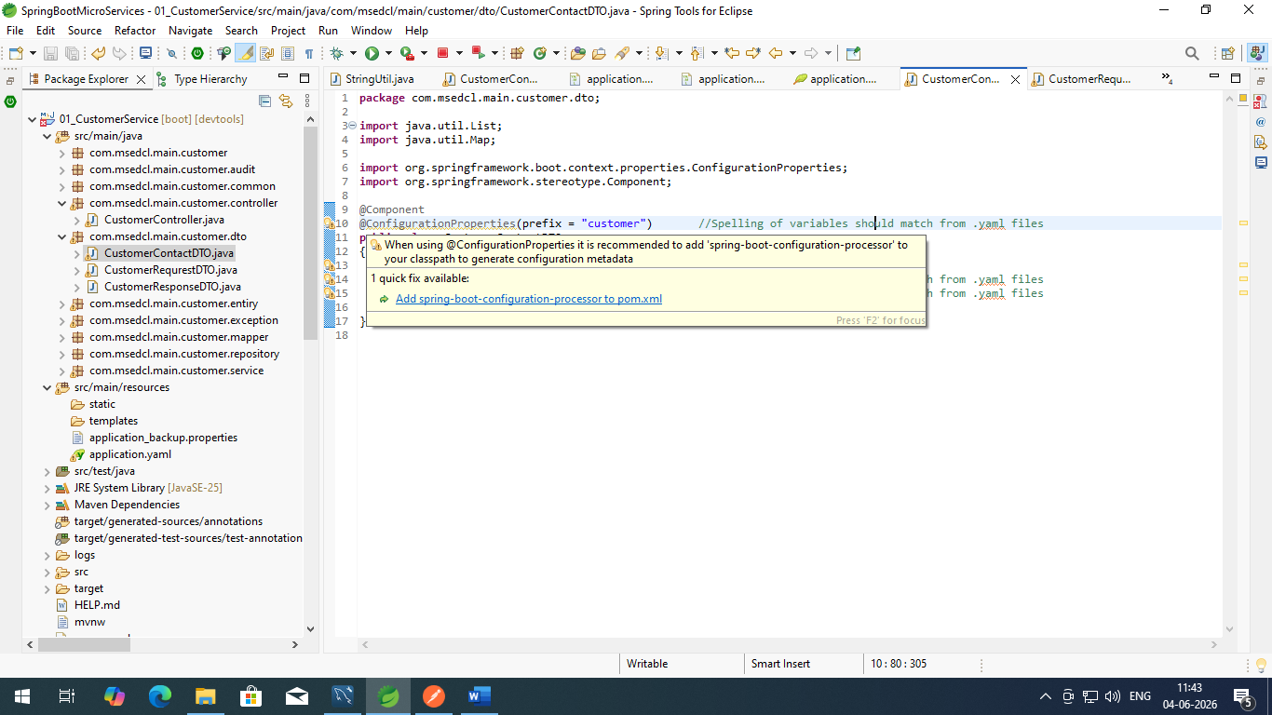

<dependency>
<groupId>org.springframework.boot</groupId>
<artifactId>spring-boot-configuration-processor</artifactId>
<optional>true</optional>
</dependency>

#spring.application.name=01_CustomerService
#spring.datasource.username=root
#spring.datasource.password=root123
#spring.datasource.url=jdbc:mysql://localhost:3306/customer_db
#spring.datasource.tomcat.driver-class-name=com.mysql.cj.jdbc.Driver
#
#logging.file.name=logs/customers.log
#
#springdoc.swagger-ui.enabled=false

spring:
application:
name: "01_CustomerService"
datasource:
username: root
password: root123
url: jdbc:mysql://localhost:3306/customer_db
driver-class-name: com.mysql.cj.jdbc.Driver

springdoc:
api-docs:
enabled: false

logging:
file:
name: logs/customers.log

#Custom Properties - Used in application
build:
version: "1.0"

customer:
message: "Welcome to MSEDCL bank customer related REST API"
contactDetails:
name: "ISHWAR"
email: "ishwar_chaudhari@mahadiscom.in"
onCallSupport:
- 1234567890
- 9876543210

*---
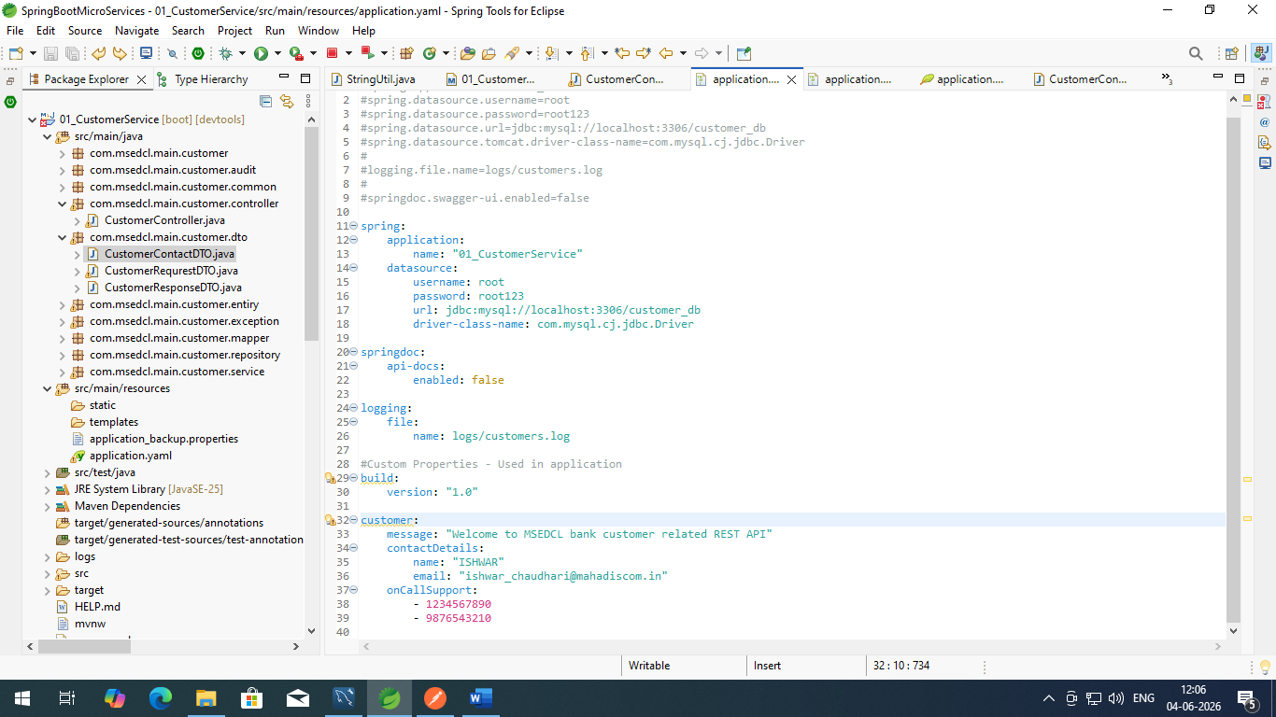

package com.msedcl.main.customer.dto;

import java.util.List;
import java.util.Map;

import org.springframework.boot.context.properties.ConfigurationProperties;
import org.springframework.stereotype.Component;

import lombok.Data;

@Data
@Component
@ConfigurationProperties(prefix = "customer") //Spelling of variables should match from .yaml files
public class CustomerContactDTO
{
private String message;
private Map<String, String> contactDetails; //Spelling of variables should match from .yaml files
private List<String> onCallSupport; //Spelling of variables should match from .yaml files

}

http://localhost:8080/customerapi/contact-details
{
"contactDetails": {
"name": "ISHWAR",
"email": "ishwar_chaudhari@mahadiscom.in"
},
"message": "Welcome to MSEDCL bank customer related REST API",
"onCallSupport": [
"1234567890",
"9876543210"
]
}

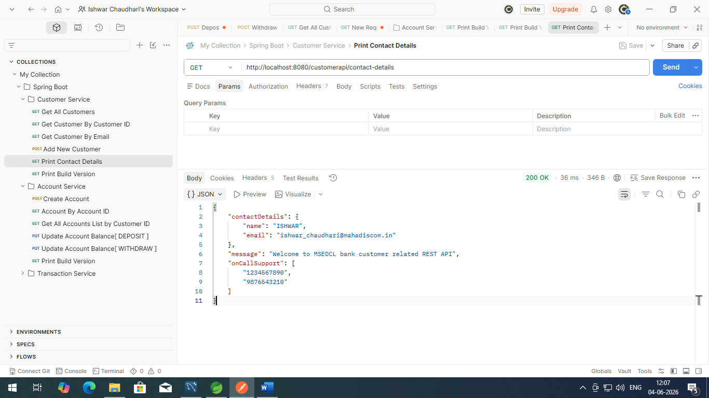

profiles:
active:
- "uat"

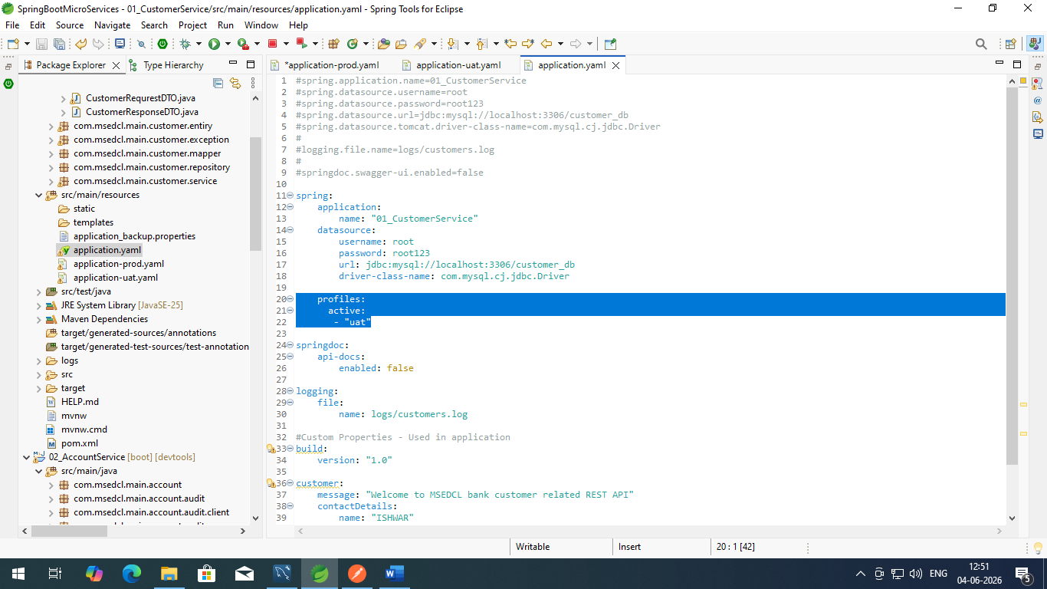
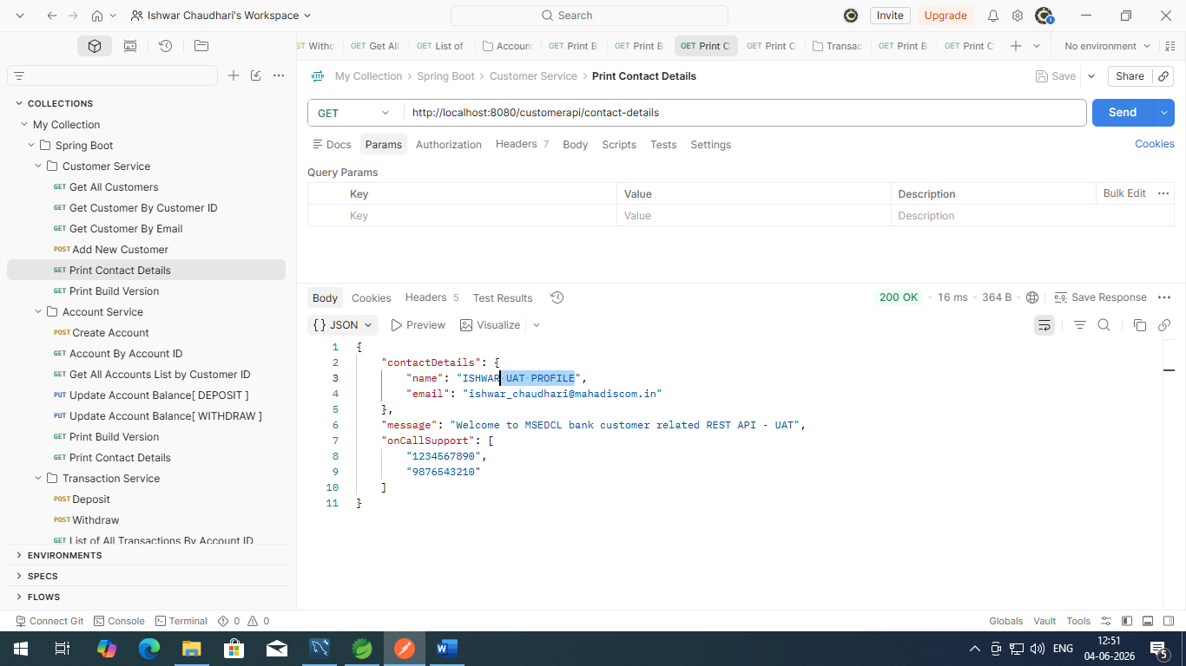

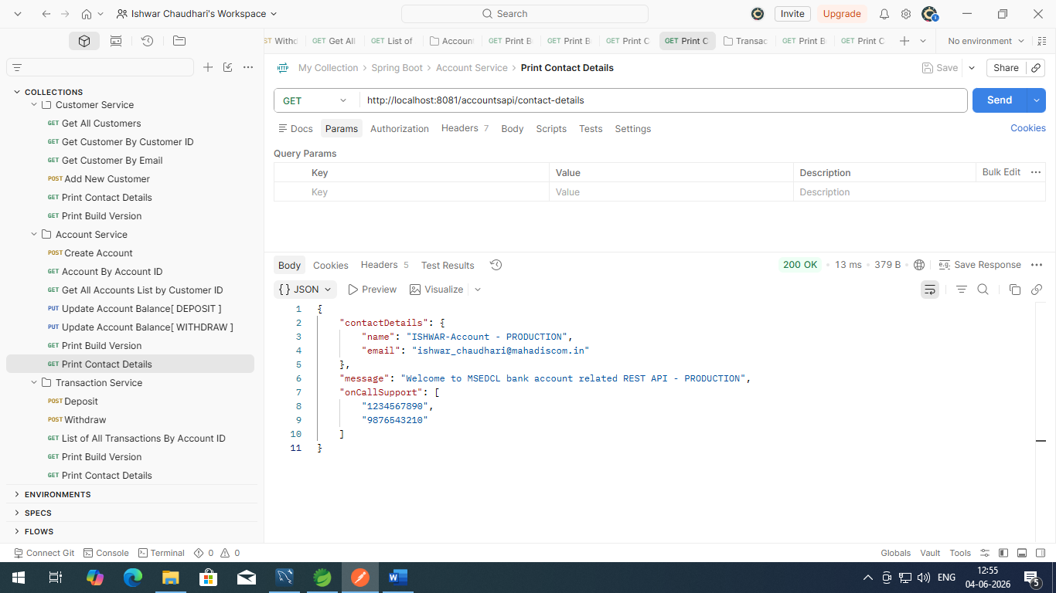

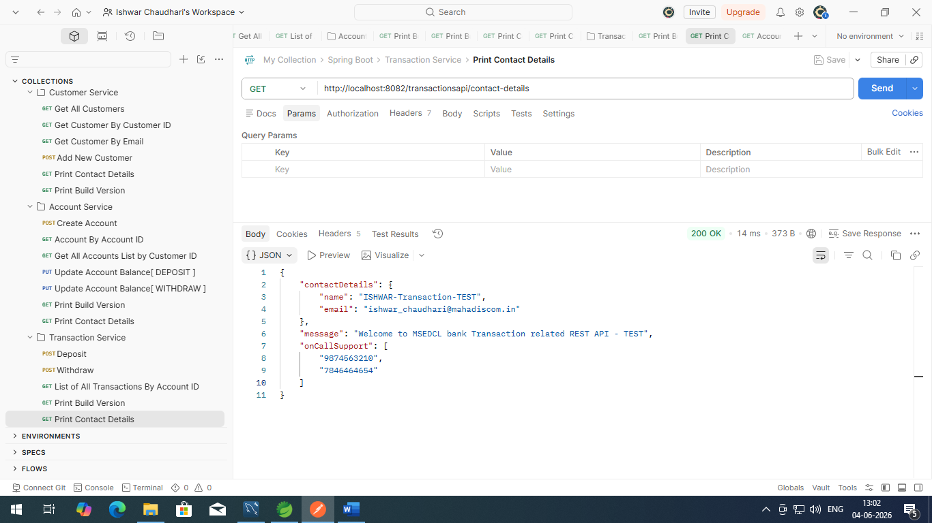

profiles:
active:
- "LIVE"

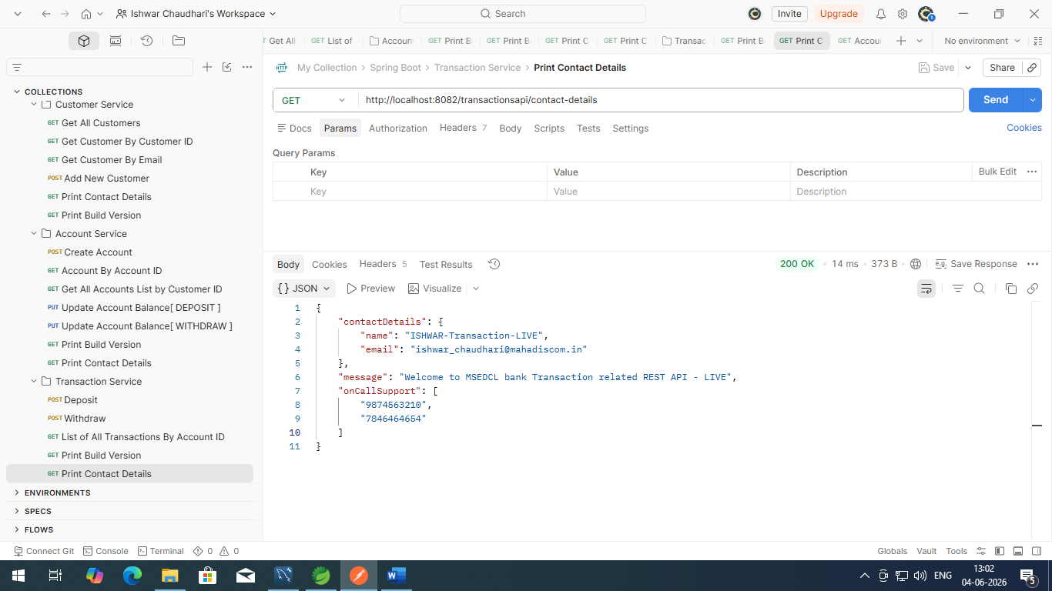

Place config .yaml files on Git and will be access from git in each projects
- Create One git repository
Repository Name : msedcl-banking-config

Create new “readme.txt” file in repository

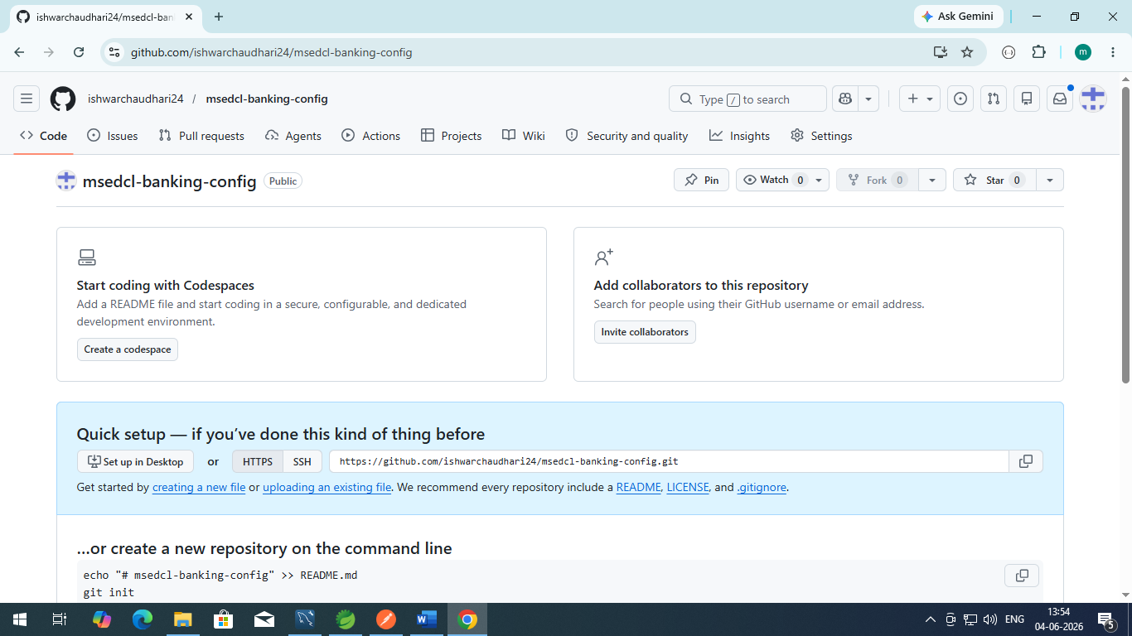

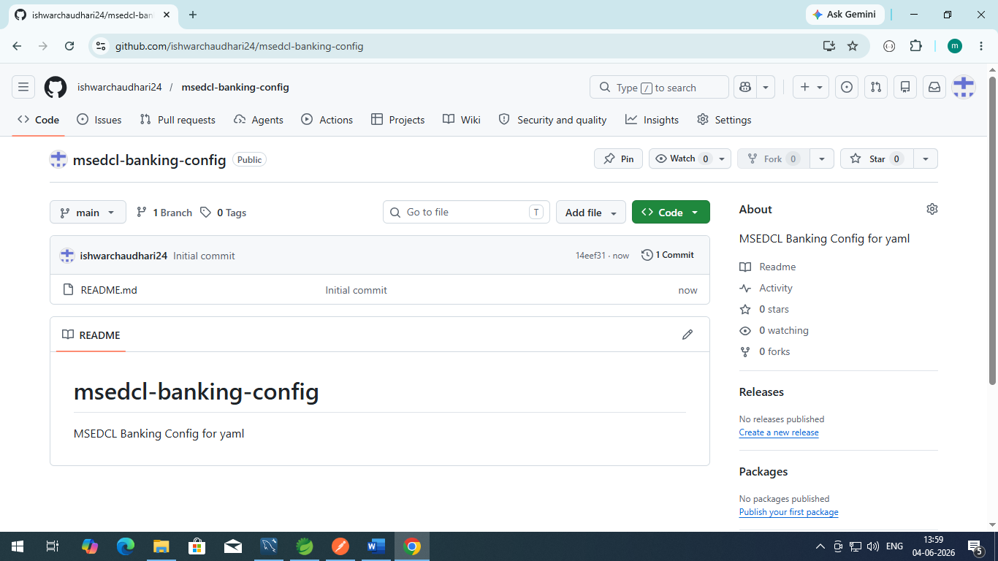

Create dir :
C:\ISHWAR\JAVA_Training\SpringBootMicroServices\Spring_Application_Configuration
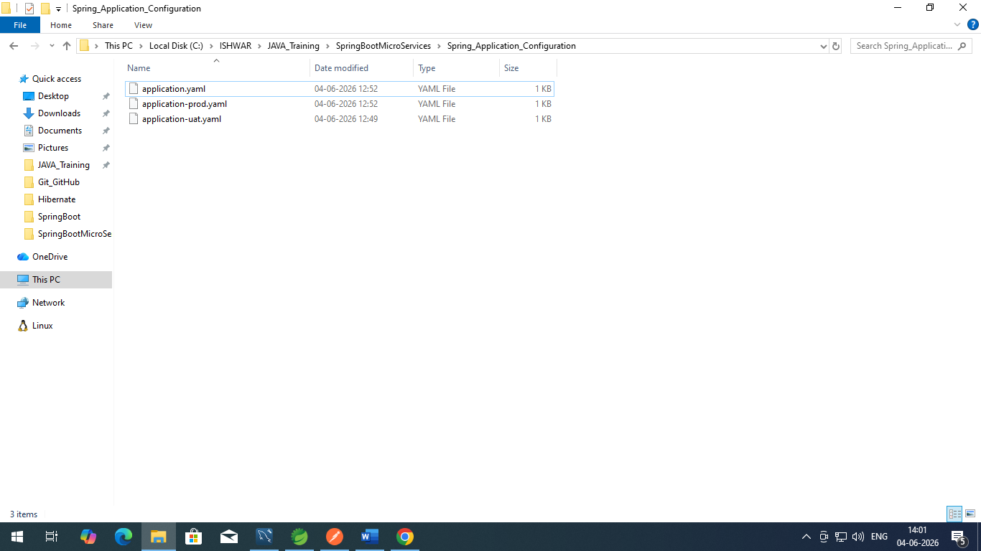
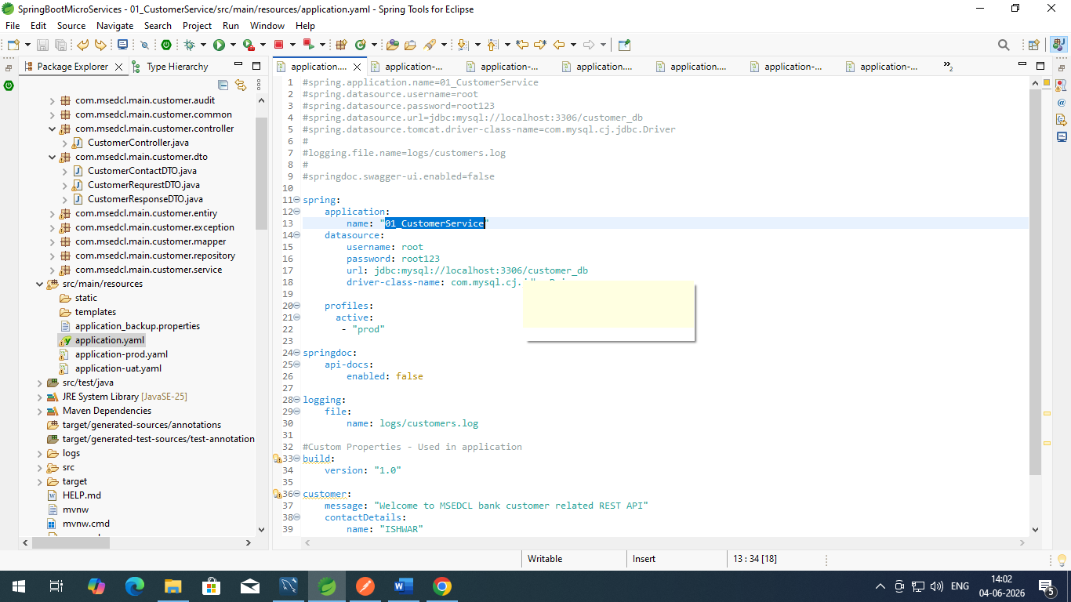

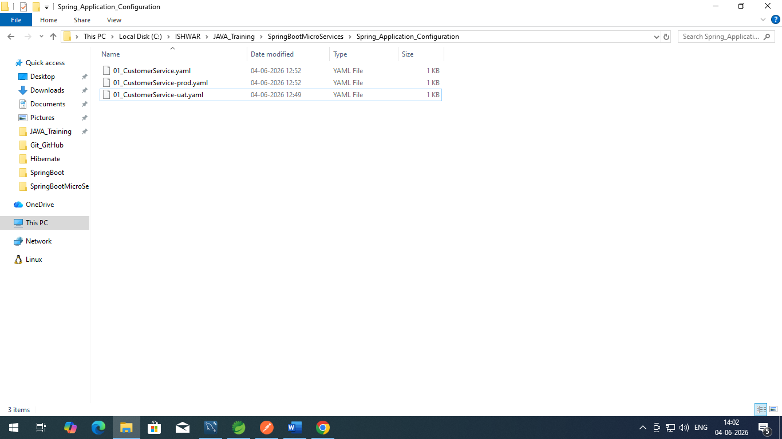

Drag and drop these files to Git repository and commit changes
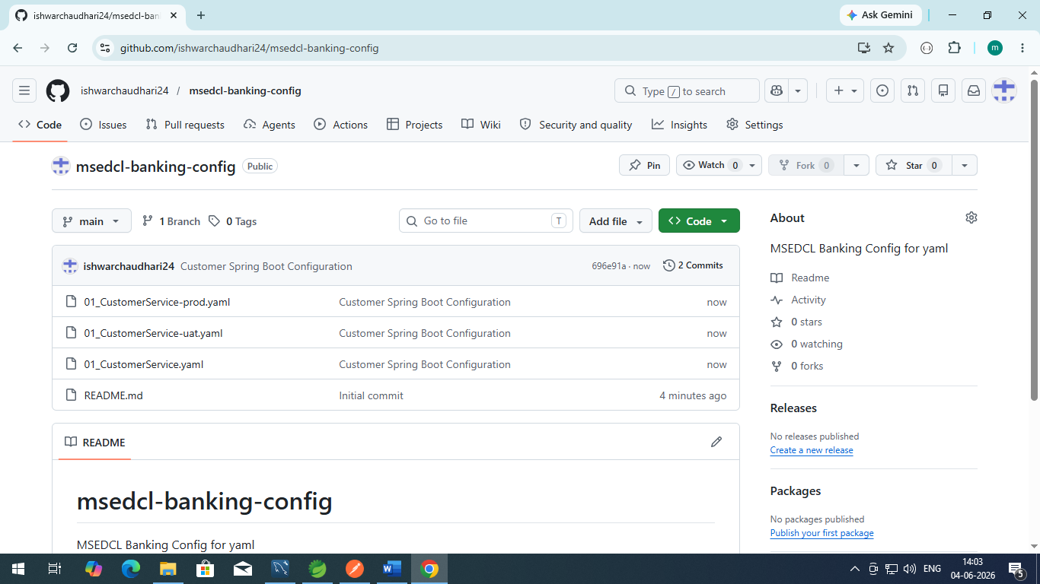
Now delete/rename files “application-prod.yaml” to application-prod_Backup.yaml

Create new spring boot starter project
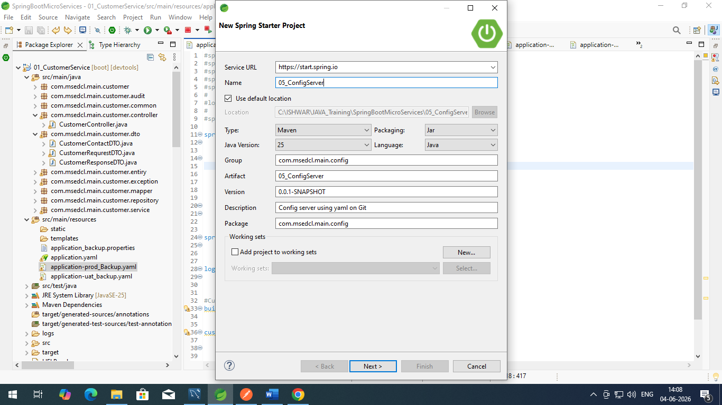

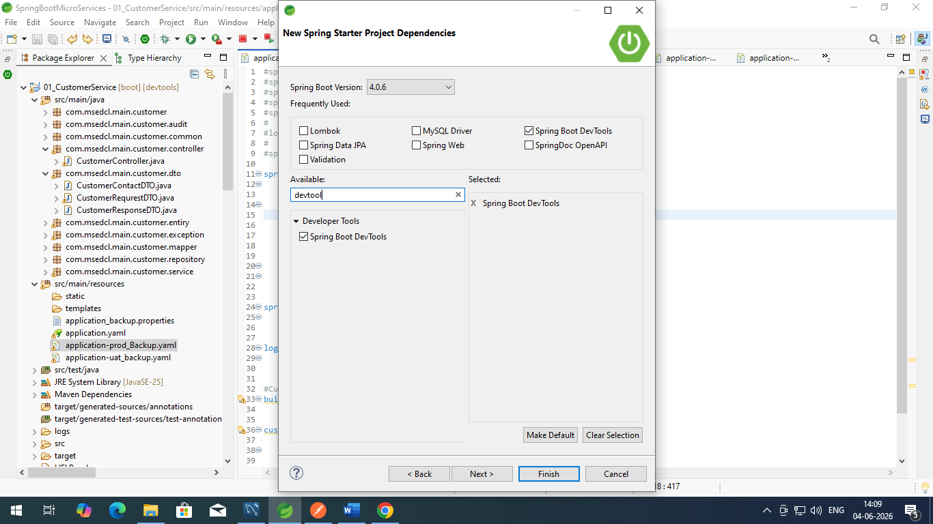

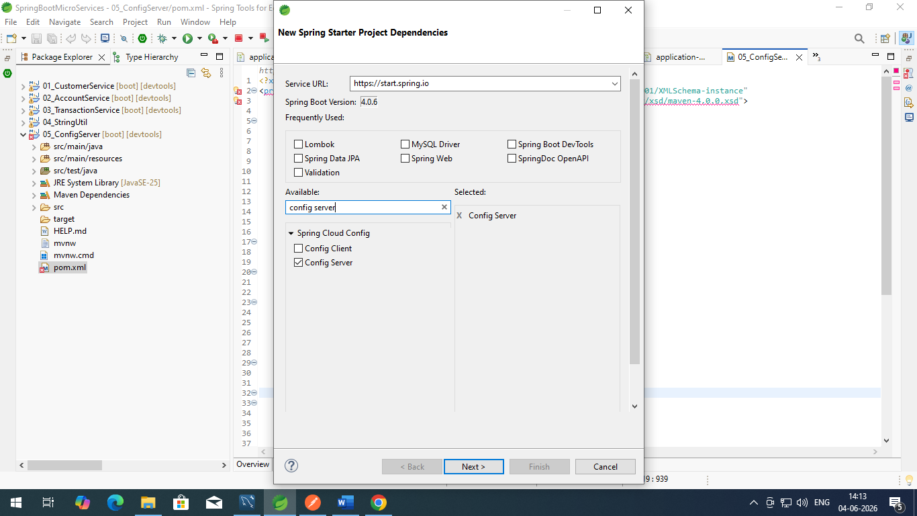

https://github.com/ishwarchaudhari24/msedcl-banking-config

Contains of yaml file : application.yaml

spring:
application:
name: "config-server"
profiles:
active:
- git
cloud:
config:
server:
git:
uri: https://github.com/ishwarchaudhari24/msedcl-banking-config
default-label: main
timeout: 5 # load properties in 5 seconds
clone-on-start: true #Copy github repository on startup of application
force-pull: true

server:
port: 8083

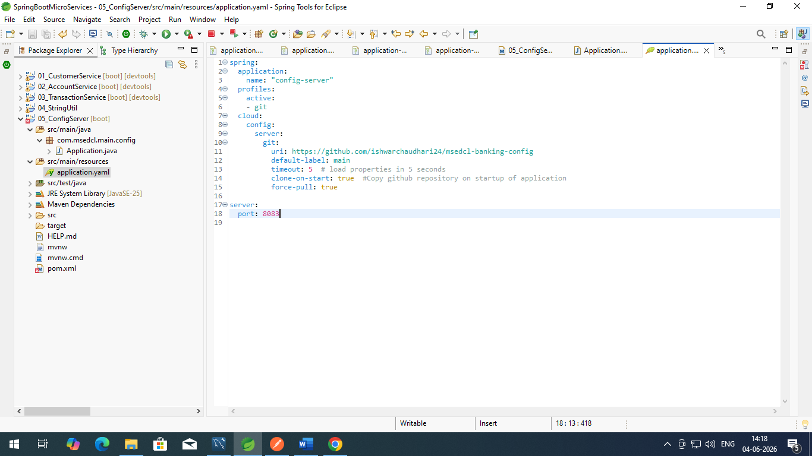

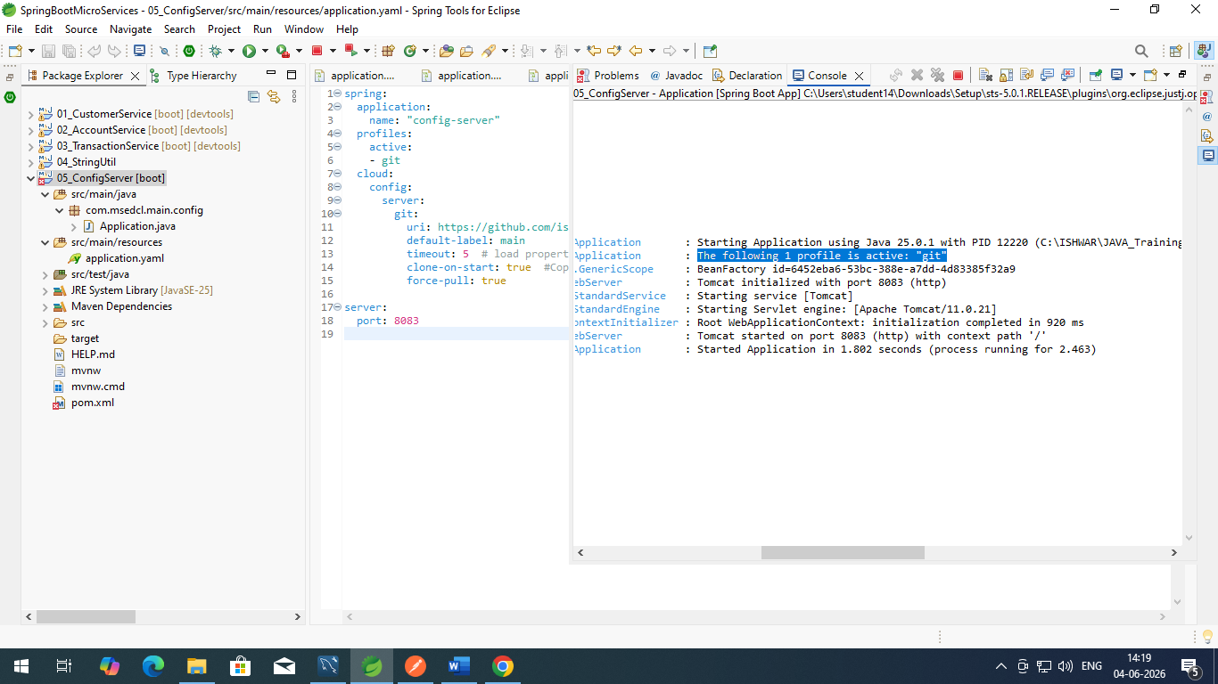

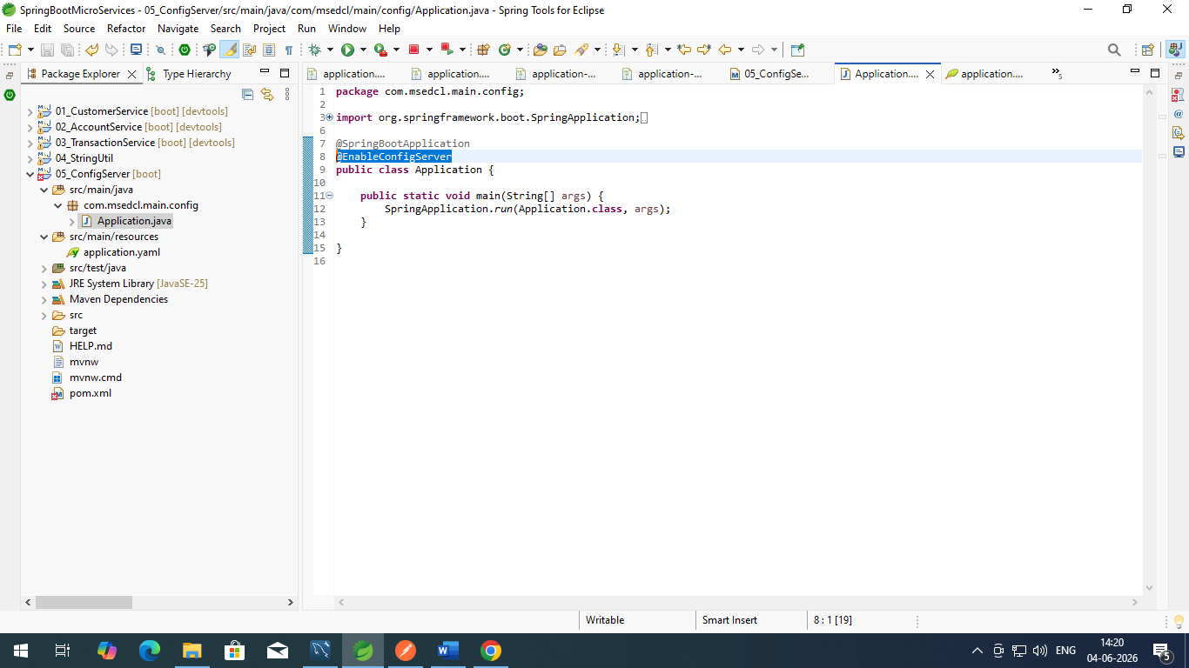

Spring Boot Actuator is a subproject of Spring Boot that provides production-ready features to help you monitor and manage your application. By simply adding a dependency, it exposes built-in REST or JMX endpoints that reveal insights into application health, metrics, environment variables, and internal configurations. [1, 2, 3]

How to Add Actuator :

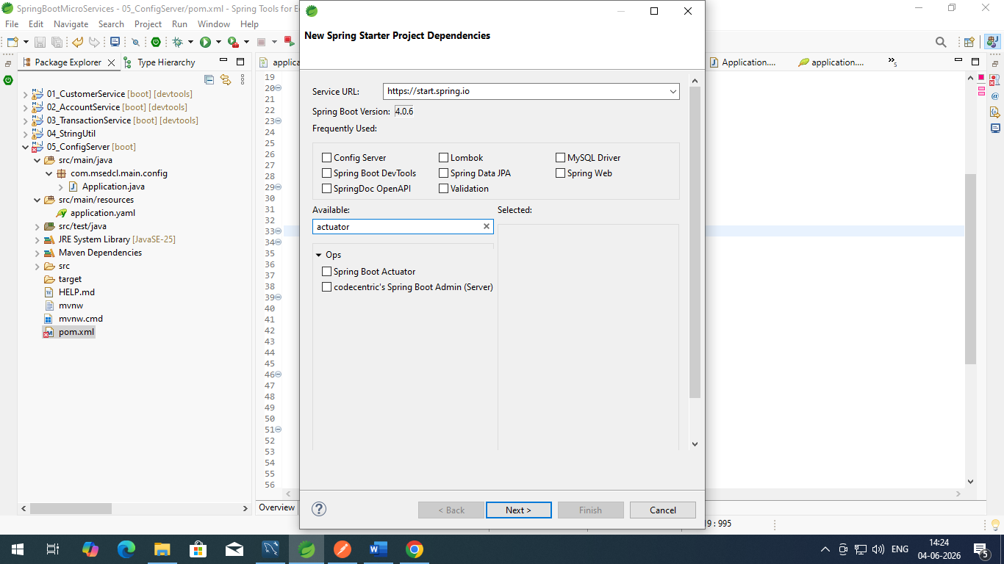

<dependency>
<groupId>org.springframework.boot</groupId>
<artifactId>spring-boot-starter-actuator</artifactId>
</dependency>
<dependency>
<groupId>org.springframework.boot</groupId>
<artifactId>spring-boot-starter-actuator-test</artifactId>
<scope>test</scope>
</dependency>

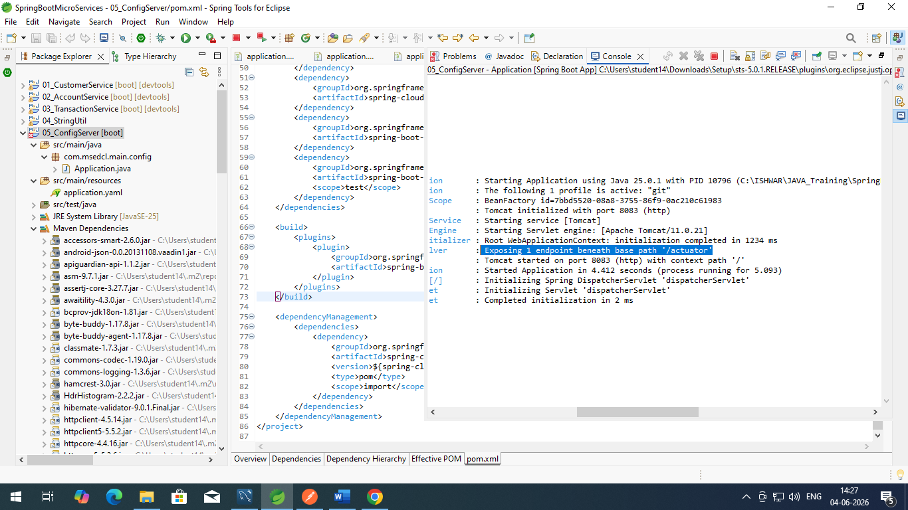

http://localhost:8083/actuator
{"_links": {"self": {"href": "http://localhost:8083/actuator","templated": false},"health-path": {"href": "http://localhost:8083/actuator/health/{*path}","templated": true},"health": {"href": "http://localhost:8083/actuator/health","templated": false}}}

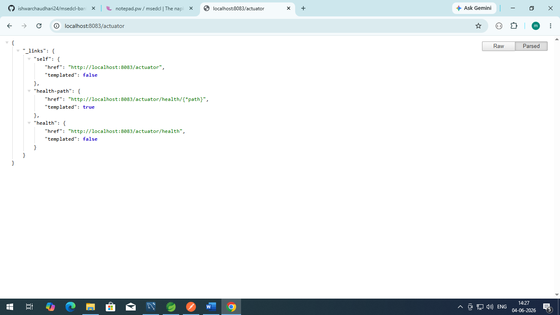
http://localhost:8083/actuator/health/
{"groups": ["liveness","readiness"],"status": "UP"}

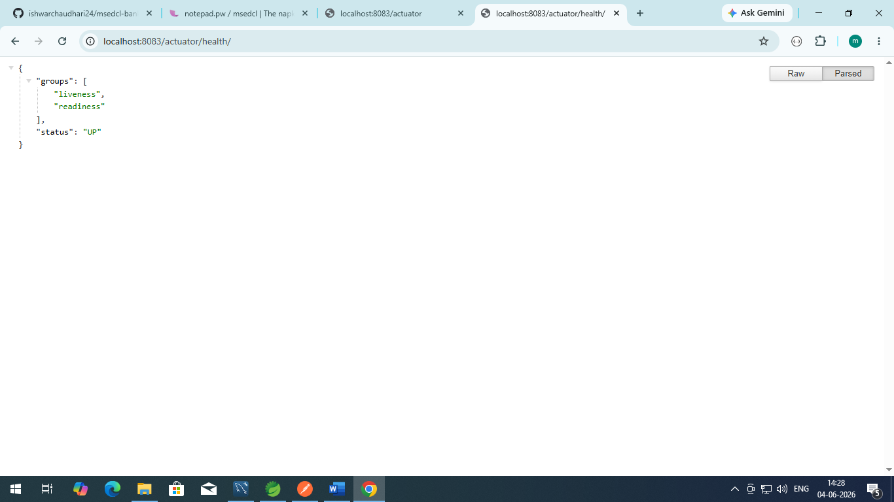

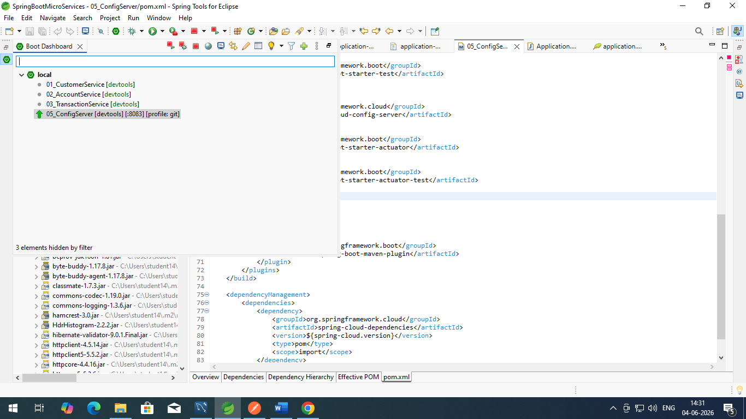

server:
port: 8083

management:
endpoints:
web:
exposure:
include: "*"

*---
Now hit the URL : http://localhost:8083/actuator

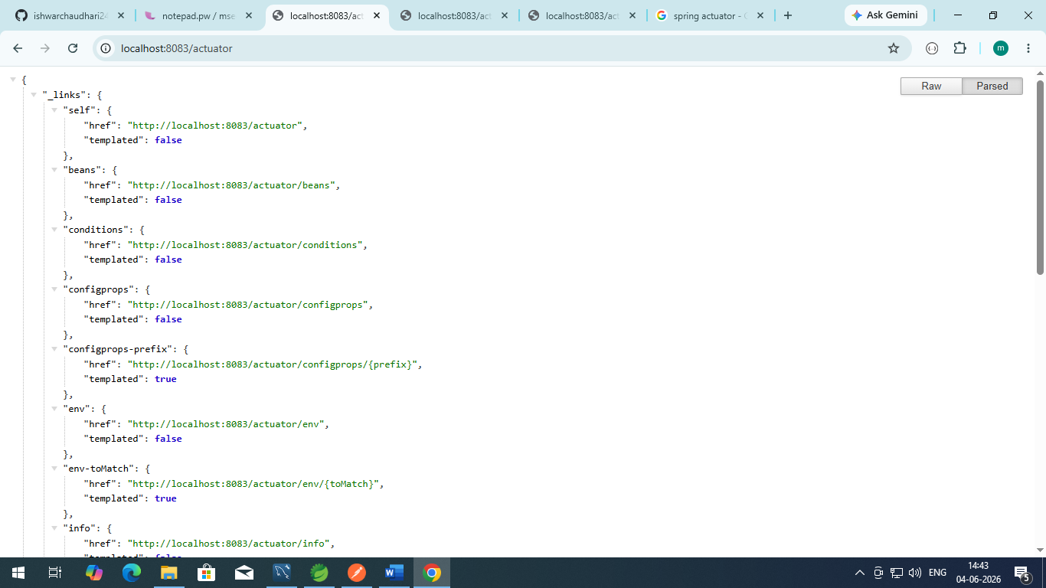

http://localhost:8083/actuator/metrics
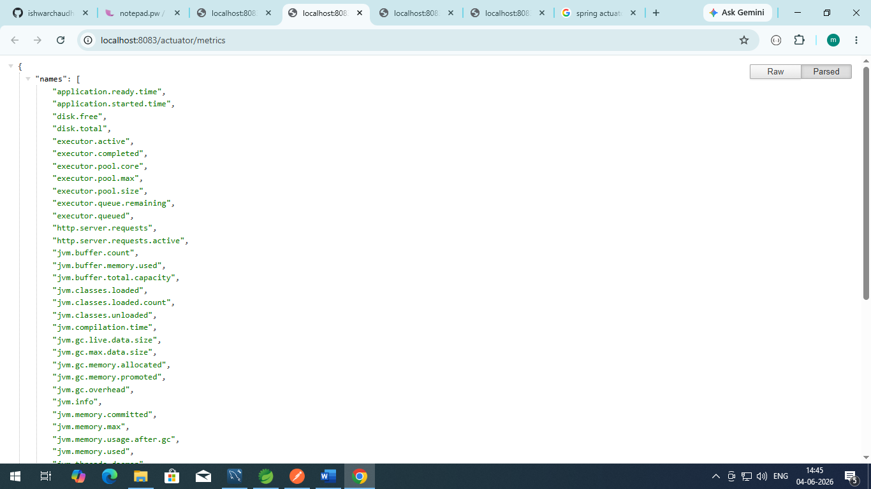

application.ready.time
alhost:8083/actuator/metrics/application.ready.time
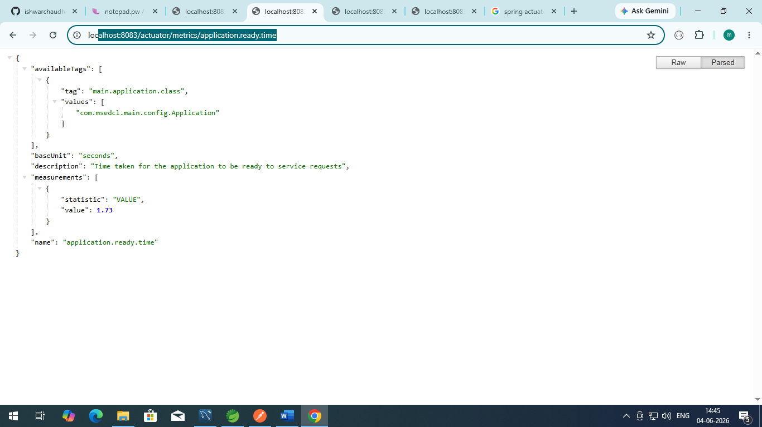

http://localhost:8083/01_customerService/default
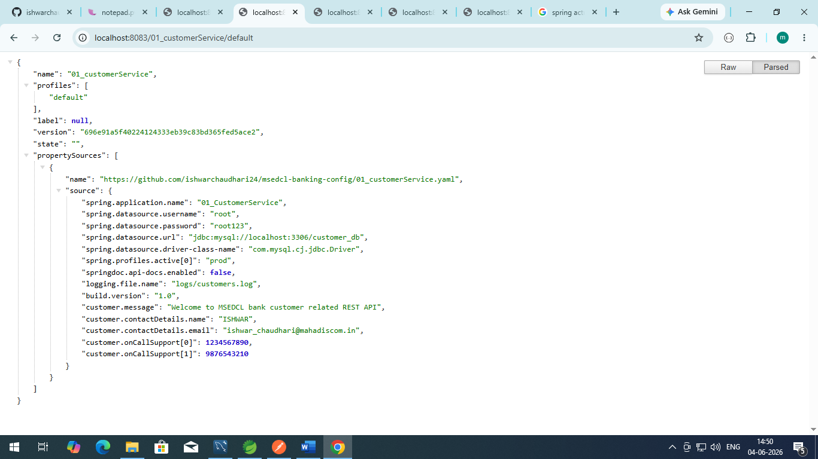

http://localhost:8083/01_customerService/prod
In Prod it shows first default and prod both
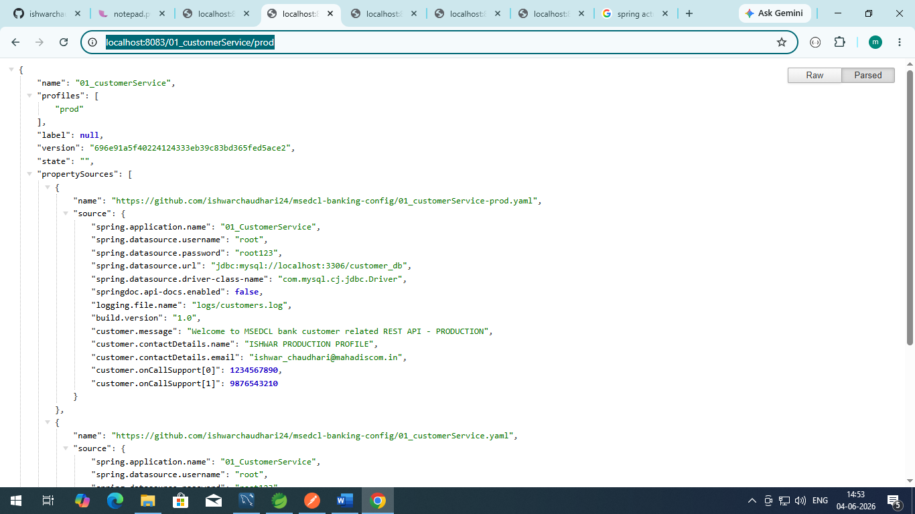

In customer service
Add dependencies
- Config client
- Actuator

<dependency>
<groupId>org.springframework.boot</groupId>
<artifactId>spring-boot-starter-actuator</artifactId>
</dependency>
<dependency>
<groupId>org.springframework.cloud</groupId>
<artifactId>spring-cloud-starter-config</artifactId>
</dependency>
<dependency>
<groupId>org.springframework.boot</groupId>
<artifactId>spring-boot-starter-actuator-test</artifactId>
<scope>test</scope>

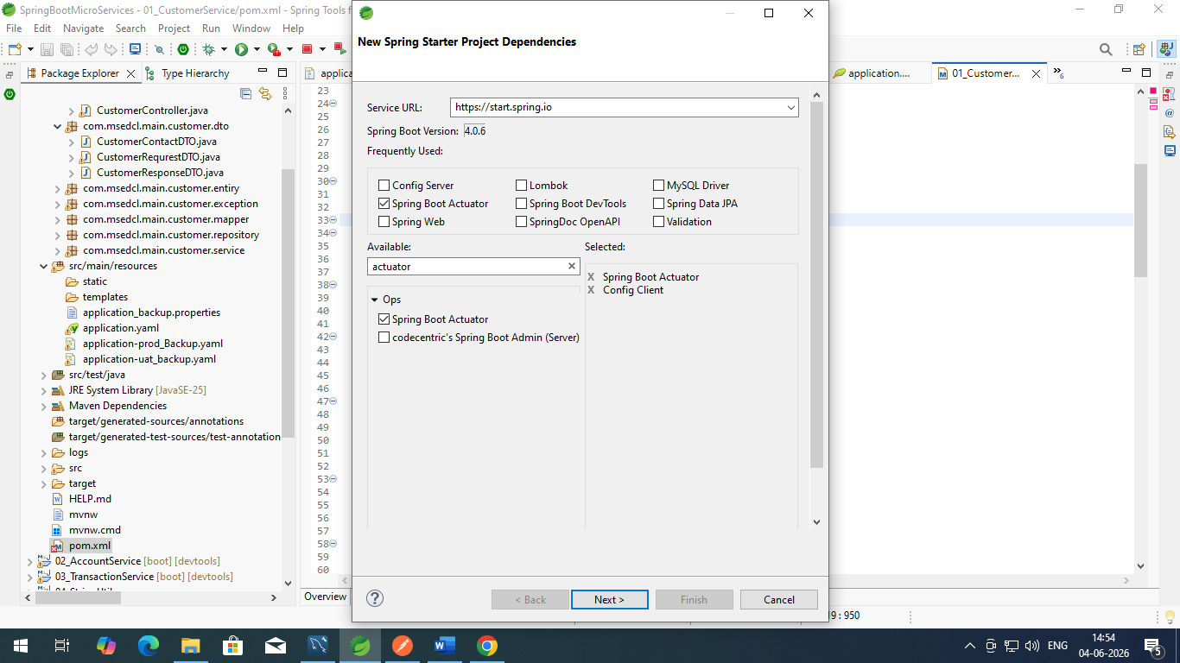

config:
import: "configserver:http://localhost:8083/" #Here is the path of actuator running server -- http://localhost:8083/actuator

profiles:
active:
- "prod"

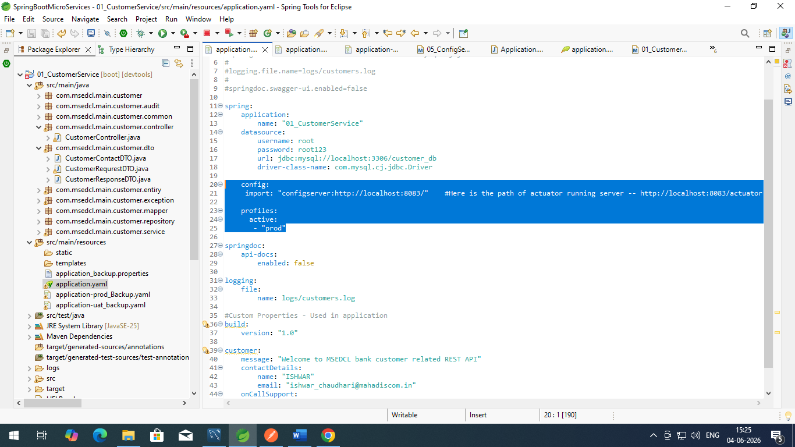

Restart the customerService.java
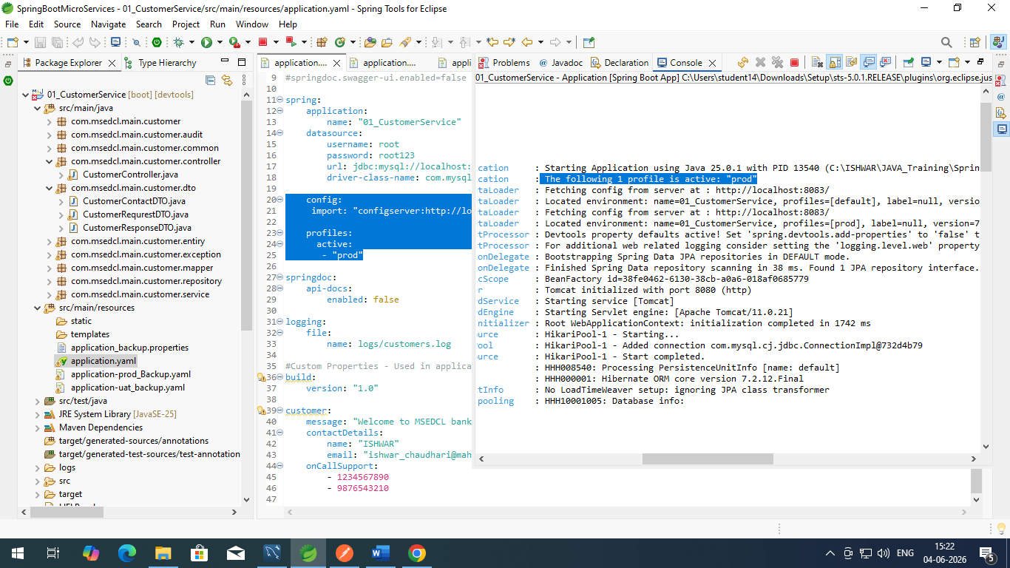

And check in postman
http://localhost:8080/customerapi/contact-details
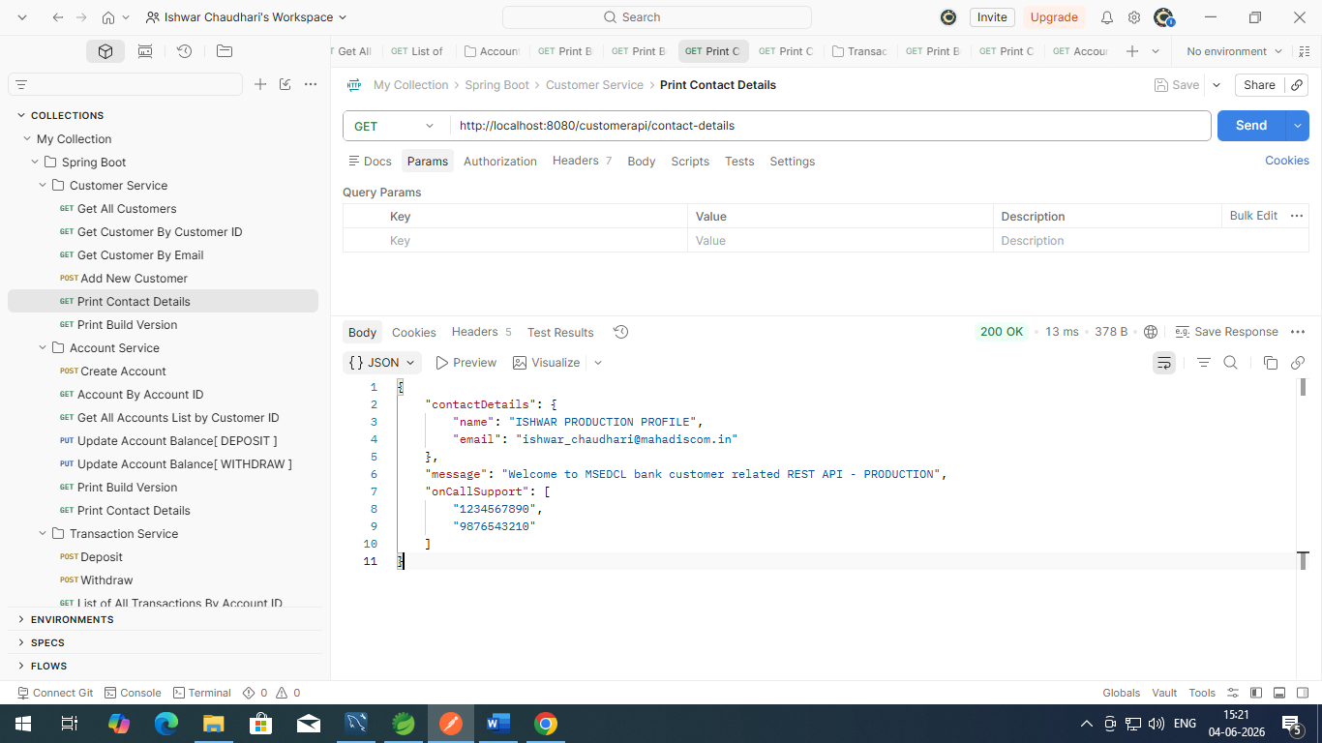

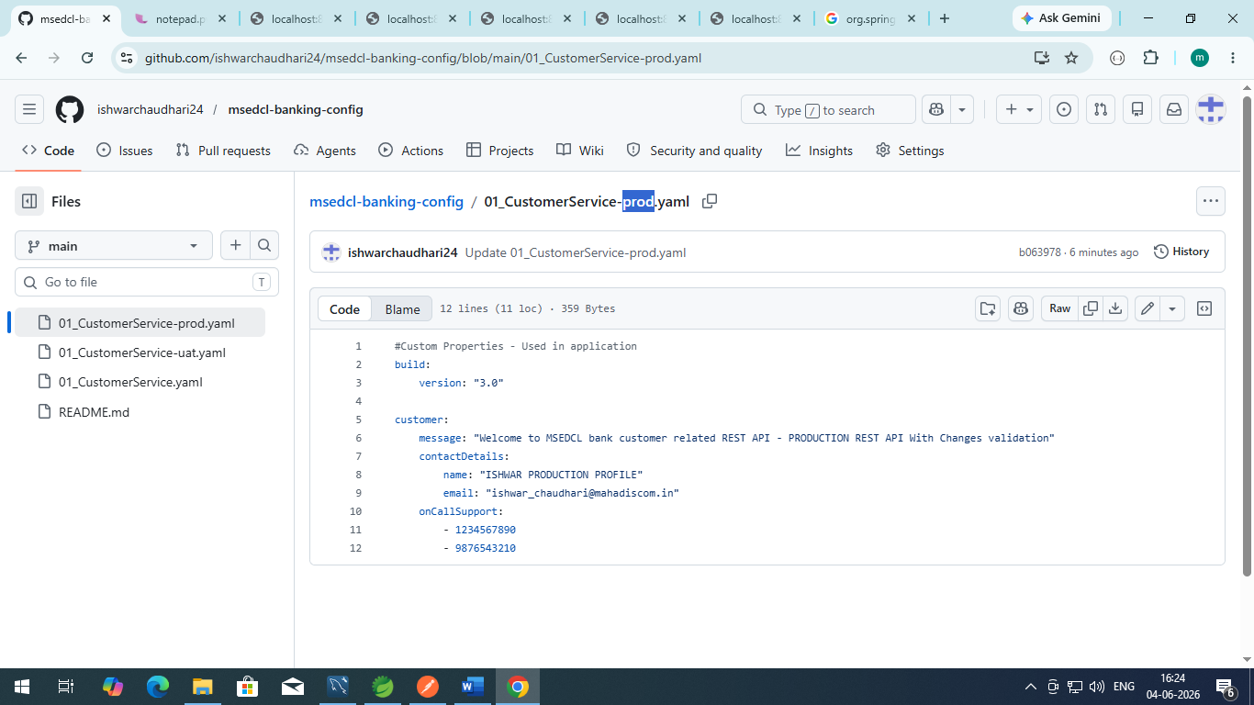

Do not required to restart the config server nor the application server and hit the Refresh POST Request of actuator from the application service

URL : http://localhost:8080/actuator/refresh
Method : POST
Properties of application service will be auto refresh without reloading the service.

Output :
[
"build.version",
"config.client.version",
"customer.message"
]

Shows which parameters are changed at git file.

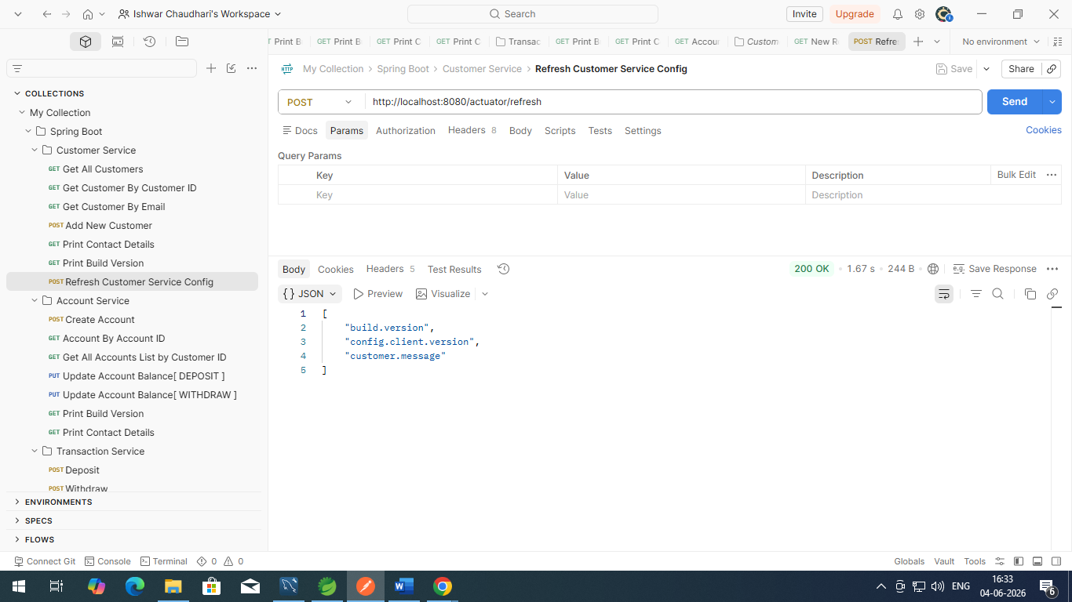

Config service i.e. Actuator port should not be exposed to public.
http://localhost:8083/actuator

