Egerton University

Software Requirements Specification

Version 1.0

September 4, 2018

Online Appointment Booking System

Alex Nyabuto
Justus Litunda
Peter Makori
Elvis Mutende
Cetric Okola

Submitted in partial fulfillment
Of the requirements of
COMP 390 Teamwork Project

Table of Contents
List of Figures ii
1.0. Introduction 1
1.1. Purpose 1
1.2. Scope of Project 1
1.3. Glossary 1
1.4. References 1
2.0. Overall Description 2
2.1 System Environment 2
2.2 Functional Requirements Specification 2
2.2.1 Student Use Case 3
2.2.2 Counsellor 4
2.2.3 Dean 4
3.0. Requirements Specification 6
3.1 External Interface Requirements 6
3.2 Functional Requirements 6
3.2.1 Book Appointment 6
3.2.2 Set Schedule 6
3.2.3 System Management 7
3.3 Detailed Non-Functional Requirements 8
3.3.1 Logical Structure of the Data 8
3.3.2 Security 9

1.0. Introduction

1.1. Purpose
The purpose of this document is to present a detailed description of the Online Appointment Booking System. It will explain the purpose and features of the system, the interfaces of the system, what the system will do, the constraints under which it must operate and how the system will react to external stimuli. This document is intended for both the stakeholders and the developers of the system and will be proposed to the Egerton University Dean of students’ office and Counselling Department Njoro Campus.

1.2. Scope of Project
This software system will be an Online Appointment Booking System for Egerton University Dean of students’ office and Counselling Department Njoro Campus. This system will be designed to maximize time utilization and elimination of concurrence situations under which students face while they make a visit to counselling and dean offices and facilitate service to all, which would otherwise have to be performed manually. By maximizing the counsellor work efficiency, the system will meet the student, counsellor and dean needs while remaining easy to understand and use.
More specifically, this system is designed to allow the students to book appointments and get attended to by counsellors and dean as well. The software will facilitate communication between students, counsellors, and the dean via E-Mail. The system also contains a relational database containing a list of sessions booked, counsellor schedules, students who are registered for counselling services and a list of counsellors.

1.3. Glossary
Term | Definition
Database | Collection of all the information monitored by this system.
Field | A cell within a form.
Student | A person registered for an undergraduate course to take studies in Egerton university Njoro Campus.
Counsellor | Staff member who will be issuing services to students.
Dean | Head of student dean department.
Software Requirements Specification | A document that completely describes all of the functions of a proposed system and the constraints under which it must operate. For example, this document.
Stakeholder | Any person with an interest in the project who is not a developer.
User | Student, counsellor or dean.

1.4. References
IEEE. IEEE Std 830-1998 IEEE Recommended Practice for Software Requirements Specifications. IEEE Computer Society, 1998.

2.0. Overall Description

2.1 System Environment
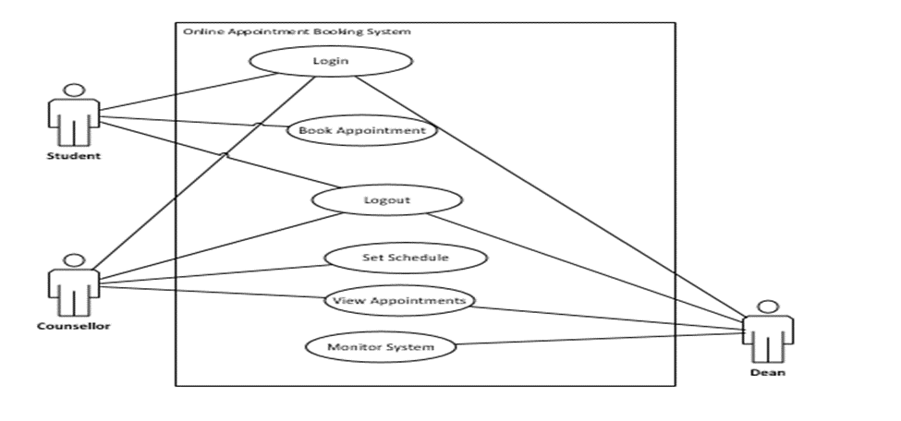
Figure 1 - System Environment

The Online Appointment Booking System has three active actors.
The student, counsellor and dean access the Online services through the Internet. Any student, counsellor or dean communication with the system is through email. The Dean accesses the entire system directly.

2.2 Functional Requirements Specification
This section outlines the use cases for each of the active users of the system separately. The counsellor and the student have only one-use case a piece while the Dean is the main actor in this system.

2.2.1 Student Use Case

Use case: Book Appointment.
Diagram:
Student
Book App.

Figure 2 - Student Use Case
Brief Description
The student accesses the Online website, searches for a counsellor who is free and books appointment to see the counsellor.

Initial Step-By-Step Description
Before this use case can be initiated, the Reader has already accessed the Online Appointment Booking Website.

- The student logs in the system using registration number or email.
- The student checks for sessions that have not been booked by checking on the booked schedules.
- The system provides links for booking appointments and viewing booked sessions.
- The student clicks the link to book appointment .
- The student selects the counsellor whom she or he wants to see.
- The student picks date that he/she wants to see the counsellor.
- The student picks time that he/she wants to see the counsellor.
- The student books appointment.

2.2.2 Counsellor
In case of long term schedule, the dean of students is manually contacted. The counsellor logs in the online appointment booking website where he/she sets time of unavailability.

Use case: Set Schedule
Diagram:
Counsellor
Set Schedule
Figure 3 - Counsellor Use Case
Brief Description
The author counsellor sets a schedule only for the time he/she will not be available.

Initial Step-By-Step Description
Before this use case can be initiated, the counsellor has already connected to the Online Appointment Booking System.

- The counsellor clicks a link to set the schedule.
- The counsellor selects the time in which he/she will be away.
- The counsellor picks number of hours he/she will be away.
- The counsellor picks time he/she will be away.
- The counsellor picks the number of days he/she will be away if any.
- The counsellor provides a reason he/she will be away.

2.2.3 Dean

Use case: Management of system
Diagram:
Figure 3 - Dean Use Case
Dean
Manage

Brief Description
The Dean conducts all the managerial activities of the system.

Initial Step-By-Step Description
Before this use case can be initiated, the Dean has already connected to the Online Appointment Booking Website.

- The dean logs in the system using username and a password..
- The System uses authentication function to validate the system user.
- The dean conducts all the managerial activities of the system as assigned.

3.0. Requirements Specification

3.1 External Interface Requirements
The system has been integrated to work only on the internal environments under which all users of the system must register with the counselling appointment booking system in order to access services provided by the system.

3.2 Functional Requirements
The Logical Structure of the Data is contained in Section 3.3.1.

3.2.1 Book Appointment
Use Case Name | Book Appointment
Trigger | The student assesses the Online Appointment booking system
Precondition | The student must be logged in and Web is displayed with menu addresses for booking
Basic Path | - The student logs in the system using registration number or email.  - The student checks for sessions that have not been booked by checking on the booked schedules.  - The system provides links for booking appointments and viewing booked sessions.  - The student clicks the link to book appointment .  - The student selects the counsellor whom she or he wants to see.  - The student picks date that he/she wants to see the counsellor.  - The student picks time that he/she wants to see the counsellor.  - The student books appointment.
Postcondition | An email is sent to the counsellor informing for the same.
Exception Paths | The student may abandon booking at any instance.

3.2.2 Set Schedule
Use Case Name | Set Schedule
Trigger | The counsellor assesses the Online Appointment booking system
Precondition | The counsellor must be logged in and Web is displayed with menu addresses for setting schedules.
Basic Path | - The counsellor clicks a link to set the schedule.  - The counsellor selects the time in which he/she will be away.  - The counsellor picks number of hours he/she will be away.  - The counsellor picks time he/she will be away.  - The counsellor picks the number of days he/she will be away if any.  - The counsellor provides a reason he/she will be away.
Postcondition | The message is sent to the dean informing for the same.
Exception Paths | The attempt may be abandoned at any time.
Other | None

3.2.3 System Management
Use Case Name | Manage System
Trigger | The dean assesses the Online Appointment booking system
Precondition | The dean must be logged in and Web is displayed with menu addresses for managerial activities.
Basic Path | - The dean logs in the system using username and a password..  - The System uses authentication function to validate the system user.  - The dean conducts all the managerial activities of the system as assigned.
Postcondition | Approval status updated
Exception Paths | The dean may abandon the operation at any time.
Other | None.

3.3 Detailed Non-Functional Requirements

3.3.1 Logical Structure of the Data

The logical structure of the data to be stored in the Online Appointment database is given below.

The data descriptions of each of these data entities is as follows:

Dean Data Entity
Data Item | Type | Description | Comment
User Name | String | Name of the dean
Password | String | Secret Password
Admin Id | Short Integer | Dean entry no. | Used as a key.
Email Address | String | Email address of the dean

Counsellor Data Entity
Data Item | Type | Description | Comment
Counsellor Name | String | Name of the counsellor
Counsellor no. | Integer | The office number the counsellor is assigned | Used as key in searching available counsellors
Email Address | Text | Internet address
Phone No. | Integer | Counsellors cell phone | May be several

Schedule Data Entity
Data Item | Type | Description | Comment
Away date | date | The date the counsellor will be away
Away Time | Time | The time the counsellor will be away
Away Period | Integer | The duration the counsellor will be away
Next time available | Time | Date returned; null if not returned
Next Available date | Date | The next time the counsellor will be available
Reason | Text | Reason for unavailability
Approval | Text | Status of the schedule set
Counsellor No. | Text | The counsellors’ office number
Counsellor Name. | Text | The name of the counsellor

Sessions Data Entity
Data Item | Type | Description | Comment
Reg. No. | String | The students’ registration number.
Student Name | Text | The name of the student
Counsellor No. | String | The name of the counsellor picked
Date | Date | The date the student will see the counsellor
Start Time | Text | The time the student will see the counsellor
End Time | Text | The time the booked session will be off
Session ID | Integer | The number that distinguishes sessions | A key for searching different sessions

The Logical Structure of the data to be stored in the Online Journal database on the server is as follows:

Student Data Entity
Data Item | Type | Description | Comment
User Id | Integer | Distinguishes students and helps identify the number of students in the database
User Email | String | The students’ email address
User password | String | The password student uses to login the system
Reg. No. | String | Students’ registration number | Key for searching students in the database
Name | String | The students’ name
Phone No. | Integer | The students’ contacts

3.3.2 Security

The server on which the Online appointment booking resides will have its own security to prevent unauthorized write/delete and read access. The PC on which the Online Appointment Booking system resides will have its own security.

