FACE RECOGNITION RESEARCH DOCUMENT

Face recognition is the ability of the computer to identify individuals based on their facial features (faces).
The context might sound huge to code to make a system intelligent enough to recognize people by looking at them, or their images.
We are going to focus on the approach to face recognition, at least the approach I used and achieve some satisfying results upon solving the problem.
The problem is a machine learning field of study, and we are going to solve this by using neural networks and deep learning methods.

The steps upon Face Recognition:
- Detect and locate faces (Identify face locations)
- Find face vectors (encode face)
- compare face vector distances

The mentioned above can give you a general idea of how we are going to tackle this problem of facial recognition. I am not going to go deep into detailed explanations, I'll try to explain it as easily as possible so we can speak the same language throughout this article.

- Detect and locate Faces
This means identifying faces from an image. The art of knowing whether an image contains a face in it, and locating the face. Locating faces looks nice when you draw bounding boxes around faces throughout the image. There are various models for face detection that are popularly used nowadays. As the technology keeps growing, more and more models are made and they perform a great job of detecting faces. Today we are going to list popular face detectors, then we will explain the face detection method that was used in my research.

Most popular face detectors
- OpenCV
- DLib
- SSD
- MTCNN
- Retina Face
Both face detectors do a great job. Although, selecting a suitable face detector for your project may depend on the purpose and objectives of your project. They range from simple algorithms to complex neural nets. OpenCV and DLib are lightweight face detectors where as openCV use Haar Cascades algorithms while DLib uses the Histogram of Oriented Gradients(HOG).
SSD, MTCNN and RetinaFace uses neural networks and deep learning algorithms to perform face detection. Deep learning approaches provide better results than normal machine learning approaches, but it does not mean openCV and DLib give bad results. They both perform excellently, the difference comes in the purpose of your project. Deep learning models take more time to compute and thus they do not fit well when your project is about speed. On the other hand, if your project is more about accuracy and computational time does not matter, then you'd better go for RetinaFace, MTCNN or SSD models.

In this research I analyzed both mentioned face detectors to observe their performance in different scenarios, and finally chose the suitable face detector for my facial recognition project.
Face detectors that use deep learning algorithms are more accurate, but have a relatively larger response time as they use more resources for computations. Thus, I would suggest if the project is about accuracy just like intense security projects, you should consider going for RetinaFace, am recommending RetinaFace as it gave best results when I was analyzing the performance of each one of them.
However, if your system is to be a lightweight project such as attendance systems, you do not expect people to spend so much time just being recognized to be marked in the attendance. For a project like attendance system, you should probably use openCV or DLib. I recommend DLib for lightweight face detection as it gave better results during my analysis.

FACE DETECTION METHOD USED IN THE FINAL PROJECT
The face detector chosen is DLib which uses the astonishing Histogram of Oriented Gradients (HOG) algorithm. HOG algorithm works so good in face detection and it is a lightweight algorithm that does not use deep learning.

HISTOGRAM OF ORIENTED GRADIENTS
HOG algorithm works as explained below
- First of all, convert the image into grayscale to make it easier to work with. Grayscale image gives a 2D array that is easier to manipulate than colored images that gives a 3D array which is more complicated in terms of computations.
- Detect the location of the faces in the image by using the Histogram of Oriented Gradients (HOG) algorithm. The HOG algorithm takes a grayscale image, it goes through every pixel in the image, For every single pixel, we want to look at the pixels that directly surrounding it:

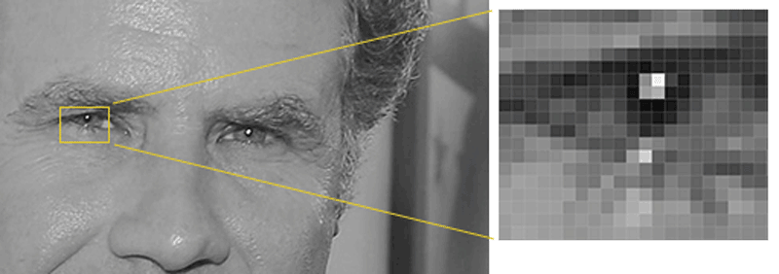Illustration 1: Detecting pixels and their surrounding pixels. ~Geitgey – Machine Learning is fun

The next step is to figure out how dark the current pixel is compared to the pixels that surround it. Then draw an arrow showing in which direction the image is getting darker.

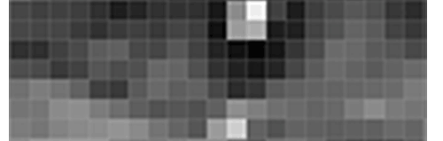Illustration 2: Arrow showing the direction of darkness

By doing so on the entire image, we will end up having an image made of arrows. These arrows are called Gradients, and they show the flow from light to dark across the entire image.

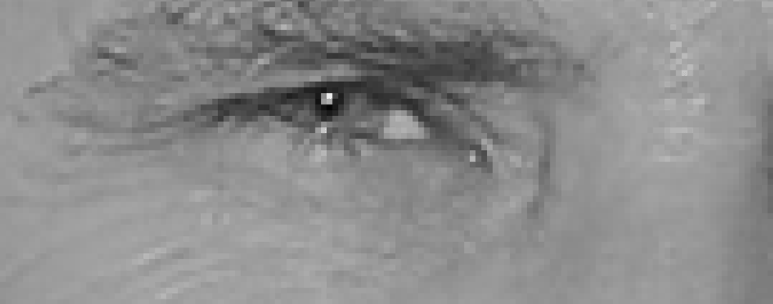Illustration 3: Image pixels replaced by arrows
The reason for using arrows instead of pixels directly is that, if we use pixels directly, really dark images and light images of the same person will give different values. But using arrows, the values will remain the same despite the darkness or lightness of the image used.

Although all these arrows give us a lot of information to process, we need to see the basic flow of lightness/darkness at a higher level so we could see the basic pattern of the image.

To do this, we’ll break up the image into small squares of 16x16 pixels each. In each square, we’ll count up how many gradients point in each major direction (how many point up, point up-right, point right, etc…). Then we’ll replace that square in the image with the arrow directions that were the strongest.
The result is we turn the original image into a very simple representation that captures the basic structure of a face only:
Illustration 4: Image turned into HOG form
To find faces in this HOG image, all we have to do is find the part of our image that looks the most similar to a known HOG pattern that was extracted from a bunch of other training faces.
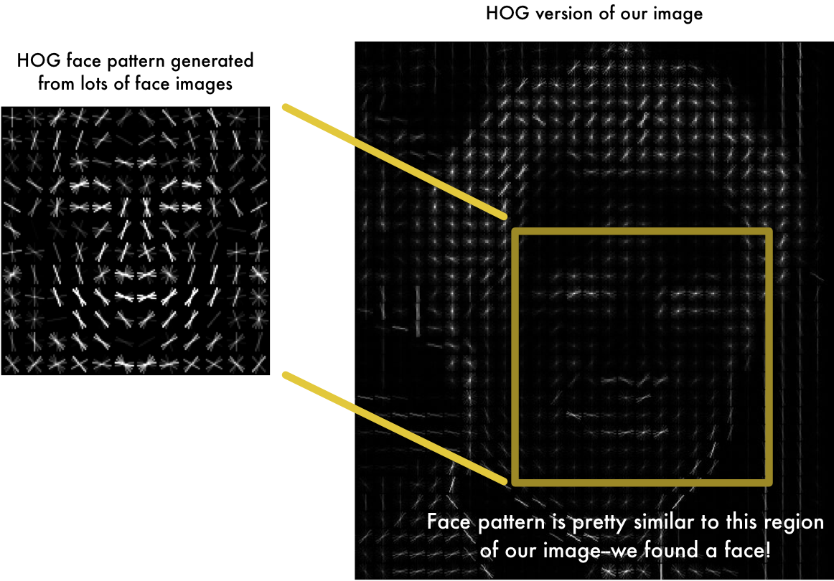Illustration 5: Detecting face location using HOG
Using this technique, we can easily find faces in any image

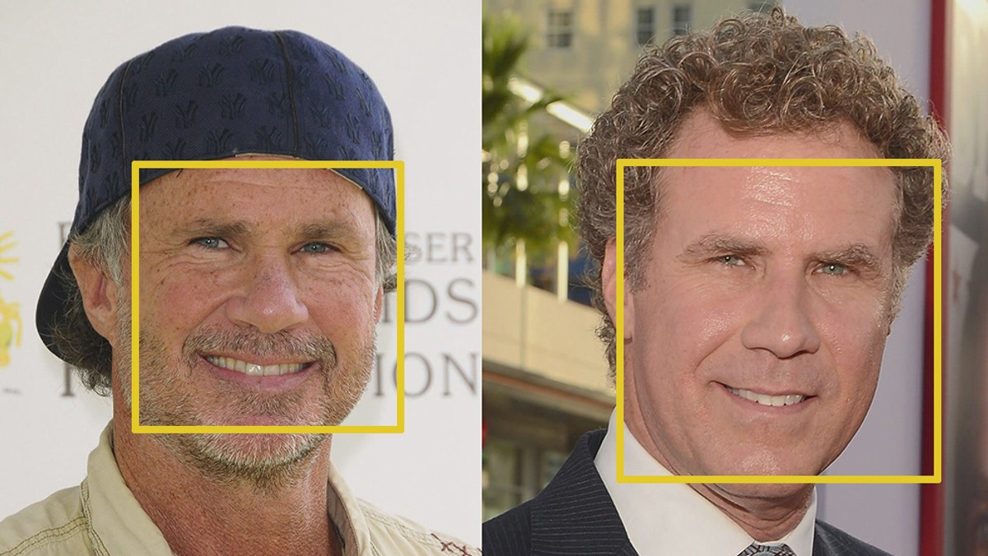Illustration 6: Detecting face locations

