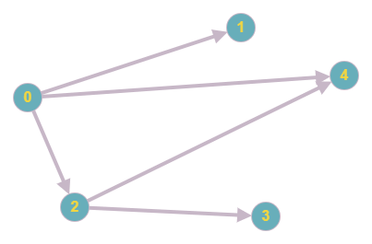

Example for graphical representation of the novel

sad

Arun

feeling

father

happy

lonely

Kumar

