Docker Environment

A **Docker .env file** is a plain text file used to define **environment variables** that can be used in your Docker Compose files.

**🔹 Purpose**

It helps to:

* **Avoid hardcoding** sensitive or environment-specific values
* **Easily switch environments** (dev, test, prod)

**🔹 Syntax**

Each line contains a key-value pair:

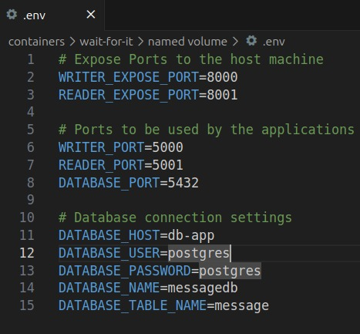

**🔹 Notes**

* Default name: .env (auto-loaded by Docker Compose if placed in the same directory)
* No quotes or spaces around =
* Comments start with #

**🔹 How It's Used**

In docker-compose.yml, you can reference these like this:

**🔹 .env in Dockerfiles**

By default, the .env file is **not automatically available** to the Dockerfile during docker build. But you **can** use .env values in a Dockerfile by **manually passing them as build arguments**.

✅ **Define Variables in .env (used previously)**

✅ **Reference Them via ARG in Dockerfile**

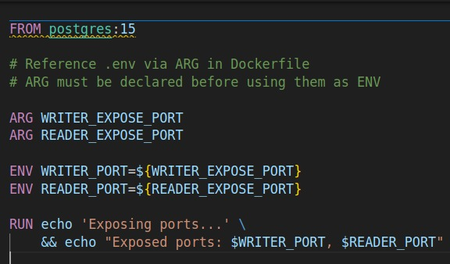

**Note:** ARG must be declared **before** using them as ENV.

✅ **Pass Them During Build Using --build-arg**

* load them with --env-file  
    
  export $(cat .env | xargs) # loads .env into shell  
    
  docker build --build-arg WRITER_PORT=$WRITER_EXPOSE_PORT --build-arg READER_PORT=$READER_EXPOSE_PORT -t dockefile:env .

**⚠️ Notes**

* ARG values are **only available during build time**, not at container runtime.
* For runtime values, use ENV or pass variables in docker run or docker-compose.yml.